*Disclaimer: This information is distributed solely for the purpose of pre-dissemination peer review under applicable information quality guidelines. It has not been formally disseminated by NOAA Fisheries. It does not represent and should not be construed to represent any agency determination or policy*

**Stock Assessment of   
Shortspine Thornyhead in 2013**

by

Ian G. Taylor

Andi Stephens

Northwest Fisheries Science Center

U.S. Department of Commerce

National Oceanic and Atmospheric Administration

National Marine Fisheries Service

2725 Montlake Boulevard East

Seattle, Washington 98112-2097

DRAFT SAFE

August 21, 2013

**Table of Contents**

**Executive Summary 4**

**Stock 4**

**Catches 4**

**Data and assessment 5**

**Stock biomass 6**

**Recruitment 8**

**Exploitation status 9**

**Ecosystem considerations 11**

**Reference points 12**

**Management performance 13**

**Unresolved problems and major uncertainties 14**

**Projections and Decision table 14**

**Research and data needs 19**

**1** **Introduction 20**

**1.1** **Distribution 20**

**1.2** **Stock structure 20**

**1.3** **Life History 20**

**1.4** **Ecosystem Considerations 21**

**1.5** **Fishery Information 21**

**1.6** **Summary of Management History 22**

**1.7** **Management Performance 22**

**1.8** **Fisheries off Canada, Alaska, and/or Mexico 22**

**2** **Assessment 22**

**2.1** **Data 22**

2.1.1 Biology 22

2.1.2 Catch History 24

2.1.3 Discards and retention 24

2.1.4 Fishery Length Compositions 24

2.1.5 Age Compositions 25

2.1.6 NMFS Surveys 25

2.1.7 Changes in data from the 2005 assessment 27

2.1.8 Environmental and Ecological Data 28

**2.2** **Model 28**

2.2.1 Overview 28

2.2.2 Fishing fleets and surveys 28

2.2.3 Parameters 28

**2.3** **Model Selection and Evaluation 30**

2.3.1 Model Convergence 30

2.3.2 Stock assessments in Alaska 31

**2.4** **Response to STAR Panel Recommendations 31**

**2.5** **Base-Model Results 32**

2.5.1 Spawning biomass and depletion 32

2.5.2 Selectivity and retention 32

2.5.3 Recruitment 33

2.5.4 Fit to data 33

**2.6** **Uncertainty and Sensitivity Analyses 34**

2.6.1 Likelihood profiles 34

2.6.2 Sensitivity analyses 36

2.6.3 Retrospective analyses 36

2.6.4 Comparison to previous assessment 37

2.6.5 Axis of uncertainty and states of nature 37

**3** **Reference Points 37**

**4** **Harvest Projections and Decision Tables 37**

**5** **Regional Management Considerations 38**

**6** **Research Needs 39**

**7** **Acknowledgments 40**

**8** **Literature Cited 40**

**9** **Tables 44**

**10** **Figures 59**

**10.1** **Catch history 59**

**10.2** **Distribution, Ecology and Life history 61**

**10.3** **Data and model fits 71**

10.3.1 Data summary 71

10.3.2 Selectivity and retention 72

10.3.3 Indices and discard data 74

10.3.4 Length compositions 77

**10.4** **Model results 92**

10.4.1 Base model results 92

10.4.2 Likelihood profiles, sensitivities, and retrospective analyses 99

**Appendix A. Estimated numbers at age 113**

**Appendix B. SS data file 119**

**Appendix C. SS control file 149**

**Appendix D. SS starter file 157**

**Appendix E. SS forecast file 158**

**Executive Summary**

**Stock**

This assessment applies to shortspine thornyhead (*Sebastolobus alascanus*) off of the west coast of the United States from the U.S.-Canadian border in the north to the U.S.-Mexico border in the south. Shortspine thornyheads have been reported as deep as 1,524 m, and this assessment applies to their full depth range although survey and fishery data are only available down to 1,280 m. This resource is modeled as a single stock because genetic analyses do not indicate significant stock structure within this range. This is the same stock assumption made in the most recent assessment of shortspine thornyhead in 2005 (Hamel, 2005).

**Catches**

Landings of shortspine are estimated to have risen to a peak of 4,815 mt in 1989, followed by a sharp decline during a period of trip limits and other management measures imposed in the 1990s. Since the institution of separate trip limits for shortspine and longspine thornyheads, the fishery had more moderate removals of between 1,000 and 2,000 mt per year from 1995 through 1998. Landings fell below 1,000 mt per year from 1999 through 2006, then rose to 1,531 in 2009 and have declined since that time. Recreational fishery landings of thornyheads were negligible, so only commercial landings were included in the model. Trawl landings represent only bottom trawl gear and non-trawl landings include all other gears, the majority of which is longline, with some catch by pot gear. Both trawl and non-trawl landings are divided into North (the waters off Washington and Oregon) and South (the waters off California) fleets although they are assumed to be fishing on the same unit stock. Discard rates (landings divided by total catch) for shortspine have been estimated as high as 43% per year, but are more frequently below 20%. Discard rates in the trawl fisheries declined over the period where they are available from West Coast Groundfish Observer Program (WCGOP) from 2003–2011 and dropped to less than 1% in 2011, the only estimate available under catch shares system that began that year.

**Table a: Recent Landings**

| Year | Landings (mt) | | | | |
| --- | --- | --- | --- | --- | --- |
| Trawl N | Trawl S | Non-trawl N | Non-trawl S | Total |
| 2003 | 270 | 364 | 11 | 155 | 800 |
| 2004 | 295 | 323 | 11 | 129 | 757 |
| 2005 | 255 | 250 | 11 | 139 | 654 |
| 2006 | 296 | 248 | 15 | 144 | 703 |
| 2007 | 562 | 285 | 16 | 143 | 1006 |
| 2008 | 902 | 330 | 20 | 175 | 1427 |
| 2009 | 948 | 383 | 29 | 172 | 1531 |
| 2010 | 770 | 355 | 22 | 206 | 1353 |
| 2011 | 424 | 288 | 24 | 237 | 974 |
| 2012 | 381 | 323 | 36 | 155 | 894 |

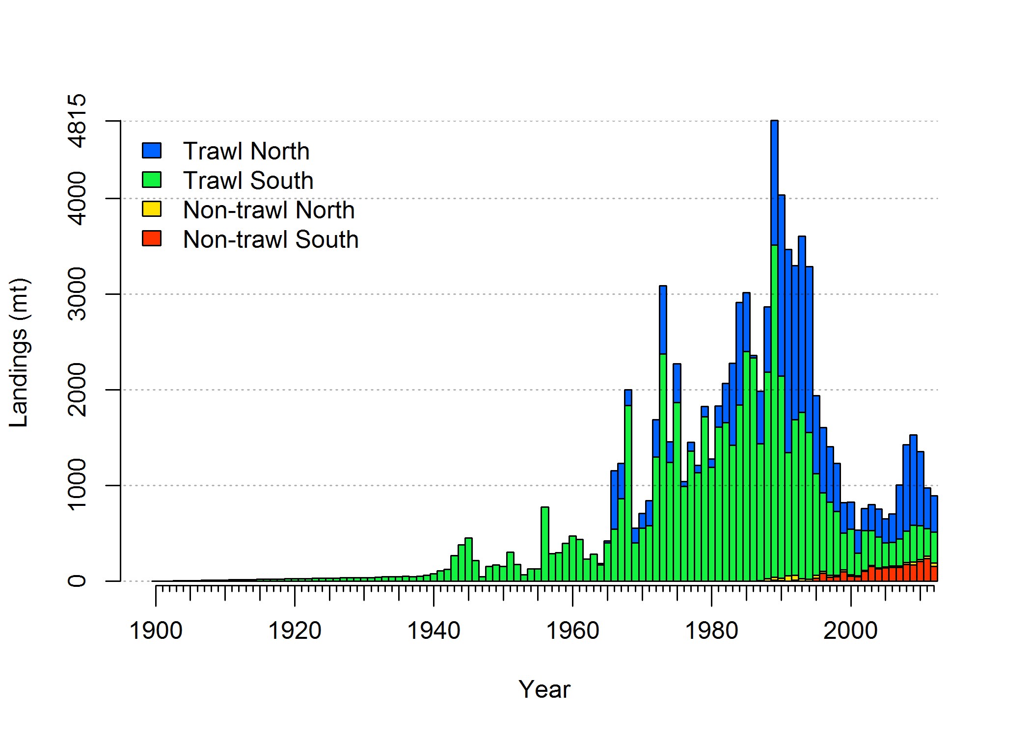

**Figure a: Landings History**

**Data and assessment**

The most recent assessment for shortspine thornyhead was conducted in 2005 (Hamel, 2005). Stock status was determined to be above the target biomass and catches did not attain the full management limits so reassessment of thornyheads has not been a higher priority.

This new assessment used Stock Synthesis (SS, Methot, 2012) Version 3.24o used in other recent west coast assessments. Additional sensitivities were conducted using Version 3.24q, which has more flexible options to model maturity at length, a change that was made to explore new data for shortspine thornyheads (R. Methot, pers. comm.).

The data are divided into four fisheries: trawl and non-trawl gears, which are each divided into North (the waters off Washington and Oregon) and South (the waters off California) and five surveys: the Alaska Fisheries Science Center (AFSC) triennial shelf survey from 55-366 meters (1980-2004), the deeper range of triennial shelf survey from 366-500 meters for the later years (1995-2004), the AFSC slope survey (1997, 1999-2001), the Northwest Fisheries Science Center (NWFSC) slope survey (1998-2002) and the NWFSC combined shelf-slope survey (2003-2012).

Most of the data used in the previous assessment has been newly extracted and processed, including length compositions from each fishing fleet and survey, indices of abundance derived from new GLMM analyses of survey data, discard rates from both a 1980s Oregon State University observer study (Pikitch et al., 1988) and the current West Coast Groundfish Observer Program (WCGOP), and the time series of catch from 1981-2012. Data retained from the previous assessment without reanalysis are the estimated historic catch for the years up to 1980 and discard rates from the Enhanced Data Collection Project (EDCP) study in the 1990s. Shortspine ovaries were collected in 2011 and 2012 from the NWFSC shelf-slope survey which allowed an exploration of alternative maturity assumptions from those used in the previous assessment. However, additional sampling and further analysis of maturity patterns is needed before revising the assumptions about maturity used in the assessment.

As in the previous assessment, no age data are used in this analysis and growth parameters are fixed at the same values used in 2005. Parameters for steepness of the stock-recruit relationship and natural mortality are likewise fixed in this assessment. There are 223 estimated parameters in the assessment. The log of the unfished equilibrium recruitment, log(*R*0), controls the scale of the population, annual deviations around the stock-recruit curve (163 parameters) allow for more uncertainty in the population trajectory, and selectivity and retention of the 4 fishing fleets and 5 surveys, including estimates of changes in retention over time (58 parameters). Finally, there is a single parameter which represents additional variability in one of the surveys that is added to the estimate of sampling error for that index.

**Stock biomass**

Unfished equilibrium spawning biomass (*B*0) is estimated to be 189,765 mt, with a 95% confidence interval of 57,435 – 322,095 mt. The *B*0 estimate represents an increase from the 130,646 mt estimate for *B*0 in the previous assessment although this previous estimate falls well within the uncertainty interval around the current estimate. Spawning biomass is estimated to have remained stable until the mid-1970s and then declined from the 1970s to about 80% in the 1990s, followed by a slower decline under the lower catch levels in the 2000s (Figure 36). The estimated spawning biomass in 2013 is 140,753 mt, which represents a stock status or “depletion” (represented as spawning biomass in 2013, *B*2013,divided by *B*0) of 74.2% (Figure 37). The depletion estimated for 2005 is 76.4%, which is higher than the 62.9% estimated for 2005 in the previous assessment. The standard deviation of the log of spawning biomass in 2013 is σ = 0.45, which is greater than the 0.36 minimum assumed for use in *p*\* adjustments to OFL values.

**Table b: Recent trend in beginning of the year biomass and depletion**

| Year | Spawning biomass (1000 mt) | ~95% confidence interval | Estimated depletion | ~95% confidence interval |
| --- | --- | --- | --- | --- |
| 2003 | 146.0 | 16.1 – 275.8 | 76.9% | 61.3% – 92.5% |
| 2004 | 145.5 | 15.5 – 275.5 | 76.7% | 60.8% – 92.5% |
| 2005 | 145.0 | 15.0 – 275.1 | 76.4% | 60.4% – 92.5% |
| 2006 | 144.7 | 14.5 – 274.8 | 76.2% | 60.0% – 92.4% |
| 2007 | 144.3 | 14.1 – 274.6 | 76.1% | 59.7% – 92.4% |
| 2008 | 143.8 | 13.4 – 274.2 | 75.8% | 59.2% – 92.4% |
| 2009 | 143.1 | 12.6 – 273.7 | 75.4% | 58.4% – 92.4% |
| 2010 | 142.3 | 11.6 – 273.0 | 75.0% | 57.7% – 92.3% |
| 2011 | 141.6 | 10.8 – 272.5 | 74.6% | 57.0% – 92.3% |
| 2012 | 141.2 | 10.2 – 272.1 | 74.4% | 56.5% – 92.3% |
| 2013 | 140.8 | 9.7 – 271.8 | 74.2% | 56.1% – 92.3% |

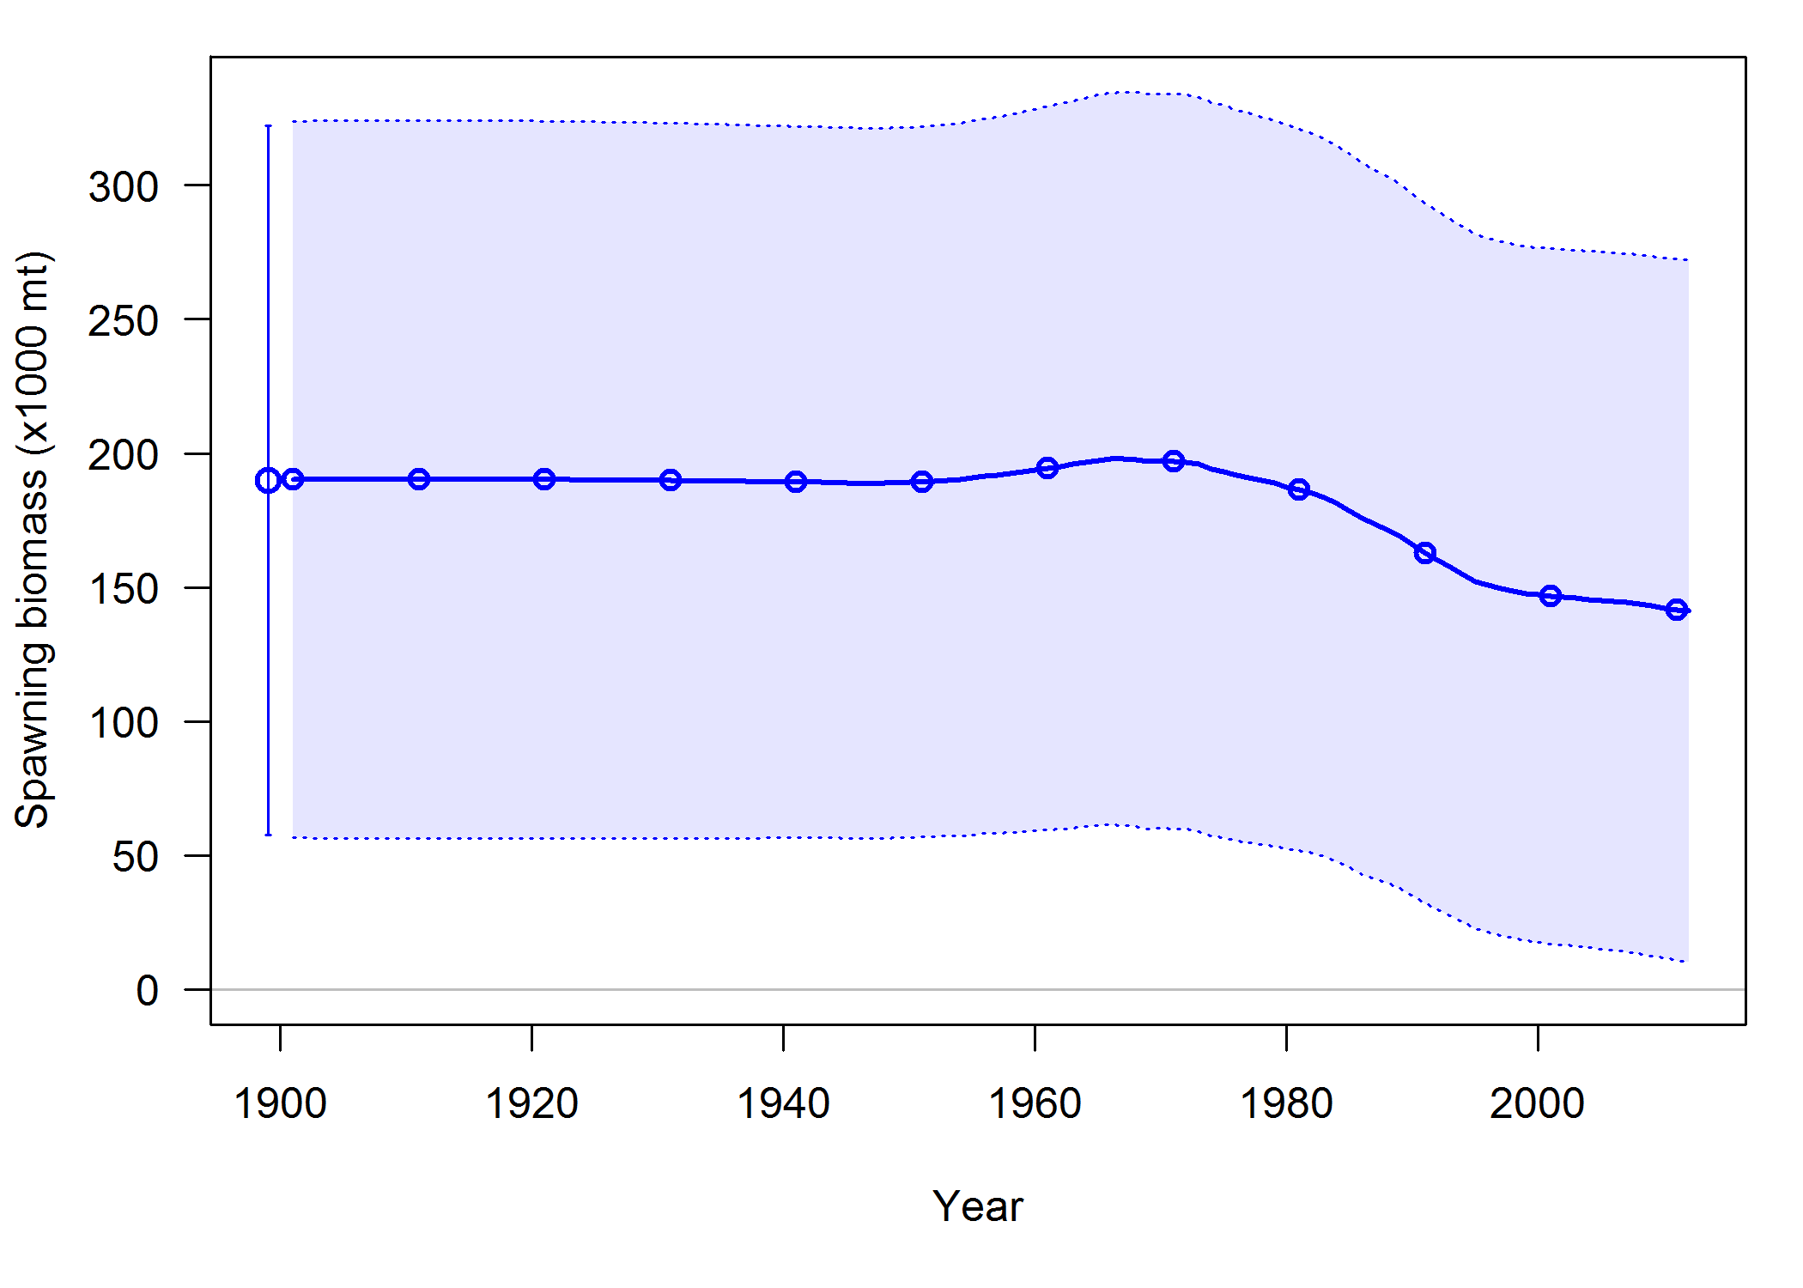

**Figure b: Biomass trajectory**

**Recruitment**

This assessment assumed a Beverton-Holt stock recruitment relationship. Steepness (the fraction of expected equilibrium recruitment associated with 20% of equilibrium spawning biomass) was kept at the value of 0.6 that was assumed in the previous assessment, although the results were relatively insensitive to alternative assumptions about steepness. The scale of the population is estimated through the log of the initial recruitment parameter (*R*0). Recruitment deviations were estimated for the years 1850 through 2012, where the values estimated in the years 1850 through 1900 are used to estimate a non-equilibrium age-structure in 1901, which is the first year of the population projection. Estimated recruitments do not show high variability, and the uncertainty in each estimate is greater than the variability between estimates.

**Table c: Recent recruitment**

| Year | Estimated recruitment (millions) | +-~95% confidence interval |
| --- | --- | --- |
| 2003 | 20.6 | 7.3 - 57.9 |
| 2004 | 22.5 | 7.9 - 64.1 |
| 2005 | 27.2 | 9.3 - 79.5 |
| 2006 | 32.7 | 10.9 - 98.5 |
| 2007 | 33.0 | 10.8 - 100.8 |
| 2008 | 30.9 | 10.1 - 94.3 |
| 2009 | 30.2 | 9.9 - 92.4 |
| 2010 | 30.5 | 9.9 - 93.5 |
| 2011 | 27.4 | 9.0 - 83.7 |
| 2012 | 28.8 | 9.3 - 89.3 |

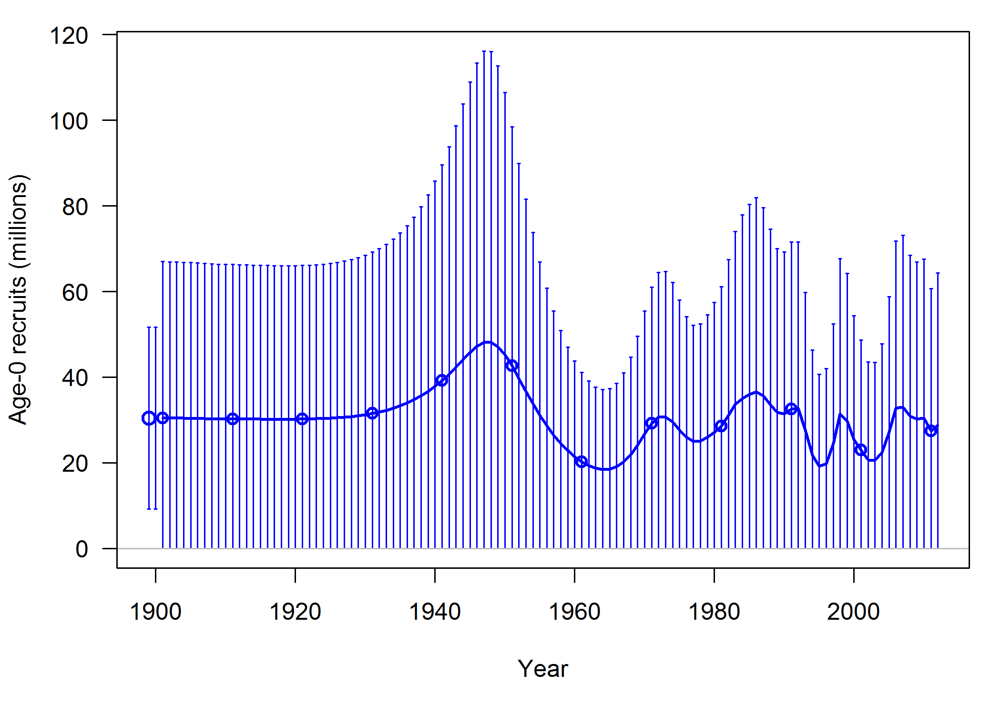

**Figure c: Recruitment**

**Exploitation status**

The summary harvest rate (total catch divided by age-1 and older biomass) closely follows the patterns of landings. The harvest rates are estimated to have never exceeded 2% and have remained below 1% in the past decade. Expressing exploitation rates in terms of spawning potential ratio (SPR) indicates that the exploitation slightly exceeded the target reference point associated with SPR50% for a single year in 1985 and then for the period 1989-1994. However, the stock status is estimated to have never fallen below the *B*40% management target.

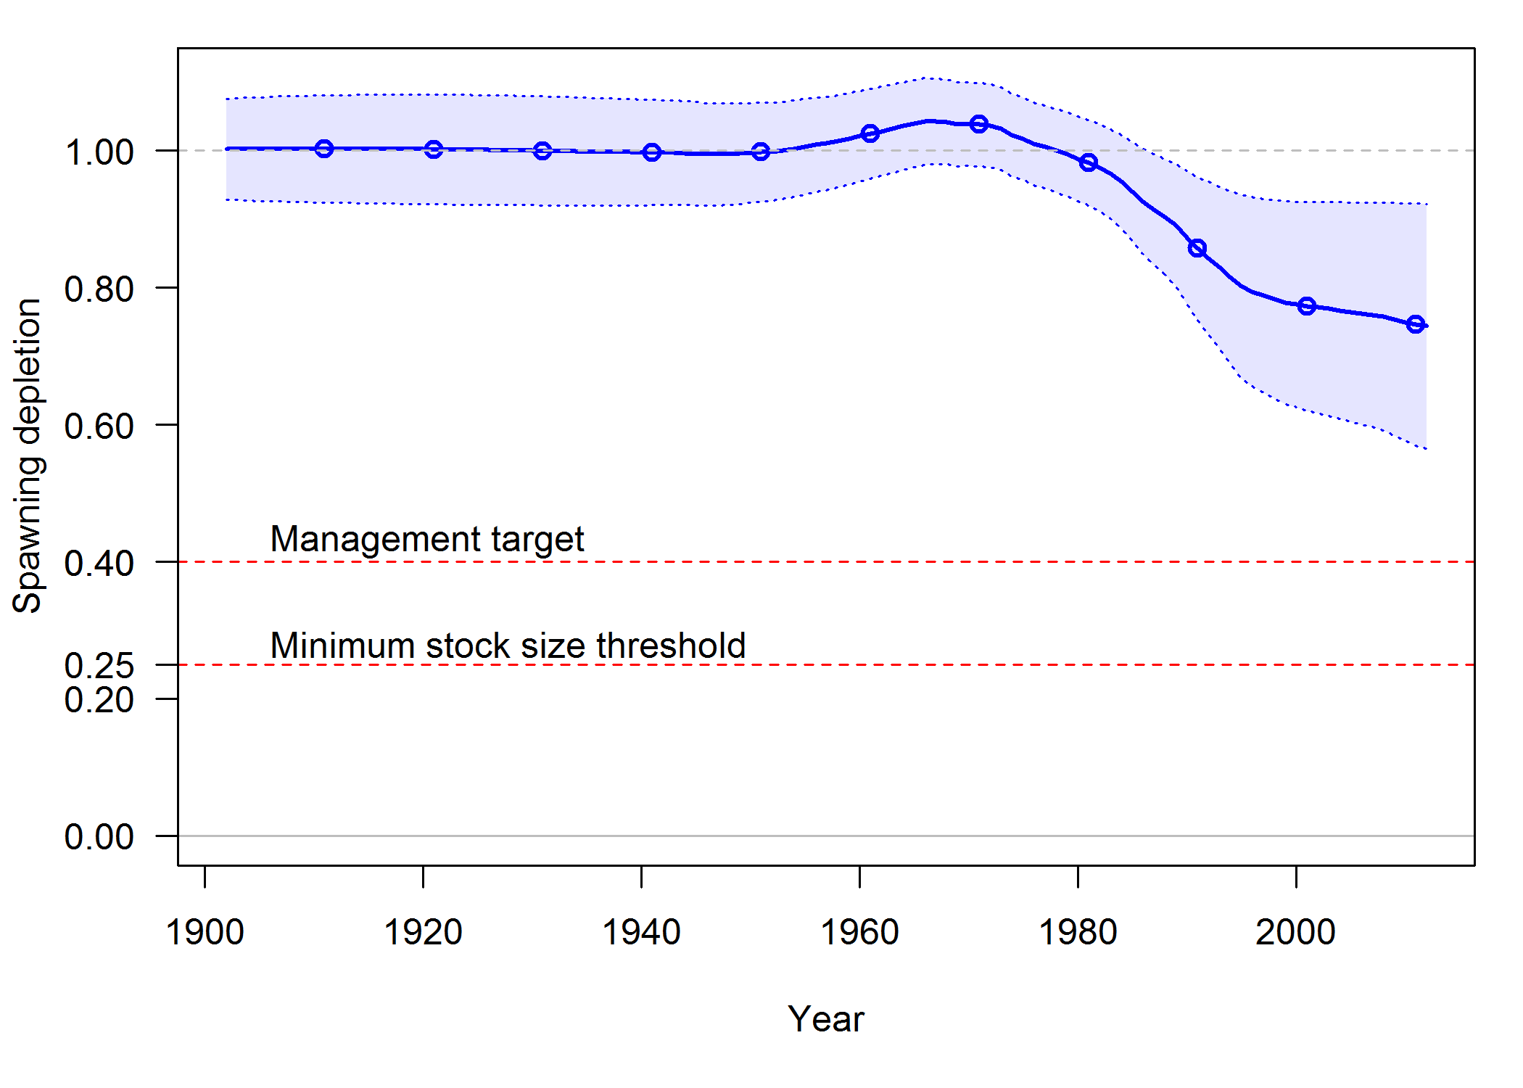

**Figure d. Estimated relative depletion with approximate 95% asymptotic confidence intervals (shaded area) for the base case assessment model.**

**Table d. Recent trend in spawning potential ratio (entered as 1-SPR) and summary exploitation rate (catch divided by biomass of age-1 and older fish).**

| Year | Estimated 1–SPR (%) | ~95% confidence interval | Harvest rate (proportion) | ~95% confidence interval |
| --- | --- | --- | --- | --- |
| 2001 | 13.0% | 2.2% - 23.8% | 0.0024 | 0.0002 - 0.0045 |
| 2002 | 17.4% | 3.4% - 31.4% | 0.0034 | 0.0003 - 0.0064 |
| 2003 | 18.4% | 3.6% - 33.2% | 0.0036 | 0.0004 - 0.0068 |
| 2004 | 17.6% | 3.3% - 31.8% | 0.0034 | 0.0003 - 0.0064 |
| 2005 | 15.5% | 2.7% - 28.3% | 0.0029 | 0.0003 - 0.0056 |
| 2006 | 16.6% | 3.0% - 30.2% | 0.0032 | 0.0003 - 0.0060 |
| 2007 | 21.8% | 4.6% - 39.0% | 0.0042 | 0.0004 - 0.0081 |
| 2008 | 29.7% | 7.6% - 51.8% | 0.0061 | 0.0005 - 0.0116 |
| 2009 | 31.4% | 8.2% - 54.5% | 0.0065 | 0.0005 - 0.0126 |
| 2010 | 28.3% | 6.7% - 49.8% | 0.0058 | 0.0004 - 0.0112 |
| 2011 | 20.3% | 3.7% - 36.9% | 0.0041 | 0.0003 - 0.0078 |
| 2012 | 18.7% | 3.1% - 34.2% | 0.0037 | 0.0002 - 0.0072 |

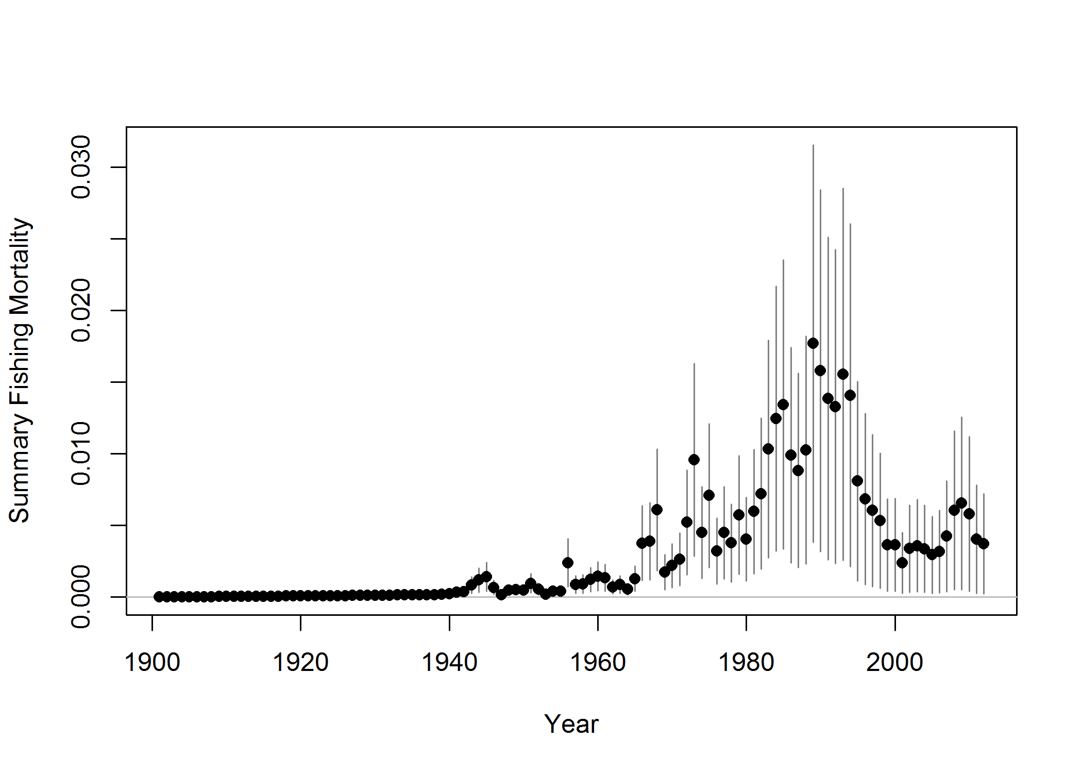

**Figure e. Time-series of estimated summary harvest rate (total catch divided by age-1 and older biomass) for the base case model (round points) with approximate 95% asymptotic confidence intervals (grey lines).**

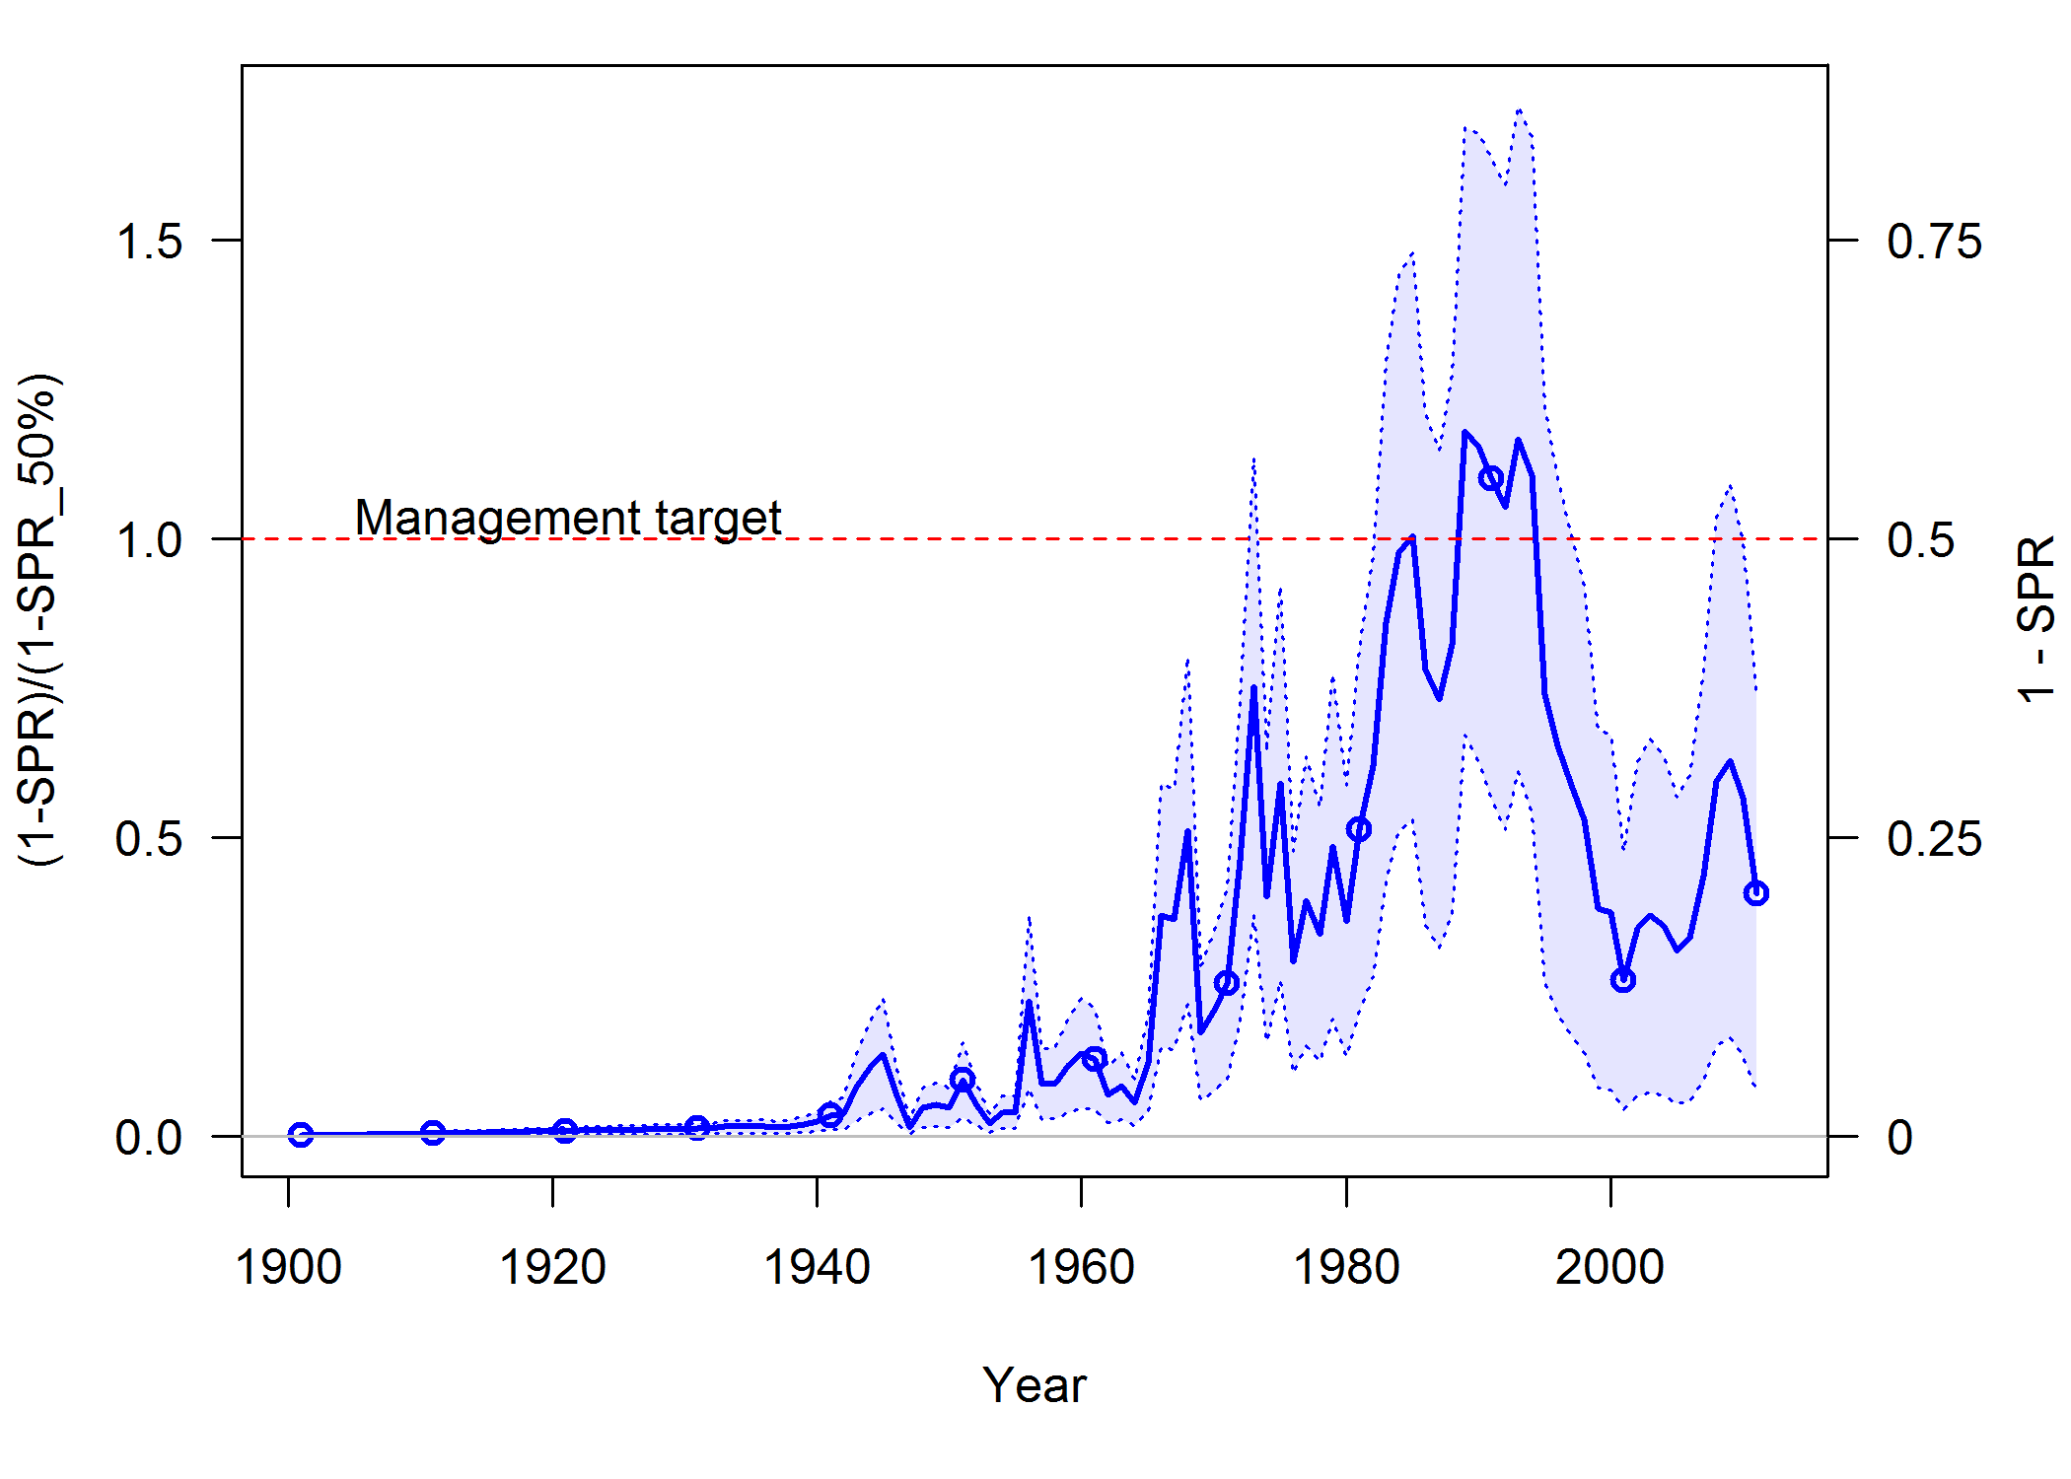

**Figure f. Estimated spawning potential ratio (SPR) for the base case model with approximate 95% asymptotic confidence intervals. Both one minus SPR (right y-axis) and the ratio of this quantity to the associated target (1 - SPR50%) (left y-axis) are shown. These quantities are chosen so that higher exploitation rates occur on the upper portion of the y-axis. The management target is plotted as red horizontal line and values above this reflect harvests in excess of the overfishing proxy based on the SPR50%.**

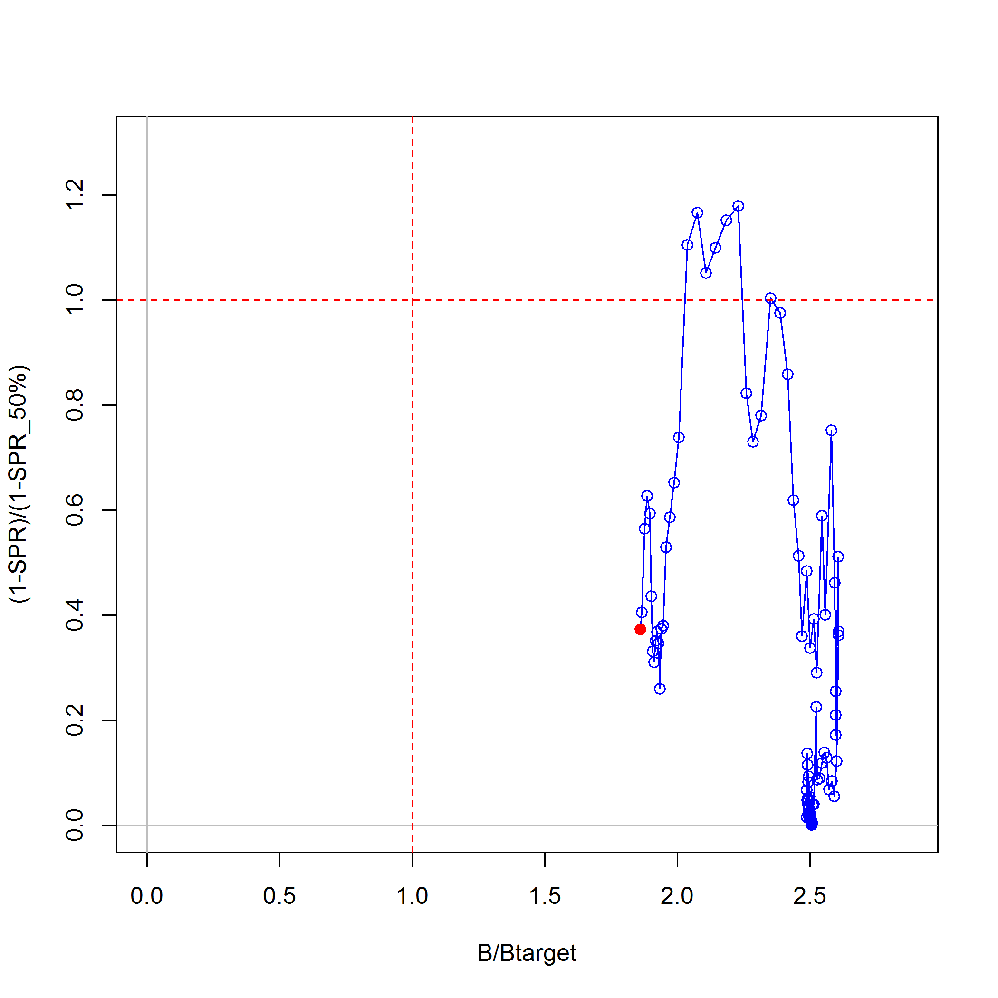

**Figure g. Phase plot of estimated relative (1-SPR) vs. relative spawning biomass for the base case model. The relative (1-SPR) is (1-SPR) divided by 50% (the SPR target). Relative depletion is the annual spawning biomass divided by the spawning biomass corresponding to 50% of the unfished spawning biomass. The red point indicates the year 2012.**

**Ecosystem considerations**

Shortspine and longspine thornyheads have historically been caught with each other and with Dover sole and sablefish, making up a “DTS” fishery. Other groundfishes that frequently co-occur in these deep waters include a complex of slope rockfishes, rex sole, longnose skate, roughtail skate, Pacific grenadier, giant grenadier, Pacific flatnose as well as non-groundfish species such as Pacific hagfish and a diverse complex of eelpouts. Shortspine thornyheads typically occur in shallower water than the shallowest longspine thornyheads, and migrate to deeper water as they age. When shortspines have reached a depth where they overlap with longspines, they are typically larger than the largest longspines. Shortspine thornyhead stomachs have been found to include longspine thornyheads, suggesting a predator-prey linkage between the two species.

Thornyheads spawn gelatinous masses of eggs which float to the surface. This may represent a significant portion of the upward movement of organic carbon from the deep ocean (Wakefield, 1990). Thornyheads have been observed in towed cameras beyond the 1280 meter limit of the current fishery and survey, but their distribution, abundance, and ecosystem interactions in these deep waters are relatively unknown.

**Reference points**

Reference points were calculated using the estimated catch distribution among fleets in the last year of the model (2012), and the estimated values are dependent on this assumption. In general, the population is at a healthy status relative to the reference points. Sustainable total yield (landings plus discards) was estimated at 2,034 mt when using an SPR50% reference harvest rate and ranged from 633 – 3,435 mt based on estimates of uncertainty. The spawning biomass equivalent to 40% of the unfished spawning output (*B*40%) was 75,906 mt. The most recent catches (landings plus discards) have been lower than the estimated long-term yields calculated using an SPR50% reference point, but not as low as the lower bound of the 95% uncertainty interval. However, this is due to the fishery not fully attaining the full ACL. The OFL and ACL values over the past 6 years have been approximately 2,400 mt and 2,000 mt, respectively. Both of those values are lower than the OFL and ACL values predicted in short-term forecasts, which are around 3,200 mt and 3,000 mt respectively for 2015–2016.

**Table e. Summary of reference points and management outputs for the base case model.**

| Quantity | Estimate | ~95% confidence interval |
| --- | --- | --- |
| Unfished Spawning biomass (mt) | 189,765 | (57,435 – 322,095) |
| Unfished age 1+ biomass (mt) | 331,047 | (100,196 – 561,898) |
| Unfished recruitment (R0, millions) | 30.4 | (15.2 – 61.1) |
| Depletion (2013) | 74.2% | (56.1% – 92.3%) |
| Spawning Biomass (2013) | 140,753 | (9,673 – 271,833) |
| SD of log Spawning Biomass (2013) | 0.45 | – |
| ***Reference points based on B40%*** |  |  |
| Proxy spawning biomass (*B40%*) | 75,906 | (22,974 – 128,838) |
| SPR resulting in *B40%* (*SPRSB40%*) | 50.0% | – |
| Exploitation rate resulting in *B40%* | 0.015 | (0.015 – 0.016) |
| Yield with *SPR50%* at *B40%* (mt) | 2,034 | (633 – 3,435) |
| ***Reference points based on SPR proxy for MSY*** |  |  |
| Spawning biomass | 75,906 | (22,974 – 128,838) |
| *SPRproxy* | 50.0% | – |
| Exploitation rate corresponding to *SPRproxy* | 0.015 | (0.015 – 0.016) |
| Yield with *SPRproxy* at *SBSPR* (mt) | 2,034 | (633 – 3,435) |
| ***Reference points based on estimated MSY values*** |  |  |
| Spawning biomass at *MSY* (*SBMSY*) | 64,600 | (19,517 – 109,683) |
| *SPRMSY* | 45.0% | (44.9% – 45.2%) |
| Exploitation rate corresponding to *SPRMSY* | 0.018 | (0.018 – 0.019) |
| *MSY* (mt) | 2,062 | (642 – 3,482) |

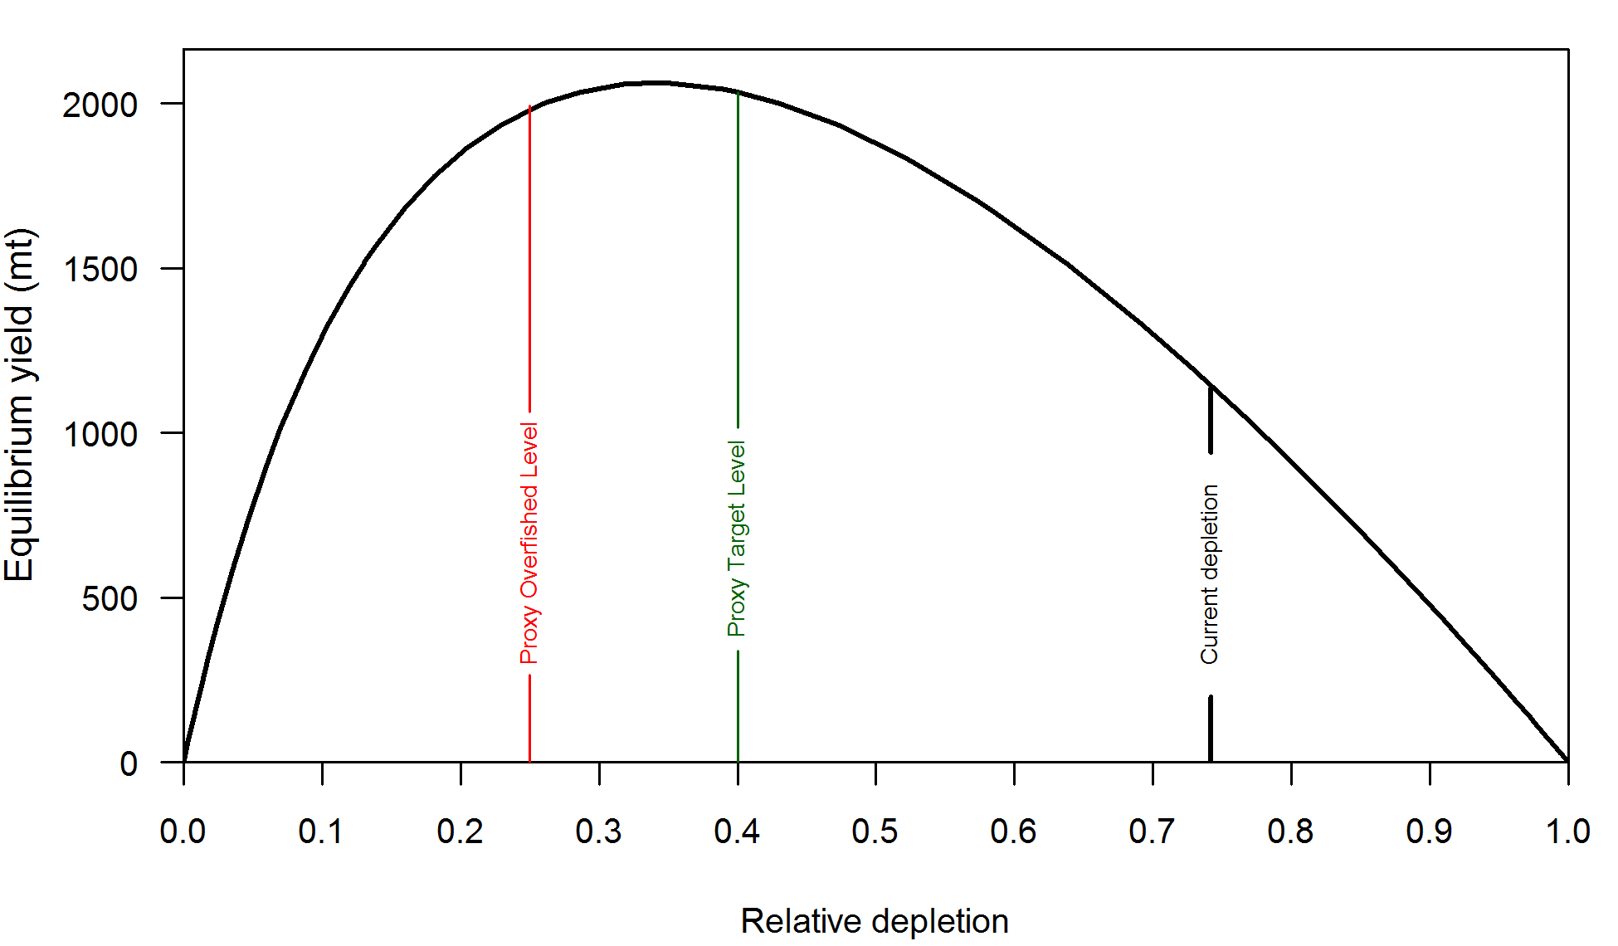

**Figure h. Equilibrium yield curve (derived from reference point values reported in Table i) for the base case model. Values are based on 2012 relative catch among fleets. The depletion is relative to unfished spawning biomass.**

**Management performance**

Catches for shortspine thornyheads have not fully attained the catch limits in recent years. Increases in ACLs in 2007 was associated with higher catch levels in 2006–2010, but in 2011 and 2012, catches were about half of the allowed limit. The fishery for shortspine thornyhead may be limited more by the ACLs on sablefish with which they co-occur and by the challenging economics of deep sea fishing, than by the management measures currently in place.

**Table f. Recent trend in total catch and commercial landings (mt) relative to the management guidelines. Estimated total catch reflect the commercial landings plus the model estimated discarded biomass.**

| Year | OFL (mt) | ACL (mt) | Commercial Landings (mt) | Estimated Total Catch (mt) |
| --- | --- | --- | --- | --- |
| 2001 | 880 | 751 | 532 | 602 |
| 2002 | 1,004 | 955 | 762 | 855 |
| 2003 | 1,004 | 955 | 800 | 903 |
| 2004 | 1,030 | 983 | 757 | 846 |
| 2005 | 1,055 | 999 | 654 | 739 |
| 2006 | 1,077 | 1,018 | 703 | 792 |
| 2007 | 2,476 | 2,055 | 1,006 | 1,058 |
| 2008 | 2,476 | 2,055 | 1,427 | 1,507 |
| 2009 | 2,437 | 2,022 | 1,531 | 1,619 |
| 2010 | 2,411 | 2,001 | 1,353 | 1,431 |
| 2011 | 2,384 | 1,978 | 974 | 994 |
| 2012 | 2,358 | 1,957 | 894 | 911 |

**Unresolved problems and major uncertainties**

The absence of a reliable ageing method provides a significant hindrance to estimating growth and natural mortality of shortspine thornyhead. New maturity data made available for this assessment indicate puzzling patterns of maturity, with higher rates of maturity in the north than in the south and a higher fraction of mature fish in the samples with length 20–30 cm than in the samples from 30–40cm. The relative distribution of different sizes of shortspine thornyheads, with smaller fish occurring shallower and further the north, suggests an ontogenetic migration pattern to deeper and more southern waters, with a potentially J-shaped pattern of migration. Understanding the rates and patterns of thornyhead migration and any potential interaction or confounding with spatial patterns of fishing would be valuable for understanding better appropriate ways to model this stock.

The indices of abundance are all relatively flat, providing little information about the scale of the population (other than providing evidence that it has not been declining). The current NWFSC index has the largest number of data points of any available index on the west coast, and each additional year of this index will be valuable for understanding any changes in size composition or abundance. However, in the absence of large changes in shortspine catch, the population is estimated to remain similar to its current state.

**Projections and Decision table**

The standard deviation of the log of spawning biomass in 2013 is σ = 0.45. This value is in the adjustment of quotas based on scientific uncertainty (a process referred to by the notation “*p*\*”) when the value is greater than an assumed 0.36 minimum, as it is in this case. The associated offset would therefore be a multiplication of the OFL by 94.5%, which is the 45% quantile of a log-normal distribution with the associated *σ*. Twelve-year projections were conducted with a total catch assumed equal to the ACL calculated by applying this adjustment to the estimated OFL for each year. The retention function and allocation of catch among fleets was assumed to match the average values for 2011–2012 (the only years in which the trawl fishery was operating under IFQs). This allocation between fleets was 43% for Trawl North, 32% for Trawl South, 3% for Non-trawl North, and 22% for Non-trawl South. Catch for 2013–2014, the limits on which have already been set, were assumed to equal the averages over 2011–2012, which correspond to a total catch of 952 mt and landings of 933 mt after applying the estimated retention function to the age structure of the population in 2013. The 933 mt value is identical to the average of the retained catch for the years 2011–2012, suggesting that the choice to model forecast catches in terms of total catch rather than landings has little influence on the forecast results.

This default harvest rate projection applied to the base model indicated that the stock status would slowly decline from 74.2% in 2013 to 67.2% in 2024, still far above the 40% biomass target and 25% minimum stock size threshold. The associated OFL values over the period 2015–2024 would average 3,053 mt and the average ACL would be 2,885. These values are above recent catch limits, which have not been fully attained in recent years. In these projections, the stock status was always above 40%, so the 40-10 adjustment in the control rule had no impact on the projections.

**Table g. Projection of potential OFL, landings, and catch, summary biomass (age-1 and older), spawning biomass, and depletion for the base case model projected with status quo catches in 2013 and 2014, and catches at the *p*\* offset (94.5%) from the OFL from 2015 onward. The 2013 and 2014 OFL’s are values specified by the PFMC and not predicted by this assessment. The OFL for 2015 and onward is the calculated total catch determined by *FSPR*.**

| Year | Predicted OFL (mt) | ACL Catch (mt) | Landings (mt) | Age 1+ biomass (mt) | Spawning Biomass (mt) | Depletion (%) |
| --- | --- | --- | --- | --- | --- | --- |
| 2013 | 2,333 | 1,836 | 933 | 243,824 | 140,753 | 74.2% |
| 2014 | 2,333 | 1,836 | 933 | 243,316 | 140,342 | 74.0% |
| 2015 | 3,203 | 3,027 | 2,968 | 242,845 | 139,977 | 73.8% |
| 2016 | 3,167 | 2,993 | 2,934 | 240,160 | 138,449 | 73.0% |
| 2017 | 3,131 | 2,959 | 2,901 | 237,526 | 136,971 | 72.2% |
| 2018 | 3,097 | 2,927 | 2,869 | 234,948 | 135,533 | 71.4% |
| 2019 | 3,064 | 2,895 | 2,838 | 232,425 | 134,127 | 70.7% |
| 2020 | 3,032 | 2,865 | 2,808 | 229,960 | 132,747 | 70.0% |
| 2021 | 3,001 | 2,836 | 2,779 | 227,554 | 131,391 | 69.2% |
| 2022 | 2,971 | 2,808 | 2,751 | 225,206 | 130,063 | 68.5% |
| 2023 | 2,943 | 2,781 | 2,725 | 222,918 | 128,763 | 67.9% |
| 2024 | 2,916 | 2,756 | 2,700 | 220,689 | 127,494 | 67.2% |

Additional projections were conducted for the base model and low and high states of nature (columns) under three catch streams (rows). The uncertainty in spawning biomass associated with the base model was very broad, so states of nature were chosen based on this range. The low state of nature was chosen from a profile over the equilibrium recruitment parameter as a model which had an estimate of 2013 spawning biomass closest to the 12.5th percentile of the spawning biomass distribution in the base model. This represents the middle of the lower 25% of probabilities in the base model. The high state of nature was not chosen in the same way, however, as 87.5th percentile of the base model did not encompass the range of models seen in sensitivity analyses as plausible alternatives. Instead, the high state of nature was taken as the model in the profile over the equilibrium recruitment that had a change in negative log-likelihood equal to 1.2 units, which is an alternative way to calculate the approximate center of the upper 25% of probable possibilities. This high state better reflected the asymmetry in uncertainty about the scale of the population (with more information about the lower range than the upper range of probable population sizes).

The catch streams chosen for the decision table were represented as total catch rather than landed catch, but discard rates were low under IFQs, so the difference in between total catch and landings is small. The low catch stream was assumed to have total catch equal to the average over the years 2011–2012, the years in which the trawl fishery was operating under IFQs was used as a low catch stream. This was a total catch of 952 mt divided among the fleets by the fraction. The high catch stream was chosen based on applying the SPR = 50% default harvest control rule to the base model, including a *p*\* offset which reduced the catch to 94.5% of the OFL. The middle catch stream was associated with SPR = 65% instead of the default SPR = 50%. This provided an intermediate level of catch while stabilizing the population at a stock status of approximately 60% (based on an exploratory 100 year forecast). The average total catch for the years 2015–2024 was 952 mt for the low catch stream, 1,795 for the middle catch stream, and 2,827 for the high catch stream.

The most pessimistic forecast scenario, combining the low state of nature with the high catch stream, resulted in a projected stock status of 39.9%, very close to the target value. All other projections led to a higher projected status, with a maximum of 89.1% for the combination of the high state of nature and low catch. Forecasts under the base case led to estimated status ranging from 2024 spawning depletion values of 67.2% in the high catch stream to 72.9% in the low catch stream.

No projections were done to explore changes in ratio of trawl to non-trawl or north to south. Due to differences in selectivity and retention among the fleets, these projections could be expected to provide slightly different results, although the general pattern of the projections suggesting stocks above target levels as described above is unlikely to change as a result of alternative ratios among the fleets.

**Table h. Summary table of 12-year projections beginning in 2015 for alternate states of nature based on an axis uncertainty. Columns range over low, mid, and high state of nature, and rows range over different assumptions of catch levels.**

|  |  |  | **State of nature** | | | | | |
| --- | --- | --- | --- | --- | --- | --- | --- | --- |
|  |  |  | Low | | Base case | | High | |
|  |  |  |  | |  | |  | |
| **Relative probability of log(*R*0)** | | | 0.25 | | 0.5 | | 0.25 | |
| **Management decision** | Year | Total catch (mt) | Spawning biomass (mt) | Depletion | Spawning biomass (mt) | Depletion | Spawning biomass (mt) | Depletion |
| Status quo catches | 2015 | 952 | 54.6 | 53.6% | 140.0 | 73.8% | 405.1 | 88.9% |
| 2016 | 952 | 54.1 | 53.2% | 139.7 | 73.6% | 405.1 | 88.8% |
| 2017 | 952 | 53.7 | 52.8% | 139.4 | 73.5% | 405.1 | 88.9% |
| 2018 | 952 | 53.3 | 52.4% | 139.2 | 73.3% | 405.2 | 88.9% |
| 2019 | 952 | 52.9 | 52.0% | 139.0 | 73.2% | 405.4 | 88.9% |
| 2020 | 952 | 52.6 | 51.7% | 138.8 | 73.1% | 405.5 | 88.9% |
| 2021 | 952 | 52.2 | 51.4% | 138.6 | 73.1% | 405.7 | 89.0% |
| 2022 | 952 | 51.9 | 51.0% | 138.5 | 73.0% | 405.8 | 89.0% |
| 2023 | 952 | 51.6 | 50.8% | 138.4 | 72.9% | 406.0 | 89.0% |
| 2024 | 952 | 51.4 | 50.5% | 138.2 | 72.9% | 406.1 | 89.1% |
| Catch associated with SPR = 65%, stabilizing population around 60% of *B*0 | 2015 | 1,828 | 54.6 | 53.6% | 140.0 | 73.8% | 405.1 | 88.9% |
| 2016 | 1,819 | 53.6 | 52.7% | 139.2 | 73.3% | 404.6 | 88.7% |
| 2017 | 1,812 | 52.7 | 51.8% | 138.4 | 72.9% | 404.1 | 88.6% |
| 2018 | 1,804 | 51.8 | 50.9% | 137.6 | 72.5% | 403.7 | 88.5% |
| 2019 | 1,797 | 50.9 | 50.0% | 136.9 | 72.1% | 403.3 | 88.5% |
| 2020 | 1,790 | 50.0 | 49.1% | 136.2 | 71.8% | 402.9 | 88.4% |
| 2021 | 1,784 | 49.1 | 48.3% | 135.5 | 71.4% | 402.6 | 88.3% |
| 2022 | 1,778 | 48.3 | 47.5% | 134.9 | 71.1% | 402.2 | 88.2% |
| 2023 | 1,773 | 47.5 | 46.7% | 134.2 | 70.7% | 401.8 | 88.1% |
| 2024 | 1,768 | 46.7 | 45.9% | 133.6 | 70.4% | 401.5 | 88.1% |
| OFL  (associated with SPR = 50%), including *p*\* offset (94.5%) | 2015 | 3,027 | 54.6 | 53.6% | 140.0 | 73.8% | 405.1 | 88.9% |
| 2016 | 2,993 | 52.9 | 52.0% | 138.4 | 73.0% | 403.9 | 88.6% |
| 2017 | 2,959 | 51.3 | 50.4% | 137.0 | 72.2% | 402.7 | 88.3% |
| 2018 | 2,927 | 49.7 | 48.8% | 135.5 | 71.4% | 401.6 | 88.1% |
| 2019 | 2,895 | 48.1 | 47.3% | 134.1 | 70.7% | 400.6 | 87.9% |
| 2020 | 2,865 | 46.5 | 45.7% | 132.7 | 70.0% | 399.5 | 87.6% |
| 2021 | 2,836 | 45.0 | 44.2% | 131.4 | 69.2% | 398.5 | 87.4% |
| 2022 | 2,808 | 43.5 | 42.7% | 130.1 | 68.5% | 397.5 | 87.2% |
| 2023 | 2,781 | 42.0 | 41.3% | 128.8 | 67.9% | 396.4 | 87.0% |
| 2024 | 2,756 | 40.6 | 39.9% | 127.5 | 67.2% | 395.5 | 86.7% |

**Table i. Summary table of the results.**

|  | 2003 | 2004 | 2005 | 2006 | 2007 | 2008 | 2009 | 2010 | 2011 | 2012 | 2013 |
| --- | --- | --- | --- | --- | --- | --- | --- | --- | --- | --- | --- |
| Commercial landings (mt) | 800 | 757 | 654 | 703 | 1,006 | 1,427 | 1,531 | 1,353 | 974 | 894 | NA |
| Estimated Total catch (mt) | 903 | 846 | 739 | 792 | 1,058 | 1,507 | 1,619 | 1,431 | 994 | 911 | NA |
| OFL (mt) | 1,004 | 1,030 | 1,055 | 1,077 | 2,476 | 2,476 | 2,437 | 2,411 | 2,384 | 2,358 | 2,333 |
| ACL (mt) | 955 | 983 | 999 | 1,018 | 2,055 | 2,055 | 2,022 | 2,001 | 1,978 | 1,957 | 1,937 |
| 1-SPR | 18% | 18% | 16% | 17% | 22% | 30% | 31% | 28% | 20% | 19% | NA |
| Exploitation rate  (catch/ age 1+ biomass) | 0.0036 | 0.0034 | 0.0029 | 0.0032 | 0.0042 | 0.0061 | 0.0065 | 0.0058 | 0.0041 | 0.0037 | NA |
| Age 1+ biomass (1000 mt) | 252.0 | 251.2 | 250.6 | 250.0 | 249.5 | 248.7 | 247.4 | 246.1 | 245.0 | 244.3 | 243.8 |
| Spawning Biomass  (1000 mt) | 146.0 | 145.5 | 145.0 | 144.7 | 144.3 | 143.8 | 143.1 | 142.3 | 141.6 | 141.2 | 140.8 |
| ~95% Confidence Interval | 16.1 –275.8 | 15.5 –275.5 | 15.0 –275.1 | 14.5 –274.8 | 14.1 –274.6 | 13.4 –274.2 | 12.6 –273.7 | 11.6 –273.0 | 10.8 –272.5 | 10.2 –272.1 | 9.7 –271.8 |
| Recruitment (millions) | 20.6 | 22.5 | 27.2 | 32.7 | 33.0 | 30.9 | 30.2 | 30.5 | 27.4 | 28.8 | NA |
| ~95% Confidence Interval | 7.3 – 57.9 | 7.9 – 64.1 | 9.3 – 79.5 | 10.9 – 98.5 | 10.8 – 100.8 | 10.1 – 94.3 | 9.9 – 92.4 | 9.9 – 93.5 | 9.0 – 83.7 | 9.3 – 89.3 | NA |
| Depletion (%) | 76.9% | 76.7% | 76.4% | 76.2% | 76.1% | 75.8% | 75.4% | 75.0% | 74.6% | 74.4% | 74.2% |
| ~95% Confidence Interval | 61.3% – 92.5% | 60.8% – 92.5% | 60.4% – 92.5% | 60.0% – 92.4% | 59.7% – 92.4% | 59.2% – 92.4% | 58.4% – 92.4% | 57.7% – 92.3% | 57.0% – 92.3% | 56.5% – 92.3% | 56.1% – 92.3% |

**Research and data needs**

Research and data needs for future assessments include the following:

1. More investigation into maturity of shortspine is necessary to understand the patterns in maturity observed in the samples collected in 2011 and 2012.
2. Information on possible migration of shortspine thornyheads would be valuable for understanding stock dynamics. Analysis of trace elements and stable isotopes in shortspine otoliths may provide valuable information on the extent of potential migrations. Possible connections between migration and maturity could likewise be explored.
3. A greater understanding of catchability of thornyheads would help define the scale of the populations. This could include a survey using a towed camera to assess the abundance in water beyond the 1280 m range of the trawl surveys. Further exploration of perceived differences in catchability between towed cameras and trawl nets could also be explored. Understanding the relative catchability of shortspine and longspine thornyhead, which are difficult to distinguish in camera observations, would have to be a component of such investigations. Differences in selectivity between the AFSC Slope survey and the NWFSC surveys may be the result of behavioral interactions with different footropes. Understanding these interactions would also improve understanding of catchability.
4. Age data would be valuable for future stock assessments. Otoliths have been collected in good quantities from the NWFSC survey, but at this time the ageing methods are not believed to be reliable. Additional research on ageing methods for thornyheads would be valuable.
5. A greater understanding of the connection between thornyheads and bottom type could be used to refine the indices of abundance. Thornyheads are very well sampled in trawlable habitat, but the extrapolation of density to a survey stratum could be improved by accounting for the proportion of different bottom types within a stratum and the relative density of thornyheads within each bottom type.
6. A comprehensive catch reconstruction for shortspine and longspine thornyheads should be completed to estimate landings for each species prior to 1981 in each of the three states.
7. Exploration of simpler assessment methods for thornyheads and evaluation of whether such methods would provide a more robust management strategy than the current approach. It is likely that any significant reduction in the size of the shortspine thornyhead population would be apparent in the NWFSC Combo Survey index. A method for setting and/or adjusting catch limits based on either absolute values or trends in the survey has the potential to be much less labor intensive than the current assessment approach.
8. More tows or visual surveys south of 34.5 deg. N. lat. including the large Cowcod Conservation Area. Because the southern Conception Area is a large potential habitat for thornyheads, more sampling effort would help refine the estimations of their abundance in this area.

# Introduction

## Distribution

Shortspine thornyhead (*Sebastolobus alascanus*) are found in the waters off of the West Coast of the United States from northern Baja California to the Bering Sea. They are found from 20 to over 1,500 meters in depth. The majority of the spawning biomass occurs in the oxygen minimum zone between 600 and 1,400 meters, where longspine thornyheads are most abundant (Jacobson and Vetter 1996, Bradburn et al. 2011). The distribution of the smallest shortspine thornyheads suggests that they tend to settle at around 100–400 meters and are believed to have ontogenetic migration down the slope, although large individuals are found across the depth range.

Shortspine thornyhead do not appear to be distributed evenly across the West Coast, with higher densities (kg/ha) of thornyheads in shallower areas (under 500 meters) off of Oregon and Washington, and higher densities in deeper areas off of California (Figure 4–Figure 9). The mean latitude of the largest shortspine is slightly further north than of the medium sizes, suggesting the possibility of either a J-shaped migration, differential patterns of recruitment, or regional differences in exploitation history (Figure 9).

Although their densities vary, shortspine thornyheads are present in almost all trawlable areas below 500 m. They are caught in 91% of the trawl survey hauls below 500 m and 94% of the commercial bottom trawl hauls below 500 m. In camera-tows, thornyheads are seen to be spaced randomly across the sea floor (Wakefield 1990), indicating a lack both of schooling and territoriality.

## Stock structure

Genetic studies of stock structure do not suggest separate stocks along the west coast. Siebenaller (1978) and Stepien (1995) found few genetic differences among shortspine thornyheads along the Pacific coast. Stepien (1995), however, did suggest that there may be a separate population of shortspine thornyhead in the isolated area around Cortes Bank off San Diego, California. Stepien (1995) also suggested that juvenile dispersion might be limited in the area where the Alaska and California currents split. This occurs towards the northern boundary of the assessment area, near 48**°** N.

Stepien et al. (2000), using a more discerning genetic material (mtDNA), found evidence of a pattern of genetic divergence corresponding to geographic distance. However, this study, which included samples collected from southern California to Alaska, did not identify a clear difference between stocks even at the extremes of the range. No such pattern was seen in longspine thornyhead, which suggests that the shorter pelagic stage (~1 yr vs. ~2 yrs) of shortspine may contribute to an increased genetic separation with distance.

## Life History

Shortspine thornyheads along the West Coast spawn pelagic, gelatinous masses between December and May (Wakefield, 1990; Erickson and Pikitch, 1993; Pearson and Gunderson, 2003). Juveniles settle at around 1 year of age (22- 27 mm in length), likely in the range of 100-200 m (Vetter and Lynn 1997), and migrate down the slope with age and size, although large individuals are found across the depth range.

Estimates of natural mortality for shortspine thornyhead range from 0.013 (Pearson and Gunderson 2003) to 0.07 (Kline 1996). However, Pearson and Gunderson’s estimate is based upon a regression model, using the gonadosomatic index as a proxy. Butler et al. (1995) estimated M to be 0.05 based upon a maximum lifespan of over 100 years for shortspine thornyhead. Butler et al. also suggested that M is lower for older, larger shortspine thornyhead residing in the oxygen minimum zone due to lack of predators. All estimates of *M* for thornyheads are highly uncertain.

Shortspine thornyhead grow very slowly, but may continue growing throughout their lives, reaching maximum lengths of over 70 cm. Females appear to reach larger sizes than do males. Maturity in females has been estimated as occurring near 18 cm, at 8-10 years of age (Pearson and Gunderson 2003), although new information suggests that patterns of maturity may be more complex.

## Ecosystem Considerations

Shortspine and longspine thornyheads have historically been caught with each other and with Dover sole and sablefish, making up a “DTS” fishery. Other groundfishes that frequently co-occur in these deep waters include a complex of slope rockfishes, rex sole, longnose skate, roughtail skate, Pacific grenadier, giant grenadier, Pacific flatnose as well as non-groundfish species such as Pacific hagfish and a diverse complex of eelpouts. Shortspine thornyheads typically occur in shallower water than the shallowest longspine thornyheads, and migrate to deeper water as they age. When shortspines have reached a depth where they overlap with longspines, they are typically larger than the largest longspines. Shortspine thornyhead stomachs have been found to include longspine thornyheads, suggesting a predator-prey linkage between the two species.

Thornyheads spawn gelatinous masses of eggs which float to the surface. This may represent a significant portion of the upward movement of organic carbon from the deep ocean (Wakefield, 1990). Thornyheads have been observed in towed cameras beyond the 1280 meter limit of the current fishery and survey, but their distribution, abundance, and ecosystem interactions in these deep waters are relatively unknown.

## Fishery Information

The history of fishing for thornyheads has seen fluctuations due to a combination of increasing depth range of the fisheries, variable markets, and changes in fisheries management.

There were few markets for thornyheads in the early part of the century. Landings were minimal until the 1930’s when thornyheads started to be landed as incidental catch from the sablefish fishery off California. In the early years, there was relatively little trawling in the depths where the majority of thornyheads occur. The first significant market for thornyheads began in northern California in the early 1960’s. At first, larger (30-35 cm) thornyhead were sold as “ocean catfish”. The minimum size decreased to 25 cm by the early 1980’s. In the late 1980’s a market for small thornyheads (~20 cm) developed because of the depletion of a related species (*Sebastolobus machrochir*) off of Japan. The fishery started moving into deeper waters with the demand for smaller (and thus longspine) thornyheads increased over time. This can be seen as the proportion of shortspine in the total thornyhead landings decreased from around 90% in 1981 to 40% in 1994 (before regulation lowered it even more in 1995) (Figure 3).

Landings of shortspine thornyheads off the coast of California peaked around 3,500 mt in 1989, and have exceeded those from further north in most years. In the northern area off of Oregon and Washington, the fishery became significant in the early 1980’s, with landings peaking in 1991 at around 2200 mt.

Non-trawl landings of shortspine thornyheads were relatively low prior to the mid-1990s, at which point the non-trawl (mostly longline) landings in California began to increase steadily from less than 5 mt in 1994 to 237 mt in 2011. This increase, combined with decreases in trawl landings in California, has made these two components similar in magnitude in that area. The increase in non-trawl landings has been driven by the development of live-fish markets for thornyheads, and the ex-vessel prices associated with the non-trawl landings are much higher than those for the trawl fishery. Nominal prices for line-caught shortspines increased steadily from $0.69/lb in 1993 to $3.81/lb in 2008, and have remained near or above that level, since. Trawl prices, on the other hand were $0.46/lb and $0.72/lb at the beginning and end of that same period, though they were commonly in the $0.80–1.06/lb range in the interim, when Japanese demand was stronger. Non-trawl landings of shortspine in Washington and Oregon have not seen a similar increase, and have remained below the estimated peak of 54 mt in 1991 since that time.

The foreign fishery off of the West Coast is estimated to have caught approximately 7,400 mt of shortspine thornyhead during the 11 year period from 1966-1976 (Rogers, 2003), which is on the order of the estimate of domestic catch (~8,600 mt) during that same period.

Management measures contributed to a decline in coastwide landings from an estimated peak of 4,815 in 1989 to between 1,000 and 2,000 mt per year from 1995 through 1998. Landings fell below 1,000 mt per year from 1999 through 2006, then rose to 1,531 in 2009 and have declined since that time (Table 1).

## Summary of Management History

Beginning in 1989, both thornyhead species were managed as part of the deepwater complex with sablefish and Dover sole (DTS). In 1991, the Pacific Fishery Management Council (PFMC) first adopted separate ABC levels for thornyheads and catch limits were imposed on the thornyhead group. Harvest guidelines (HG) were instituted in 1992 along with an increase in the minimum mesh size for bottom trawl fisheries. In 1995 separate landing limits were placed on shortspine and longspine thornyheads and trip limits became more restrictive. Trip limits (predominantly 2-month limits on cumulative vessel landings) have often been adjusted during the year since 1995 in order to not exceed the HG or OY for that year. At first, the HG for shortspine thornyhead was set higher than the ABC (1,500 vs. 1,000 mt in 1995-1997) in order to allow a greater catch of longspine thornyhead, which was considered relatively undepleted. In 1999 the OY was set at less than 1,000 mt and remained close to that level through 2006. As a result of the 2005 shortspine assessment, catch limits increased to about 2,000 mt per year and have remained near that level to the present.

Since early 2011, trawl harvest of each thornyhead species has been managed under the PFMC’s catch share, or individual fishing quota (IFQ), program. Whereas the trip limits previously used to limit harvest restricted only the amount of fish each vessel could land, individual vessels fishing under the catch-share program are now held accountable for all of the quota-share species they catch.

## Management Performance

Landings of shortspine thornyhead have been below the catch limits since 1999. Estimated total catch, including discards, has likewise remained below the limit during this period.

## Fisheries off Canada, Alaska, and/or Mexico

The Alaska Fishery Science Center conducts assessments of thornyheads as a mixed stock complex, including shortspine and longspine thornyheads. The 2011 assessment reports that “It is unlikely that thornyheads are overfished or approaching overfished condition”, however noting that fishing in the Western Gulf of Alaska approaches the ABC for the complex (Murphy and Ianelli, 2011).

# Assessment

## Data

An overview of the data sources available for each combination of fleet and year is provided in Figure 15.

### Biology

***Natural mortality and longevity***

Butler et al. (1995) estimated the lifespan of shortspine thornyhead to exceed 100 years, and suggested that *M* was likely less than 0.05. *M* may decrease with age as shortspine migrate ontogenetically down the slope to the oxygen minimum zone, which is largely devoid of predators for fish of their body size. The previous assessment fixed the natural mortality parameter at 0.05. For this assessment, a prior on natural mortality was developed based on a maximum age of 100 years which had a mean of 0.0505 and a standard deviation on a log scale of 0.5361 (Hamel, pers. comm.). For the base case, natural mortality was fixed at the mean of this prior distribution.

***Length-weight relationship***

The length-weight relationship for shortspine thornyhead was calculated from 10,787 fish collected in the NWFSC trawl survey over the years 1999-2012. Males and females showed very similar patterns so a single relationship was used for both sexes. Unsexed fish were excluded from the analysis. The unsexed fish were primarily small fish which have little influence on the conversion of numbers to biomass in the model, but including them in the estimation resulted in a reduction of fit to the larger fish. This may have been caused by less relative precision in the scale for weights below 0.05 kg. The estimated mean weight at length (Figure 11) is

*W*(*L*) = 4.771E-6 · *L*3.263,

where L is length in cm and W is weight in kg. This is very similar to the values from Jacobson (1990) used in the previous assessment,

*W*(*L*) = 4.9E-6 · *L* 3.264.

***Length at age***

No new age data or information on growth or length at age has been developed since the previous assessment. Therefore, growth parameters were fixed at the same values used in 2005. These parameters were based on the Kline (1996) data, while accounting for differences in maximum size between the sexes by setting the length at age 100 for males to be 90% of that of females. The Von Bertalanffy K parameter is set to 0.018, a choice that fit the data well, while accounting for biases towards larger individuals among the younger ages (Hamel, 2005). Length at age 2 is set to 7 cm for both males and females, and average length at age 100 is 75 cm and 67.5 cm respectively.

***Maturation and fecundity***

Pearson and Gunderson (2003) estimated length at 50% maturity to be 18.2 cm on the West coast. With most females maturing between 17 and 19 cm. This was represented in the previous assessment by the logistic function,

*M*(*L*) = (1 + *e*-2.3·(*L*-18.2))-1,

where *L* is the length in cm.

Shortspine thornyhead ovaries were collected for maturity analysis on the NWFSC trawl survey in 2011 (N = 130) and 2012 (N = 160). Histological analysis of these samples (M. Head, pers. comm.) indicated puzzling patterns of spawning, with a higher fraction of fish spawning within most size bins in the north than in the south, and a higher fraction of spawning fish in the samples with length 20-30 cm than in the larger fish in the 30-40cm range (Figure 10, Figure 12). In general it is difficult to differentiate immature thornyheads from mature thornyheads that were not spawning (Pearson and Gunderson, 2003), so in this assessment “maturity” is used to indicate fish that were both mature and showed indication of spawning, and “immature” may refer to fish that are resting. Atresia was observed in relatively few samples. One hypothesis that could explain the spatial patterns in spawning would be different migration directions associated with mature and immature fish. Alternatively, environmental conditions could have influenced the growth and maturity in different locations and depths.

The complexity of the observed patterns of maturity suggest that the 290 samples collected in 2011 and 2012 were not adequate to estimate a new maturity curve to be used as representative of the shortspine thornyhead population throughout the assessment period, and more ovaries are expected to be collected in the 2013 survey. Ovaries from winter months, when the survey is not operating, may also be needed to understand the ability to accurately estimate maturity throughout the year. For the base model, the maturity curve was retained from the previous assessments. Sensitivity analyses were conducted using alternative maturity curves based on the new samples. In the most extreme sensitivity, the empirical estimates of maturity in each 2cm length bin were used in the alternative model. An intermediate pattern was also developed by multiplying the logistic maturity ogive used in the previous assessment by a maximum fraction of mature or spawning fish which was assumed to increase linearly from 50% at 20 cm to 100% at 70cm,

*f*(*L*) = 0.3 + 0.01·*L*.

The maturity ogive used in this alternative was the product of the linear and logistic functions,

*M*(*L*) = (0.3 + 0.01·*L*) · (1 + *e*-2.3·(*L*-18.2))-1.

Sizes beyond 70cm were assumed to be 100% mature.

These base model and alternative maturity curves are shown in Figure 12. The spawning output of each size used in the calculation of spawning biomass is the product of the length-weight relationship and the maturity ogive under the assumption that fecundity of mature, spawning fish is proportional to weight (Figure 13). The slow but steady rate of growth for shortspine thornyheads, with growth still occurring at age 100, reduces the importance of assumptions about maturity because older individuals will have significantly higher spawning output due to their much larger size, regardless of the fraction spawning.

### Catch History

PacFIN data from 1981-present was used to estimate landings in the north and south (Table 1, Table 2, Figure 1). All landings reported for the shortspine and nominal shortspine categories were considered shortspine, whereas landings placed in the thornyheads category were split between longspine and shortspine by the ratio of specified longspine and shortspine landings for the entire coast. The values of this ratio from 1981-2012 are shown in Figure 3. The fraction of unspecified thornyheads in the landings was around 20% in the 1980s, but has averaged 2% of the landings from 1988 onward (Figure 3).

Catches prior to 1981 were set equal to those used in the previous model, rather than to the reconstructed history provided by CDFW and ODFW for most West Coast assessments. The California catch reconstruction did not split unspecified thornyheads into the two species. Furthermore, the recordings of longspine thornyhead prior to 1981 (e.g. 0.2 mt in 1977) are so low that the ratio of specified catch is not likely to be representative of the true ratio. The impact on the shortspine assessment of assuming all pre-PacFIN catch was shortspine is smaller than the impact of this assumption on the longspine assessment, but using the catch reconstruction for one species and the values from the previous assessment for another would risk double counting catch. Therefore, the catch from the previous assessments, both of which had a thorough independent review, were used for both species in the current assessments for the years prior to 1981. A sensitivity analysis indicated that the differences in these alternative assumptions about historical catch had very little impact on the model results (Figure 62, Figure 63).

### Discards and retention

Discard rates were estimated from three periods. The first estimates for the years 1985–1987 were calculated from Oregon State University observer study (Pikitch et al., 1988), which included data from only the Trawl North fleet. The second set covered the years 1995–1999 using the Enhanced Data Collection Project (EDCP), which again only included data from the Trawl North fleet. The third, and most precise set of estimates covered the years 2002–2011 using the ongoing West Coast Groundfish Observer Program (WCGOP), which included samples from all four fleets used in the base model.

Discard rates and associated uncertainty were newly calculated from the early discard study (J. Wallace, pers. comm.) and the WCGOP data (J. Jannot, pers. comm.). The EDCP discard rates and uncertainty intervals were retained from the previous assessment as the raw data were not obtained in time to do a reanalysis of these rates. For the other three fleets, discard rates were only available for the years 2002–2011 from the WCGOP database.

### Fishery Length Compositions

Fishery size-composition data were obtained from PacFIN for 1978-2012. The number of fish sampled by port samplers from different trips has not been proportional to the amount of landed catch in these trips. Sampling effort has also varied among the states. In order to account for non-proportional sampling and generate more representative length-frequency distributions, the observed length data were expanded using the following algorithm:

1. Length data were acquired at the trip level by sex, year and state.
2. The raw numbers in each trip were scaled by a per-trip expansion factor calculated by dividing the total weight of trip landings by the total weight of the species sampled.
3. A per-year, per-state expansion factor was computed by dividing the total weight of state landings by the total weight of the species sampled for length in the state.
4. The per-trip expanded numbers were multiplied by the per-state expansion factor and summed to provide the coastwide length-frequency distributions by year.

Only randomly collected samples were used. The sample sizes associated with the length compositions from the fishing fleets are shown in Table 3 (landings) and Table 4 (discards). The length samples from the Trawl North fleet in the years 1994 and 1995 showed a very different pattern than the surrounding years (and different from each-other). The sample sizes for these years was lower than most other years, so the observed differences are more likely due to non-representative than changes in the fishery or population. Therefore these two years were not included in the base model. This change made very little difference in model results.

In camera-tows, thornyheads are seen to be spaced randomly across the sea floor (Wakefield 1990), indicating a lack both of schooling and territoriality. This likelihood contributes to the conclusion in a bootstrapping analysis by Stewart and Hamel (2013), that “thornyheads had the highest average effective sample size per haul…and also the greatest independence among fish within tows”. Based on these findings, the input samples sizes for both fishery and survey length compositions were calculated from the number of fish sampled in each year, independent of the number of hauls from which these fish were collected. The input sample sizes were set to *Ninput* = *Nsampled* 0.6, which is an approximation to the pattern found by Stewart and Hamel (2013; their figure 4D). The input sample sizes were further tuned in the manner suggested by Stewart and Hamel (2013). This involved adjusting the input sample size so that the arithmetic mean of the input length composition sample sizes for each fleet was similar to the harmonic mean of the estimated effective sample sizes for that fleet (Table 7). The tuning was not updated after changes to the model were made in the review panel, but the resulting differences in adjusted input and effective samples sizes were viewed by the reviewers as small enough to remain present in the final base model.

All length data from commercial fisheries included in the model with sexes combined. This avoids the possibility of bias due to difficulty in sex determination of thornyheads (also see notes below on sex ratios in survey data).

### Age Compositions

No age composition data was used for this assessment, because thornyheads have proven very difficult to age (P. MacDonald, pers. comm.). Even in directed studies such as those done by Kline (1996) and Butler et al. (1995) there are large inter-reader differences and a second reading by the same ager can produce a markedly different result. Kline (1996) reported only about 60% of the multiple reads were within 5 years of each other and inter-reader differences were as large as 24 years for a sample of 50 otoliths. No production ageing of thornyheads is undertaken at this time for the west coast, although shortspine thornyhead otoliths are routinely collected in the NWFSC trawl survey.

### NMFS Surveys

Four trawl surveys have been conducted on the U.S. west coast over the past four decades. The Alaska Fisheries Science Center (AFSC), conducted a triennial groundfish trawl survey on the continental shelf, from 1977 to 2001, although the 1977 survey had incomplete coverage and is not believe to be comparable to the later years. A final survey was conducted in 2004 by the NWFSC using the same survey design. In 1995, the timing of the survey shifted so that instead of occurring between mid-July and late September, it was conducted from early June through mid-August. The years 1980–1992 had a maximum depth of 366 m, while from 1995 onward, the maximum depth was extended to 500 m. The shallow limit of the survey was 55 m in all years, but for purposes of computing indices, only tows deeper than 100 m were used as shortspines are rarely seen at less than this depth.

For some species the shift in timing between the 1992 and 1995 surveys would be expected to influence their catchability, availability, or distribution. However, thornyheads are believed to be sedentary enough that the change in timing would not be as influential. However, the increase in depth is expected to significantly increase the range of shortspine thornyhead habitat covered by the survey. In order to preserve a time-series of maximum length while eliminating the influence of the increase depth range, the triennial survey was split into two time series, separated by the 366 m depth contour. The first, here referred to as “AFSC Triennial Shelf Survey 1”, consists of 9 data points, every third year spanning the range 1980–2004 covering the depths 100–366 m. The second, “AFSC Triennial Shelf Survey 2”, consists of 4 data points spanning the years 1995–2004 and covering the depths 366–500 m. This second time series is recognized as providing little information about stock status due to the limited number of points and limited depth range, but there is no compelling reason to exclude it from the assessment.

Starting in the late 1990s, two slope surveys were conducted on the west coast, one using the research vessel Miller Freeman, “AFSC Slope Survey”, which ended in 2001, and the other a cooperative survey using commercial fishing vessels, conducted by the Northwest Fisheries Science Center, “NWFSC Slope Survey” which covered the years 1998–2002. The AFSC Slope Survey was a source of valuable information on the depth distribution and overlap of shortspine and longspine thornyheads in the 1980s, but the early years had very limited latitudinal range. This survey also had a different net and larger roller gear than the NWFSC Slope Survey.

In 2003, the design of the NWFSC Slope Survey was modified and the survey was expanded to cover the shelf and slope between 50 m and 1280 m. This combination shelf-slope survey, “NWFSC Combo Survey”, has been conducted every year from 2003 to the present with consistent design. Data for the years 2003–2012 were available for this assessment. The NWFSC Combo Survey now represents the largest number of survey observations, the largest depth range, and the most consistent groundfish sampling program in the history of west coast fisheries. Continuing this time series in a consistent manner is vital for improving estimates of current stock status and detecting any future changes in size distribution or abundance of west coast groundfish.

The results from these four (nominally five) fishery-independent surveys are used in this assessment (Figure 18; Table 6). Indices of abundance for all of the surveys were derived using a delta-generalized linear mixed model (GLMM) following the methods of Thorson and Ward (2013). The surveys were stratified by latitude and depth, and vessel-specific differences in catchability (via inclusion of random effects for the NWFSC surveys and fixed effects for the AFSC and Triennial survey) were estimated for each survey time series. The Delta-GLMM approach explicitly models both the zero and non-zero catches and allows for skewness in the distribution of catch rates. Gamma error structures were assumed for the positive tows although log-normal error produced essentially identical results. Model convergence was evaluated using the effective sample size of all estimated parameters (typically >500 of more than 1000 kept samples would indicate convergence).

The stratification for the surveys was as follows. A single stratum was used for each of the AFSC Triennial Shelf Survey time series, as these had a narrow depth range. The AFSC Slope Survey was split into two strata: shallower and deeper than 500 m. The NWFSC Slope Survey was divided into 6 strata, with breaks dividing a southern, central, and northern strata at 40.5º N and 43º N, each of which was further divided with a break at 550 m. The NWFSC Combo Survey was divided into 7 strata, with two southern strata below 34.5º N, one covering 183–550 m and the other covering 550–1280 m. Two central strata between 34.5º N and 40.5º N, had the same depth ranges. North of 40.5º N, three strata were used, covering the ranges 100–183 m, 183–550 m and the other covering 550–1280 m. The depth breaks at 183 m and 550 m are associated with changes in sampling intensity of the survey and are recommended to be used. South of 40.5º N, there are very few shortspine thornyheads shallower than 183 m so no shallow stratum was used in these latitudes.

The frequency of occurrence of both shortspine and longspine thornyheads in trawl surveys and fishery is extremely high. 91% of the tows in the NWFSC Combo Survey below 500 m have at least one shortspine thornyhead in the catch (and 97% have at least one longspine). This is similar to the rate for commercial trawl fisheries, which is greater than 94% (a value that doesn’t include for trips in which shortspines were landed but not recorded by the observer as associated with a particular tow). The distribution of catch rates among the frequent tows that included shortspine thornyheads showed no evidence of extreme catch events, a pattern which is consistent with the conclusion of Wakefield (1990), that thornyheads in camera-tows are seen to be spaced randomly across the sea floor. Together, the high frequency of occurrence and the low variability in catch between tows lead to model-based (GLMM) index estimates that are very similar to the design-based (raw) estimates (Table 6).

Length-composition data were available for each year of each survey. However, the length data for the triennial survey were collected from a single tow in both 1980 and 1983, so these samples were not included in the model. In all cases, the length compositions were calculated by weighting length compositions in each tow by the estimated catch per unit effort (in terms of numbers rather than biomass) and then weighting the length composition in each chosen stratum.

The number of survey hauls and shortspine thornyheads sampled available for this assessment is described in Table 5. All samples were included in the model with sexes combined with the exception of the NWFSC Combo survey for the years 2005–2012, as this period had a much lower rate of unsexed fish (averaging 16% per year compared to 67% in 2004), suggesting that sexes determination was being done in a more systematic way. This improvement in sex determination was likely informed by the comparison of visual estimates with laboratory analysis described in Fruh et al. (2010) which was based associated with data collected during the 2003 NWFSC Combo survey. The sex ratio of all samples with sex determined collected in 2005 and onward was 50.04%.

### Changes in data from the 2005 assessment

Most of the data used in the previous assessment has been newly extracted and processed, including length compositions from each fishing fleet and survey, indices of abundance derived from new GLMM analyses of survey data, discard rates from both the 1980s Pikitch study and the current West Coast Groundfish Observer Program (WCGOP), and the time series of catch from 1981-2012. Data retained from the previous assessment without reanalysis are the estimated historic catch for the years up to 1980 and the discard rates from the EDCP study in the 1990s.

New data for this assessment include the maturity data collected from the NWFSC survey in 2011 and 2012 for use in a sensitivity analysis, the additional WCGOP observations of discards and length compositions from retained and discarded fish. For the 2005 assessment, the NWFSC Combo Survey had just begun in its current configuration, so the data from 2003–2004 were used as an extension of the NWFSC Slope Survey. The NWFSC Combo Survey now has 10 years of observations and was treated as an independent survey for this assessment. Length compositions were developed from this survey and observations of weight-at-length were used in revising the weight-length relationship used in the assessment.

### Environmental and Ecological Data

No ecological or environmental information was used in this assessment.

## Model

### Overview

The most recent assessment for shortspine thornyhead was conducted in 2005 (Hamel, 2005). Stock status was determined to be above the target biomass and catches did not attain the full management limits so reassessment of thornyheads has not been a higher priority. The current assessment model adds new data from the past 8 years, refines the indices of abundance, separates trawl and non-trawl data and uses a different functional form for selectivity, but otherwise does not diverge in any large way from the previous assessment. This is both testament to the high quality of the work conducted by Hamel (2005) and the absence of any information to suggest that the model structure and assumptions made in 2005 were incorrect.

This new assessment used Stock Synthesis (SS, Methot, 2012) Version 3.24o used in other recent west coast assessments. Additional sensitivities were conducted using Version 3.24q, which has more flexible options to model maturity at length, a change that was made to explore new data for shortspine thornyheads (R. Methot, pers. comm.).

### Fishing fleets and surveys

The commercial landings and other data were divided into four fisheries: trawl and non-trawl gears, which are each divided into North (the waters off Washington and Oregon) and South (the waters off California).

Five surveys were represented in the model: a shallower subset of the Alaska Fisheries Science Center (AFSC) triennial shelf survey from 100-366 meters (1980-2004), the deeper range of triennial shelf survey from 366-500 meters for the later years (1995-2004), the AFSC slope survey (1997, 1999-2001), the Northwest Fisheries Science Center (NWFSC) slope survey (1998-2002) and the NWFSC combined shelf-slope survey (2003-2012).

### Parameters

#### Overview

There are 223 estimated parameters in the assessment. The log of the unfished equilibrium recruitment, log(*R*0), controls the scale of the population, annual deviations around the stock-recruit curve (163 parameters) allow for more uncertainty in the population trajectory, and selectivity and retention of the 4 fishing fleets and 5 surveys, including estimates of changes in retention over time (58 parameters). Finally, there is a single parameter which represents additional variability in one of the surveys that is added to estimated sampling error for that index.

#### Growth, mortality, and recruitment

Growth parameters are fixed at the same values used in 2005 (Table 8, Figure 14). With no age data in the model, the ability to estimate a growth curve is limited, and there was no apparent lack of model fit that indicated that growth was mis-specified. A likelihood profile exploring alternative growth parameters was conducted to estimate the influence of this assumption (Figure 56).

For this assessment, a prior distribution on natural mortality was developed based on a maximum age of 100 years which had a mean of 0.0505 and a standard deviation on a log scale of 0.5361 (Hamel, pers. comm., Figure 45). For the base case, natural mortality was fixed at the mean of this prior distribution. A likelihood profile exploring alternative natural mortality parameters was conducted (Figure 54).

As in the previous shortspine thornyhead assessment, a Beverton-Holt stock recruitment relationship was assumed with steepness (the fraction of expected equilibrium recruitment associated with 20% of equilibrium spawning biomass) fixed at 0.6. A likelihood profile exploring alternative steepness parameters was conducted and the model results were found to be relatively insensitive to the assumed value (Figure 52).

The scale of the population is estimated through the log of the initial recruitment parameter (*R*0). Recruitment deviations were estimated for the years 1850 through 2012, where the values estimated in the years 1850 through 1900 are used to estimate a non-equilibrium age-structure in 1901, which is the first year of the population projection and first year of catch data. Estimated recruitments do not show high variability, and the uncertainty in each estimate is greater than the variability between estimates. The σ*R* parameter which controls the variability in recruitment deviations was fixed at 0.5 as in the previous assessment. Methot and Taylor (2011) suggested that σ*R*2 could be tuned to match the sum of the variance of the estimate recruitment deviations and the square of the average standard error of these estimates. Applying this method to the estimated values and their uncertainty for the base model provided a value of 0.526, which was seen as similar enough to the assumed value of σ*R* = 0.5 that no additional tuning was applied. A sensitivity to alternative values of σ*R* was conducted including the alternative model with no deviations in recruitment around the stock-recruit curve. These alternative models had similar overall patterns to the base case (Figure 60).

#### Selectivity and retention

Gear selectivity parameters used in this assessment were specified as a function of size with the additional assumption that age 0 fish were not selected, regardless of their size. Separate size-based selectivity curves were fit to each fishery fleet and survey.

The selectivity curves for all fisheries and surveys were allowed to be dome-shaped and modeled with double-normal selectivity. The double-normal selectivity curve was used in a configuration that has four parameters, including: 1) peak, which is the length at which selectivity is first fully selected, 2) width of the plateau on the top, 3) width of the ascending part of the curve, 4) width of the descending part of the curve. For some fleets, the plateau of fully selected lengths was estimated to be of negligible width. In these cases, the 2nd parameter described above often hit the lower bound. Having these parameters against the bound did not appear to lead to convergence problems for any other parameter, and previous attempts to fix these parameters at the lower bound led to the use of incorrect values and necessitated a presentation of errata to the review panel. Therefore, all selectivity parameters remained estimated whether they hit a bound or not.

Retention curves are defined as a logistic function of size. These are controlled by four parameters: (1) inflection, (2) slope, (3) asymptotic retention, and (4) male offset to inflection. Male offset to retention was fixed at 0 (i.e. no male offset was applied). The parameters for inflection and asymptotic retention were modeled as time-varying quantities via use of time blocks, where the definition of the time blocks was chosen to match the data available for each fleet. Although the North Trawl fleet had observed discard rates going back to 1985, there was not clear evidence in the data for a change in retention prior to the 2000s. Therefore, both North Trawl and South Trawl fleets were broken into three periods: (1) 1901–2006, (2) 2007–2010, (3) 2011–2012. The first break was based on observation of a strong reduction in discard rates for both North and South Trawl in this year, while the later break was associated with the beginning of the IFQ program.

The Non-trawl North fleet showed little change in discard rates and has been associated with low levels of landings and small sample sizes of the composition data. Therefore, a single retention function was used for all years for this fleet. Retention for the Non-trawl South fleet was divided into two periods: (1) 1901–2006, and (2) 2007–2012. Like the trawl fleets, this fleet had a reduction in discards in 2007, but the non-trawl catch of thornyheads was not subject to the changes associated with the IFQ program and therefore did not exhibit a further reduction in discards in 2011.

Alternative retention blocking, including breaks in 1989 and 1996 were explored as well as having blocks for every 2-year period starting in 2005. However, the more parsimonious set of blocks chosen for the base model had a very similar fit to the data with many fewer parameters. Selectivity would be expected to shift when larger mesh sizes were adopted by the trawl fishery in the early 1990s. However, exploration of time-varying selectivity did not lead to plausible estimates. In general, changes in markets, gear, and fishery distribution are likely to have occurred far more frequently than what is captured in the base model. However, for the years prior to the WCGOP program, there is little data to accurately capture a larger set of such changes within the assessment model. This suggests that the continued collection of large numbers of length observations from both fishery discards and landings will be valuable to understand any future changes in fishery dynamics and the impact that they may have on thornyhead populations.

The changes between blocks are represented as random walks with normal prior distributions that cause the retention parameters to remain constant across blocks in the absence of additional information suggesting changes over time.

This model depends on the assumptions that thornyheads are long-lived, slow-growing, and relatively sedentary groundfish. They are assumed to represent a single stock within the area considered for this assessment. If the assumptions about growth, natural mortality, or stock structure turn out to be far from the true life history and ecology of shortspine thornyheads, this assessment will be highly inaccurate.

## Model Selection and Evaluation

A variety of model configurations were explored on the way to choosing the base model presented here. The following assumptions were considered but not retained:

* Asymptotic selectivity rather than dome-shaped selectivity. This was associated with poor fits to the length compositions.
* Splitting the AFSC Triennial Survey into an early and a late period with different depth ranges in each, rather than a long shallow time series and a shorter deeper time series. This was associated with large changes in the estimated catchability between the two time periods in spite of similar length compositions.
* Modeling the retention and selectivity as having more frequent changes as described above.

### Model Convergence

The ADMB search for maximum likelihood estimates indicated a well-converged model. The base model had a small maximum gradient component of (0.00006) and a positive definite Hessian matrix, both of which are associated with converged models.

Runs with 100 alternative sets of starting parameter values jittered from the base model found no model with a better likelihood (Table 15). Out of the 100 model runs, only 27 returned to the best estimates associated with the base model. This may be an indication that the data do not provide very strong information population dynamics of shortspine thornyheads and a wide range of model estimates can have a somewhat similar likelihood. It may also be related to selectivity parameters hitting bounds as described above.

### Stock assessments in Alaska

The stock assessment for shortspine thornyheads in the Gulf of Alaska (Murphy and Ianelli, 2011) is classified as “Tier 5” under the North Pacific Fishery Management Council system. This assessment is based on a swept area biomass estimate from a groundfish trawl survey. The use of this approach is essentially assuming a catchability of 1.0, depending on the interpretation of selectivity (which is not estimated in the assessment). The estimated biomass is 78,795 mt, which is slightly higher in magnitude to the index values estimated from the NWFSC Combo Survey (44,137–58,430). Murphy and Ianelli use a value of *M* = 0.03 to calculate an OFL value of 2,360 mt.

## Response to STAR Panel Recommendations

The STAR panel report associated with the previous shortspine thornyhead assessment in 2005 outlined a number of research and modeling recommendations (Barnes et al. 2005). These are listed below along with notes on what progress has been made toward meeting these recommendations..

1. *Better age information is needed for this stock. As well as more samples, research is needed on how to age this species accurately.*   
   **Response**: no progress has been made toward improved ageing methods for thornyheads. This has been retained as a research recommendation but reduced in priority in recognition that progress in the near future is unlikely.
2. *A survey using a towed camera to assess the abundance in deeper water. The proportion of the stock and its size range in deeper water is unknown.***Response:** use of towed cameras as well as cameras mounted on AUV and ROV devices has continued in various locations on the west coast. But no systematic survey has been developed, likely due to both the costs involved and the need to work out technical challenges. It is uncertain whether the water beyond 1280 m (700 fathoms), where trawling is currently prohibited would be a high priority if and when the finances and technology were available to conduct such a survey. Better understanding of the density of thornyheads in deeper water has been retained as a research recommendation along with other issues related to the catchability of the populations.
3. *More tows or visual surveys south of 34.5 deg. N. lat. including the area closed for cowcod. Because the southern Conception Area is a large potential habitat for thornyheads, more effort is required to define their distribution in this area.***Response:** the NWFSC Combo survey has provided much more detail on the abundance and distribution of thornyheads south of Point Conception than any previous survey. However, this survey has not entered the Cowcod Conservation Area. More detailed maps of bottom type and estimates of associations of thornyheads with different sediment types could improve the estimation of thornyheads within the Cowcod Conservation Area even in the absence of additional survey data.
4. *Length frequencies for discards are needed. As well, SS2 should be enhanced to include a more sophisticated description of the discard fraction at length.***Response**:the WCGOP program has provided excellent information on discards length frequencies and discard rates. This data has been particularly detailed in 2011 due to the increase to full observer coverage of the trawl fishery under the IFQ program. The IFQ program has also led to very low discard rates, which reduces the impact of discarded fish on the dynamics of the population. The options for modeling retention in Stock Synthesis have been enhanced since 2005 and at this point are likely to have more than enough flexibility to capture patterns in the data available.
5. *A critical evaluation of the significance at q’s for surveys of absolute abundance when they are far from 1, especially those greater than 1.***Response**:the interpretation of catchability remains a vexing problem for many west coast groundfish species along with almost every other fish stock assessment around the world. This assessment differed from the previous one in freely estimating the catchability for all surveys. This led to a larger, more realistic portrayal of the uncertainty in population size. Thornyheads are particularly well sampled by trawl surveys, however, and it would be expected that catchability of shortspine and longspine thornyhead might be somewhat comparable if the interaction between selectivity and catchability could be better understood. Research into survey catchability remains a high priority research recommendation.

## Base-Model Results

### Spawning biomass and depletion

Unfished equilibrium spawning biomass (*B*0) is estimated to be 189,765 mt, with a 95% confidence interval of 57,435 – 322,095 mt. The *B*0 estimate represents an increase from the 130,646 mt estimate for *B*0 in the previous assessment although this previous estimate falls well within the uncertainty interval around the current estimate. Spawning biomass is estimated to have remained stable until the mid-1970s and then declined from the 1970s to about 80% in the 1990s, followed by a slower decline under the lower catch levels in the 2000s (Table 11, Figure 36). The estimated spawning biomass in 2013 is 140,753 mt, which represents a stock status or “depletion” (represented as spawning biomass in 2013, *B*2013,divided by *B*0) of 74.2% (Figure 37). The depletion estimated for 2005 is 76.4%, which is higher than the 62.9% estimated for 2005 in the previous assessment. The standard deviation of the log of spawning biomass in 2013 is σ = 0.45, which is greater than the 0.36 minimum assumed for use in *p*\* adjustments to OFL values.

The parameter with the greatest influence on population scale is log(*R*0), which was estimated at 10.32 in the base model (in units of 1000s of fish on a log scale). This corresponds to *R*0 = 30.4 million age 0 recruits at unfished equilibrium. A full list of parameter estimates for the base model is provided in Table 8–Table 10.

### Selectivity and retention

Selectivity was estimated as dome-shaped for all fleets, with the highest degree of dome-shape occurring in the AFSC Triennial Shelf Survey (1 and 2) and for the AFSC Slope Survey. It is not clear why the AFSC Slope Survey, which includes deep waters in which larger shortspines occur, would have such a high degree of dome-shape. However, the footrope and roller gear used by this survey may play a role in the catchability of thornyheads. The length compositions observed for these three fleets with strongly dome-shaped selectivity show a much smaller proportion of large fish than the other fleets.

The estimated selectivity patterns for the four components of the fishery seem reasonable (Table 9, Figure 16). The Trawl North fleet selects smaller fish than the other components, which is consistent with the higher presence of small fish off the coasts of Washington and Oregon where this fleet is designated. Both non-trawl fleets select fewer small fish than the trawl fleets, which is consistent with the expectation that the hooks used in longline gear (which makes up the majority of non-trawl catch) would not select the smallest shortspines. The degree of dome-shape of the fisheries may be somewhat confounded with the assumptions about natural mortality and growth. However, some extent of dome-shaped selectivity is expected to occur for both fisheries and surveys due to the ontogenetic migration of shortspines to deeper water, combined with the lower rates of fishing effort in the deepest waters and the presence of shortspines beyond the deepest extent of the fishery.

Retention is generally estimated to peak at about 40 cm in the early period of the fishery and then shift toward higher retention of smaller fish in the most recent years (Figure 17). The trawl fleets were estimated to have 100% retention of the largest fish while the non-trawl fleets were estimated to have an asymptote slightly below 100%, indicating that a small fraction of all sizes is discarded. This is consistent with the understanding that the landings from non-trawl fisheries are primarily occurring in the live-fish fishery, which represents a relatively small fraction of the fleet operating primarily in Southern California.

### Recruitment

This assessment assumed a Beverton-Holt stock recruitment relationship. Steepness (the fraction of expected equilibrium recruitment associated with 20% of equilibrium spawning biomass) was kept at the value of 0.6 that was assumed in the previous assessment, although the results were relatively insensitive to alternative assumptions about steepness. The scale of the population is estimated through the log of the initial recruitment parameter (*R*0). Recruitment deviations were estimated for the years 1850 through 2012, where the values estimated in the years 1850 through 1900 are used to estimate a non-equilibrium age-structure in 1901, which is the first year of the population projection. Estimated recruitments do not show high variability, and the uncertainty in each estimate is greater than the variability between estimates (Figure 38, Figure 39).

Recruitment deviations were modeled as recommended by Methot and Taylor (2011). This involved estimating the uncertainty associated with the recruitment deviates and using this uncertainty to adjust the lognormal recruitment distributions to account for differences between the median and mean. The values used in this bias adjustment (Figure 40) were estimated by a function in the R4SS software package (Taylor et al., 2013). With no age data and relatively little signal in the length data about variability in recruitment, the bias adjustment was very small. As noted in the section on parameters above, the model did not show evidence that the assumed variability in recruitment, σ*R* = 0.5, was inconsistent with the data, so this value was retained from the previous assessment.

### Fit to data

#### Indices of abundance

The base model had reasonable fits to all indices of abundance (Figure 18). The AFSC Triennial Shelf Survey 1, which had the longest time series, had the lowest index values during the middle period of the survey (1986–1992) and highest estimate in the final year. The expected index values from the base model showed a slow decline from 1980–1995 and a slight increase over the period 1995–2004. This index was the only one where a parameter was used to estimate additional variance beyond what was estimated by the GLMM. The additional parameter increased the mean CV from 16% to 26%. This additional variance caused the variance of the index residuals to be of similar magnitude to the index uncertainty. This index was associated with the shallowest depth range (100–366 m) and samples primarily smaller fish. The additional variance may be accounting for processes such as variability in the settlement of young shortspines in or outside the survey range. It also may be caused by variability in survey design that is not captured in the GLMM analysis.

All other indices were relatively flat and the model expectations fell within the 95% intervals of all observations with no additional variance component estimated.

#### Discard fractions

The base model had relatively good fit to the estimated discard fractions (Figure 19). The three time blocks chosen for the Trawl North fleet allowed it to capture the decreasing discard fractions in recent years. The fleet with the least good fit to the discard fractions was Trawl South where in spite of the presence of a time block allowing separate retention prior to 2007, the estimated discard rates were similar before and after this break point and the discard fractions from WCGOP for the years 2002–2006 are significantly higher than the model expectation. This is likely the result of the length data of the discarded fish not showing a similar change. The net result is that the total mortality estimated within the model (the combination of retained and discarded catch shown in Figure 1 and Figure 2) may be slightly lower than the actual mortality experienced by the population. This is likely to have a relatively minor impact on the over results, however.

#### Mean body weight

Mean weight of discarded fish followed the same trend as discard fraction. However, there was greater variability in the mean weight estimates from the data so the base model estimates did not fit the data as closely. In general, the base model’s expected mean individual weight is slightly lower than the observed values (Figure 20).

#### Length compositions

In general, none of the sources of length composition data for shortspine thornyhead showed large changes over the time periods for which data were available (Figure 21–Figure 24). The trawl fleets showed a slight shift toward smaller fish, but this appears to have been fit well by increased retention of small fish rather than estimates of large removals of the larger fish (Figure 25–Figure 29). Time-varying selectivity was not included in the model, as there was no clear lack of fit that suggested that this process was occurring. The years and fleets that had the greatest lack of fit to the length data were typically those with the smallest sample sizes. The Trawl South fleet, however, showed relatively large variability between years over the past decade, with some years showing a bimodal distribution.

The fit to the length compositions of the discarded fish was of similar quality as discards of retained fish. Discards in the trawl fisheries were characterized by a size composition with a mode around 20 cm and few fish greater than 40cm, while the non-trawl fisheries had few fish below 20 cm in either discards or retained, and the discards showed a long tail of larger fish extending above 60 cm (Figure 25).

Fits to the survey length compositions were generally adequate (Figure 30–Figure 31). The survey data from 2005–2012, in which the length data was separated by sex, showed that the slightly larger proportion of females at lengths greater than 50cm was fit reasonably well the assumptions about differences in growth between the two sexes. The split-sex data are represented in the model as a single vector stretching across the length bins for both sexes in each year with observations. In this context, a mismatch between the sex-ratios of the data and the expected sex-ratios in the model would appear as a mis-fit to the length compositions. However, no such mis-fit was apparent.

In general, the effective sample sizes of the length data were higher than the input sample sizes and the Pearson residuals did not show any obviously bad patterns (Figure 32–Figure 35).

## Uncertainty and Sensitivity Analyses

The scale of the population is very imprecisely estimated, with a CV around the 2013 spawning biomass of 47.5%. This large amount of uncertainty occurred in spite of a large number of simplifying assumptions and fixed parameters that were made in the absence of data that would allow a more complex model or one with more estimated quantities.

However, sensitivity analyses provide a valuable exploration of alternative scenarios and the robustness of the base model results to alternative assumptions about population dynamics. In general, the alternative model runs from likelihood profiles, sensitivities and retrospective analyses showed that the stock status of shortspine thornyheads is currently above the *B*40% target biomass (Table 16, Figure 64).

### Likelihood profiles

Likelihood profiles were conducted to look at the sensitivity of the model to assumptions about steepness (*h*), natural mortality (*M*), and growth (by varying the parameter controlling the length at age 100).

A likelihood profile over the log(*R*0) parameter was conducted to explore the influence of different data sources on the scale of the population and stock status (Figure 46–Figure 51). This indicated that there is some tension between data sources, but generally very little information in any data source about the scale of the population. The abundance indices, which are all relatively flat, were best fit by large populations with little depletion. The discard data and length compositions were best fit at lower *R*0 values, although the length data had very similar likelihood contribution over a broad range of population sizes. At low *R*0 values, the total likelihood is dominated by the recruitment likelihood. This is driven by the penalty associated with the estimation of an increasingly large recruitment event in the early years that serves to increase spawning biomass above *B*0 in the 1960s which serves to offset the impact of a fishery on a lower initial population.

Examination of likelihood contributions by each fleet (Figure 47, Figure 48) indicated that the length data for the Trawl South fleet was fit best at high biomass and the other fleets at lower biomass. The AFSC Triennial Survey 1 had a larger contribution to the changes in likelihood than any other index, and it’s best fit occurred at high biomass where the fishery had little impact on the population. This is consistent with the large time-period spanned by this index and its coverage of the years in which the fishery was at its peak. The NWFSC Combo Survey has better depth and latitudinal coverage, more consistent design, more tows per year and more years of observations, but it has occurred during a period of lower fishing intensity in which the population is less likely to have experienced any large changes in abundance. Therefore, this survey will likely be more influence in future years, especially if catches for thornyheads increase to a point that the population exhibits larges changes in abundance that what has been estimated in this assessment.

The likelihood profile over log(*R*0) allows a consideration of the relationship between stock status and catchability of the NWFSC Combo Survey (Figure 51). As expected, larger populations are associated with lower catchability values. Interpretation of catchability is generally difficult. However, comparisons between camera sleds and trawl surveys (Lauth et al., 2004) and the presence of fish beyond the deepest extent of the survey both suggest that catchability is likely to be less than 1.0. The base model catchability for this survey is 0.43 and catchability estimates less than 1.0 are associated with spawning biomass that is above 50% of *B*0. The catchability values are dependent on the estimated selectivity, so interpretation of these values can be difficult.

Likelihood values and model results were relatively insensitive to changes in steepness (Figure 52, Figure 53). The change in negative log likelihood over the range of *h* = 0.3–0.9 was less than 1.5 units with the largest contribution coming from the discard fractions. No other likelihood component had a change of greater than 1 unit. The lowest *B*0 and depletion values were associated with the least productive population, with *h* = 0.3, but there was little qualitative difference between any of these cases. The influence of *h* on population dynamics for shortspine thornyhead is likely the result of the relatively high stock status associated with most model configurations. That is, assumptions about the stock-recruit relationship are less influential when the population remains relatively close to *B*0 and the expected recruitments in each year therefore remain closer to the equilibrium recruitment, *R*0, regardless of the steepness value.

Likelihood values and model results were much more sensitive to changes in natural mortality (Figure 54, Figure 55). A range of *M* = 0.02 – 0.08 was explored (relative to a base model value of 0.0505), but the models with *M* = 0.07 and 0.08 did not converge so results are only reported for values in the range 0.02 – 0.06. The change in negative log likelihood over these *M* values was over 30 units, with the largest change occurring in the likelihood contribution for the fit to the length composition data. The lowest negative log likelihood was associated with *M* = 0.02. The *B*0 values estimated in this profile ranged from 126,245 mt to 1,691,150 mt and the depletion in 2013 ranged from 41.8% to 95.6%. The lowest *B*0 and depletion values were associated with *M* = 0.03. The lowest mortality value considered, *M* = 0.02, had slightly higher estimated stock status and equilibrium biomass.

A likelihood profile over the parameter for mean length at age 100 indicated that the fit to the length composition data was improved slightly with a lower rate of growth. However, the difference in negative log likelihood between the base model with this parameter fixed at 75 cm and the best fit alternative with the parameter at 70 cm was only 0.12 units (Figure 56), which did not suggest compelling reason to change the assumptions about growth in the base model away from the values used in the previous assessment. In all cases, the mean length at age 100 for males was set to 90% of the value for females. The smaller growth parameter was associated with a higher stock status, while the higher value had a very similar status to the base model (Figure 57).

### Sensitivity analyses

Several sensitivity analyses were conducted for quantities that aren’t amenable to likelihood profiles. In the first two, the maturity ogive was changed to one of two the alternative maturity curves associated with the ovaries collected in 2011 and 2012 (Figure 12). In these cases, the scale of the spawning biomass changed slightly (Figure 58), but the spawning depletion showed almost no difference between maturity assumptions (Figure 59). The lack of sensitivity to alternative maturity assumptions is likely due to the relatively high stock status and short history of fishing pressure. Under these circumstances, there has been no opportunity for reductions in recruitment associated with declining spawning biomass to feed back into lower numbers growing into maturity. Furthermore, the steady growth assumed for shortspine thornyheads causes the increase in spawning contribution due to increase in body mass to be more significant than the effect of either of the alternative assumptions about fecundity (Figure 13).

The next sensitivity analyses looked at the impact of assuming a higher or lower value for σ*R*, the parameter controlling the variability of recruitment around the stock-recruit curve. The base model assumed a value of σ*R* = 0.5 as was used in the previous assessment. Alternatives explored were σ*R* = 0.25 and σ*R* = 0.75 as well as deterministic recruitment (no deviations from the stock-recruit curve, equivalent to σ*R* = 0). In all cases, the estimated spawning biomass time series was similar to the base model (Figure 60). The cases with σ*R* > 0 had lower variability between years than the uncertainty within each of the estimated deviations (Figure 61).

The final sensitivity analysis examined the effect of using an alternative timeseries of catch for the years prior to 1981 (Figure 62, discussed under Catch History above). The model was found to be very insensitive to the differences in early catch, with equilibrium spawning biomass and 2013 depletion estimates changing by less than 1% (Figure 63).

### Retrospective analyses

Retrospective analysis indicates that removing the most recent years of data a large impact on the estimates of spawning biomass (Figure 65). This is consistent with the results of the likelihood profile over *R*0 (Figure 46) which showed that the data provide very little information about the scale of the population. In this context, small changes in the data have the potential to cause large changes in the best estimates of *R*0 and hence population scale. However, all estimates of spawning biomass in the retrospective analysis fell within the wide 95% uncertainty interval around the base model spawning biomass timeseries (Figure 65).

An examination of the fit to the NWFSC Combo survey by the models in the retrospective analysis (Figure 66) did not reveal any patterns which indicate that the survey index was the primary cause of differences between these models. Therefore, removal of the most recent years of length composition data may be presumed to be the primary cause of the changes in the retrospective analysis.

Most models in the retrospective analysis had lower estimates of spawning biomass, but removing the most recent 2 years of data led to higher estimates.

### Comparison to previous assessment

Comparing the time series of spawning biomass and depletion from the 2005 assessment with the base model indicates that the 95% confidence interval around the base model spawning biomass includes the values from the 2005 assessment, but the lower uncertainty associated with the 2005 assessment (which had fixed catchability for one of the surveys) does not encompass the base model estimates (Figure 67). The spawning depletion values in the current assessment are slightly higher than the previous assessment for the overlapping years, but both show the population at a high stock status (Figure 68).

### Axis of uncertainty and states of nature

The uncertainty in spawning biomass associated with the base model was very broad (Figure 36), so the log(*R*0) parameter, which controls the scale of the population, was chosen as the axis of uncertainty, and states of nature were chosen based on this range. The low state of nature was chosen from a profile over the equilibrium recruitment parameter as a model which had an estimate of 2013 spawning biomass closest to the 12.5th percentile of the spawning biomass distribution in the base model This represents the middle of the lower 25% of probabilities in the base model. The high state of nature was not chosen in the same way, however, as 87.5th percentile of the base model did not encompass the range of models seen in sensitivity analyses as plausible alternatives. Instead, the high state of nature was taken as the model in the profile over the equilibrium recruitment that had a change in negative log-likelihood equal to 1.2 units, which is an alternative way to calculate the approximate center of the upper 25% of probable possibilities. This high state better reflected the asymmetry in uncertainty about the scale of the population (with more information about the lower range than the upper range of probable population sizes).

# Reference Points

Reference points were calculated using the estimated catch distribution among fleets in the last year of the model (2012), and the estimated values are dependent on this assumption. In general, the population is at a healthy status relative to the reference points (Figure 44). Sustainable total yield (landings plus discards) was estimated at 2,034 mt when using an SPR50% reference harvest rate and ranged from 633 – 3,435 mt based on estimates of uncertainty (Table 12). The spawning biomass equivalent to 40% of the unfished spawning output (*B*40%) was 75,906 mt. The most recent catches (landings plus discards) have been lower than the estimated long-term yields calculated using an SPR50% reference point, but not as low as the lower bound of the 95% uncertainty interval. However, this is due to the fishery not fully attaining the full ACL. The OFL and ACL values over the past 6 years have been approximately 2,400 mt and 2,000 mt, respectively. Both of those values are lower than the OFL and ACL values predicted in short-term forecasts, which are around 3,200 mt and 3,000 mt respectively for 2015–2016 (Table 13). This is reflected in the timeseries of low harvest rates (Figure 41), low 1-SPR values (Figure 42), and the phase plot showing the history of being above the target biomass and below the target fishing intensity reference points (Figure 43).

# Harvest Projections and Decision Tables

The standard deviation of the log of spawning biomass in 2013 is σ = 0.45. This value is in the adjustment of quotas based on scientific uncertainty (a process referred to by the notation “*p*\*”) when the value is greater than an assumed 0.36 minimum, as it is in this case. The associated offset would therefore be a multiplication of the OFL by 94.5%, which is the 45% quantile of a log-normal distribution with the associated *σ*. Twelve-year projections were conducted with a total catch assumed equal to the ACL calculated by applying this adjustment to the estimated OFL for each year. The retention function and allocation of catch among fleets was assumed to match the average values for 2011–2012 (the only years in which the trawl fishery was operating under IFQs). This allocation between fleets was 43% for Trawl North, 32% for Trawl South, 3% for Non-trawl North, and 22% for Non-trawl South. Catch for 2013–2014, the limits on which have already been set, were assumed to equal the averages over 2011–2012, which correspond to a total catch of 952 mt and landings of 933 mt after applying the estimated retention function to the age structure of the population in 2013. The 933 mt value is identical to the average of the retained catch for the years 2011–2012, suggesting that the choice to model forecast catches in terms of total catch rather than landings has little influence on the forecast results.

This default harvest rate projection applied to the base model indicated that the stock status would slowly decline from 74.2% to 67.2% in 2024, still far above the 40% biomass target and 25% minimum stock size threshold. The associated OFL values over this period would average 3,053 mt and the average ACL would be 2,885. These values are above recent catch limits, which have not been fully attained in recent years. In these projections, the stock status was always above 40%, so the 40-10 adjustment in the control rule had no impact on the projections.

A decision table (Table 14) was assembled using the projection described above along with projections associated with the high and low states of nature (columns) under three catch streams (rows).

The catch streams chosen for the decision table were represented as total catch rather than landed catch, but discard rates were low under IFQs, so the difference in between total catch and landings is small. The low catch stream was assumed to have total catch equal to the average over the years 2011–2012, the years in which the trawl fishery was operating under IFQs was used as a low catch stream. This was a total catch of 952 mt divided among the fleets by the fraction. The high catch stream was chosen based on applying the SPR = 50% default harvest control rule to the base model, including a *p*\* offset which reduced the catch to 94.5% of the OFL. The middle catch stream was associated with SPR = 65% instead of the default SPR = 50%. This provided an intermediate level of catch while stabilizing the population at a stock status of approximately 60% (based on an exploratory 100 year forecast). The average total catch for the years 2015–2024 was 952 mt for the low catch stream, 1,795 for the middle catch stream, and 2,827 for the high catch stream.

The most pessimistic forecast scenario, combining the low state of nature with the high catch stream, resulted in a projected stock status in 2024 of 39.9%, very close to the target value. All other projections led to a higher projected status in 2024, with a maximum of 89.1% for the combination of the high state of nature and low catch. Forecasts under the base case led to estimated status ranging from 67.2% in the high catch stream to 72.9% in the low catch stream.

No projections were done to explore changes in ratio of trawl to non-trawl or north to south. Due to differences in selectivity and retention among the fleets, these projections could be expected to provide slightly different results, although the general pattern of the projections suggesting stocks above target levels as described above is unlikely to change as a result of alternative ratios among the fleets.

# Regional Management Considerations

Currently both shortspine and longspine thornyheads have a management boundary at Pt. Conception, 34º27’ N latitude. There is no evidence of stock structure associated with this line and the amount of data associated with fishery to the south of this boundary is unlikely to justify any effort to develop a spatial model with explicit accounting for this boundary. The choice to implement this boundary as a management line was made during a period when the surveys did not extend south of Pt. Conception and the assessment did not include this region. Thus, estimated quotas were not applicable to the southern area.

At this point, however, the NWFSC Combo survey has been consistently sampling between the Mexican border and Pt. Conception (though not in the Cowcod Conservation Area), and the assessment is applied to all thornyheads within the boundaries of the west coast of the continental United States. Therefore, there no longer appears to be any scientific basis for maintaining separate quotas north and south of the 34º27’ N latitude boundary.

If this boundary is maintained for social or political reasons, the best method for apportioning the quotas between areas is the fraction of the population observed in the trawl survey. The fraction of the total estimated biomass south of 34º27’ N in the NWFSC Combo Survey is 34.6% based on the median GLMM results. This is very similar to 34.3% of the raw, swept area biomass. The survey trends associated with the two subsets of the coast are similarly flat (Figure 69). Due to the smaller size of the southern area with fewer survey stations, the uncertainty in the south is higher, with a mean CV of 19.3% compared to a 7.6% CV in the north. These estimates include extrapolation of observed densities south of 34º27’ N into the large, unobserved, Cowcod Conservation Area (indicated by the absence of tows centered around 33º N, 119º W in Figure 5). The uncertainty associated with that extrapolation is difficult to quantify at this point. However, the uncertainty in the fraction of the population north or south of Pt. Conception is likely lower than the uncertainty in the size of the total coastwide population. Therefore, if separate quotas are to be maintained, it does not appear necessary to include a higher buffer for scientific uncertainty in the southern quota on the scale of what has been done in the past.

# Research Needs

Research and data needs for future assessments include the following:

1. More investigation into maturity of shortspine is necessary to understand the patterns in maturity observed in the samples collected in 2011 and 2012.
2. Information on possible migration of shortspine thornyheads would be valuable for understanding stock dynamics. Analysis of trace elements and stable isotopes in shortspine otoliths may provide valuable information on the extent of potential migrations. Possible connections between migration and maturity could likewise be explored.
3. A greater understanding of catchability of thornyheads would help define the scale of the populations. This could include a survey using a towed camera to assess the abundance in water beyond the 1280 m range of the trawl surveys. Further exploration of perceived differences in catchability between towed cameras and trawl nets could also be explored. Understanding the relative catchability of shortspine and longspine thornyhead, which are difficult to distinguish in camera observations, would have to be a component of such investigations. Differences in selectivity between the AFSC Slope survey and the NWFSC surveys may be the result of behavioral interactions with different footropes. Understanding these interactions would also improve understanding of catchability.
4. Age data would be valuable for future stock assessments. Otoliths have been collected in good quantities from the NWFSC survey, but at this time the ageing methods are not believed to be reliable. Additional research on ageing methods for thornyheads would be valuable.
5. A greater understanding of the connection between thornyheads and bottom type could be used to refine the indices of abundance. Thornyheads are very well sampled in trawlable habitat, but the extrapolation of density to a survey stratum could be improved by accounting for the proportion of different bottom types within a stratum and the relative density of thornyheads within each bottom type.
6. A comprehensive catch reconstruction for shortspine and longspine thornyheads should be completed to estimate landings for each species prior to 1981 in each of the three states.
7. Exploration of simpler assessment methods for thornyheads and evaluation of whether such methods would provide a more robust management strategy than the current approach. It is likely that any significant reduction in the size of the shortspine thornyhead population would be apparent in the NWFSC Combo Survey index. A method for setting and/or adjusting catch limits based on either absolute values or trends in the survey has the potential to be much less labor intensive than the current assessment approach.
8. More tows or visual surveys south of 34.5 deg. N. lat. including the large Cowcod Conservation Area. Because the southern Conception Area is a large potential habitat for thornyheads, more sampling effort would help refine the estimations of their abundance in this area.

# Acknowledgments

The authors are grateful to Owen Hamel for his 2005 assessment of shortspine thornyhead on which this assessment depends and for his guidance throughout the assessment process. Conversations with Kevin Piner and Rick Methot, both of whom have worked on previous shortspine assessments led to new insights about thornyheads, a greater recognition of the challenges faced, and an inspiration to explore many alternative modeling approaches that could not be included here due to lack of time, data, or ability.

The base model and this document were improved through the review process and the authors appreciate all those who took part in the STAR panel process: JJ Maguire, Yan Jiao, Ray Conser, Pete Leipzig, Corey Niles, John DeVore, and especially the panel chair, Meisha Key, who also provided a more careful reading of this document than the authors themselves.

Stacey Miller is appreciated for her excellent organization of the logistics and for putting together a web-based pre-assessment meeting during a period of low travel funding. All those who took part in this webinar are appreciated. Gary Richter and Bob Leos provided valuable information about shortspine fisheries in California.

All those who collected and processed the data on which this assessment depends are greatly appreciated, including the excellent groundfish trawl survey team at NWFSC, the port samplers, the observers, the database programmers, and countless others.

The ageing lab is appreciated for storing thornyhead otoliths in the hope that someday ageing methods will be developed to read them.

Lastly, the NWFSC assessment team and their fearless leader Jim Hastie are appreciated for their assistance at many stages in the process of developing this assessment and for the congenial work environment they provide which makes this type of work survivable.

# Literature Cited

Best, E. A. 1964. Spawning of longspine channel rockfish, *Sebastolobus altivelis*. California Fish and Game 50: 265-267.

Bradburn, M. J., A. Keller, B. H. Horness. 2011. The 2003 to 2008 U.S. West Coast bottom trawl surveys of groundfish resources off Washington, Oregon, and California: Estimates of distribution, abundance, length, and age composition. U.S. Dept. of Commerce, NOAA Tech. Memo., NMFS-NWFSC-114, 323pp.

Buckley, T. W., G. E. Tyler, D. M. Smith, and P. A. Livingston. 1999. Food habits of some commercially important groundfish off the coasts of California, Oregon, Washington, and British Columbia. NOAA Technical Memorandum. NFMS-AFSC- 102. 173pp.

Butler, J.L., C. Kastelle, K. Rubin, D. Kline, H. Heijnis, L. Jacobson, A. Andrews and W.W.Wakefield.1995. Age determination of shortspine thornyhead Sebastes alascanus, using otolith sections and 210Pb:226Ra Ratios. NMFS Admin Rep. LJ-95-12. 22pp.

Cooper, D. W., K. E. Pearson and D. R. Gunderson 2005. Fecundity of shortspine thornyhead (Sebastolobus alascanus) and longspine thornyhead (S.altivelis) (Scorpaenidae) from the northeastern Pacific Ocean, determined by stereological and gravimetric techniques. Fishery Bulletin 103: 15-22.

Erickson, D. L., and E. K. Pikitch. 1993. A histological description of shortspine thornyhead, Sebastolobus alascanus, ovaries: structures associated with the production of gelatinous egg masses. Environ. Biol. Fishes 36:273−282.

Fay, G. 2005. Stock Assessment and Status of Longspine Thornyhead (Sebatolobus altivelis) off California, Oregon and Washington in 2005. Pacific Fishery Management Council, Portland, OR, 98 pp.

Fruh, E. L., A. Keller, J. Trantham, V. Simon. 2010. Accuracy of Sex Determination for northeastern Pacific Ocean thornyheads (Sebastolobus altivelis and S. alascanus). Fishery Bulletin, 108:226-232.

Gunderson, D. R., and T. M. Sample. 1980. Distribution and abundance of rockfish off Washington, Oregon, and California during 1977. U.S. Natl. Mar. Fish. Serv., Mar. Fish. Rev. 42(3-4):2-16.

Hamel, O.S. 2005. Status and Future Prospects for the Shortspine Thornyhead Resource in Waters off Washington, Oregon, and California as Assessed in 2005. Pacific Fishery Management Council, Portland, OR, 74 pp.

Hankin, D. G. 1991. Temporal and spatial variation in the species composition of the deep water Eureka trawl fisheries, with emphasis on sablefish. HSU.

Ianelli, J. N., R. R. Lauth and L. D. Jacobson 1994. Status of the thornyhead (*Sebastolobus sp.*) resource in 1994. In: Status of the pacific coast groundfish fishery through 1994 and recommended acceptable biological catches for 1995. Appendix D. Pacific Fishery Management Council. Portland, Oregon. D1-D58.

Jacobson, L. D., and R. D. Vetter. 1996. Bathymetric demography and niche separation of thornyhead rockfish: *Sebastolobus alascanus* and *Sebastablobus altivelis*. Can. J. Fish. Aquat. Sci. 53:600-609.

Kline, D. E. 1996. Radiochemical age verification for two deep-sea rockfishes. M.S. Thesis, Moss Landing Marine Laboratories, San Jose State University. Ca. 124pp.

Laidig, T. E., P. B. Adams and W. M. Samiere. 1997. Feeding habits of Sablefish, Anoplopoma fimbria, off the coast of Oregon and California. In Wilkins, M.E. and M.W. Saunders (editors) Biology and management of sablefish, Anoplopma fimbria: Papers from the international symposium on the biology and management of Sablefish. NOAA Technical Report NMFS 130.

Lauth, R. R., J. Ianelli and W. W. Wakefield 2004a. Estimating the size selectivity and catching efficiency of a survey bottom trawl for thornyheads, Sebastolobus spp. Using a towed video camera sled. Fisheries Research 70: 27-37.

Lauth, R. R., W. W. Wakefield and K. Smith 2004b. Estimating the density of thornyheads, *Sebastolobus* *spp*., using a towed video camera sled. Fisheries Research 70: 39-48.

Methot, R., T. Helser, and J. Hastie. 2000. A preliminary analysis of discarding in the 1995-1999 West Coast groundfish fishery.

Methot, R.D., Taylor, I.G., 2011. Adjusting for bias due to variability of estimated recruitments in fishery assessment models. Can. J. Fish. Aquat. Sci. 68, 1744–1760.

Moser, H. G. 1974. Development and distribution of larvae and juveniles of Sebastolobus (Pisces: Family Scorpaenidae). Fishery Bulletin 72: 865-884.

Murphy J. and Ianelli J. 2011. 2011 Assessment of the Thornyhead stock in the Gulf of Alaska. NMFS Alaska Fisheries Science Center. SAFE report. December 2011. p1199-1238.

Orr, J. W., M. A. Brown and D. C. Baker. 1998. Guide to Rockfishes (Scorpaenidae) of the Genera Sebastes, Sebastolobus, and Adelosebastes of the Northeast Pacific Ocean.

Pearcy, W. G. 1962. Egg masses and early developmental stages of the scorpaneid fish, *Sebastolobus*. Journal of the Fisheries Research Board of Canada 19: 1169-1173.

Pearson, K. E. and D. R. Gunderson. 2003. Reproductive biology and ecology of shortspine thornyhead rockfish, *Sebastolobus alascanus*, and longspine thornyhead rockfish, *S. altivelis*, from the northeastern Pacific Ocean. Environmental Biology of Fishes 67: 117-136.

Pikitch, E. K., D. L. Erickson, and J. R. Wallace. 1988. An evaluation of the effectiveness of trip limits as a management tool. U.S. Department of Commerce, National Marine Fisheries Service, NWAFC Processed Report 88-27.

Piner, K. and R. D. Methot. 2001. Stock Status of Shortspine Thornyhead off the Pacific West Coast of the United States 2001. In: Status of the Pacific coast groundfish fishery through 2001 and recommended acceptable biological catches for 2002. Pacific Fishery Management Council. Portland, Oregon,

Rogers, J. B. 1994. Assemblages of groundfish caught using commercial fishing strategies off the coasts of Oregon and Washington from 1985-1987. Ph.D. Thesis. Oregon State University. Corvallis, OR. 134pp.

Rogers, J. B. 2003. Species allocation of Sebastes and Sebastolobus sp. caught by foreign countries from 1965 through 1976 off Washington, Oregon, and California, USA. U.S. Department of Commerce. NOAA Tech. Memo NMFS-NWFSC-57, 117 p.

Rogers, J. B., T. Builder, P. R. Crone, J. Brodziak, R. D. Methot and R. Conser. 1998. Status of the shortspine thornyhead resource in 1998. Appendix E. Status of the Pacific coast groundfish fishery through 1998 and recommended acceptable biological catches for 1999. Pacific Fishery Management Council. Portland, Oregon.

Rogers, J., L. D. Jacobson, R. R. Lauth, J. Ianelli and M. Wilkins. 1997. Status of the Thornyhead (Sebastolobus sp.) Resource in 1997. In: Pacific Fishery Management Council. 1997. Appendix: Status of the Pacific Coast Groundfishery Through 1997 and Recommended Biological Catches for 1998: Stock Assessment and Fishery Evaluation. Pacific Fishery Management Council. 2130 SW Fifth Avenue, Suite 224, Portland, Oregon 97201,

Siebenaller, J. F. 1978. Genetic variability in deep-sea fishes of the genus Sebastolobus (Scorpaenidae). In: Battaglia, B. and Beardmore, J.A, [Eds.] Marine organisms: genetics, ecology and evolution.

Siebenaller, J. F. and G. N. Somero. 1982. The Maintenance of Different Enzyme Activity Levels in Congeneric Fishes Living at Different Depths. Physiological Zoology. 55: 171-179.

Starr, P. J. and R. Haigh 2000. Assessment of the Canadian longspine thornyhead (*Sebastolobus altivelis*) for 2000. Canadian Stock Assessment Secretariat. Nanaimo, British Columbia.

Stepien, C. A., A. K. Dillon and A. K. Patterson. 2000. Population genetics, phylogeography, and systematics of the thornyhead rockfishes (*Sebastolobus*) along the deep continental slopes of the North Pacific Ocean. Canadian Journal of Fisheries and Aquatic Sciences 57: 1701-1717.

Stepien. C. A. 1995. Population Genetic Divergence and Geographic Patterns from DNA Sequences: Examples from Marine and Freshwater Fishers. American Fisheries Society Symposium. 17:263-287.

Stewart, I. J. and O. S. Hamel. In review. Bootstrapping to inform effective sample sizes for length- or age-composition data used in stock assessments.

Taylor, I.G., Stewart, I.J., Hicks, A., Garrison, T.M., Punt, A.E., Wallace, J.R., Wetzel, C.R., 2013. r4ss: R code for stock synthesis. R package version 1.20. <http://R-Forge.R-project.org/projects/r4ss/>.

Thorson, J. T. and E. J. Ward, 2013. Accounting for space–time interactions in index standardization models, Fish. Res., Available online 24 April 2013, ISSN 0165-7836, http://dx.doi.org/10.1016/j.fishres.2013.03.012.

Vetter, R.D. and E. A. Lynn.1997. Bathymetric demography, enzyme activity patterns, and bioenergetics of deep-living scorpaenid fishes: paradigms revisited. Mar. Eco. Prog. Ser. 155:173-188.

Wakefield, W. W. 1990. Patterns in the distribution of demersal fishes on the upper continental slope off central California with studies on the role of ontogenetic vertical migration in particle flux. Ph.D. dissertation. University of California. San Diego, CA.

Wakefield, W. W. and K. L. Smith, Jr. 1990. Ontogenetic vertical migration in Sebastolobus altivelis as a mechanism for transport of particulate organic matter at continental slope depths. Limnology and Oceanography 35: 1314-1328.

# Tables

**Table 1: Estimated landings history for shortspine thornyhead. Note that fleets are only shown for range of years in which they had non-zero landings.**

| Year | Catch (mt) | |  | Year | Catch (mt) | | |  | Year | Catch (mt) | | | | |
| --- | --- | --- | --- | --- | --- | --- | --- | --- | --- | --- | --- | --- | --- | --- |
| Trawl S | Total |  | Trawl N | Trawl S | Total |  | Trawl N | Trawl S | Non-trawl N | Non-trawl S | Total |
| 1901 | 2 | 2 |  | 1941 | - | 109 | 109 |  | 1981 | 242 | 1,623 | - | 1 | 1,830 |
| 1902 | 2 | 2 |  | 1942 | - | 122 | 122 |  | 1982 | 554 | 1,655 | - | 1 | 2,069 |
| 1903 | 4 | 4 |  | 1943 | - | 269 | 269 |  | 1983 | 1,493 | 1,562 | - | 1 | 2,279 |
| 1904 | 5 | 5 |  | 1944 | - | 380 | 380 |  | 1984 | 1,681 | 1,961 | - | 1 | 2,914 |
| 1905 | 6 | 6 |  | 1945 | - | 453 | 453 |  | 1985 | 1,346 | 2,560 | - | 2 | 3,016 |
| 1906 | 8 | 8 |  | 1946 | - | 216 | 216 |  | 1986 | 458 | 2,422 | - | 3 | 2,362 |
| 1907 | 9 | 9 |  | 1947 | - | 48 | 48 |  | 1987 | 558 | 1,953 | 4 | 3 | 1,984 |
| 1908 | 10 | 10 |  | 1948 | - | 152 | 152 |  | 1988 | 696 | 2,163 | 23 | 2 | 2,868 |
| 1909 | 11 | 11 |  | 1949 | - | 168 | 168 |  | 1989 | 1,340 | 3,506 | 29 | 10 | 4,815 |
| 1910 | 13 | 13 |  | 1950 | - | 153 | 153 |  | 1990 | 1,918 | 2,228 | 27 | 3 | 4,036 |
| 1911 | 14 | 14 |  | 1951 | - | 305 | 305 |  | 1991 | 2,157 | 1,306 | 54 | 2 | 3,467 |
| 1912 | 15 | 15 |  | 1952 | - | 176 | 176 |  | 1992 | 1,669 | 1,625 | 52 | 9 | 3,299 |
| 1913 | 17 | 17 |  | 1953 | - | 68 | 68 |  | 1993 | 2,037 | 1,774 | 24 | 1 | 3,609 |
| 1914 | 17 | 17 |  | 1954 | - | 128 | 128 |  | 1994 | 1,835 | 1,538 | 20 | 3 | 3,287 |
| 1915 | 19 | 19 |  | 1955 | - | 128 | 128 |  | 1995 | 815 | 1,064 | 28 | 32 | 1,940 |
| 1916 | 20 | 20 |  | 1956 | - | 776 | 776 |  | 1996 | 686 | 831 | 21 | 81 | 1,608 |
| 1917 | 21 | 21 |  | 1957 | - | 286 | 286 |  | 1997 | 580 | 771 | 23 | 40 | 1,406 |
| 1918 | 23 | 23 |  | 1958 | - | 296 | 296 |  | 1998 | 505 | 669 | 17 | 47 | 1,232 |
| 1919 | 24 | 24 |  | 1959 | - | 398 | 398 |  | 1999 | 319 | 398 | 18 | 99 | 824 |
| 1920 | 25 | 25 |  | 1960 | - | 472 | 472 |  | 2000 | 282 | 490 | 14 | 53 | 824 |
| 1921 | 26 | 26 |  | 1961 | - | 437 | 437 |  | 2001 | 236 | 241 | 13 | 46 | 532 |
| 1922 | 28 | 28 |  | 1962 | - | 230 | 230 |  | 2002 | 231 | 428 | 10 | 104 | 762 |
| 1923 | 29 | 29 |  | 1963 | - | 285 | 285 |  | 2003 | 270 | 374 | 11 | 155 | 800 |
| 1924 | 30 | 30 |  | 1964 | 12 | 172 | 184 |  | 2004 | 295 | 319 | 11 | 129 | 757 |
| 1925 | 32 | 32 |  | 1965 | 20 | 400 | 420 |  | 2005 | 255 | 252 | 11 | 139 | 654 |
| 1926 | 32 | 32 |  | 1966 | 612 | 543 | 1,155 |  | 2006 | 296 | 247 | 15 | 144 | 703 |
| 1927 | 34 | 34 |  | 1967 | 369 | 864 | 1,233 |  | 2007 | 562 | 279 | 16 | 143 | 1,006 |
| 1928 | 35 | 35 |  | 1968 | 168 | 1,835 | 2,003 |  | 2008 | 902 | 325 | 20 | 175 | 1,427 |
| 1929 | 36 | 36 |  | 1969 | 155 | 400 | 555 |  | 2009 | 948 | 382 | 29 | 172 | 1,531 |
| 1930 | 38 | 38 |  | 1970 | 149 | 557 | 706 |  | 2010 | 770 | 357 | 22 | 206 | 1,353 |
| 1931 | 39 | 39 |  | 1971 | 260 | 582 | 842 |  | 2011 | 424 | 287 | 24 | 237 | 974 |
| 1932 | 40 | 40 |  | 1972 | 389 | 1,297 | 1,686 |  | 2012 | 381 | 323 | 36 | 155 | 894 |
| 1933 | 49 | 49 |  | 1973 | 712 | 2,377 | 3,089 |  |  |  |  |  |  |  |
| 1934 | 49 | 49 |  | 1974 | 215 | 1,244 | 1,459 |  |  |  |  |  |  |  |
| 1935 | 49 | 49 |  | 1975 | 405 | 1,867 | 2,272 |  |  |  |  |  |  |  |
| 1936 | 51 | 51 |  | 1976 | 52 | 992 | 1,044 |  |  |  |  |  |  |  |
| 1937 | 47 | 47 |  | 1977 | 91 | 1,359 | 1,450 |  |  |  |  |  |  |  |
| 1938 | 53 | 53 |  | 1978 | 76 | 1,136 | 1,212 |  |  |  |  |  |  |  |
| 1939 | 63 | 63 |  | 1979 | 109 | 1,720 | 1,829 |  |  |  |  |  |  |  |
| 1940 | 76 | 76 |  | 1980 | 87 | 1,192 | 1,279 |  |  |  |  |  |  |  |

**Table 2. Recent trend in commercial landings (mt) relative to the management guidelines.**

| Year | OFL (mt) | ACL (mt) | Commercial Landings (mt) |
| --- | --- | --- | --- |
| 2001 | 880 | 751 | 532 |
| 2002 | 1,004 | 955 | 762 |
| 2003 | 1,004 | 955 | 800 |
| 2004 | 1,030 | 983 | 757 |
| 2005 | 1,055 | 999 | 654 |
| 2006 | 1,077 | 1,018 | 703 |
| 2007 | 2,476 | 2,055 | 1,006 |
| 2008 | 2,476 | 2,055 | 1,427 |
| 2009 | 2,437 | 2,022 | 1,531 |
| 2010 | 2,411 | 2,001 | 1,353 |
| 2011 | 2,384 | 1,978 | 974 |
| 2012 | 2,358 | 1,957 | 894 |

**Table 3: Summary of sampling effort of landings data (number of hauls and fish sampled) used to create length compositions. The samples from the Trawl North in 1994 and 1995 appeared to be outliers associated with small sample sizes taken from hauls that were not representative of the population and were excluded from the base model.**

| Year | Trawl N | | Trawl S | | Non-trawl N | | Non-trawl S | |
| --- | --- | --- | --- | --- | --- | --- | --- | --- |
|  | Hauls | Samples | Hauls | Samples | Hauls | Samples | Hauls | Samples |
| 1978 |  |  | 861 | 1,188 |  |  |  |  |
| 1979 | 268 | 447 | 488 | 649 |  |  |  |  |
| 1980 | 175 | 268 | 243 | 298 |  |  |  |  |
| 1981 | 119 | 180 | 75 | 88 |  |  |  |  |
| 1982 | 133 | 180 | 341 | 405 |  |  |  |  |
| 1983 |  |  | 961 | 1,230 |  |  |  |  |
| 1984 |  |  | 1,958 | 2,755 |  |  |  |  |
| 1985 |  |  | 2,311 | 3,176 |  |  | 3 | 3 |
| 1986 |  |  | 739 | 978 |  |  | 9 | 9 |
| 1987 |  |  | 289 | 343 |  |  | 46 | 54 |
| 1988 |  |  | 91 | 140 |  |  | 8 | 8 |
| 1989 |  |  | 505 | 741 |  |  | 18 | 18 |
| 1990 | 299 | 510 | 392 | 517 |  |  | 22 | 24 |
| 1991 | 785 | 1,060 | 390 | 532 |  |  |  |  |
| 1992 | 733 | 1,227 | 339 | 448 |  |  | 48 | 75 |
| 1993 | 225 | 293 | 649 | 993 |  |  | 3 | 3 |
| 1994 | 20 | 40 | 819 | 1,367 |  |  | 36 | 46 |
| 1995 | 19 | 24 | 1,260 | 2,248 |  |  | 23 | 36 |
| 1996 | 265 | 497 | 1,188 | 2,062 |  |  | 15 | 26 |
| 1997 | 1,036 | 2,322 | 1,101 | 1,720 |  |  | 27 | 36 |
| 1998 | 543 | 757 | 659 | 1,130 |  |  | 71 | 130 |
| 1999 | 621 | 819 | 524 | 821 |  |  | 883 | 1,852 |
| 2000 | 498 | 660 | 695 | 1,027 | 3 | 3 | 228 | 444 |
| 2001 | 990 | 1,632 | 841 | 1,413 | 21 | 30 | 59 | 102 |
| 2002 | 1,216 | 2,313 | 1,565 | 2,320 | 9 | 10 | 447 | 1,026 |
| 2003 | 1,537 | 2,461 | 1,130 | 1,909 |  |  | 373 | 834 |
| 2004 | 1,074 | 1,509 | 628 | 1,073 | 1 | 1 | 93 | 132 |
| 2005 | 1,094 | 1,649 | 912 | 1,393 |  |  | 353 | 620 |
| 2006 | 1,120 | 1,573 | 2,268 | 3,109 | 2 | 2 | 306 | 594 |
| 2007 | 1,708 | 2,432 | 1,297 | 1,893 | 77 | 115 | 149 | 278 |
| 2008 | 1,933 | 2,631 | 1,458 | 2,212 | 152 | 251 | 732 | 1,786 |
| 2009 | 1,986 | 2,854 | 1,201 | 2,137 | 106 | 130 | 565 | 1,168 |
| 2010 | 1,981 | 2,980 | 1,057 | 1,720 | 161 | 210 | 588 | 1,136 |
| 2011 | 1,600 | 2,381 | 1,583 | 2,950 | 284 | 515 | 1,550 | 2,762 |
| 2012 | 1,608 | 2,262 | 1,385 | 2,423 | 323 | 538 | 1,119 | 1,881 |

**Table 4: Summary of sampling effort of discard data (fish sampled, hauls not reported here) used to create length compositions.**

| Year | Trawl N | | Trawl S | | Non-trawl N | | Non-trawl S | |
| --- | --- | --- | --- | --- | --- | --- | --- | --- |
|  | Hauls | Samples | Hauls | Samples | Hauls | Samples | Hauls | Samples |
| 1985 |  | 208 |  |  |  |  |  |  |
| 1986 |  | 2,551 |  |  |  |  |  |  |
| 1987 |  | 435 |  |  |  |  |  |  |
| 2005 |  |  |  |  |  | 7 |  |  |
| 2006 |  | 708 |  | 247 |  | 112 |  | 200 |
| 2007 |  | 1,124 |  | 338 |  | 245 |  | 273 |
| 2008 |  | 1,712 |  | 326 |  | 67 |  | 177 |
| 2009 |  | 2,423 |  | 495 |  | 50 |  | 108 |
| 2010 |  | 1,281 |  | 201 |  | 73 |  | 200 |
| 2011 |  | 1,446 |  | 441 |  | 236 |  | 183 |

**Table 5: Summary of sampling effort of survey data (number of hauls and fish sampled) used to create length compositions. Samples from the 1980 and 1983 (AFSC Triennial Shelf Survey 1) were excluded from the base model as they represented only a single tow in each case. Sex-specific numbers are not shown, but for the years 2005 and onward, the NWFSC Combo samples included a total of 17,599 females, 17,572 males, and 6,715 unsexed shortspine thornyheads.**

| Year | AFSC Triennial Shelf Survey 1 | | AFSC Triennial Shelf Survey 2 | | AFSC Slope Survey | | NWFSC Slope Survey | | NWFSC Combo Survey | |
| --- | --- | --- | --- | --- | --- | --- | --- | --- | --- | --- |
|  | Hauls | Samples | Hauls | Samples | Hauls | Samples | Hauls | Samples | Hauls | Samples |
| 1980 | 1 | 153 |  |  |  |  |  |  |  |  |
| 1983 | 1 | 78 |  |  |  |  |  |  |  |  |
| 1986 | 10 | 246 |  |  |  |  |  |  |  |  |
| 1989 | 54 | 1,877 |  |  |  |  |  |  |  |  |
| 1992 | 29 | 1,254 |  |  |  |  |  |  |  |  |
| 1995 | 145 | 4,027 | 145 | 7,235 |  |  |  |  |  |  |
| 1997 |  |  |  |  | 171 | 7,454 |  |  |  |  |
| 1998 | 161 | 4,515 | 161 | 6,109 |  |  | 210 | 7,827 |  |  |
| 1999 |  |  |  |  | 188 | 6,752 | 300 | 10,042 |  |  |
| 2000 |  |  |  |  | 196 | 7,017 | 288 | 7,932 |  |  |
| 2001 | 198 | 4,255 | 198 | 6,220 | 196 | 6,072 | 294 | 8,076 |  |  |
| 2002 |  |  |  |  |  |  | 371 | 11,761 |  |  |
| 2003 |  |  |  |  |  |  |  |  | 289 | 7,685 |
| 2004 | 137 | 3,400 | 137 | 5,108 |  |  |  |  | 213 | 6,692 |
| 2005 |  |  |  |  |  |  |  |  | 314 | 8,046 |
| 2006 |  |  |  |  |  |  |  |  | 332 | 6,198 |
| 2007 |  |  |  |  |  |  |  |  | 367 | 5,499 |
| 2008 |  |  |  |  |  |  |  |  | 361 | 4,712 |
| 2009 |  |  |  |  |  |  |  |  | 340 | 4,195 |
| 2010 |  |  |  |  |  |  |  |  | 358 | 3,841 |
| 2011 |  |  |  |  |  |  |  |  | 347 | 4,697 |
| 2012 |  |  |  |  |  |  |  |  | 349 | 4,678 |

**Table 6: Final design and model (GLMM)-based abundance indices for shortspine thornyhead.**

|  | AFSC Triennial Shelf Survey 1 | | |  |  | NWFSC Slope Survey | | |
| --- | --- | --- | --- | --- | --- | --- | --- | --- |
| Year | Design | Model | log_SD |  | Year | Design | Model | log_SD |
| 1980 | 2,627 | 2,660 | 0.144 |  | 1998 | 27,512 | 27,416 | 0.086 |
| 1983 | 3,406 | 3,415 | 0.118 |  | 1999 | 28,213 | 28,311 | 0.079 |
| 1986 | 1,628 | 1,636 | 0.133 |  | 2000 | 30,673 | 30,897 | 0.081 |
| 1989 | 2,015 | 2,010 | 0.139 |  | 2001 | 26,192 | 26,376 | 0.080 |
| 1992 | 2,069 | 2,064 | 0.177 |  | 2002 | 32,562 | 32,404 | 0.080 |
| 1995 | 3,483 | 3,480 | 0.152 |  |  |  |  |  |
| 1998 | 3,056 | 3,076 | 0.152 |  |  | NWFSC Combo Survey | | |
| 2001 | 3,690 | 3,698 | 0.142 |  | Year | Design | Model | log_SD |
| 2004 | 4,128 | 4,117 | 0.181 |  | 2003 | 51,666 | 52,474 | 0.103 |
|  |  |  |  |  | 2004 | 53,181 | 53,885 | 0.105 |
|  | AFSC Triennial Shelf Survey 2 | | |  | 2005 | 48,162 | 48,155 | 0.091 |
| Year | Design | Model | log_SD |  | 2009 | 58,273 | 58,430 | 0.096 |
| 1995 | 3,494 | 3,523 | 0.122 |  | 2010 | 46,229 | 46,489 | 0.090 |
| 1998 | 2,809 | 2,815 | 0.126 |  | 2011 | 48,095 | 48,556 | 0.089 |
| 2001 | 3,353 | 3,384 | 0.124 |  | 2009 | 58,273 | 58,430 | 0.096 |
| 2004 | 3,485 | 3,504 | 0.129 |  | 2010 | 46,229 | 46,489 | 0.090 |
|  |  |  |  |  | 2011 | 48,095 | 48,556 | 0.089 |
|  | AFSC Slope Survey | | |  | 2012 | 53,426 | 53,045 | 0.101 |
| Year | Design | Model | log_SD |  |  |  |  |  |
| 1997 | 27,068 | 27,148 | 0.084 |  |  |  |  |  |
| 1999 | 25,525 | 25,641 | 0.082 |  |  |  |  |  |
| 2000 | 31,912 | 31,971 | 0.083 |  |  |  |  |  |
| 2001 | 31,377 | 31,567 | 0.081 |  |  |  |  |  |

**Table 7: Summary of input and effective sample sizes and sample size adjustments.**

| Fleet | Arithmetic mean of adjusted input N | Harmonic mean of effective N | Sample size adjustment | Ratio of harmonic to adjusted input N |
| --- | --- | --- | --- | --- |
| Trawl North | 38.8 | 37.5 | 0.56 | 0.97 |
| Trawl South | 66.0 | 70.8 | 0.98 | 1.07 |
| Non-trawl North | 9.1 | 8.8 | 0.54 | 0.97 |
| Non-trawl South | 13.2 | 13.4 | 0.40 | 1.02 |
| AFSC Triennial Shelf Survey 1 | 75.4 | 78.9 | 0.68 | 1.05 |
| AFSC Triennial Shelf Survey 2 | 121.9 | 150.8 | 0.65 | 1.24 |
| AFSC Slope Survey | 199.6 | 473.1 | 1.00 | 2.37 |
| NWFSC Slope Survey | 121.5 | 136.6 | 0.51 | 1.12 |
| NWFSC Combo Survey | 176.6 | 573.3 | 1.00 | 3.25 |

**Table 8: Parameters related to biology, stock-recruit relationship and index variance. Only log(*R*0) and the Extra SD parameter (shown in bold) are estimated so the prior distribution on *M* had no impact on model results.**

|  |  |  |  | Prior | | |
| --- | --- | --- | --- | --- | --- | --- |
| Parameter | Value | Min | Max | Type | Mean | SD  (of log) |
| Natural mortality (*M*) | 0.0505 | 0.01 | 0.15 | Log-normal | 0.0505 | 0.5361 |
| Length at age 2 | 7.0 |  |  |  |  |  |
| Length at age 100 (females) | 75.0 |  |  |  |  |  |
| Length at age 100 (males) | 67.5 |  |  |  |  |  |
| von Bertalanffy K | 0.018 |  |  |  |  |  |
| Length CV at age 2 | 0.125 |  |  |  |  |  |
| Length CV at age 100 | 0.125 |  |  |  |  |  |
| Weight-Length a | 4.7707 × 10-6 |  |  |  |  |  |
| Weight-Length b | 3.2630 |  |  |  |  |  |
| log(*R*0) | **10.32** | 7 | 13 |  |  |  |
| Steepness (*h*) | 0.6 |  |  |  |  |  |
| *σR* | 0.5 |  |  |  |  |  |
| Extra SD for AFSC Triennial Shelf Survey 1 | **0.113** | 0.01 | 0.50 |  |  |  |

**Table 9: Parameters related to selectivity and retention for each fishing fleet. Estimated quantities are indicated in bold.**

|  | Prior | | |  |  | Fleet | | | |
| --- | --- | --- | --- | --- | --- | --- | --- | --- | --- |
| Parameter | Type | Mean | SD | Min | Max | Trawl N | Trawl S | Non-trawl N | Non-trawl S |
| Double-normal 1 (peak) |  |  |  | 10 | 60 | **23.53** | **28.05** | **40.81** | **30.93** |
| Double-normal 2 (plateau width) |  |  |  | -7 | 7 | **-7.00** | **-0.30** | **-7.00** | **-2.12** |
| Double-normal 3 (ascending slope) |  |  |  | -5 | 10 | **3.77** | **4.25** | **4.55** | **3.41** |
| Double-normal 4 (descending slope) |  |  |  | -5 | 10 | **6.78** | **4.85** | **6.29** | **5.72** |
| Double-normal 5 (optional initial) |  |  |  |  |  | -999 | -999 | -999 | -999 |
| Double-normal 6 (optional final) |  |  |  |  |  | -999 | -999 | -999 | -999 |
| Retention curve inflection |  |  |  | 5 | 70 | **28.11** | **23.74** | **21.75** | **26.18** |
| Retention curve slope |  |  |  | 0.1 | 40 | **3.43** | **2.42** | **4.87** | **2.87** |
| Retention curve asymptote |  |  |  | 0.0001 | 1 | **1.00** | **1.00** | **0.94** | **0.95** |
| Retention curve male-offset |  |  |  |  |  | 0.00 | 0.00 | 0.00 | 0.00 |
| Retention inflection offset 2007-2010 | Normal | 0 | 5 | -10 | 10 | **-0.23** | **-0.04** | - | - |
| Retention inflection offset 2011-2012 | Normal | 0 | 5 | -10 | 10 | **-0.53** | **-0.18** | - | - |
| Retention inflection offset 2007-2012 | Normal | 0 | 5 | -10 | 10 | - | - | - | **-0.23** |
| Retention asymptote offset 2007-2010 | Normal | 0 | 0.2 | -0.5 | 0.5 | **0.00** | **0.01** | - | - |
| Retention asymptote offset 2011-2012 | Normal | 0 | 0.2 | -0.5 | 0.5 | **0.00** | **0.00** | - | - |
| Retention asymptote offset 2007-2012 | Normal | 0 | 0.2 | -0.5 | 0.5 | - | - | - | **0.03** |

**Table 10: Parameters related to selectivity and retention for each survey. Estimated quantities are indicated in bold.**

|  |  |  | Survey | | | | |
| --- | --- | --- | --- | --- | --- | --- | --- |
| Parameter | Min | Max | AFSC Triennial Shelf Survey 1 | AFSC Triennial Shelf Survey 2 | AFSC Slope Survey | NWFSC Slope Survey | NWFSC Combo Survey |
| Double-normal 1 (peak) | 10 | 60 | **22.90** | **21.36** | **20.61** | **22.63** | **24.73** |
| Double-normal 2 (plateau width) | -7 | 7 | **-7.00** | **-7.00** | **-7.00** | **-7.00** | **-7.00** |
| Double-normal 3 (ascending slope) | -5 | 10 | **3.67** | **3.82** | **3.43** | **4.06** | **4.52** |
| Double-normal 4 (descending slope) | -5 | 10 | **4.04** | **4.50** | **4.26** | **6.77** | **6.77** |
| Double-normal 5 (optional initial) |  |  | -999 | -999 | -999 | -999 | -999 |
| Double-normal 6 (optional final) |  |  | -999 | -999 | -999 | -999 | -999 |

**Table 11: Time-series of total biomass, summary (age 1+) spawning biomass, spawning output, depletion (stock status), recruitment, and exploitation rate estimated in the model.**

| Year | Total biomass (1000 mt) | Summary biomass (age 1+, 1000 mt) | Spawning biomass (1000 mt) | Depletion | Age-0 recruits (millions) | Total catch (mt) | 1 - SPR | Relative exploitation rate |
| --- | --- | --- | --- | --- | --- | --- | --- | --- |
| 1901 | 331.9 | 331.8 | 190.2 | 100.2% | 30.5 | 2 | 0.0% | 0.000 |
| 1902 | 331.9 | 331.9 | 190.2 | 100.2% | 30.4 | 2 | 0.0% | 0.000 |
| 1903 | 331.9 | 331.9 | 190.2 | 100.2% | 30.4 | 4 | 0.1% | 0.000 |
| 1904 | 331.9 | 331.9 | 190.2 | 100.3% | 30.4 | 5 | 0.1% | 0.000 |
| 1905 | 331.9 | 331.9 | 190.3 | 100.3% | 30.4 | 6 | 0.1% | 0.000 |
| 1906 | 331.9 | 331.9 | 190.3 | 100.3% | 30.3 | 8 | 0.1% | 0.000 |
| 1907 | 331.9 | 331.9 | 190.3 | 100.3% | 30.3 | 9 | 0.1% | 0.000 |
| 1908 | 332.0 | 331.9 | 190.3 | 100.3% | 30.3 | 10 | 0.2% | 0.000 |
| 1909 | 332.0 | 331.9 | 190.3 | 100.3% | 30.2 | 11 | 0.2% | 0.000 |
| 1910 | 332.0 | 331.9 | 190.3 | 100.3% | 30.2 | 13 | 0.2% | 0.000 |
| 1911 | 331.9 | 331.9 | 190.3 | 100.3% | 30.2 | 14 | 0.2% | 0.000 |
| 1912 | 331.9 | 331.9 | 190.3 | 100.3% | 30.2 | 15 | 0.2% | 0.000 |
| 1913 | 331.9 | 331.9 | 190.3 | 100.3% | 30.2 | 18 | 0.3% | 0.000 |
| 1914 | 331.9 | 331.9 | 190.3 | 100.3% | 30.2 | 18 | 0.3% | 0.000 |
| 1915 | 331.9 | 331.9 | 190.3 | 100.3% | 30.2 | 20 | 0.3% | 0.000 |
| 1916 | 331.9 | 331.8 | 190.2 | 100.2% | 30.2 | 21 | 0.3% | 0.000 |
| 1917 | 331.8 | 331.8 | 190.2 | 100.2% | 30.1 | 22 | 0.3% | 0.000 |
| 1918 | 331.8 | 331.8 | 190.2 | 100.2% | 30.1 | 24 | 0.4% | 0.000 |
| 1919 | 331.8 | 331.7 | 190.2 | 100.2% | 30.2 | 25 | 0.4% | 0.000 |
| 1920 | 331.7 | 331.7 | 190.2 | 100.2% | 30.2 | 26 | 0.4% | 0.000 |
| 1921 | 331.7 | 331.6 | 190.1 | 100.2% | 30.2 | 27 | 0.4% | 0.000 |
| 1922 | 331.6 | 331.6 | 190.1 | 100.2% | 30.2 | 29 | 0.4% | 0.000 |
| 1923 | 331.6 | 331.5 | 190.1 | 100.2% | 30.3 | 30 | 0.5% | 0.000 |
| 1924 | 331.5 | 331.5 | 190.1 | 100.2% | 30.3 | 31 | 0.5% | 0.000 |
| 1925 | 331.5 | 331.4 | 190.0 | 100.1% | 30.4 | 33 | 0.5% | 0.000 |
| 1926 | 331.4 | 331.4 | 190.0 | 100.1% | 30.5 | 33 | 0.5% | 0.000 |
| 1927 | 331.3 | 331.3 | 189.9 | 100.1% | 30.6 | 35 | 0.5% | 0.000 |
| 1928 | 331.2 | 331.2 | 189.9 | 100.1% | 30.8 | 36 | 0.5% | 0.000 |
| 1929 | 331.2 | 331.1 | 189.9 | 100.0% | 31.0 | 37 | 0.6% | 0.000 |
| 1930 | 331.1 | 331.1 | 189.8 | 100.0% | 31.2 | 39 | 0.6% | 0.000 |
| 1931 | 331.0 | 331.0 | 189.8 | 100.0% | 31.5 | 40 | 0.6% | 0.000 |
| 1932 | 331.0 | 330.9 | 189.7 | 100.0% | 31.9 | 41 | 0.6% | 0.000 |
| 1933 | 330.9 | 330.8 | 189.7 | 99.9% | 32.3 | 50 | 0.8% | 0.000 |
| 1934 | 330.8 | 330.8 | 189.6 | 99.9% | 32.7 | 50 | 0.8% | 0.000 |
| 1935 | 330.7 | 330.7 | 189.6 | 99.9% | 33.3 | 50 | 0.8% | 0.000 |
| 1936 | 330.7 | 330.6 | 189.5 | 99.9% | 33.9 | 53 | 0.8% | 0.000 |
| 1937 | 330.6 | 330.6 | 189.5 | 99.8% | 34.7 | 48 | 0.7% | 0.000 |
| 1938 | 330.6 | 330.5 | 189.4 | 99.8% | 35.6 | 55 | 0.8% | 0.000 |
| 1939 | 330.5 | 330.5 | 189.4 | 99.8% | 36.6 | 65 | 1.0% | 0.000 |
| 1940 | 330.5 | 330.5 | 189.3 | 99.8% | 37.8 | 78 | 1.2% | 0.000 |

**Table 11 continued**

| Year | Total biomass (1000 mt) | Summary biomass (age 1+, 1000 mt) | Spawning biomass (1000 mt) | Depletion | Age-0 recruits (millions) | Total catch (mt) | 1 - SPR | Relative exploitation rate |
| --- | --- | --- | --- | --- | --- | --- | --- | --- |
| 1941 | 330.5 | 330.5 | 189.3 | 99.8% | 39.2 | 112 | 1.7% | 0.000 |
| 1942 | 330.5 | 330.5 | 189.3 | 99.7% | 40.7 | 126 | 1.9% | 0.000 |
| 1943 | 330.5 | 330.5 | 189.2 | 99.7% | 42.3 | 277 | 4.1% | 0.001 |
| 1944 | 330.4 | 330.4 | 189.1 | 99.7% | 44.1 | 392 | 5.8% | 0.001 |
| 1945 | 330.2 | 330.2 | 189.0 | 99.6% | 45.7 | 467 | 6.8% | 0.001 |
| 1946 | 330.0 | 330.0 | 188.8 | 99.5% | 47.2 | 223 | 3.3% | 0.001 |
| 1947 | 330.2 | 330.1 | 188.8 | 99.5% | 48.1 | 50 | 0.8% | 0.000 |
| 1948 | 330.5 | 330.5 | 188.9 | 99.5% | 48.1 | 157 | 2.4% | 0.000 |
| 1949 | 330.9 | 330.9 | 189.0 | 99.6% | 47.1 | 174 | 2.6% | 0.001 |
| 1950 | 331.3 | 331.3 | 189.2 | 99.7% | 45.2 | 158 | 2.4% | 0.000 |
| 1951 | 331.9 | 331.8 | 189.4 | 99.8% | 42.6 | 315 | 4.7% | 0.001 |
| 1952 | 332.3 | 332.3 | 189.6 | 99.9% | 39.7 | 182 | 2.7% | 0.001 |
| 1953 | 333.0 | 333.0 | 189.9 | 100.1% | 36.7 | 70 | 1.1% | 0.000 |
| 1954 | 333.9 | 333.9 | 190.4 | 100.3% | 33.8 | 133 | 2.0% | 0.000 |
| 1955 | 334.9 | 334.9 | 190.9 | 100.6% | 31.1 | 133 | 2.0% | 0.000 |
| 1956 | 335.9 | 335.9 | 191.5 | 100.9% | 28.6 | 806 | 11.3% | 0.002 |
| 1957 | 336.3 | 336.2 | 191.8 | 101.1% | 26.4 | 297 | 4.3% | 0.001 |
| 1958 | 337.2 | 337.2 | 192.4 | 101.4% | 24.5 | 308 | 4.5% | 0.001 |
| 1959 | 338.2 | 338.2 | 193.1 | 101.8% | 22.8 | 414 | 5.9% | 0.001 |
| 1960 | 339.1 | 339.1 | 193.8 | 102.1% | 21.4 | 491 | 6.9% | 0.001 |
| 1961 | 340.0 | 339.9 | 194.5 | 102.5% | 20.2 | 455 | 6.4% | 0.001 |
| 1962 | 340.8 | 340.8 | 195.2 | 102.8% | 19.3 | 239 | 3.4% | 0.001 |
| 1963 | 341.9 | 341.9 | 195.9 | 103.3% | 18.7 | 297 | 4.2% | 0.001 |
| 1964 | 342.8 | 342.8 | 196.7 | 103.6% | 18.4 | 193 | 2.8% | 0.001 |
| 1965 | 343.8 | 343.8 | 197.4 | 104.0% | 18.5 | 440 | 6.1% | 0.001 |
| 1966 | 344.5 | 344.5 | 197.9 | 104.3% | 19.1 | 1,299 | 18.5% | 0.004 |
| 1967 | 344.2 | 344.1 | 197.9 | 104.3% | 20.2 | 1,336 | 18.1% | 0.004 |
| 1968 | 343.7 | 343.6 | 197.7 | 104.2% | 21.9 | 2,097 | 25.6% | 0.006 |
| 1969 | 342.2 | 342.2 | 197.0 | 103.8% | 24.1 | 596 | 8.6% | 0.002 |
| 1970 | 342.3 | 342.3 | 197.1 | 103.9% | 26.7 | 749 | 10.5% | 0.002 |
| 1971 | 342.1 | 342.0 | 197.1 | 103.8% | 29.2 | 903 | 12.8% | 0.003 |
| 1972 | 341.5 | 341.5 | 196.8 | 103.7% | 30.6 | 1,784 | 23.1% | 0.005 |
| 1973 | 340.0 | 339.9 | 195.9 | 103.2% | 30.7 | 3,260 | 37.6% | 0.010 |
| 1974 | 336.7 | 336.7 | 194.1 | 102.3% | 29.5 | 1,521 | 20.0% | 0.005 |
| 1975 | 335.2 | 335.1 | 193.2 | 101.8% | 27.7 | 2,373 | 29.5% | 0.007 |
| 1976 | 332.6 | 332.6 | 191.7 | 101.0% | 25.9 | 1,074 | 14.5% | 0.003 |
| 1977 | 331.4 | 331.4 | 190.9 | 100.6% | 25.0 | 1,492 | 19.7% | 0.005 |
| 1978 | 329.6 | 329.6 | 189.8 | 100.0% | 25.1 | 1,247 | 16.9% | 0.004 |
| 1979 | 328.0 | 328.0 | 188.8 | 99.5% | 26.0 | 1,880 | 24.2% | 0.006 |
| 1980 | 325.7 | 325.7 | 187.5 | 98.8% | 27.1 | 1,316 | 18.0% | 0.004 |

**Table 11 continued**

| Year | Total biomass (1000 mt) | Summary biomass (age 1+, 1000 mt) | Spawning biomass (1000 mt) | Depletion | Age-0 recruits (millions) | Total catch (mt) | 1 - SPR | Relative exploitation rate |
| --- | --- | --- | --- | --- | --- | --- | --- | --- |
| 1981 | 323.9 | 323.9 | 186.4 | 98.3% | 28.6 | 1,933 | 25.7% | 0.006 |
| 1982 | 321.4 | 321.3 | 185.0 | 97.5% | 31.1 | 2,319 | 31.0% | 0.007 |
| 1983 | 318.4 | 318.4 | 183.4 | 96.6% | 33.6 | 3,288 | 43.0% | 0.010 |
| 1984 | 314.3 | 314.3 | 181.2 | 95.5% | 35.0 | 3,916 | 48.8% | 0.012 |
| 1985 | 309.5 | 309.4 | 178.5 | 94.1% | 36.0 | 4,156 | 50.2% | 0.013 |
| 1986 | 304.4 | 304.4 | 175.7 | 92.6% | 36.6 | 3,010 | 39.0% | 0.010 |
| 1987 | 300.6 | 300.5 | 173.5 | 91.4% | 35.6 | 2,652 | 36.5% | 0.009 |
| 1988 | 297.1 | 297.1 | 171.5 | 90.4% | 33.6 | 3,049 | 41.1% | 0.010 |
| 1989 | 293.3 | 293.3 | 169.2 | 89.2% | 31.8 | 5,191 | 59.0% | 0.018 |
| 1990 | 287.2 | 287.2 | 165.7 | 87.3% | 31.5 | 4,541 | 57.6% | 0.016 |
| 1991 | 281.8 | 281.8 | 162.6 | 85.7% | 32.5 | 3,907 | 55.0% | 0.014 |
| 1992 | 277.1 | 277.0 | 160.0 | 84.3% | 32.7 | 3,684 | 52.6% | 0.013 |
| 1993 | 272.7 | 272.6 | 157.5 | 83.0% | 27.7 | 4,239 | 58.3% | 0.016 |
| 1994 | 267.7 | 267.7 | 154.7 | 81.5% | 21.8 | 3,769 | 55.3% | 0.014 |
| 1995 | 263.3 | 263.3 | 152.2 | 80.2% | 19.2 | 2,129 | 36.9% | 0.008 |
| 1996 | 260.7 | 260.7 | 150.8 | 79.5% | 19.8 | 1,787 | 32.6% | 0.007 |
| 1997 | 258.6 | 258.6 | 149.6 | 78.8% | 24.5 | 1,561 | 29.3% | 0.006 |
| 1998 | 256.8 | 256.8 | 148.6 | 78.3% | 31.4 | 1,371 | 26.5% | 0.005 |
| 1999 | 255.2 | 255.2 | 147.7 | 77.8% | 29.8 | 928 | 19.0% | 0.004 |
| 2000 | 254.2 | 254.2 | 147.2 | 77.6% | 25.4 | 925 | 18.7% | 0.004 |
| 2001 | 253.3 | 253.3 | 146.7 | 77.3% | 22.9 | 602 | 13.0% | 0.002 |
| 2002 | 252.8 | 252.8 | 146.4 | 77.1% | 20.6 | 855 | 17.4% | 0.003 |
| 2003 | 252.0 | 252.0 | 146.0 | 76.9% | 20.6 | 903 | 18.4% | 0.004 |
| 2004 | 251.3 | 251.2 | 145.5 | 76.7% | 22.5 | 846 | 17.6% | 0.003 |
| 2005 | 250.6 | 250.6 | 145.0 | 76.4% | 27.2 | 739 | 15.5% | 0.003 |
| 2006 | 250.1 | 250.0 | 144.7 | 76.2% | 32.7 | 792 | 16.6% | 0.003 |
| 2007 | 249.5 | 249.5 | 144.3 | 76.1% | 33.0 | 1,058 | 21.8% | 0.004 |
| 2008 | 248.7 | 248.7 | 143.8 | 75.8% | 30.9 | 1,507 | 29.7% | 0.006 |
| 2009 | 247.5 | 247.4 | 143.1 | 75.4% | 30.2 | 1,619 | 31.4% | 0.007 |
| 2010 | 246.1 | 246.1 | 142.3 | 75.0% | 30.5 | 1,431 | 28.3% | 0.006 |
| 2011 | 245.0 | 245.0 | 141.6 | 74.6% | 27.4 | 994 | 20.3% | 0.004 |
| 2012 | 244.4 | 244.3 | 141.2 | 74.4% | 28.8 | 911 | 18.7% | 0.004 |

**Table 12: Summary of reference points and management outputs for the base case model.**

| Quantity | Estimate | ~95% confidence interval |
| --- | --- | --- |
| Unfished Spawning biomass (mt) | 189,765 | (57,435 – 322,095) |
| Unfished age 1+ biomass (mt) | 331,047 | (100,196 – 561,898) |
| Unfished recruitment (R0, millions) | 30.4 | (15.2 – 61.1) |
| Depletion (2013) | 74.2% | (56.1% – 92.3%) |
| Spawning Biomass (2013) | 140,753 | (9,673 – 271,833) |
| SD of log Spawning Biomass (2013) | 0.45 | – |
| ***Reference points based on B40%*** |  |  |
| Proxy spawning biomass (*B40%*) | 75,906 | (22,974 – 128,838) |
| SPR resulting in *B40%* (*SPRSB40%*) | 50.0% | – |
| Exploitation rate resulting in *B40%* | 0.015 | (0.015 – 0.016) |
| Yield with *SPR50%* at *B40%* (mt) | 2,034 | (633 – 3,435) |
| ***Reference points based on SPR proxy for MSY*** |  |  |
| Spawning biomass | 75,906 | (22,974 – 128,838) |
| *SPRproxy* | 50.0% | – |
| Exploitation rate corresponding to *SPRproxy* | 0.015 | (0.015 – 0.016) |
| Yield with *SPRproxy* at *SBSPR* (mt) | 2,034 | (633 – 3,435) |
| ***Reference points based on estimated MSY values*** |  |  |
| Spawning biomass at *MSY* (*SBMSY*) | 64,600 | (19,517 – 109,683) |
| *SPRMSY* | 45.0% | (44.9% – 45.2%) |
| Exploitation rate corresponding to *SPRMSY* | 0.018 | (0.018 – 0.019) |
| *MSY* (mt) | 2,062 | (642 – 3,482) |

**Table 13: Projection of potential OFL, landings, and catch, summary biomass (age-1 and older), spawning biomass, and depletion for the base case model projected with status quo catches in 2013 and 2014, and catches at the *p*\* offset (94.5%) from the OFL from 2015 onward. The 2013 and 2014 OFL’s are values specified by the PFMC and not predicted by this assessment. The OFL for 2015 and onward is the calculated total catch determined by *FSPR*.**

| Year | Predicted OFL (mt) | ACL Catch (mt) | Landings (mt) | Age 1+ biomass (mt) | Spawning Biomass (mt) | Depletion (%) |
| --- | --- | --- | --- | --- | --- | --- |
| 2013 | 2,333 | 1,836 | 933 | 243,824 | 140,753 | 74.2% |
| 2014 | 2,333 | 1,836 | 933 | 243,316 | 140,342 | 74.0% |
| 2015 | 3,203 | 3,027 | 2,968 | 242,845 | 139,977 | 73.8% |
| 2016 | 3,167 | 2,993 | 2,934 | 240,160 | 138,449 | 73.0% |
| 2017 | 3,131 | 2,959 | 2,901 | 237,526 | 136,971 | 72.2% |
| 2018 | 3,097 | 2,927 | 2,869 | 234,948 | 135,533 | 71.4% |
| 2019 | 3,064 | 2,895 | 2,838 | 232,425 | 134,127 | 70.7% |
| 2020 | 3,032 | 2,865 | 2,808 | 229,960 | 132,747 | 70.0% |
| 2021 | 3,001 | 2,836 | 2,779 | 227,554 | 131,391 | 69.2% |
| 2022 | 2,971 | 2,808 | 2,751 | 225,206 | 130,063 | 68.5% |
| 2023 | 2,943 | 2,781 | 2,725 | 222,918 | 128,763 | 67.9% |
| 2024 | 2,916 | 2,756 | 2,700 | 220,689 | 127,494 | 67.2% |

**Table 14: Summary table of 12-year projections beginning in 2015 for alternate states of nature based on an axis uncertainty. Columns range over low, mid, and high state of nature, and rows range over different assumptions of catch levels.**

|  |  |  | **State of nature** | | | | | |
| --- | --- | --- | --- | --- | --- | --- | --- | --- |
|  |  |  | Low | | Base case | | High | |
|  |  |  |  | |  | |  | |
| **Relative probability of log(*R*0)** | | | 0.25 | | 0.5 | | 0.25 | |
| **Management decision** | Year | Total catch (mt) | Spawning biomass (mt) | Depletion | Spawning biomass (mt) | Depletion | Spawning biomass (mt) | Depletion |
| Status quo catches | 2015 | 952 | 54.6 | 53.6% | 140.0 | 73.8% | 405.1 | 88.9% |
| 2016 | 952 | 54.1 | 53.2% | 139.7 | 73.6% | 405.1 | 88.8% |
| 2017 | 952 | 53.7 | 52.8% | 139.4 | 73.5% | 405.1 | 88.9% |
| 2018 | 952 | 53.3 | 52.4% | 139.2 | 73.3% | 405.2 | 88.9% |
| 2019 | 952 | 52.9 | 52.0% | 139.0 | 73.2% | 405.4 | 88.9% |
| 2020 | 952 | 52.6 | 51.7% | 138.8 | 73.1% | 405.5 | 88.9% |
| 2021 | 952 | 52.2 | 51.4% | 138.6 | 73.1% | 405.7 | 89.0% |
| 2022 | 952 | 51.9 | 51.0% | 138.5 | 73.0% | 405.8 | 89.0% |
| 2023 | 952 | 51.6 | 50.8% | 138.4 | 72.9% | 406.0 | 89.0% |
| 2024 | 952 | 51.4 | 50.5% | 138.2 | 72.9% | 406.1 | 89.1% |
| Catch associated with SPR = 65%, stabilizing population around 60% of *B*0 | 2015 | 1,828 | 54.6 | 53.6% | 140.0 | 73.8% | 405.1 | 88.9% |
| 2016 | 1,819 | 53.6 | 52.7% | 139.2 | 73.3% | 404.6 | 88.7% |
| 2017 | 1,812 | 52.7 | 51.8% | 138.4 | 72.9% | 404.1 | 88.6% |
| 2018 | 1,804 | 51.8 | 50.9% | 137.6 | 72.5% | 403.7 | 88.5% |
| 2019 | 1,797 | 50.9 | 50.0% | 136.9 | 72.1% | 403.3 | 88.5% |
| 2020 | 1,790 | 50.0 | 49.1% | 136.2 | 71.8% | 402.9 | 88.4% |
| 2021 | 1,784 | 49.1 | 48.3% | 135.5 | 71.4% | 402.6 | 88.3% |
| 2022 | 1,778 | 48.3 | 47.5% | 134.9 | 71.1% | 402.2 | 88.2% |
| 2023 | 1,773 | 47.5 | 46.7% | 134.2 | 70.7% | 401.8 | 88.1% |
| 2024 | 1,768 | 46.7 | 45.9% | 133.6 | 70.4% | 401.5 | 88.1% |
| OFL  (associated with SPR = 50%), including *p*\* offset (94.5%) | 2015 | 3,027 | 54.6 | 53.6% | 140.0 | 73.8% | 405.1 | 88.9% |
| 2016 | 2,993 | 52.9 | 52.0% | 138.4 | 73.0% | 403.9 | 88.6% |
| 2017 | 2,959 | 51.3 | 50.4% | 137.0 | 72.2% | 402.7 | 88.3% |
| 2018 | 2,927 | 49.7 | 48.8% | 135.5 | 71.4% | 401.6 | 88.1% |
| 2019 | 2,895 | 48.1 | 47.3% | 134.1 | 70.7% | 400.6 | 87.9% |
| 2020 | 2,865 | 46.5 | 45.7% | 132.7 | 70.0% | 399.5 | 87.6% |
| 2021 | 2,836 | 45.0 | 44.2% | 131.4 | 69.2% | 398.5 | 87.4% |
| 2022 | 2,808 | 43.5 | 42.7% | 130.1 | 68.5% | 397.5 | 87.2% |
| 2023 | 2,781 | 42.0 | 41.3% | 128.8 | 67.9% | 396.4 | 87.0% |
| 2024 | 2,756 | 40.6 | 39.9% | 127.5 | 67.2% | 395.5 | 86.7% |

**Table 15: Change in likelihood associated with model estimates using 100 alternative starting values for all parameters.**

| Difference in likelihood from base model | Number of occurrences |  | Difference in likelihood from base model | Number of occurrences |
| --- | --- | --- | --- | --- |
| 0 | 27 |  | 12.01 | 1 |
| 0.54 | 34 |  | 21.83 | 1 |
| 0.57 | 11 |  | 24.13 | 1 |
| 1.21 | 12 |  | 26.25 | 1 |
| 2.78 | 1 |  | 31.28 | 1 |
| 2.79 | 1 |  | 31.59 | 1 |
| 2.92 | 1 |  | 40.07 | 1 |
| 2.97 | 1 |  | 77.46 | 1 |
| 3.38 | 1 |  | 140.89 | 1 |
| 3.53 | 1 |  | 267.70 | 1 |

**Table 16: Summary of results for likelihood profiles and sensitivity analyses. Likelihood values are change relative to base model with larger values indicating a worse fit.**

| Quantity | Base model | Low state of nature log(*R*0) = 9.7 | High state of nature log(*R*0) = 11.2 | Low steep. *h*=0.4 | High steep. *h*=0.8 | Low mort. *M*=0.04 | High mort. *M*=0.06 | Alt. maturity 1 | Alt. maturity 2 | No recruit var. | Low recruit var. σ*R*=0.25 | High recruit var. σ*R*=0.75 | Alt. early catch |
| --- | --- | --- | --- | --- | --- | --- | --- | --- | --- | --- | --- | --- | --- |
| **Likelihood values relative to base model** | | | | |  |  |  |  |  |  |  |  |  |
| Total likelihood | 0.00 | 3.65 | 1.17 | -0.92 | -0.61 | -7.29 | 7.46 | -0.03 | -0.06 | 53.91 | 9.96 | -4.25 | -0.63 |
| Survey indices | 0.00 | 2.18 | -0.41 | 0.27 | -0.09 | 1.74 | -0.34 | -0.01 | -0.02 | 1.88 | 0.00 | 0.52 | -0.01 |
| Length data | 0.00 | -1.41 | 0.57 | -0.01 | -0.02 | -5.86 | 4.80 | -0.02 | -0.04 | 59.56 | 14.63 | -4.87 | 0.05 |
| Discard fractions | 0.00 | -1.00 | 1.30 | -0.51 | 0.22 | -0.57 | 0.49 | 0.02 | 0.05 | -2.70 | -0.84 | 0.13 | 0.00 |
| **Quantities of interest** |  |  |  |  |  |  |  |  |  |  |  |  |  |
| Unfished Spawning biomass (1000 mt) | 189.8 | 101.7 | 455.9 | 167.9 | 201.3 | 126.8 | 1691.2 | 159.5 | 141.3 | 129.6 | 198.2 | 153.8 | 190.9 |
| Unfished recruitment (R0, millions) | 30.4 | 16.3 | 73.1 | 26.9 | 32.3 | 10.9 | 442.4 | 30.6 | 30.8 | 20.8 | 31.8 | 24.7 | 30.6 |
| Depletion (2013) | 74.2% | 54.6% | 88.9% | 69.6% | 76.2% | 53.6% | 95.6% | 74.2% | 73.8% | 59.8% | 74.1% | 69.0% | 74.6% |
| Catchability for NWFSC Combo Survey | 0.43 | 1.04 | 0.15 | 0.52 | 0.40 | 1.21 | 0.03 | 0.43 | 0.42 | 0.69 | 0.40 | 0.58 | 0.43 |

# Figures

## Catch history

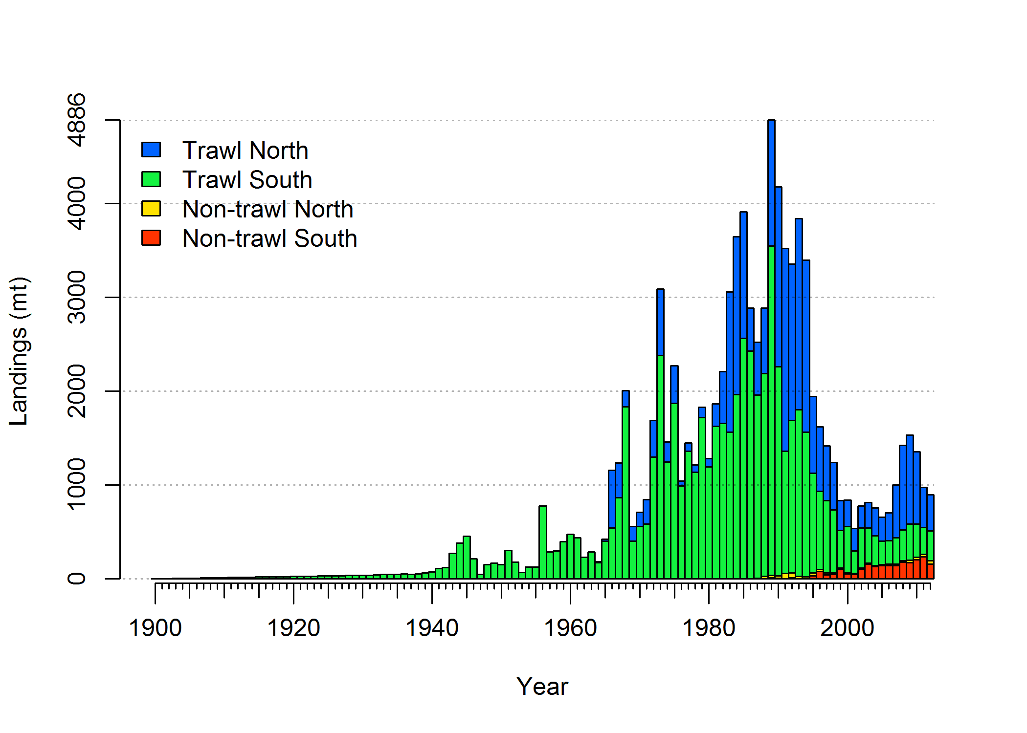

**Figure 1: Estimated landings history for shortspine thornyhead.**

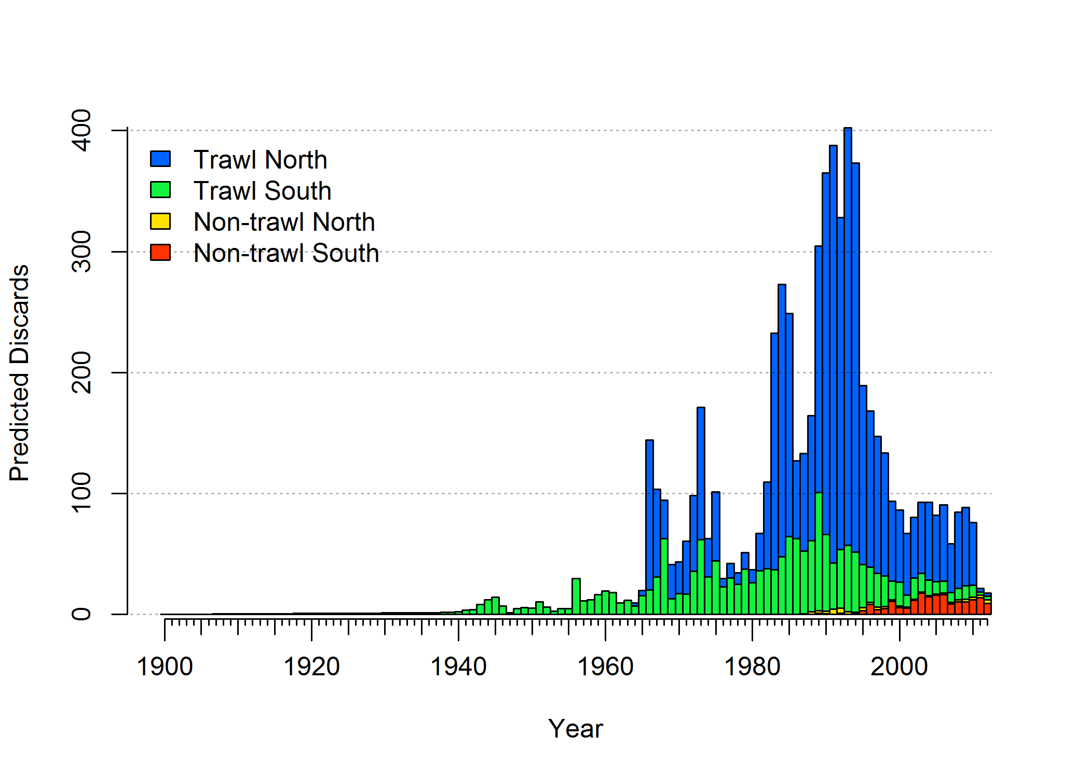

**Figure 2: Predicted discards based estimated retention and selectivity for each fleet.**

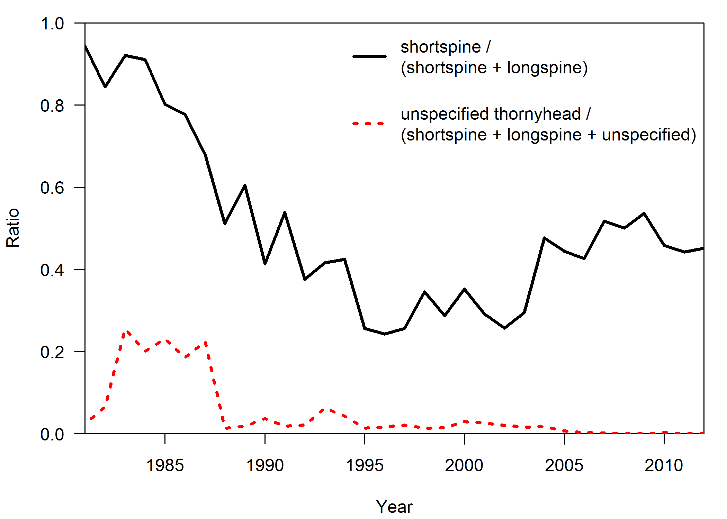

**Figure 3: Ratio of shortspine to combined thornyheads in the subset of the landings for which the species was identified (solid black line), and the ratio of unspecified landings to total landings of both thornyhead species (dotted red line). The ratio of specified thornyheads was used to apportion the unspecified landings into estimates of the landings for each species.**

## Distribution, Ecology and Life history

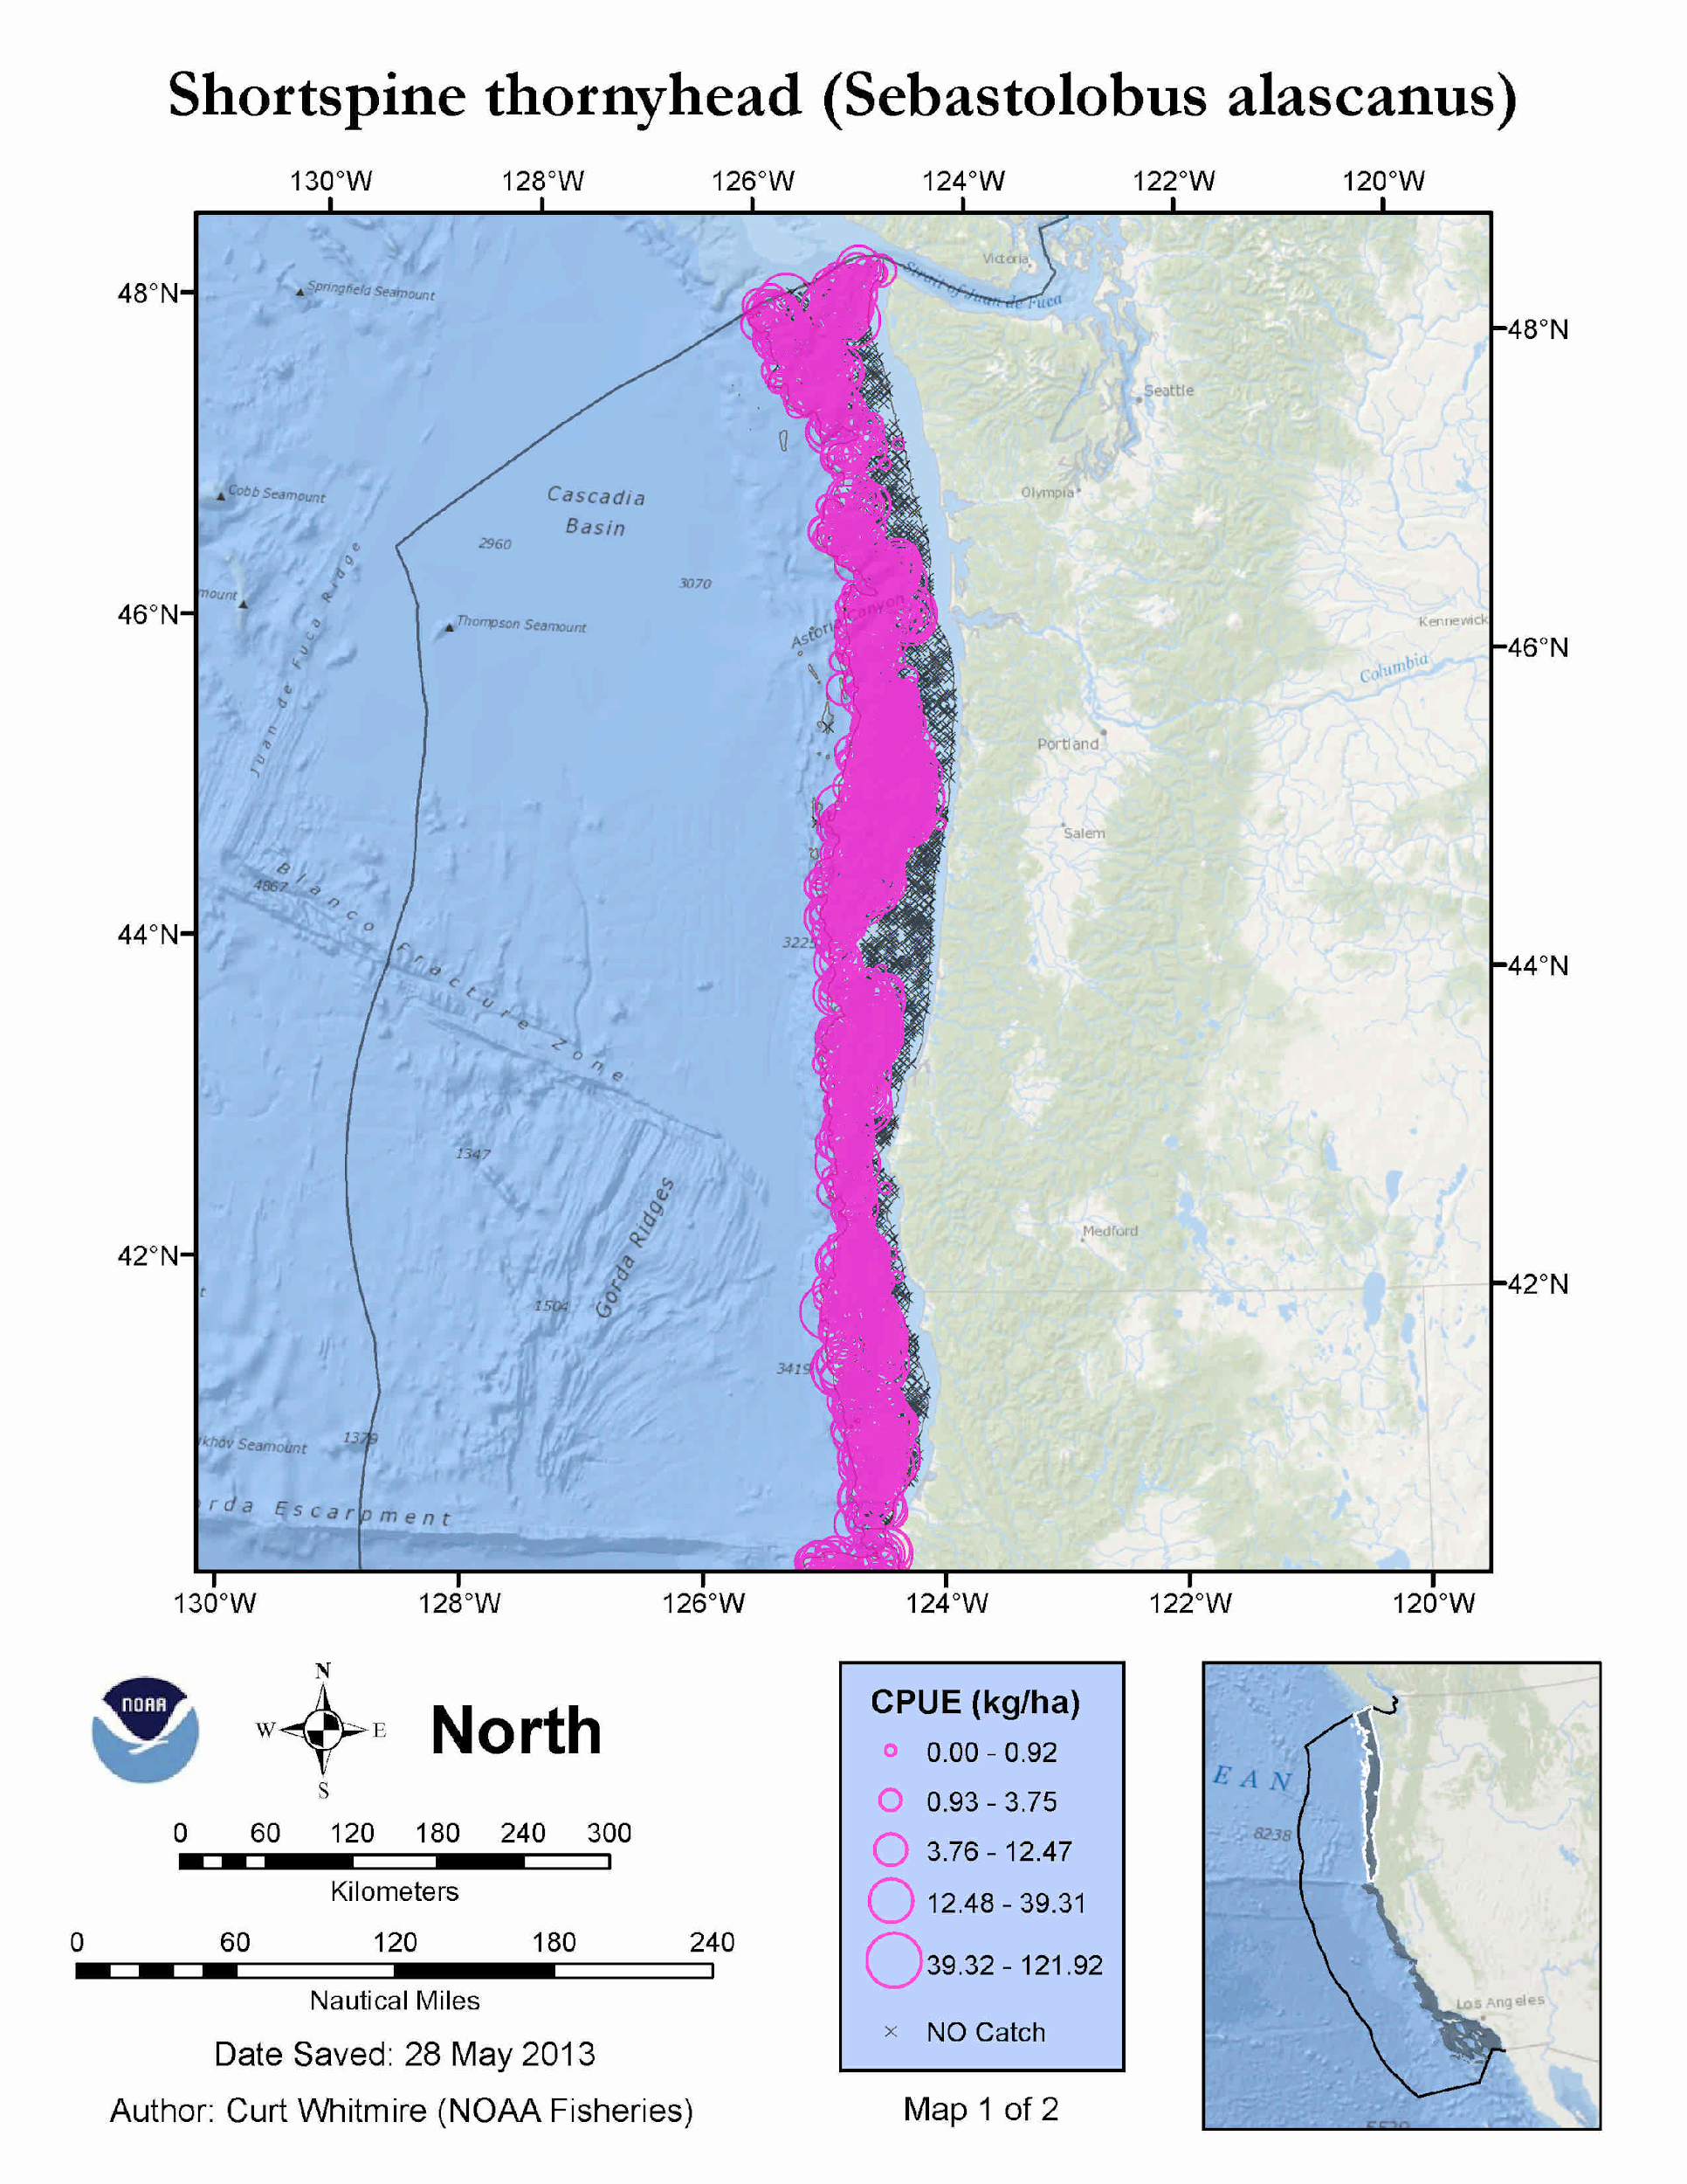

**Figure 4: Occurrence and abundance of shortspine thornyhead found in the NWFSC annual survey (2003-2012) north of 40º10’ N latitude.**

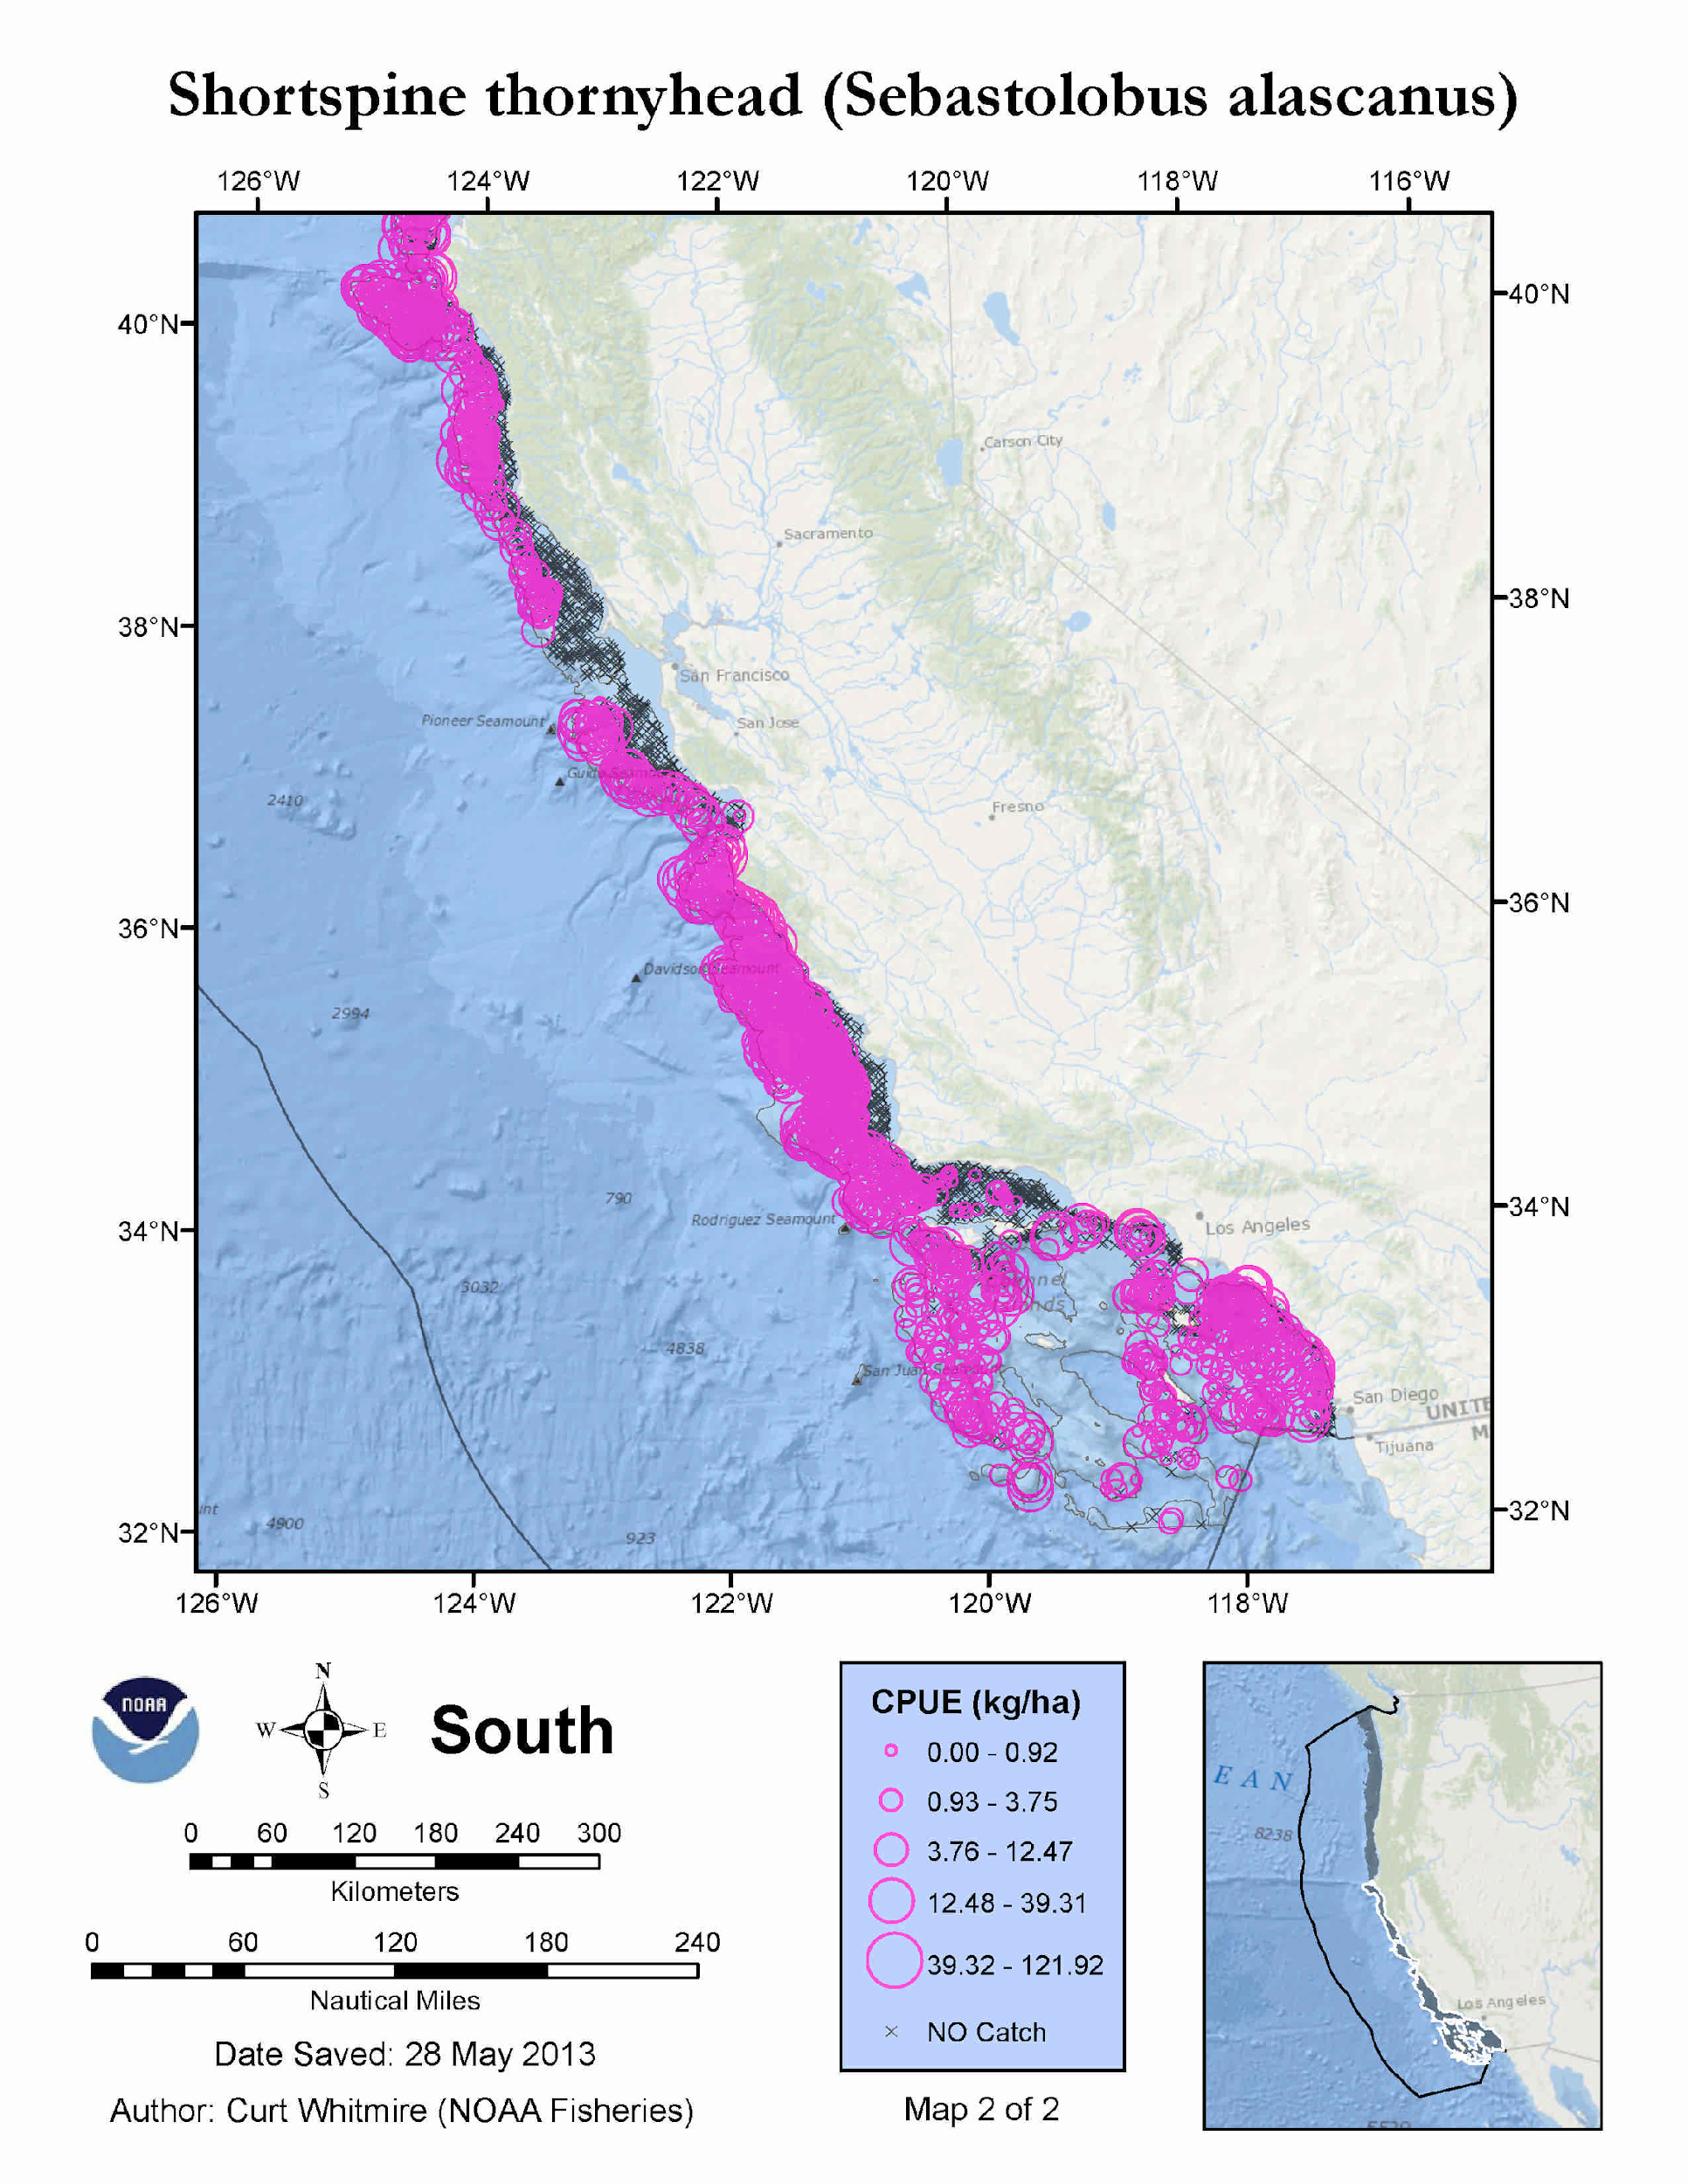

**Figure 5: Occurrence and abundance of shortspine thornyhead found in the NWFSC annual survey (2003-2012) south of 40º10’ N latitude.**

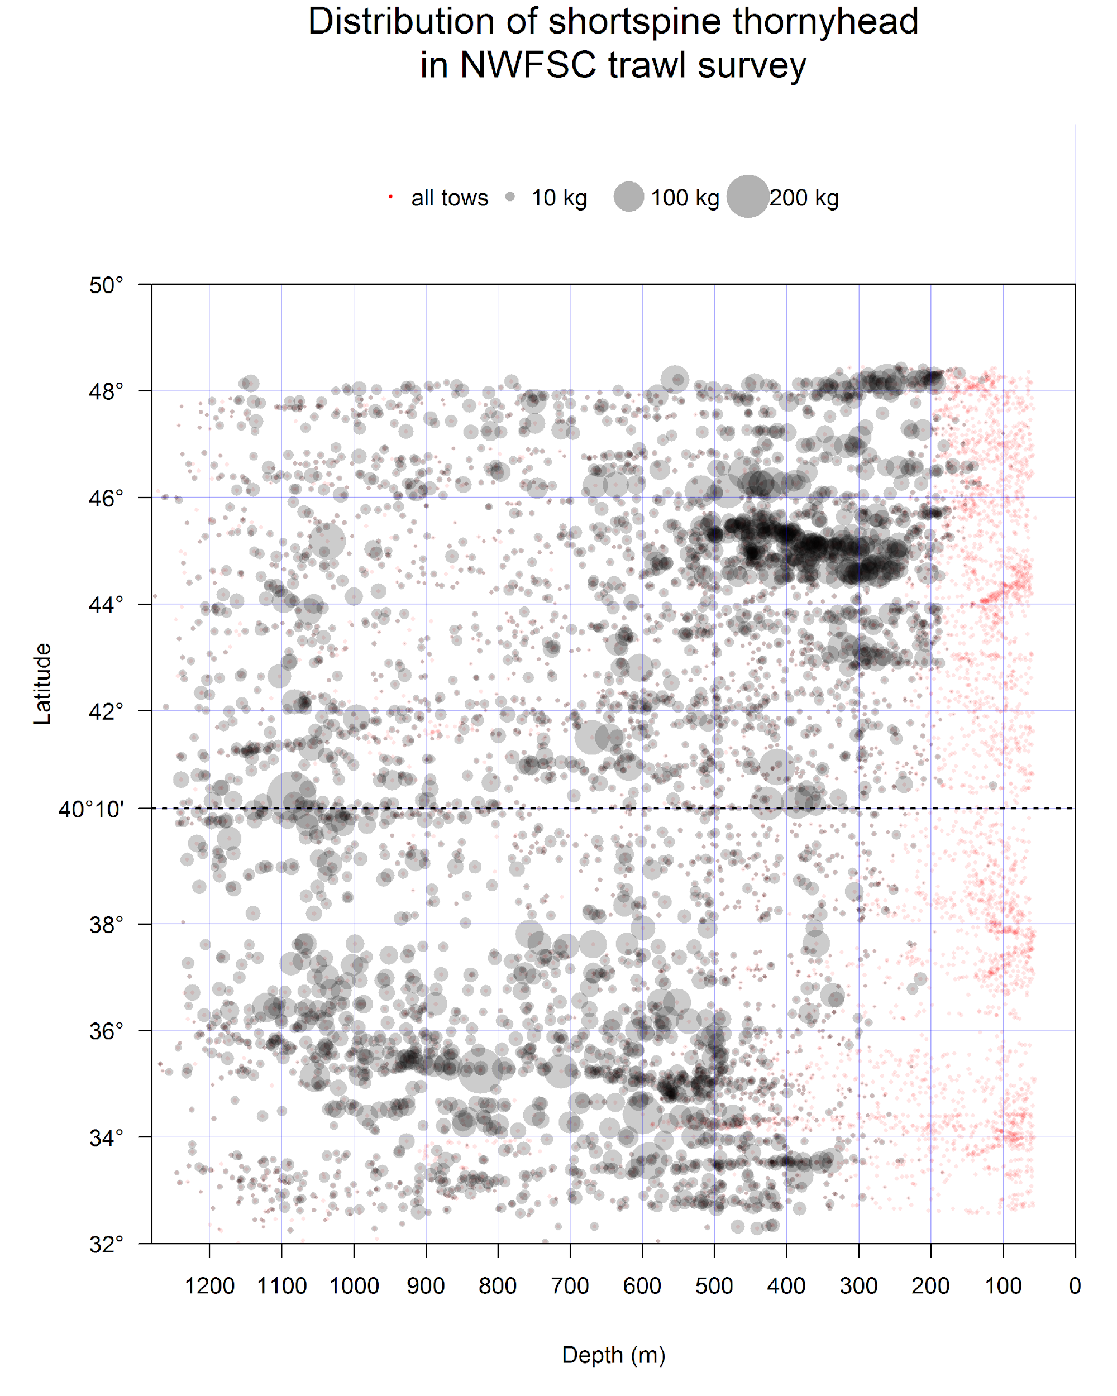

**Figure 6: Spatial distribution of shortspine thornyhead in NWFSC shelf-slope survey data (2003 – 2012). Red points indicate location of all tows. Grey points indicate location of shortspine thornyheads with area of circle proportional to biomass of catch with scale indicated in key at the top. Swept area is not accounted for in this figure, but tows typically cover similar area.**

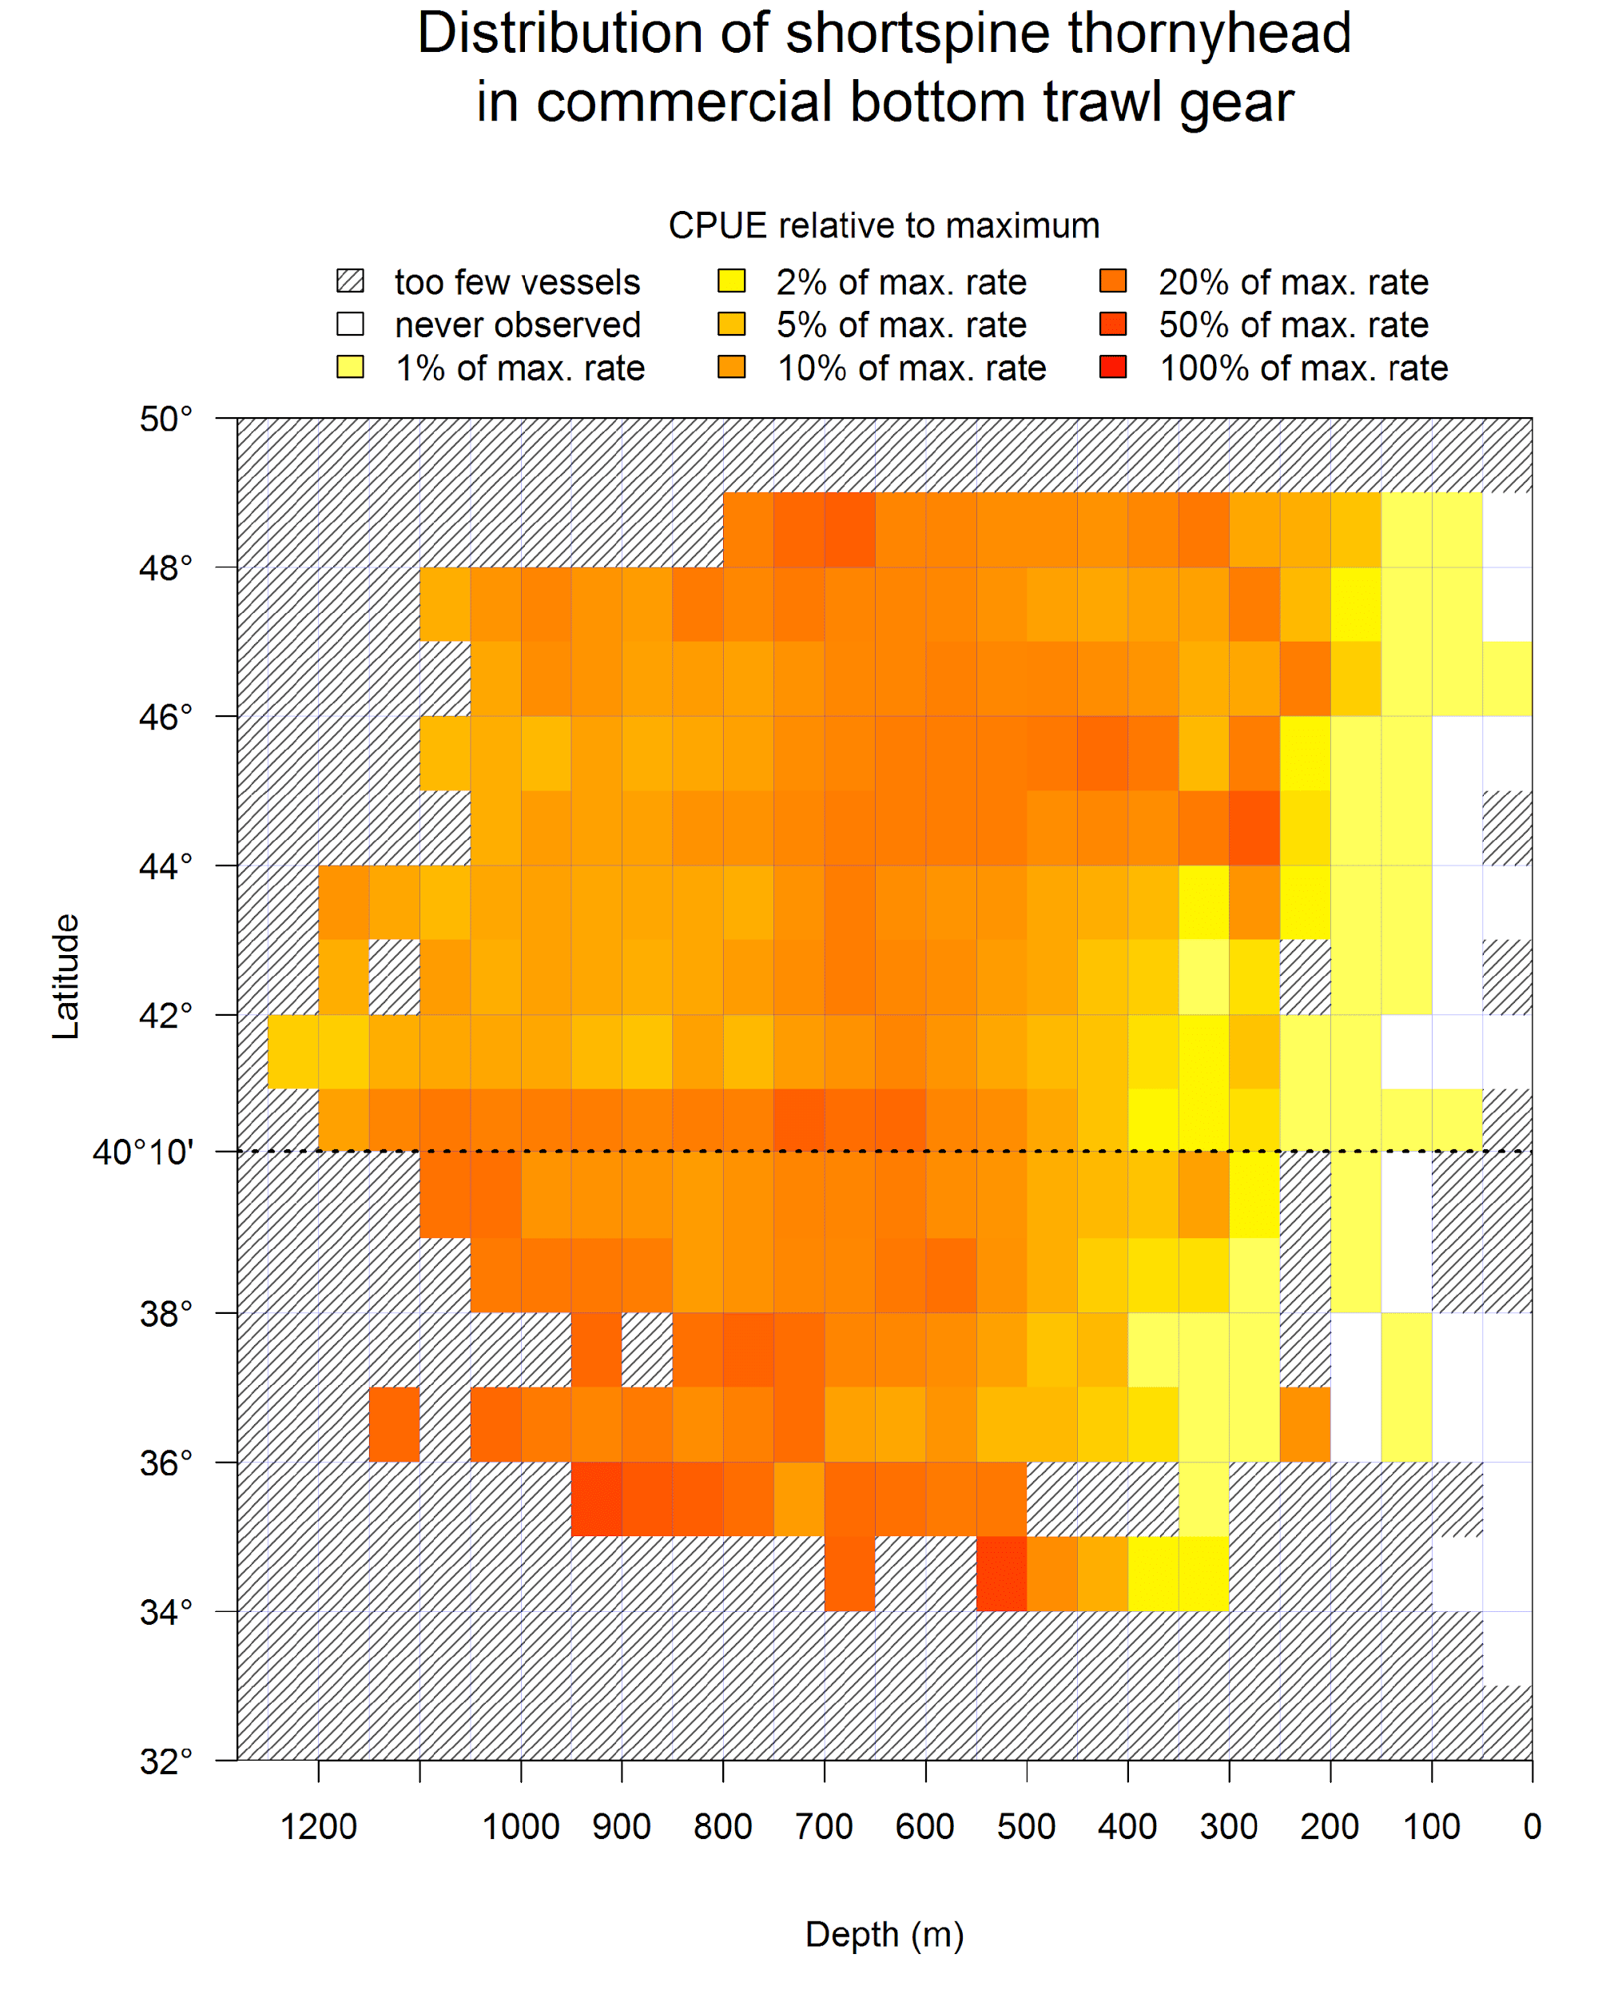

**Figure 7: Spatial distribution of shortspine thornyhead in WCGOP trawl data (2002 – 2011). Colors represent CPUE relative to the maximum. Darkest red = highest CPUE; lightest yellow = lowest CPUE. Data for hatched boxes could not be displayed because of confidentiality (only 1 or 2 vessels carrying observers fished in the area) or because no vessels carrying observers fished in the area. White areas are places where 3 or more vessels fished and carried observers, but the species in question was not caught. CPUE represented here is the sum of the observed catch across all years divided by the sum of the trawl durations during observed hauls within each cell.**

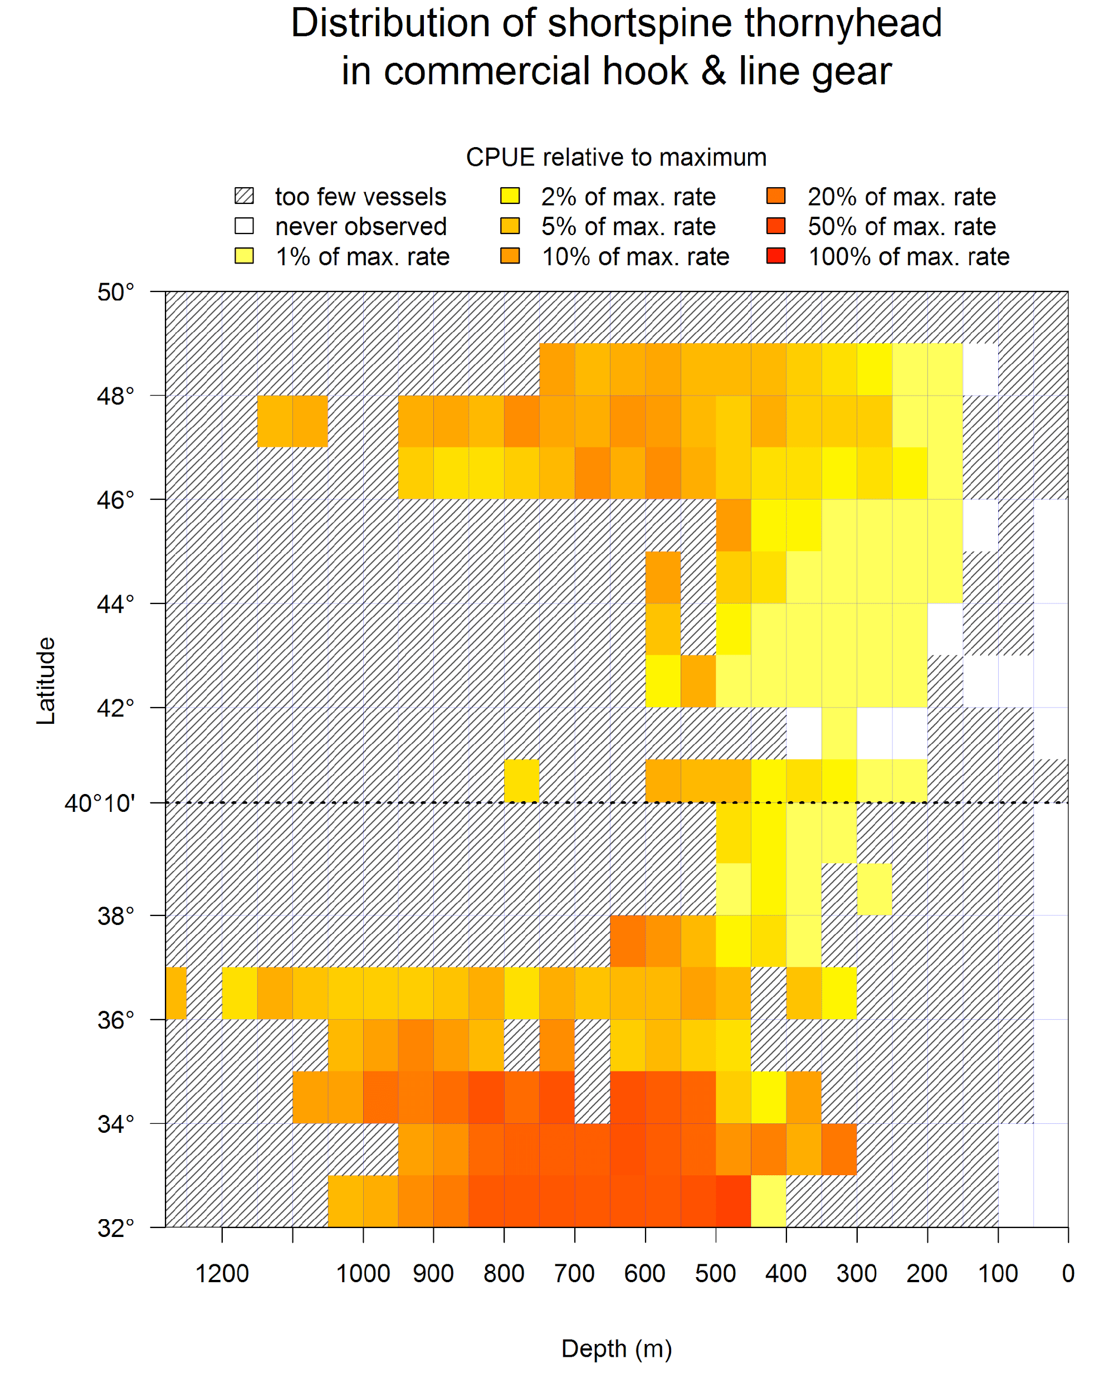

**Figure 8: Spatial distribution of shortspine thornyhead in WCGOP hook and line fishery data (2002 – 2011). Colors represent CPUE relative to the maximum. Darkest red = highest CPUE; lightest yellow = lowest CPUE. Data for hatched boxes could not be displayed because of confidentiality (only 1 or 2 vessels carrying observers fished with hook and line in the area) or because no vessels carrying observers fished in the area. White areas are places where 3 or more vessels fished and carried observers, but the species in question was not caught. CPUE represented here is the sum of the observed catch across all years divided by the sum of the number of hooks set hauls within each cell.**

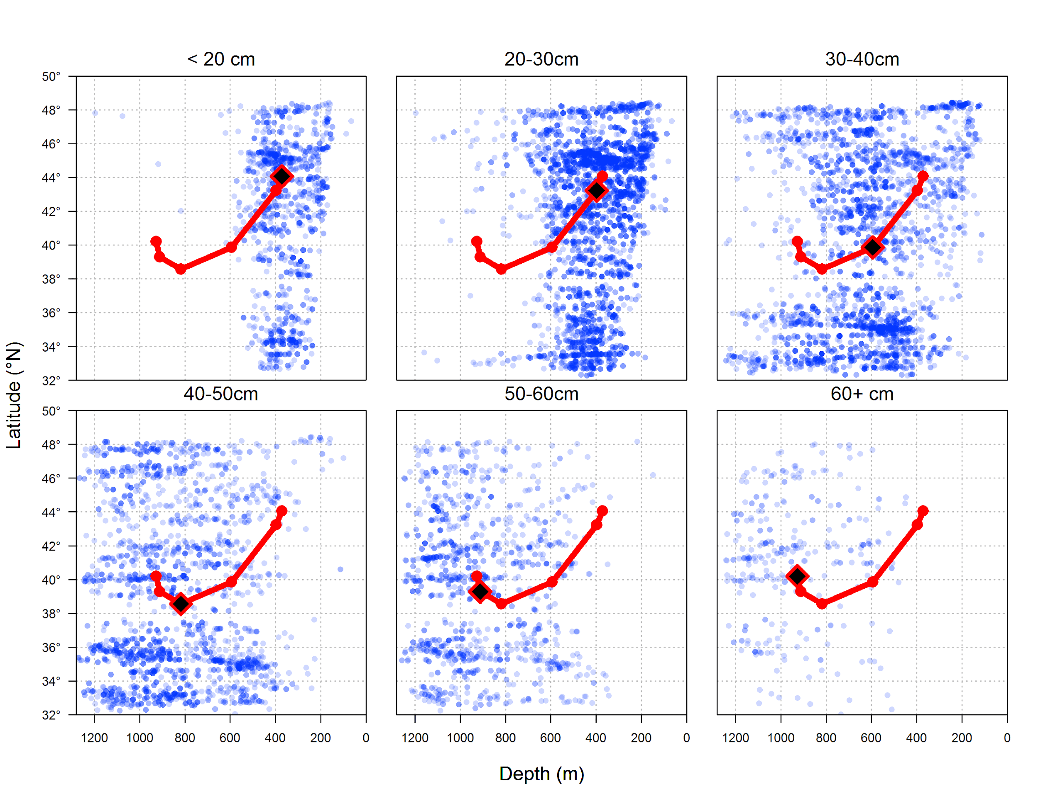

**Figure 9: Distribution of different size groups of shortspine thornyheads. Blue points represent location of samples in each size bin. Black diamonds indicate the weighted average of depth and latitude for each bin, and the red lines show the connected series of average values across bins.**

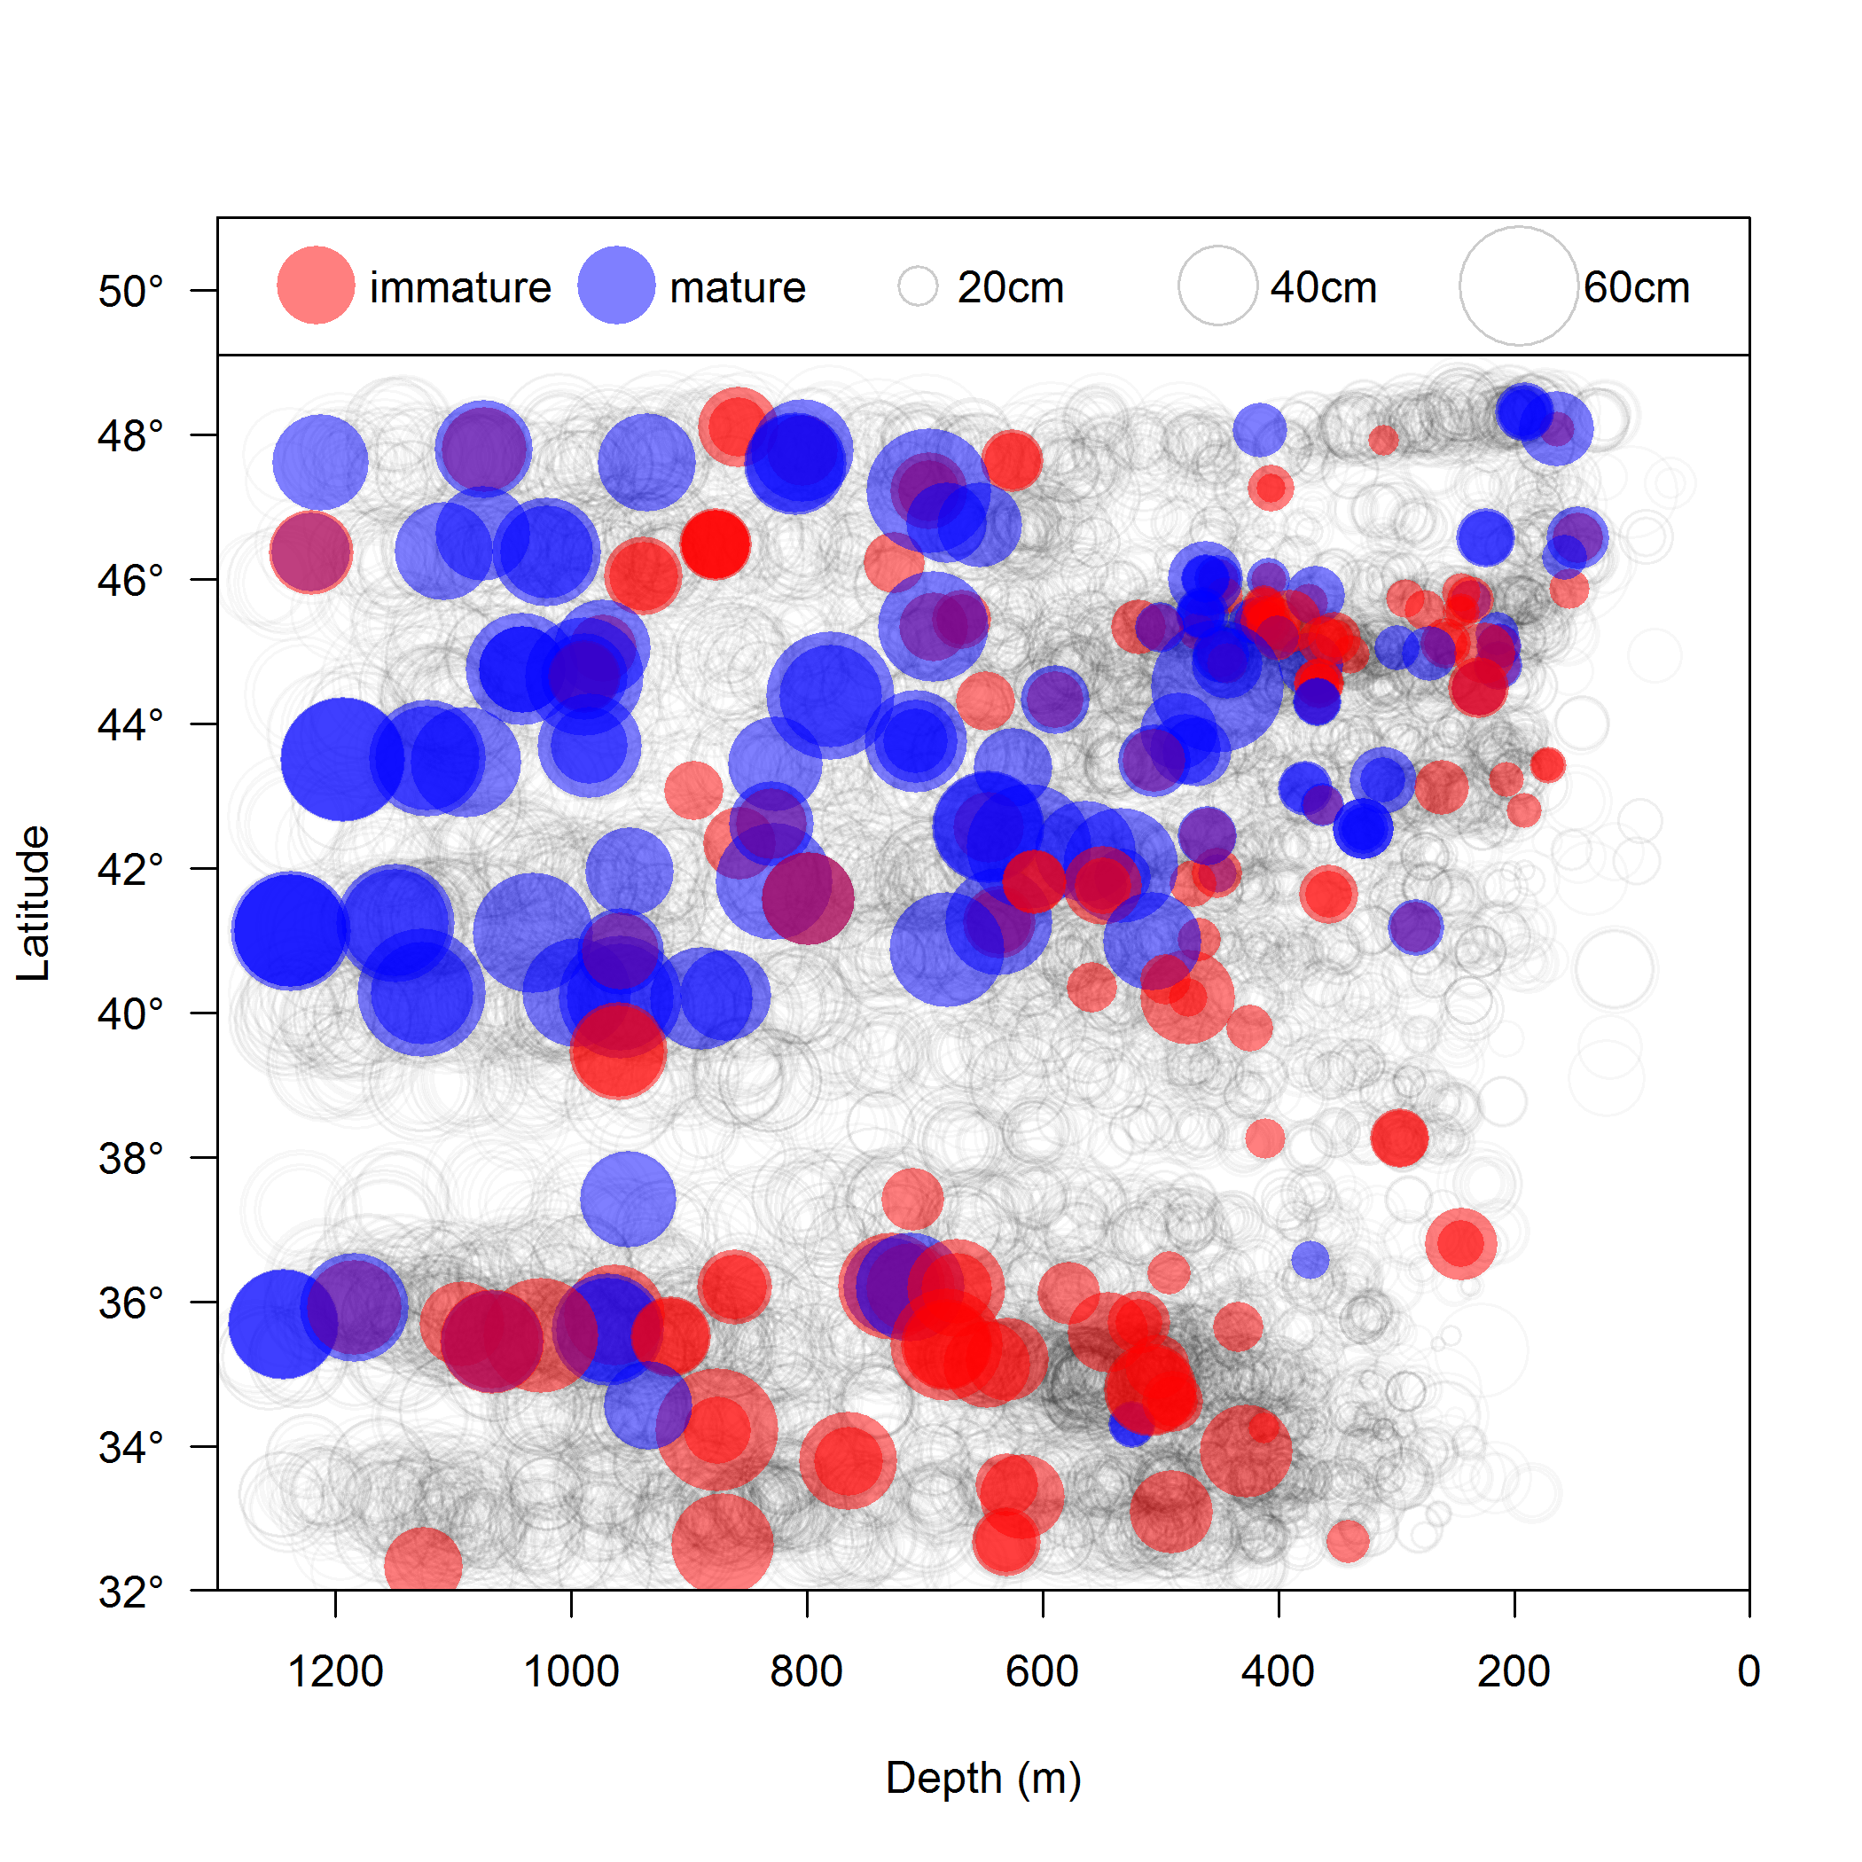

**Figure 10: Distribution of mature and immature shortspine thornyheads based on ovaries collected in the NWFSC Combo Survey in 2011 and 2012. Due to difficulty in determining maturity of individuals that are not spawning, immature samples may include fish that were skipping spawning. Open circles indicate all length samples. Filled circles represent locations where ovaries were collected. Circle Diameter of circles is proportional to observed length.**

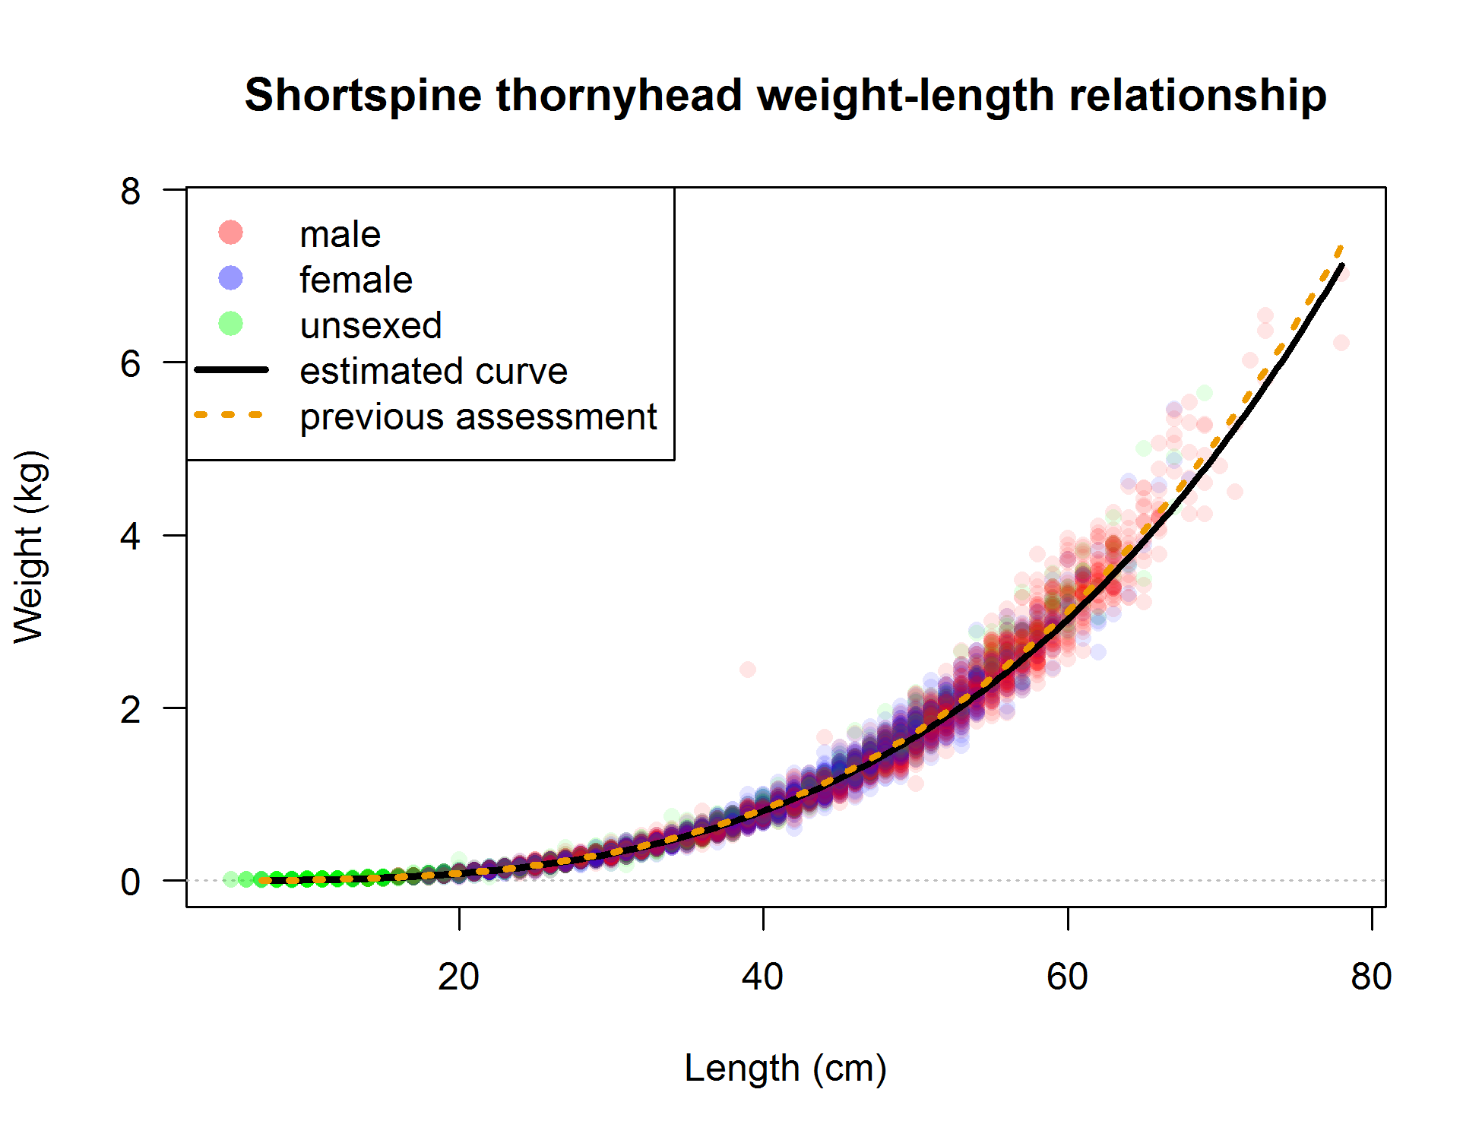

**Figure 11: Weight at length observations and estimation mean relationship used in the assessment.**

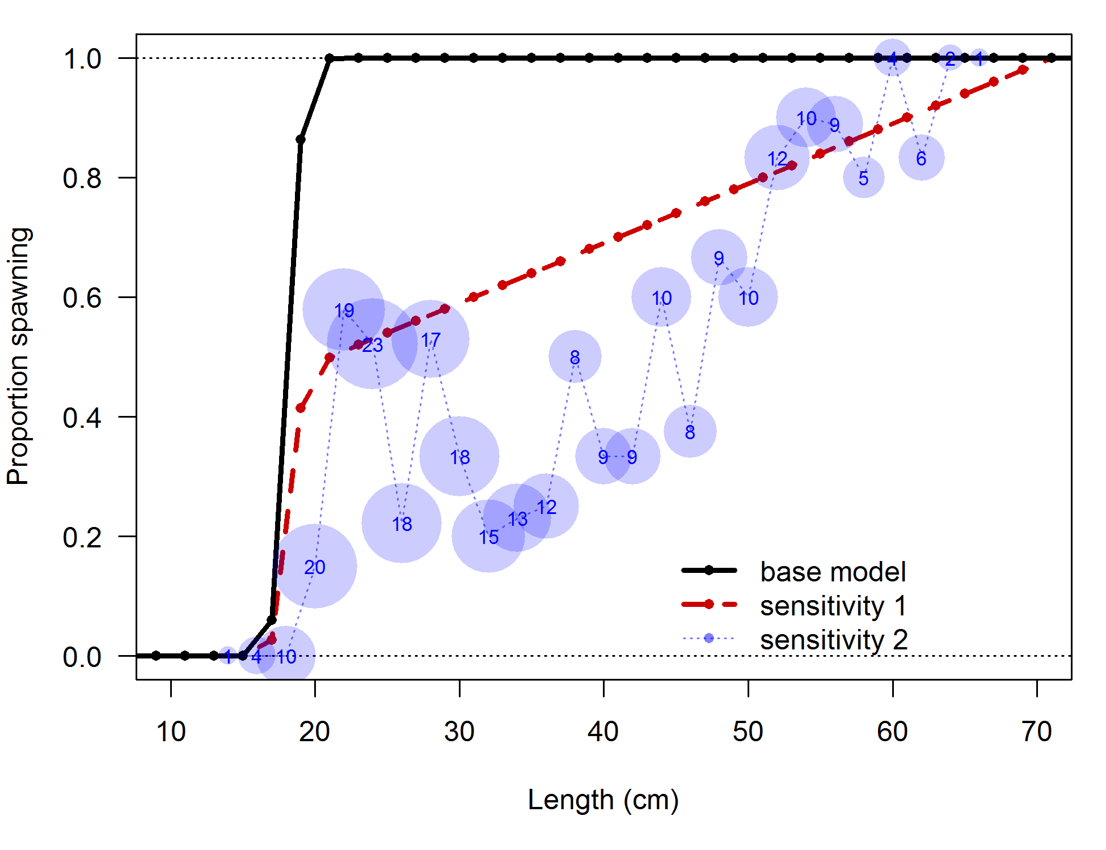

**Figure 12: Recently collected data on proportion spawning by length bin (circles) with sample size indicated by area of circle and number within. Maturity schedules for the base model and sensitivity analyses are shown by the solid and dashed lines.**

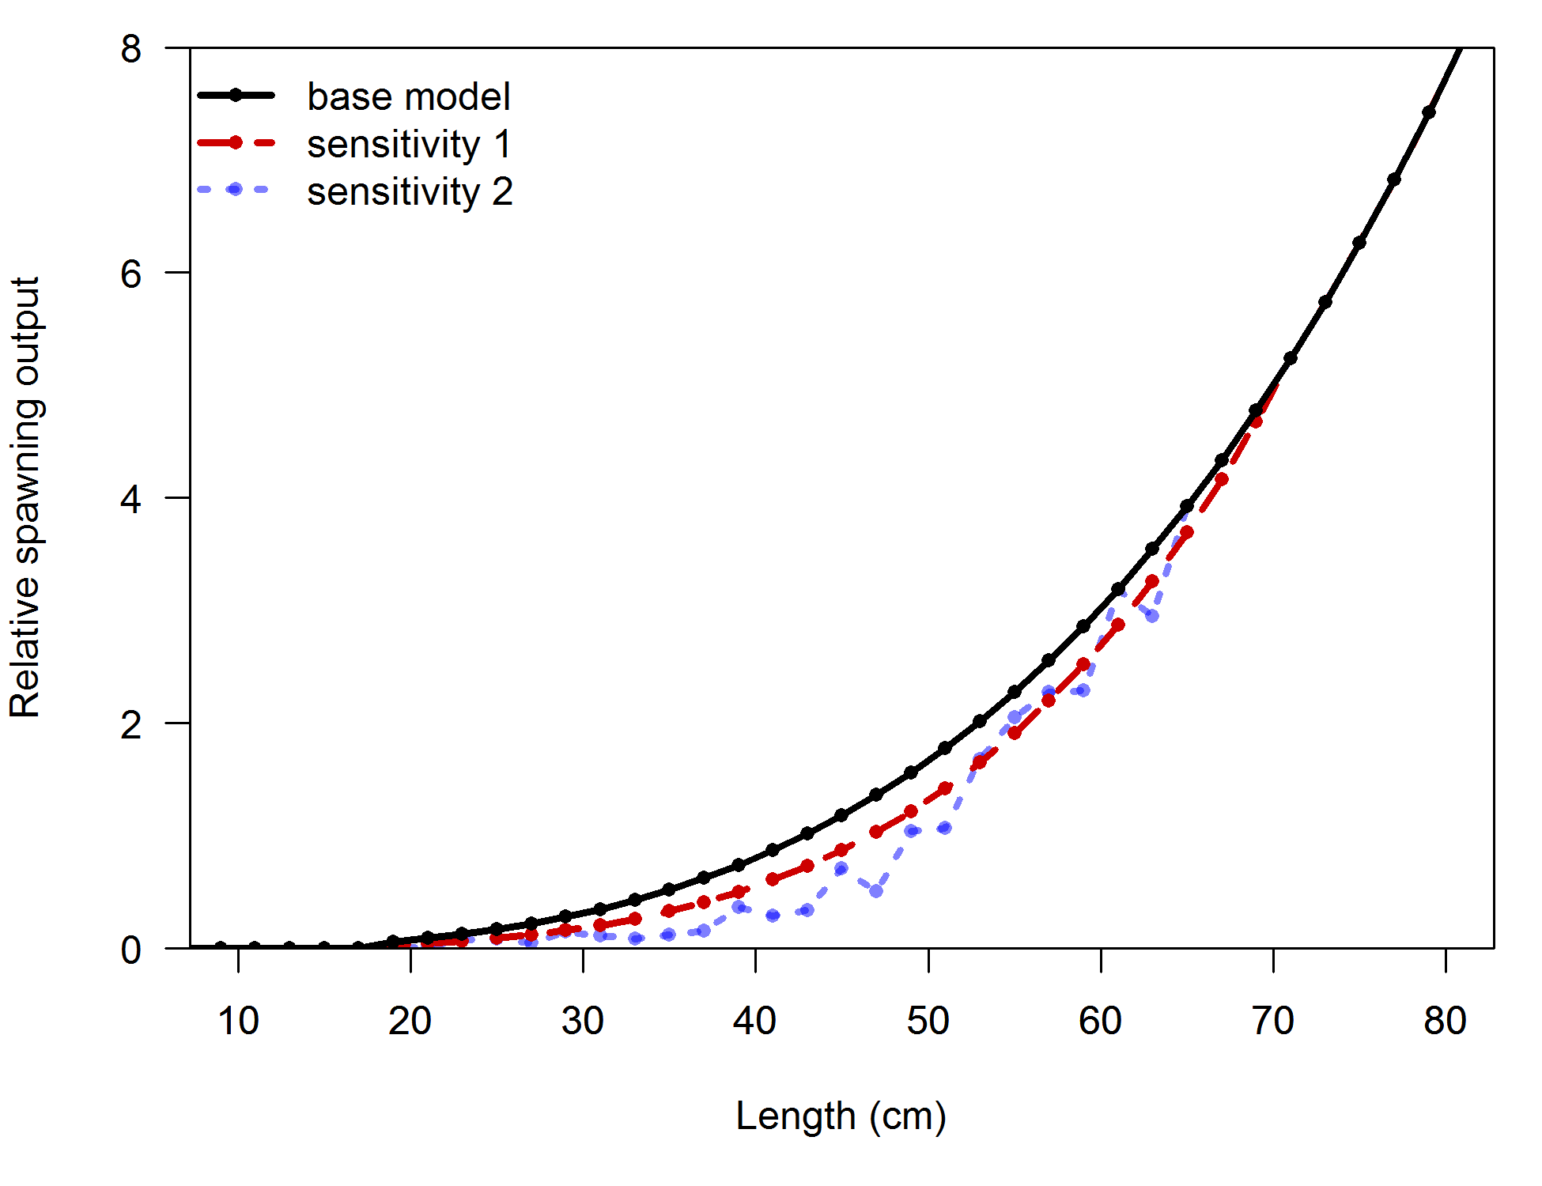

**Figure 13: Spawning output as a function of length for the base model and the sensitivity analyses. This is the product of fraction spawning and fecundity (assumed proportional to weight).**

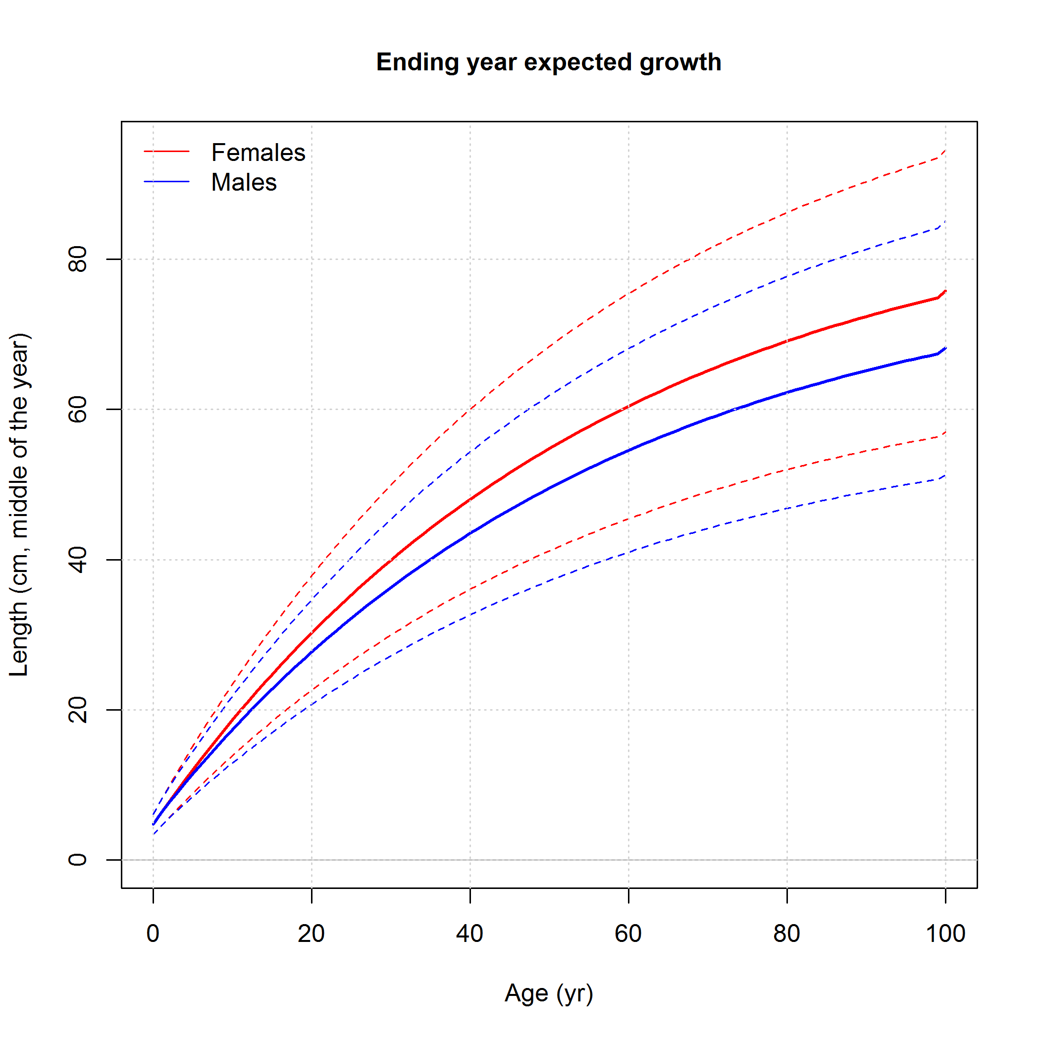

**Figure 14: Growth curves (solid lines) and 95% variability in length-at-age used in the model.**

## Data and model fits

### Data summary

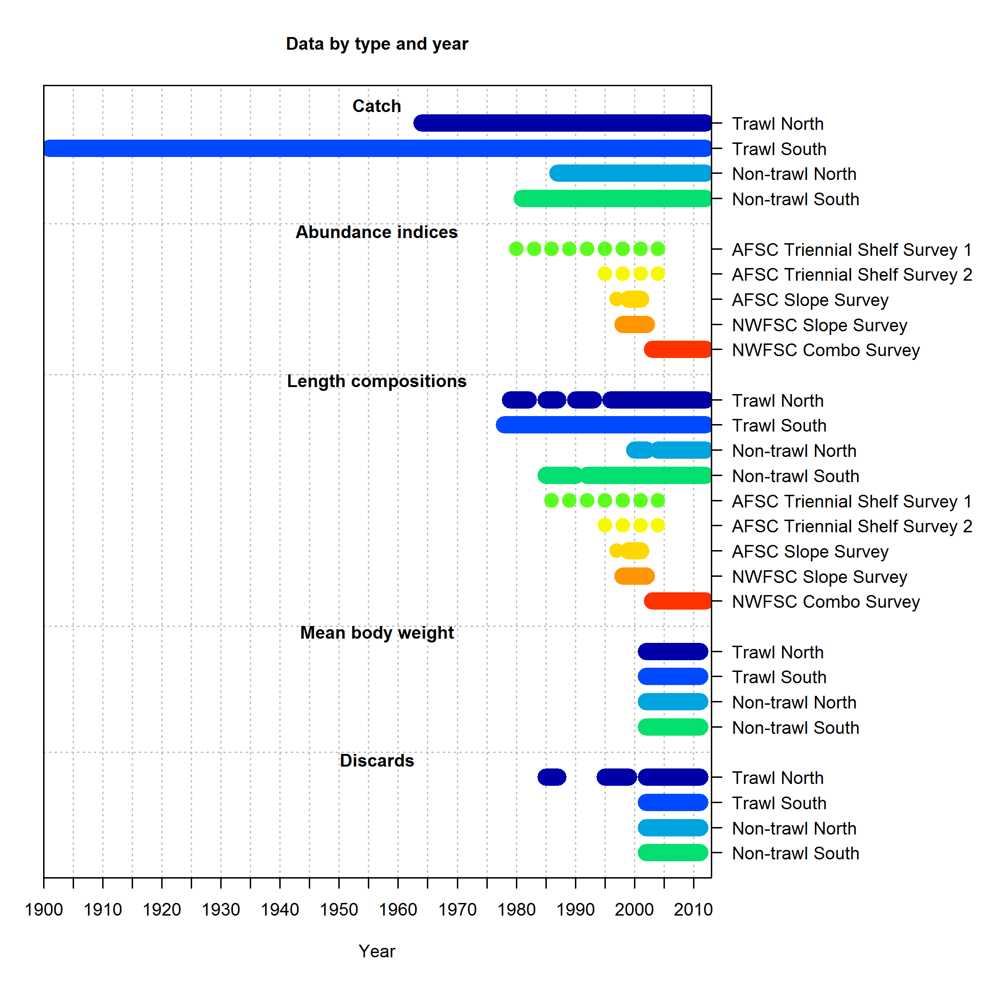

**Figure 15: Chart of data availability by year for each fleet.**

### Selectivity and retention

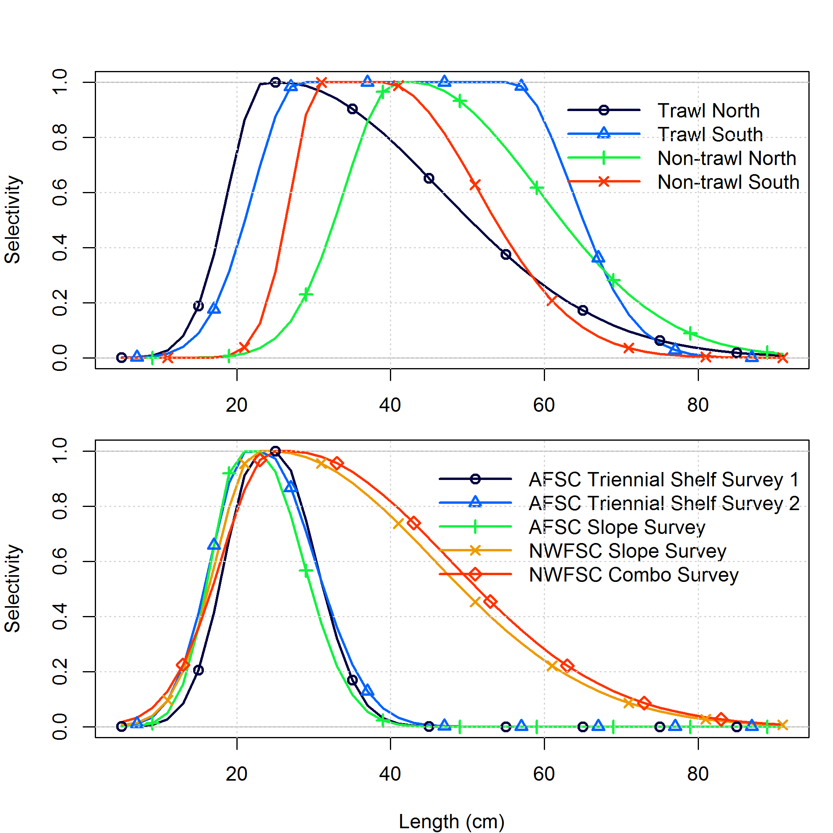

**Figure 16: Selectivity for each fishing fleet (upper panel) and survey (lower panel).**

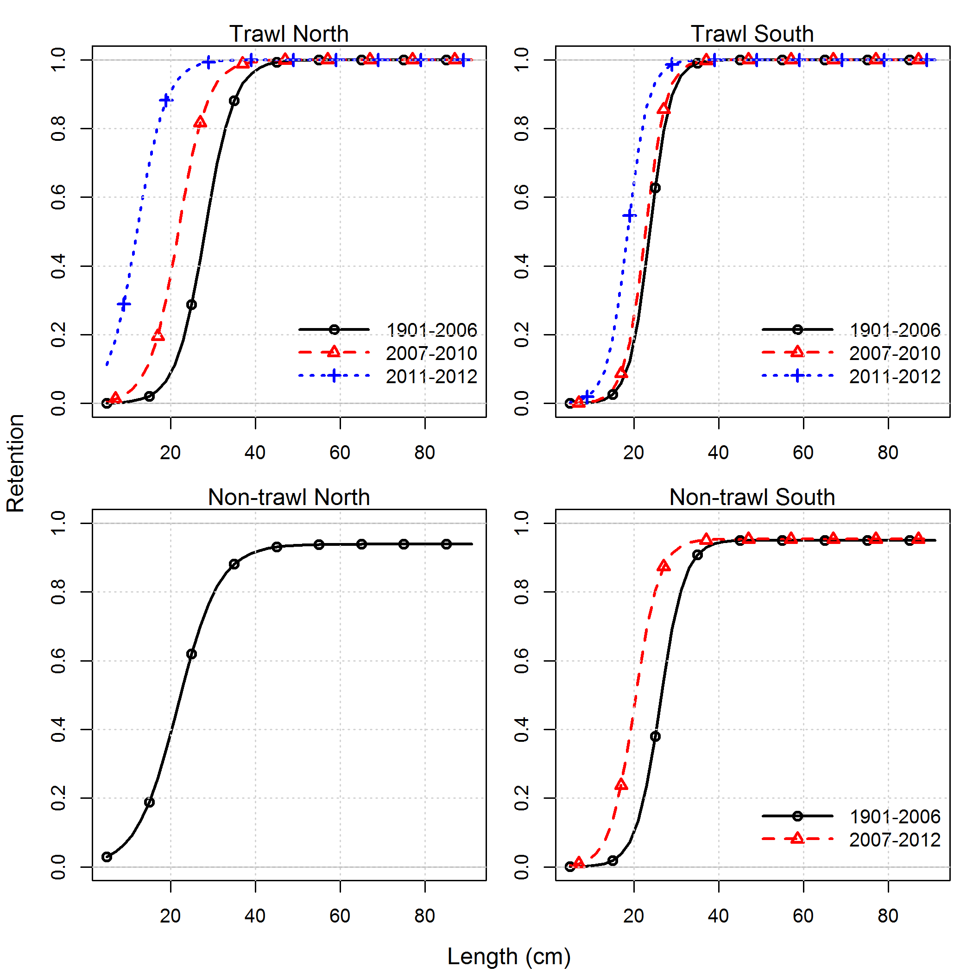

**Figure 17: Retention functions for each fleet in the base model indicating increased retention of smaller fish in more recent years.**

### Indices and discard data

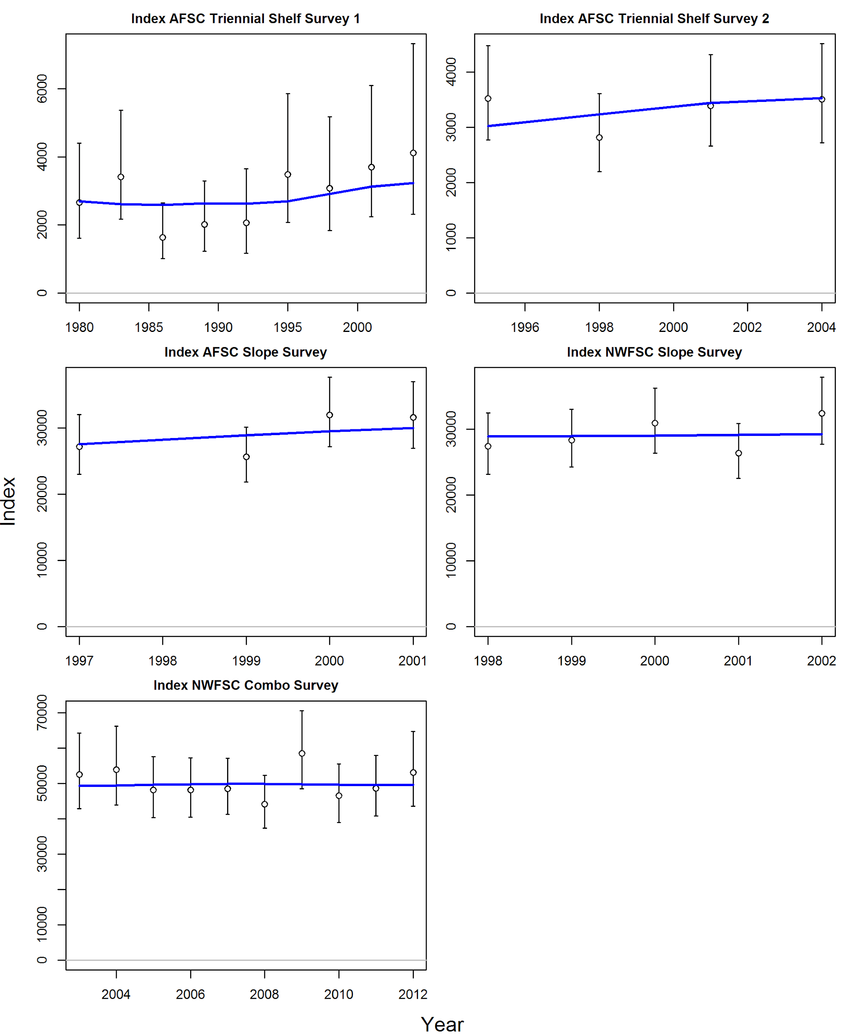

**Figure 18: Indices of abundance used in the assessment (open circles) shown with 95% intervals (black vertical lines) and model fits (blue lines).**

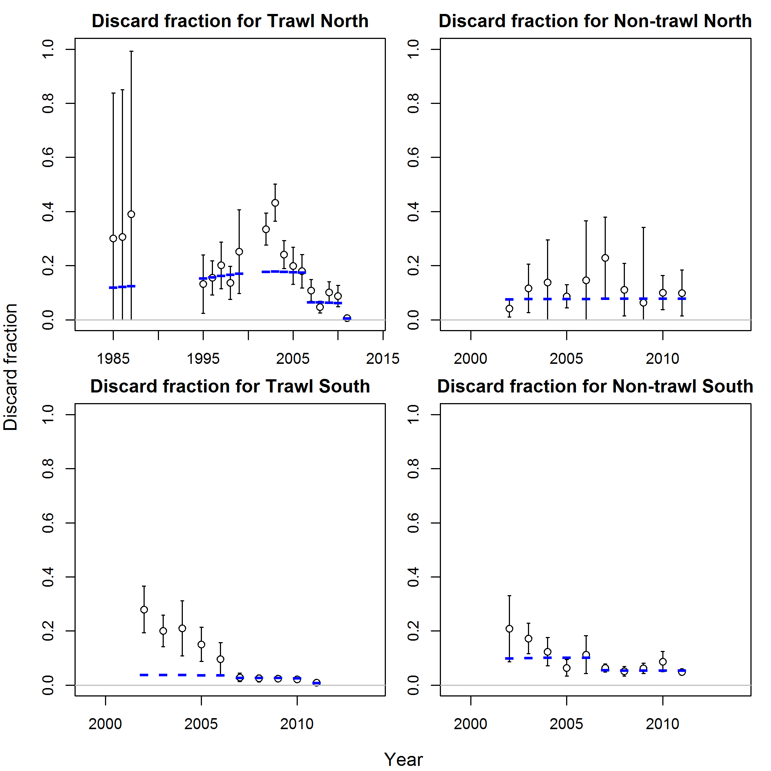

**Figure 19: Discard fractions estimated for each fleet (open circles) shown with 95% intervals (black vertical lines) and model fits (blue lines).**

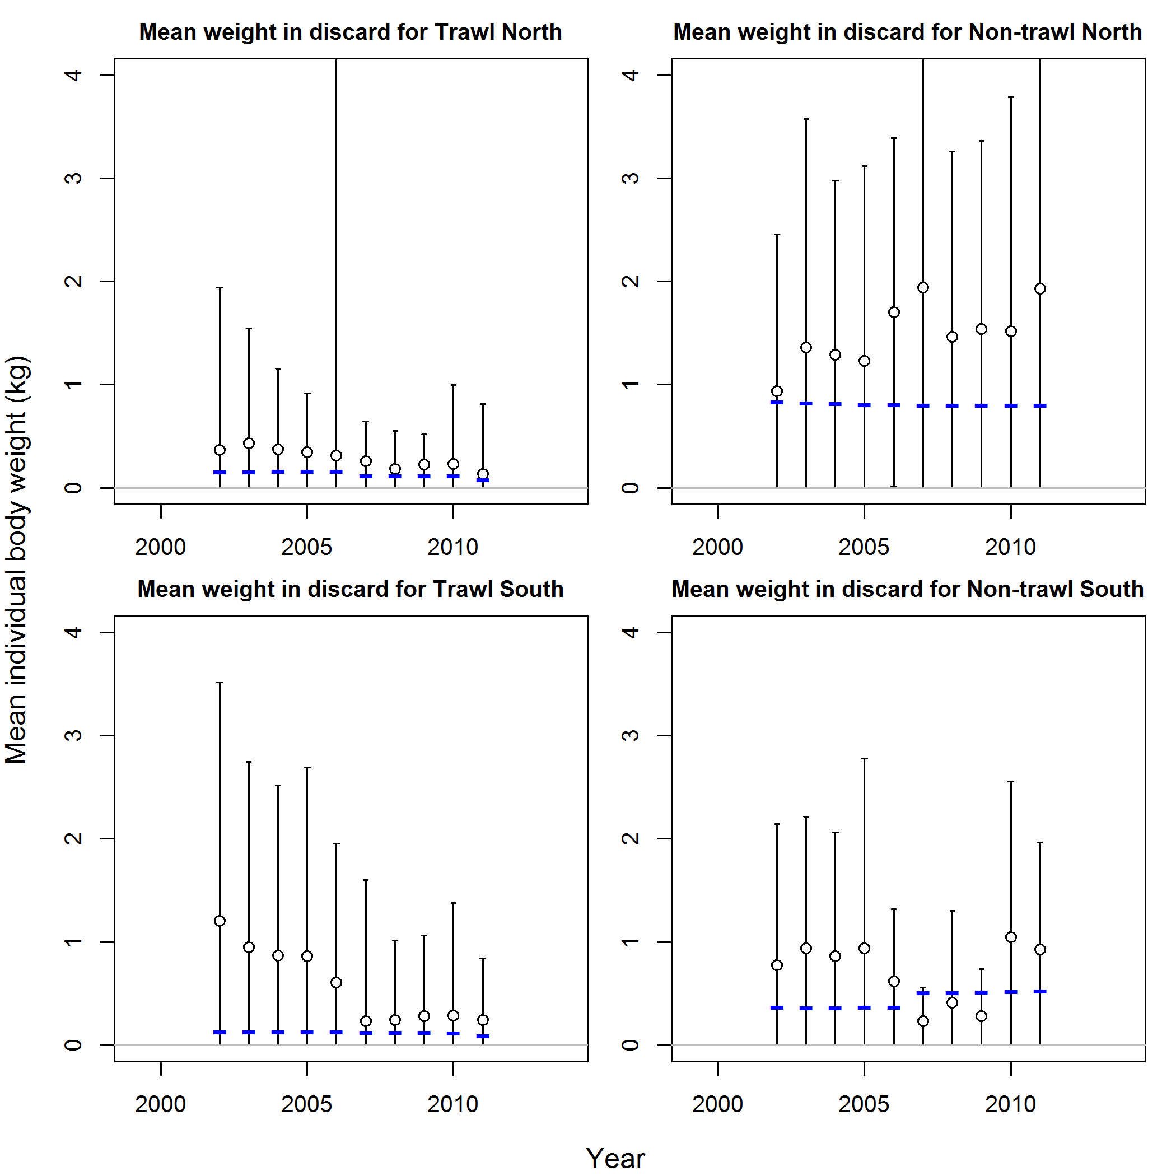

**Figure 20: Mean weight of discard data for each fleet (open circles) shown with 95% intervals (black vertical lines) and model fits (blue lines).**

### Length compositions

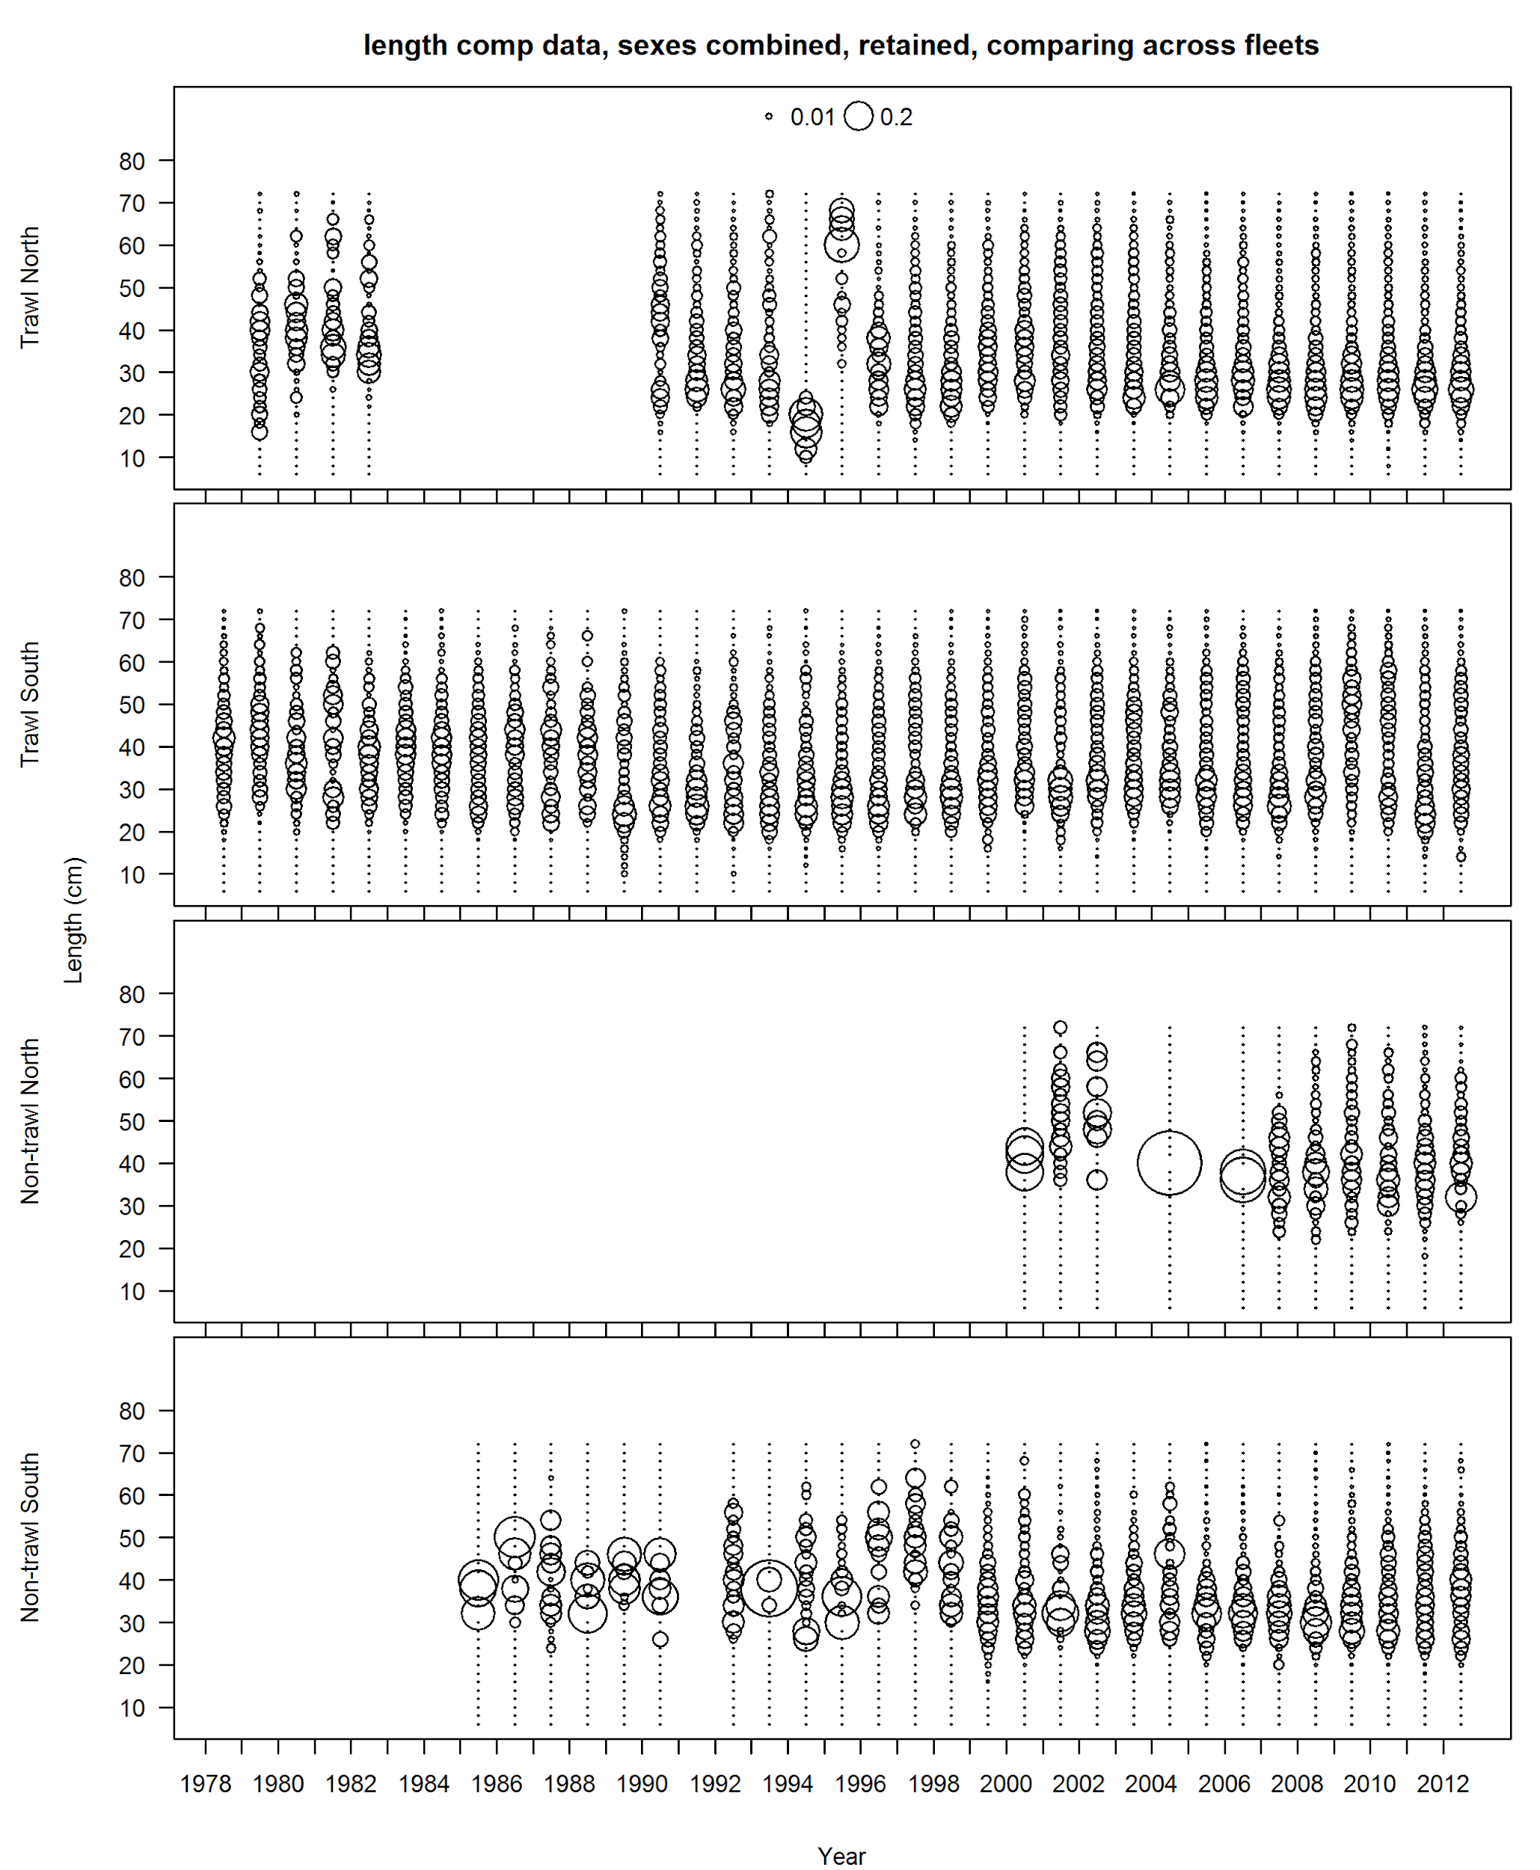

**Figure 21: Fishery length compositions calculated from landed catch. Bubble sizes indicate proportion in each length bin. Sexes are combined. Shaded section in top panel indicates observations from 1994–95 that were considered outliers and removed from base model.**

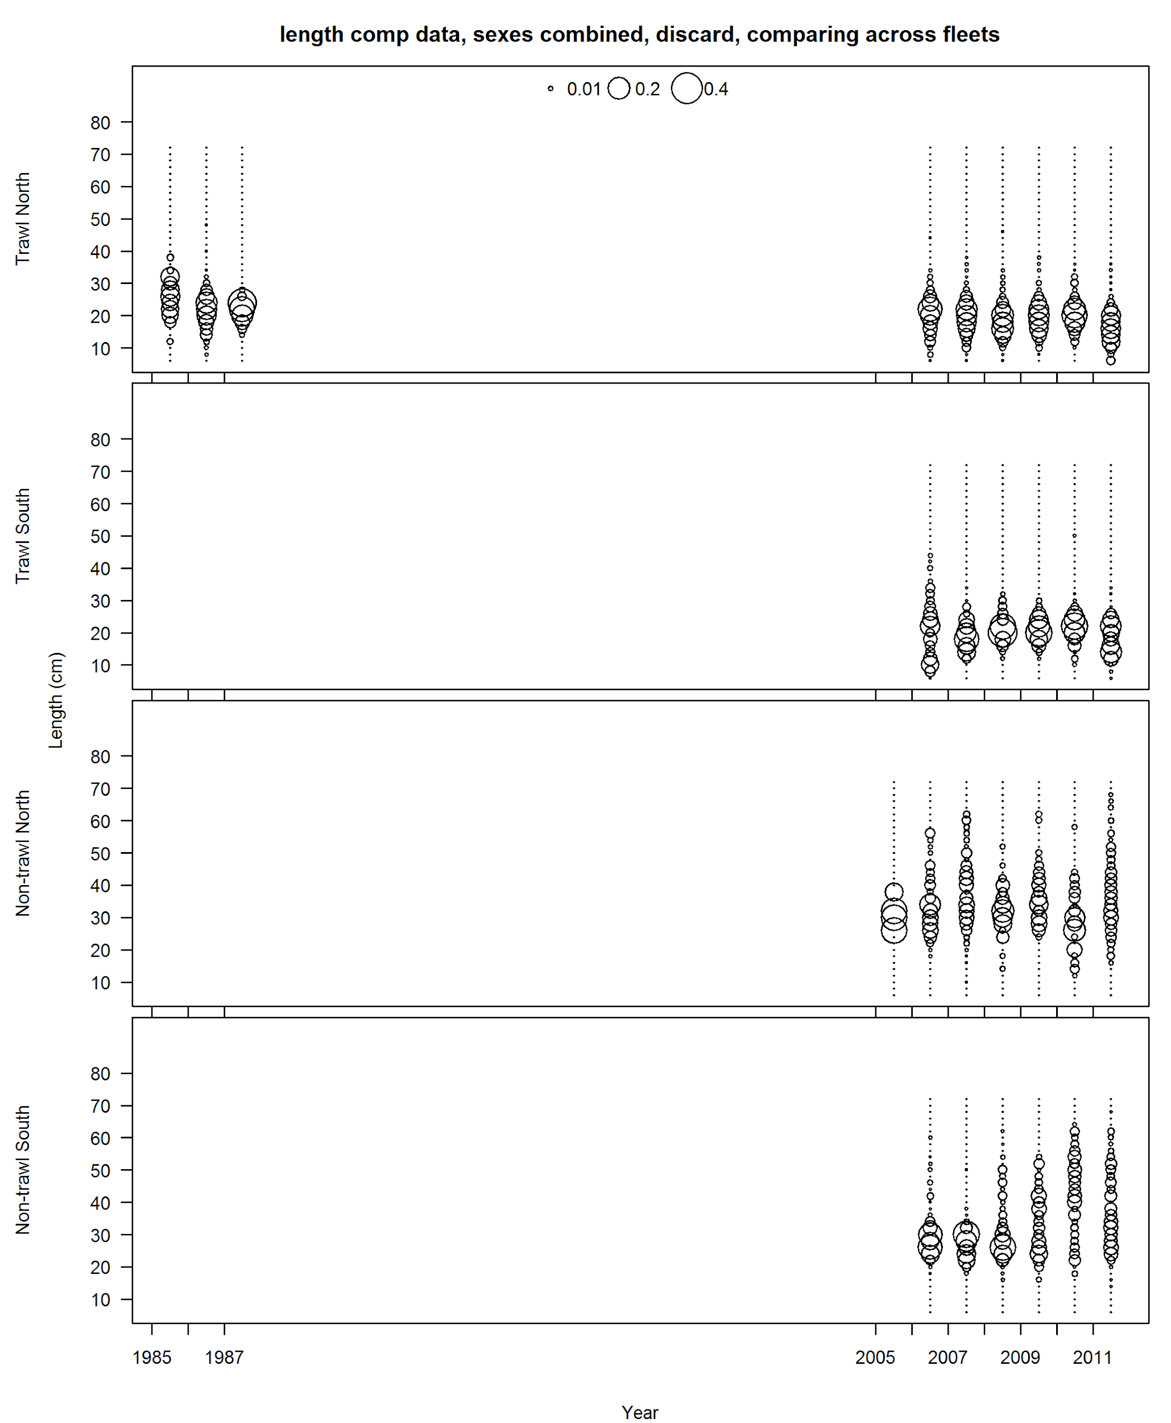

**Figure 22: Fishery length compositions calculated from discards. Sexes are combined.**

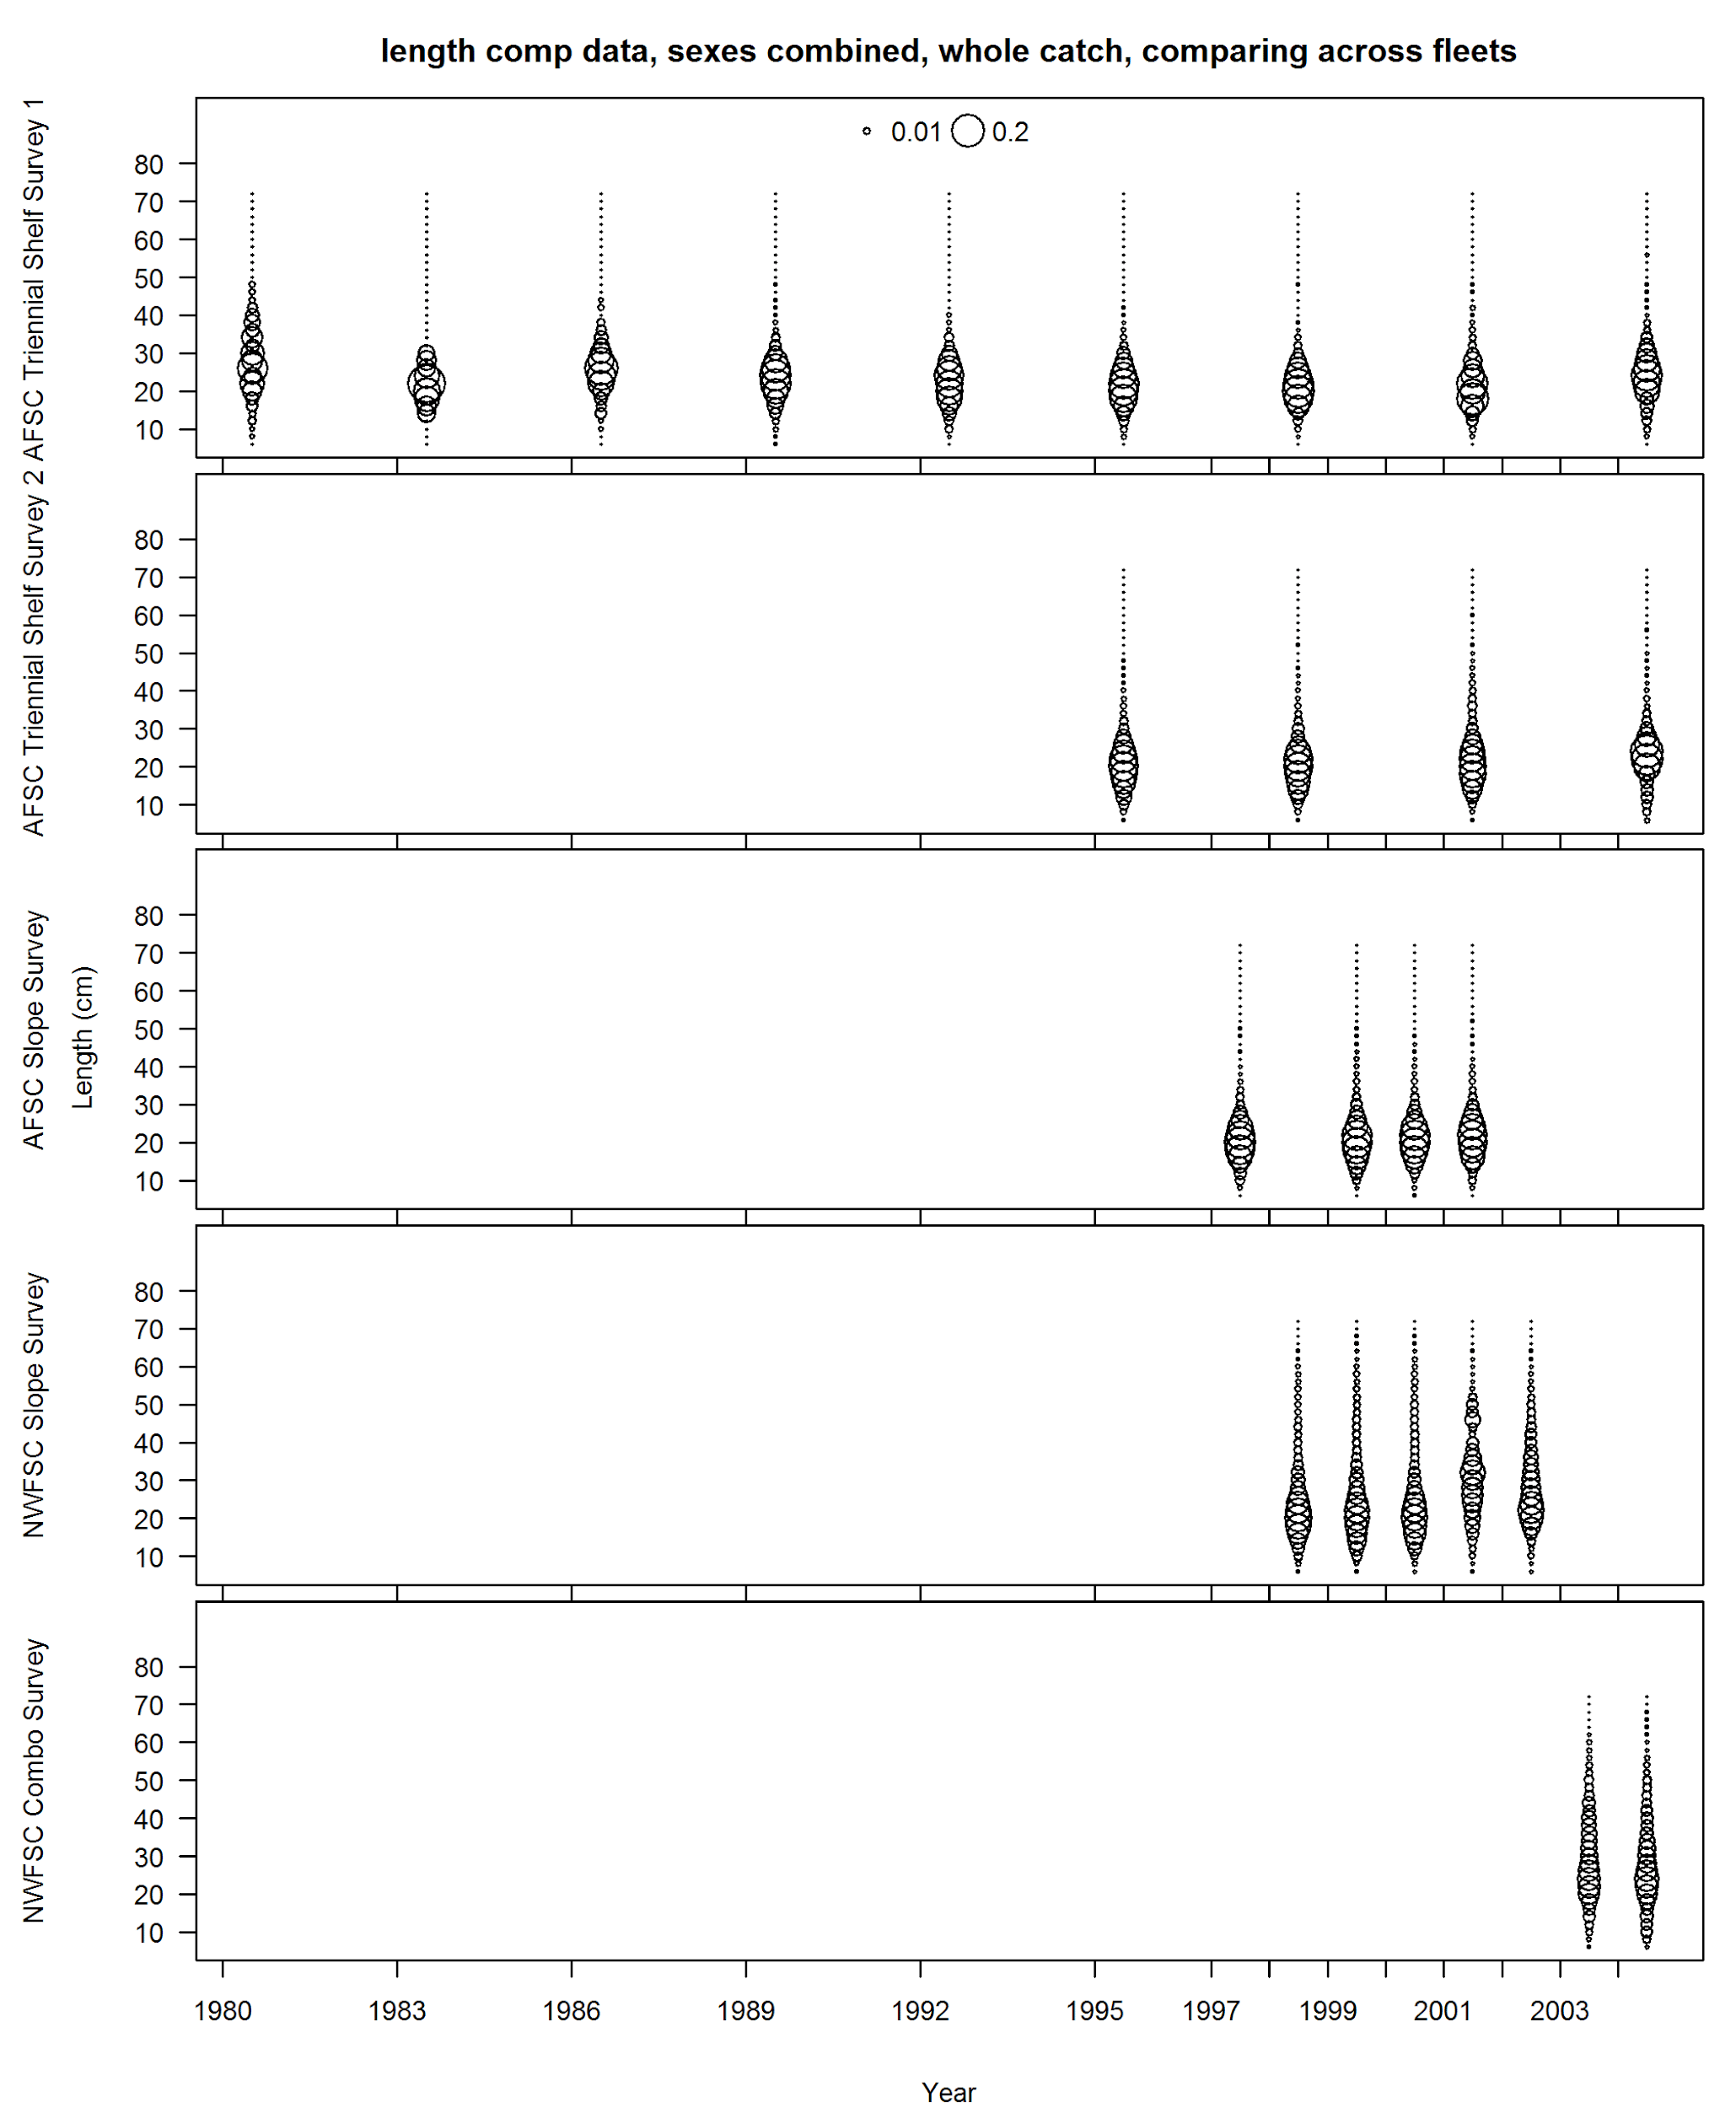

**Figure 23: Survey length compositions for years with combined sex data. Shaded region in top panel indicates observations that were associated with only a single tow and removed from the base model.**

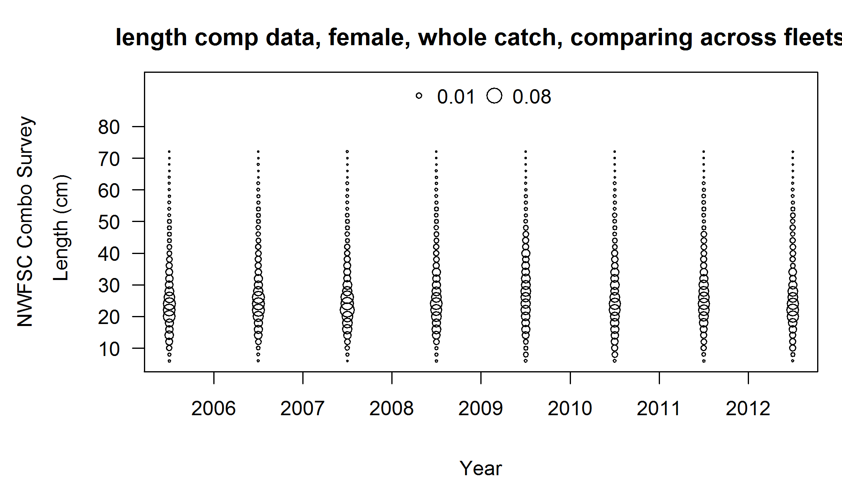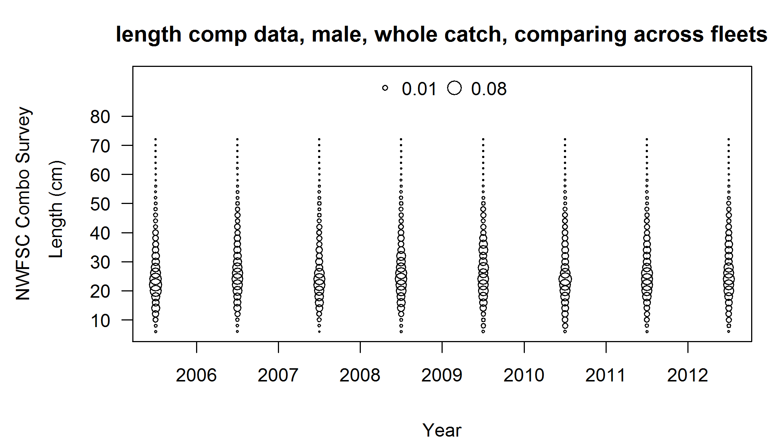

**Figure 24: Survey length compositions for females (top) and males (bottom) for the NWFSC Combo Survey.**

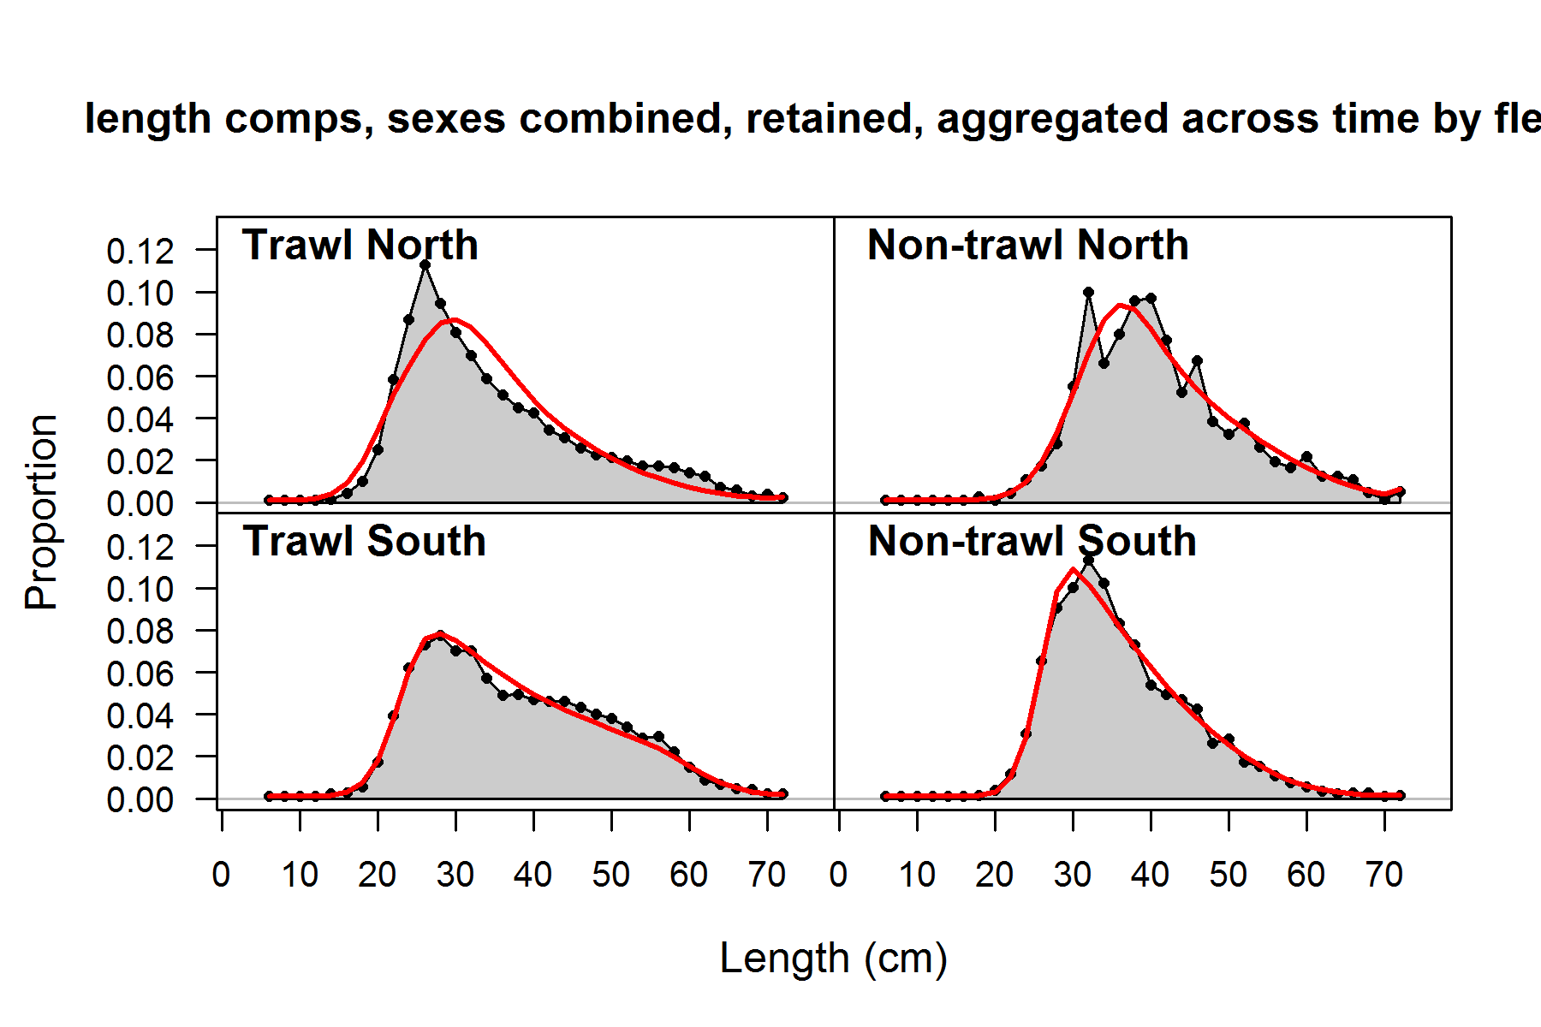

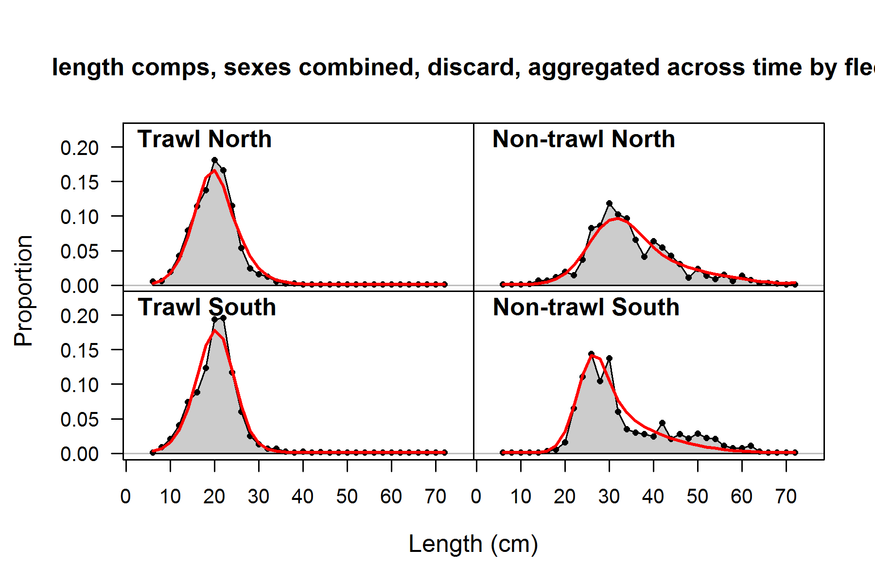

**Figure 25: Fits to fishery length compositions aggregated across all years for each fleet. Top panels show retained catch and bottom panels show discarded catch. Grey polygons indicate aggregated observed length compositions and red lines indicate aggregated model fit.**

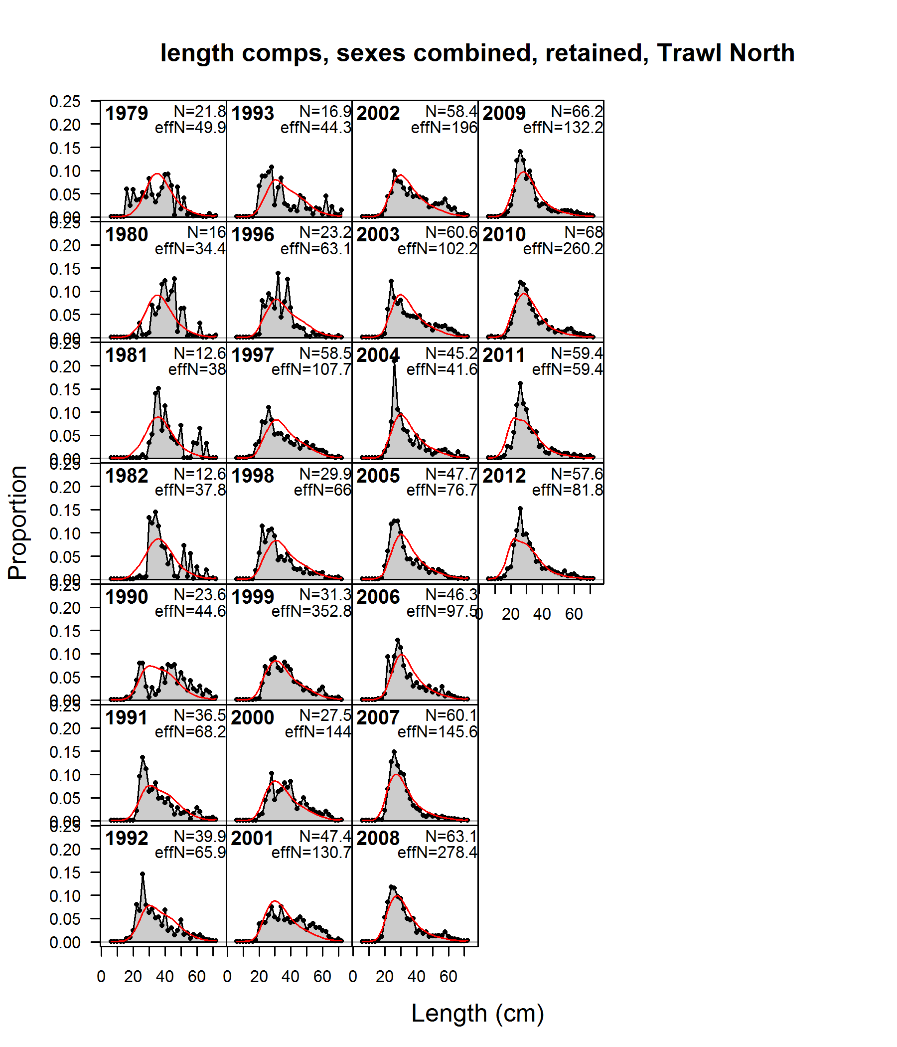 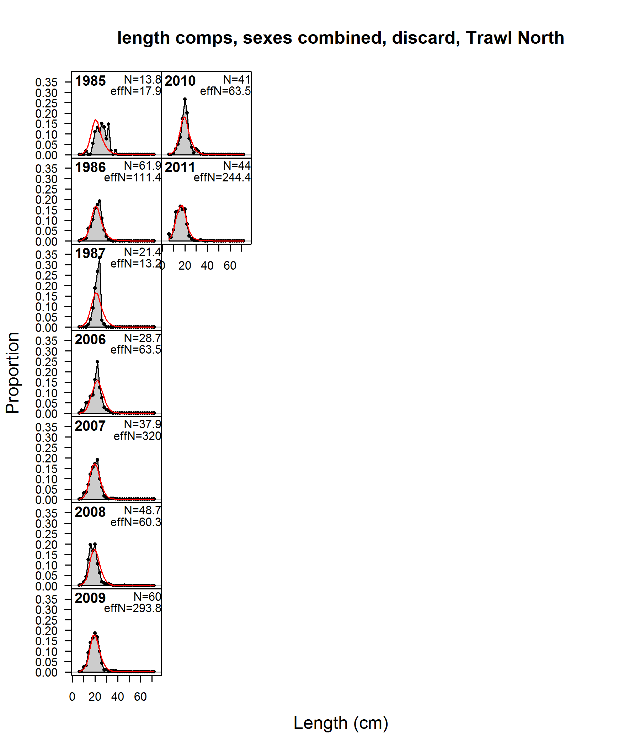

**Figure 26: Fits to fishery length compositions for the Trawl North fishery. Retained catch is shown for the years 1979–2012 in the panels on the left (with outliers in 1994–95 removed). Discards are shown for the years 1985–1987 and 2006–2011 in the panels on the right. Grey polygons indicate observed length compositions and red lines indicate model fit. Numeric values labeled “N” and “effN” indicate the input sample sizes and the estimated effective sample sizes associated with each composition.**

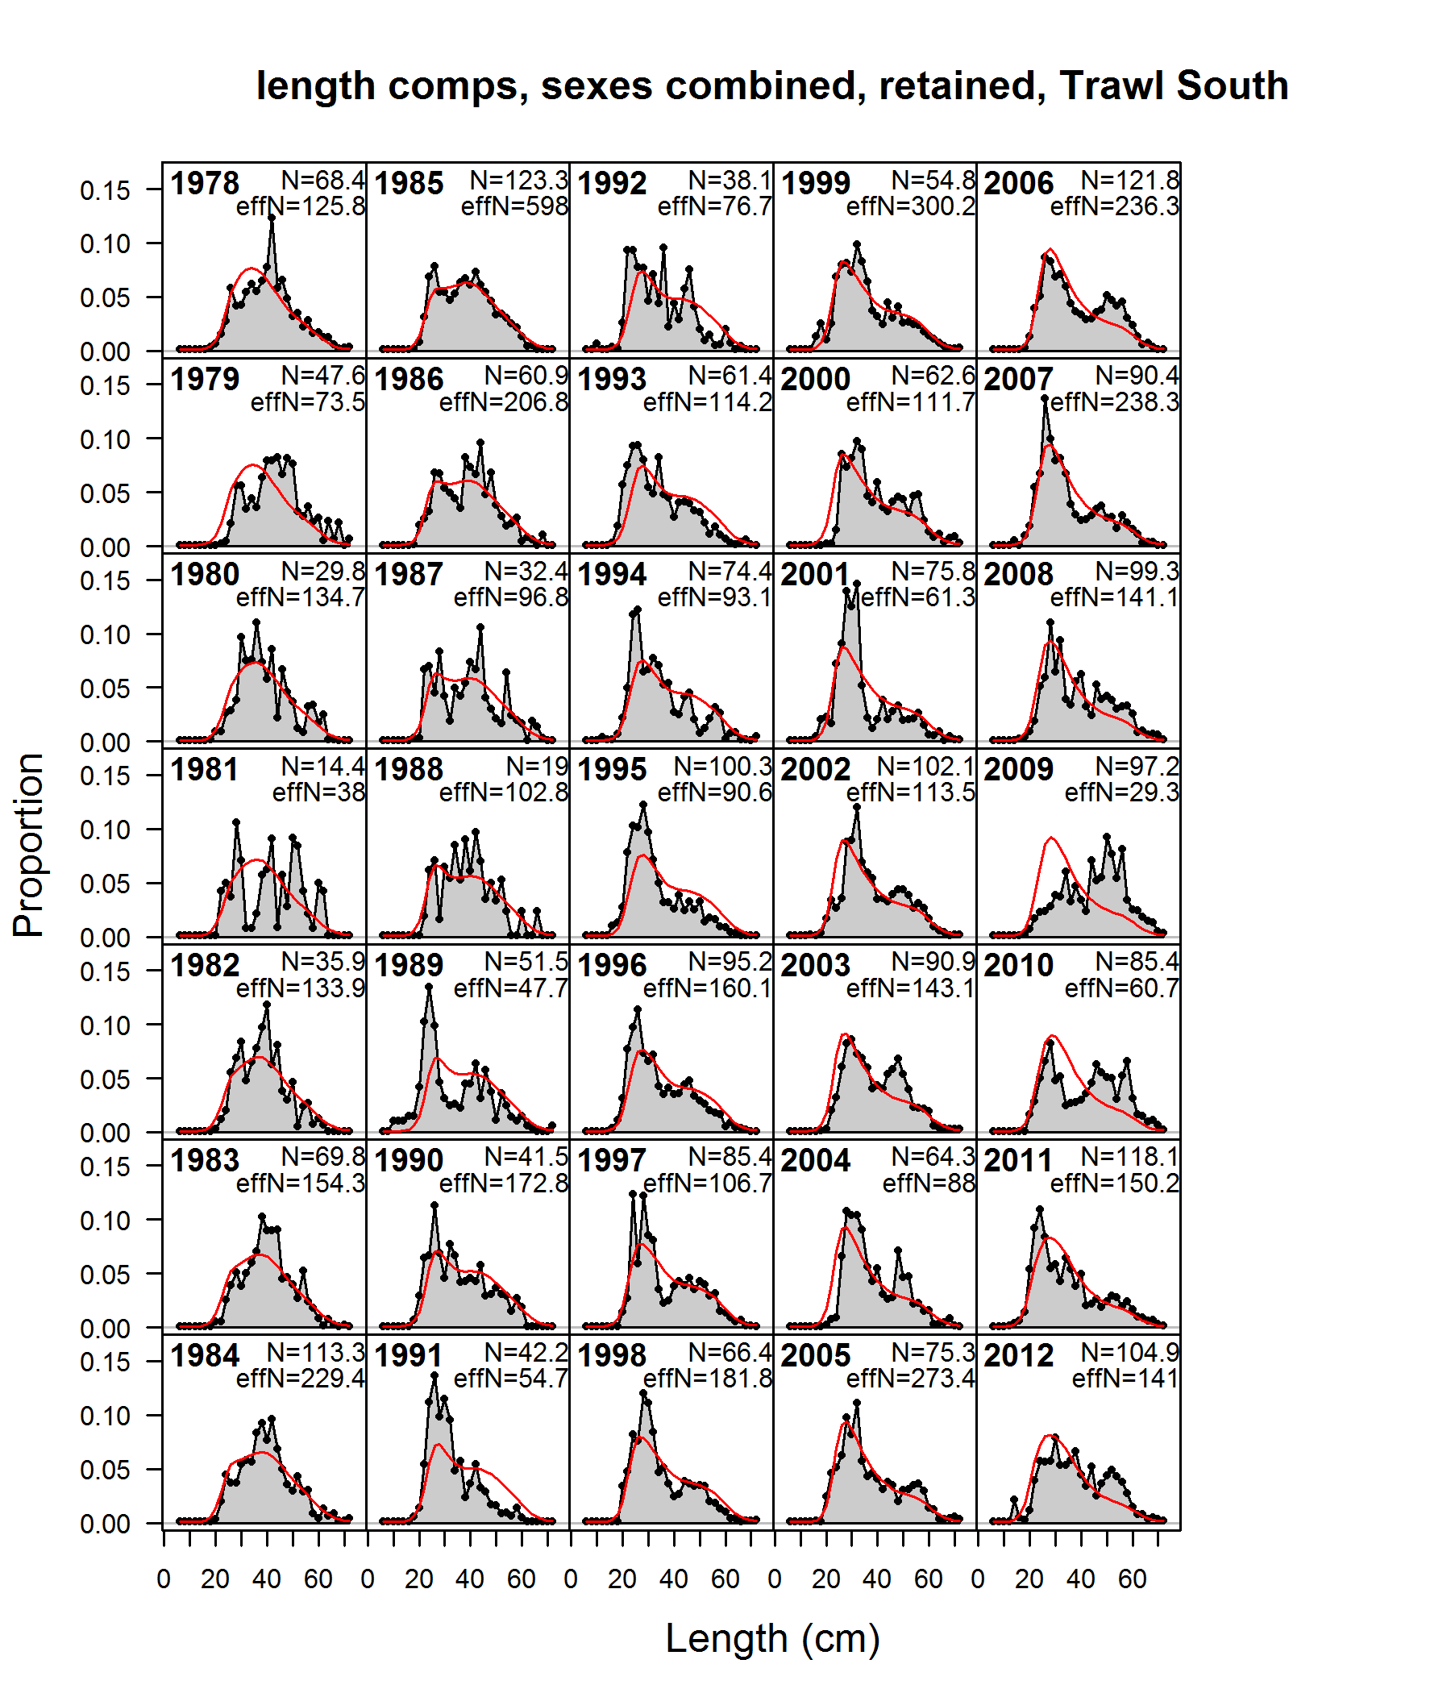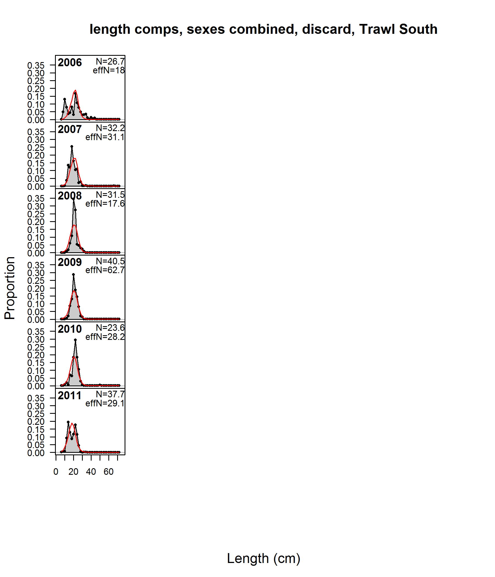

**Figure 27: Fits to fishery length compositions for the Trawl South fishery. Retained catch is shown for the years 1978–2012 in the panels on the left. Discards are shown for the years 2006–2011 in the panels on the right. Plot details are provided under Figure 26.**

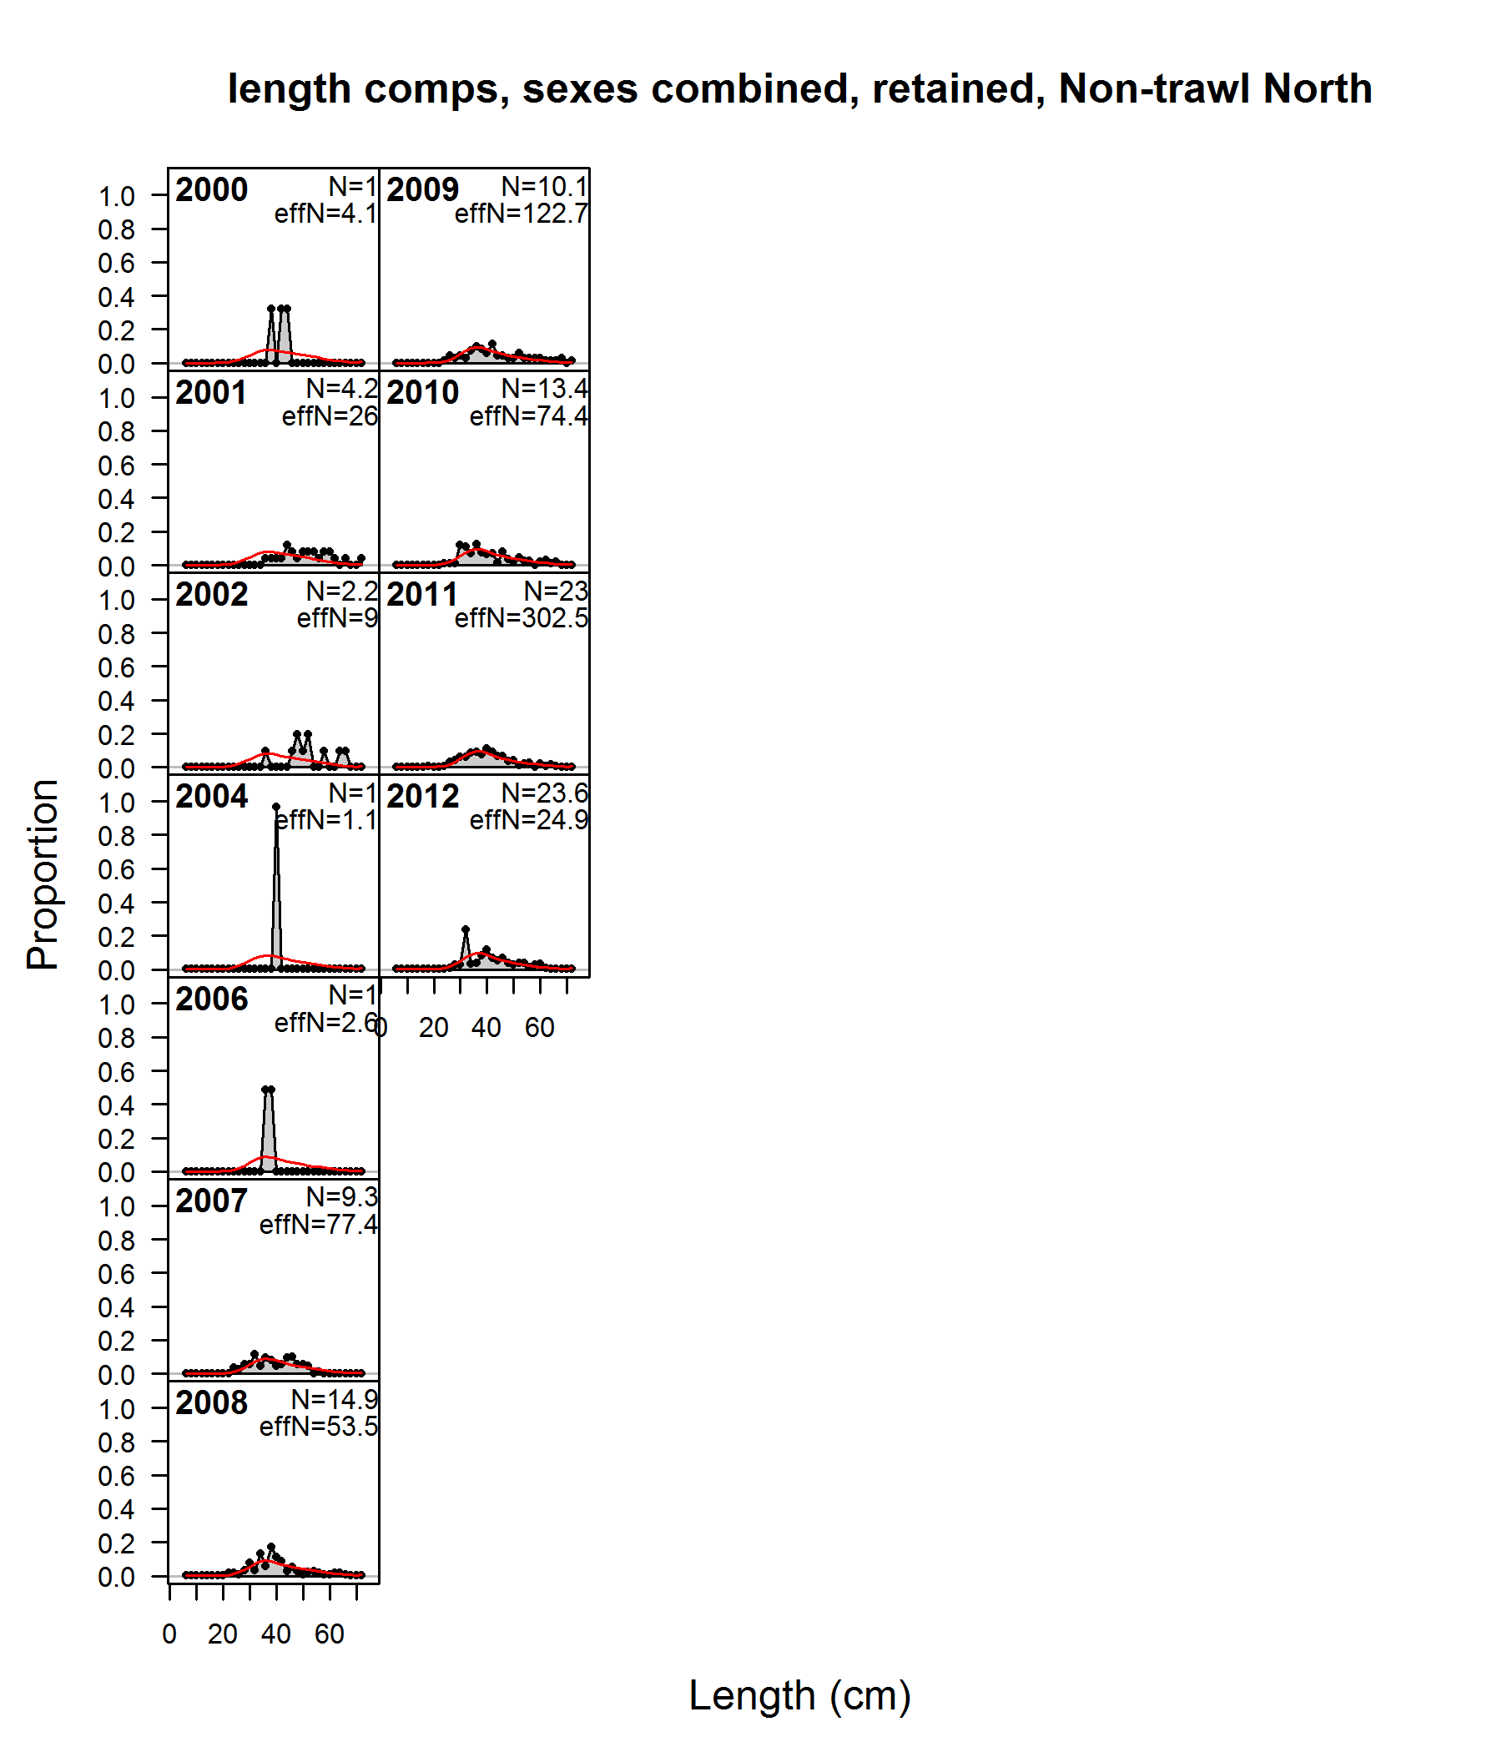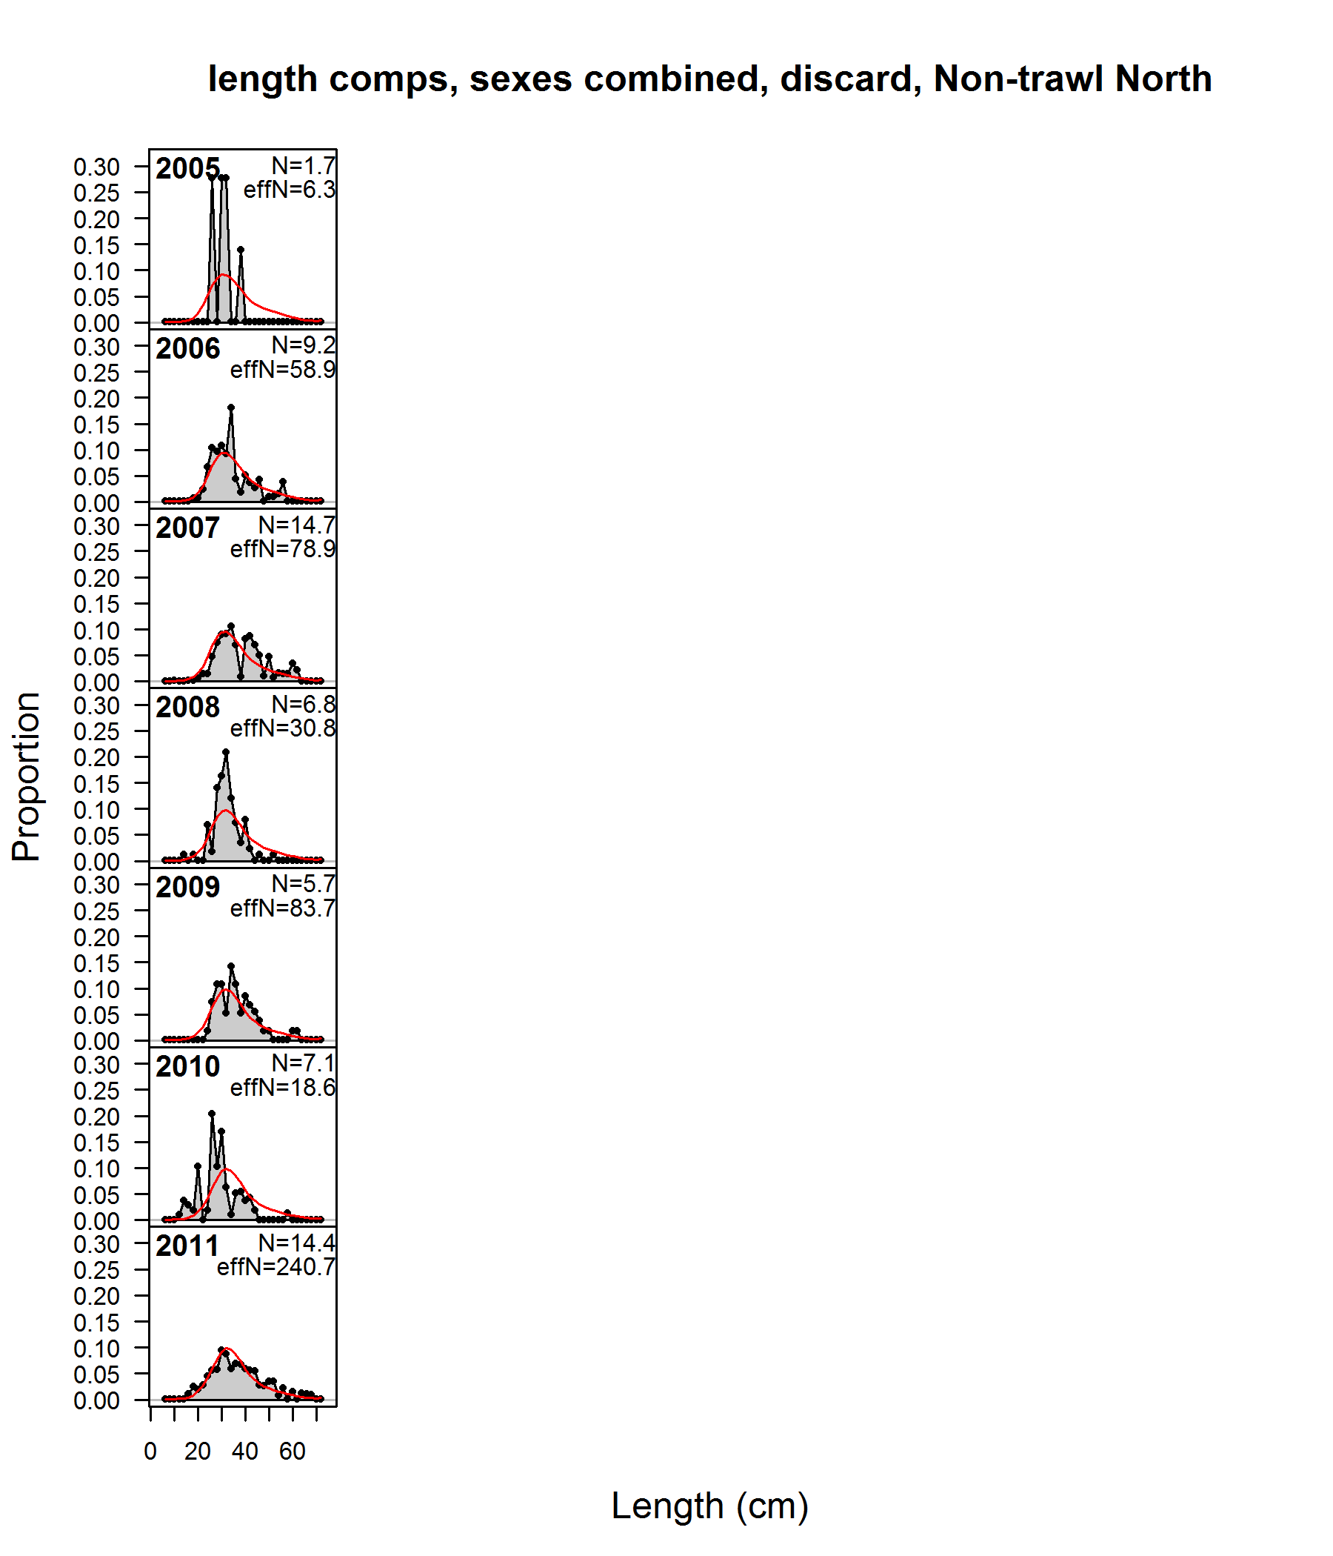

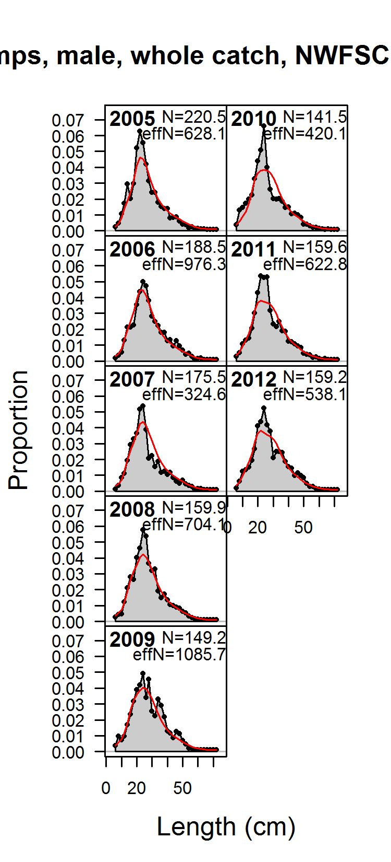

**Figure 28: Fits to fishery length compositions for the Non-Trawl North fishery. Retained catch is shown for the years 2000–2012 (no data for 2003 or 2005) in the panels on the left. Discards are shown for the years 2005–2011 in the panels on the right. Plot details are provided under Figure 26.**

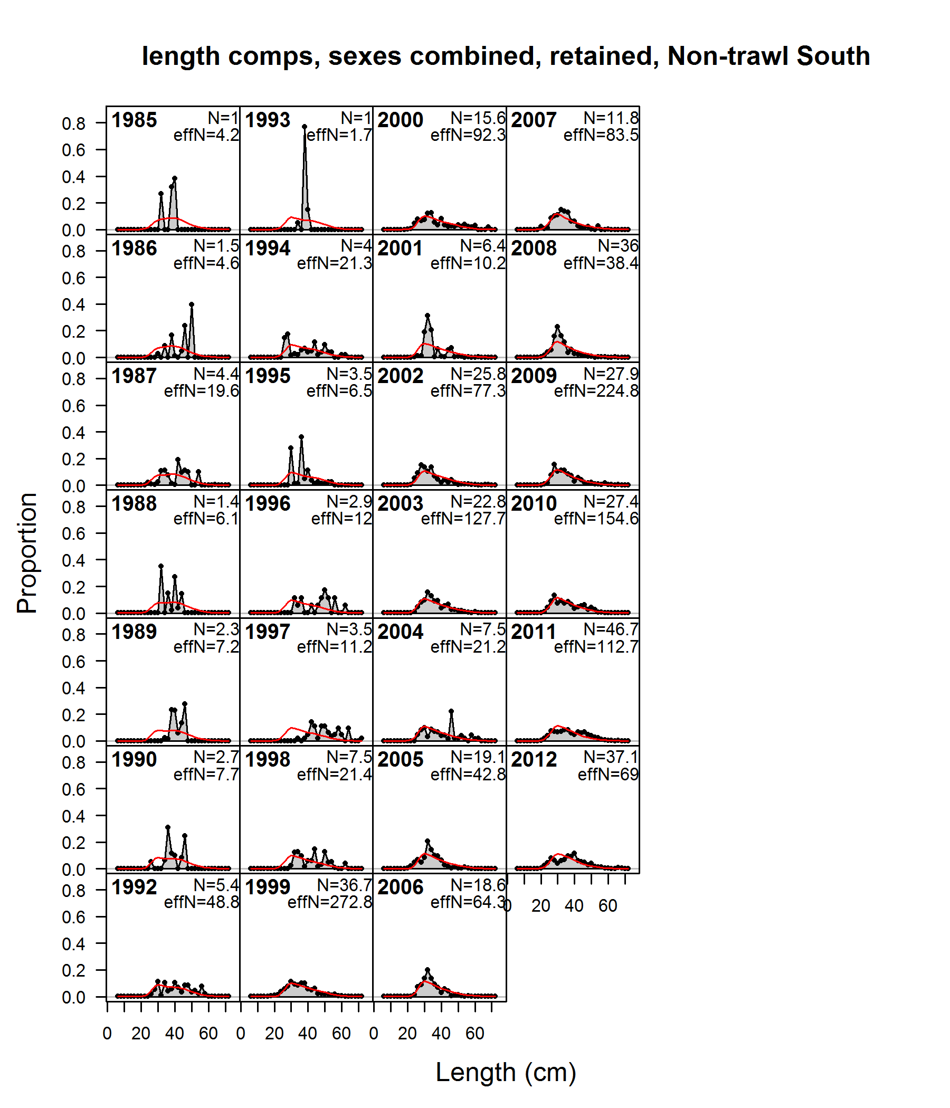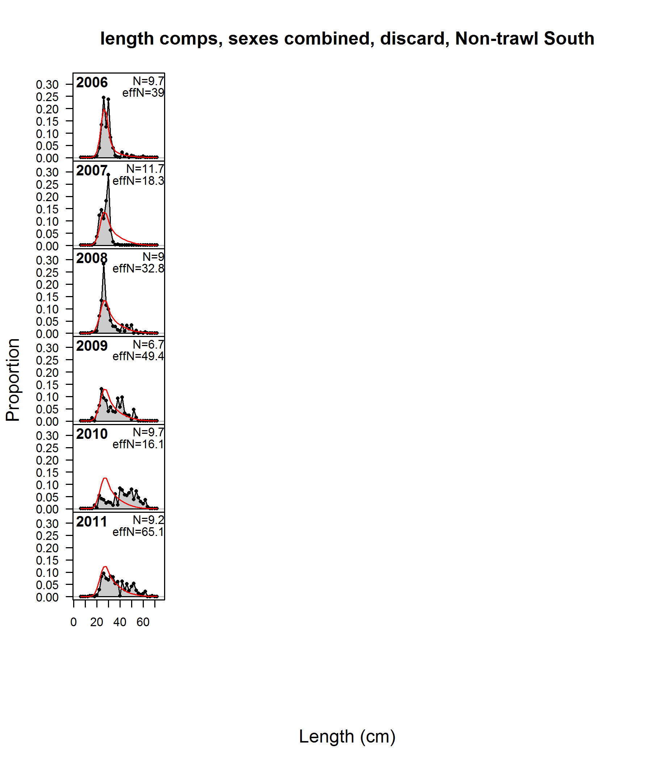

**Figure 29: Fits to fishery length compositions for the Non-Trawl North fishery. Retained catch is shown for the years 1985–2012 (no data for 1991) in the panels on the left. Discards are shown for the years 2006–2011 in the panels on the right. Plot details are provided under Figure 26.**

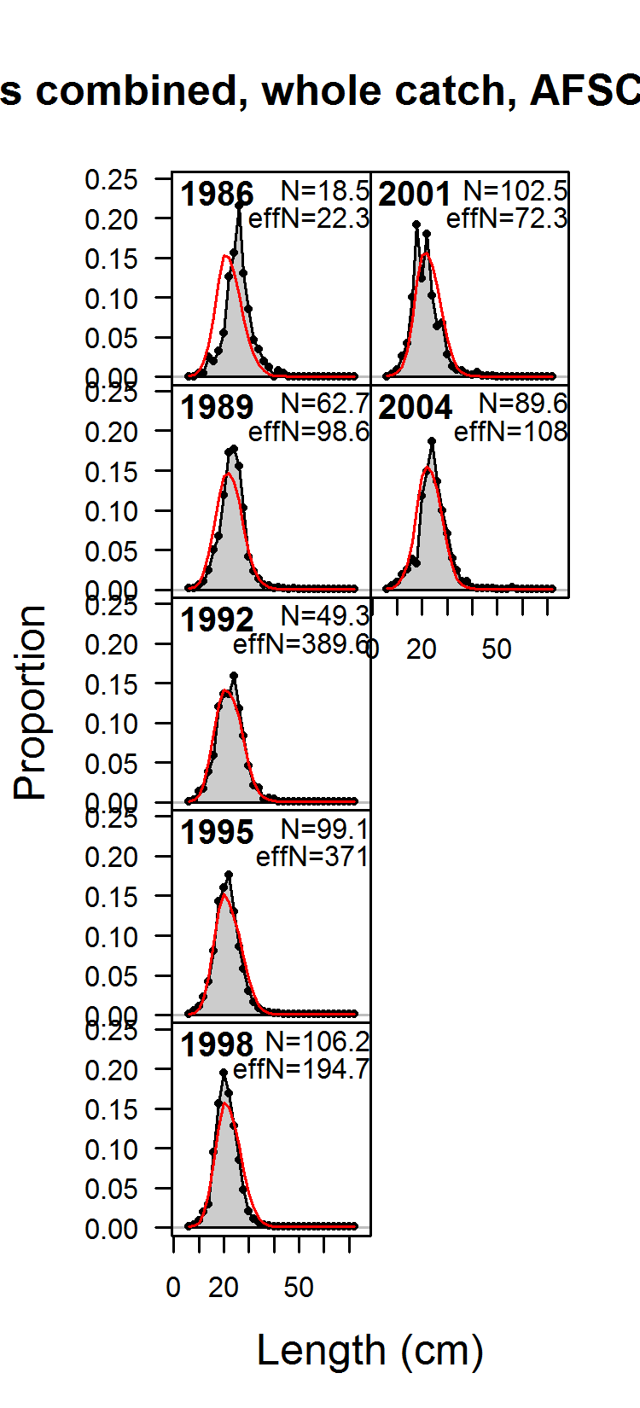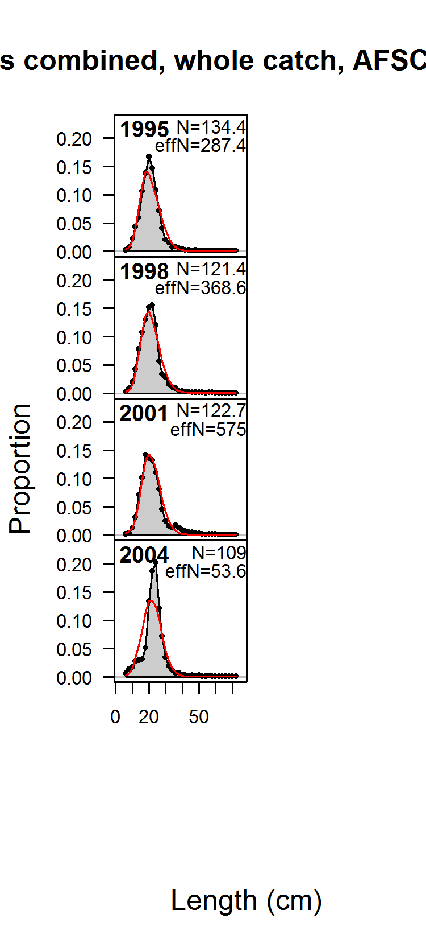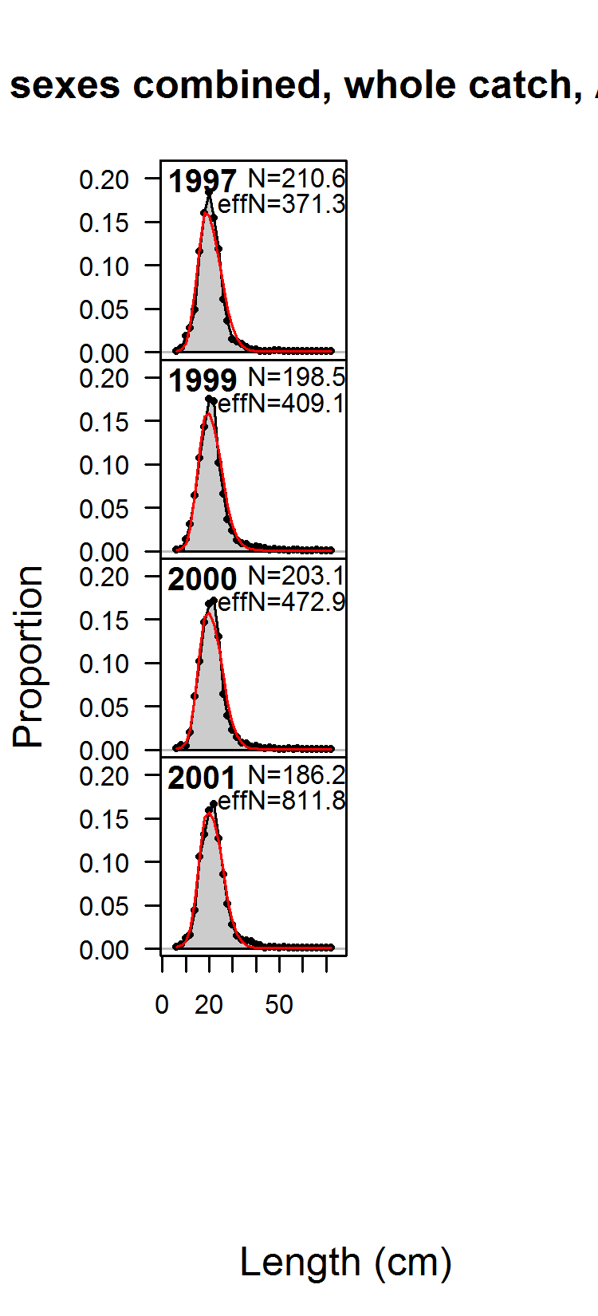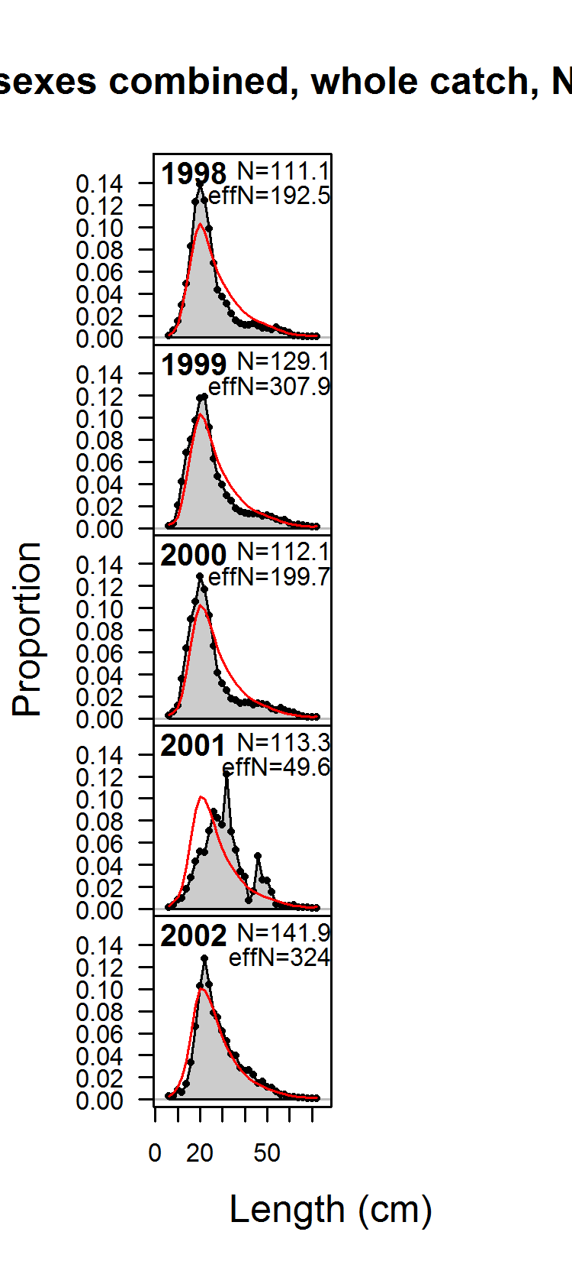

**Figure 30: Fits to survey length compositions for the AFSC Triennial Survey 1 (far left, 1986–2004, samples from 1980 and 1983 not shown), AFSC Triennial Survey 2 (center-left, 1995–2004), AFSC Slope Survey (center-right, 1997–2001) and NWFSC Slope Survey (far right, 1998–2002). Plot details are provided under Figure 26.**

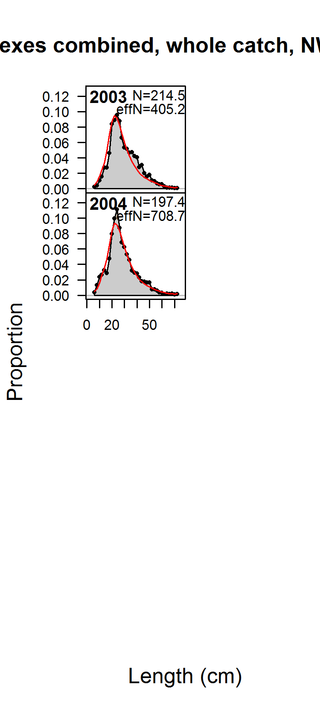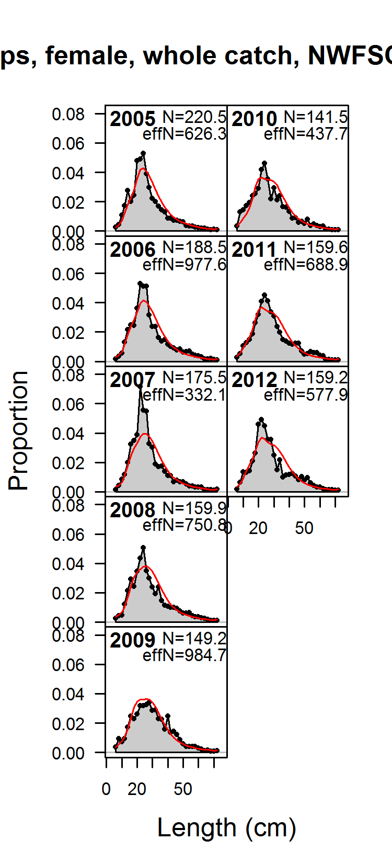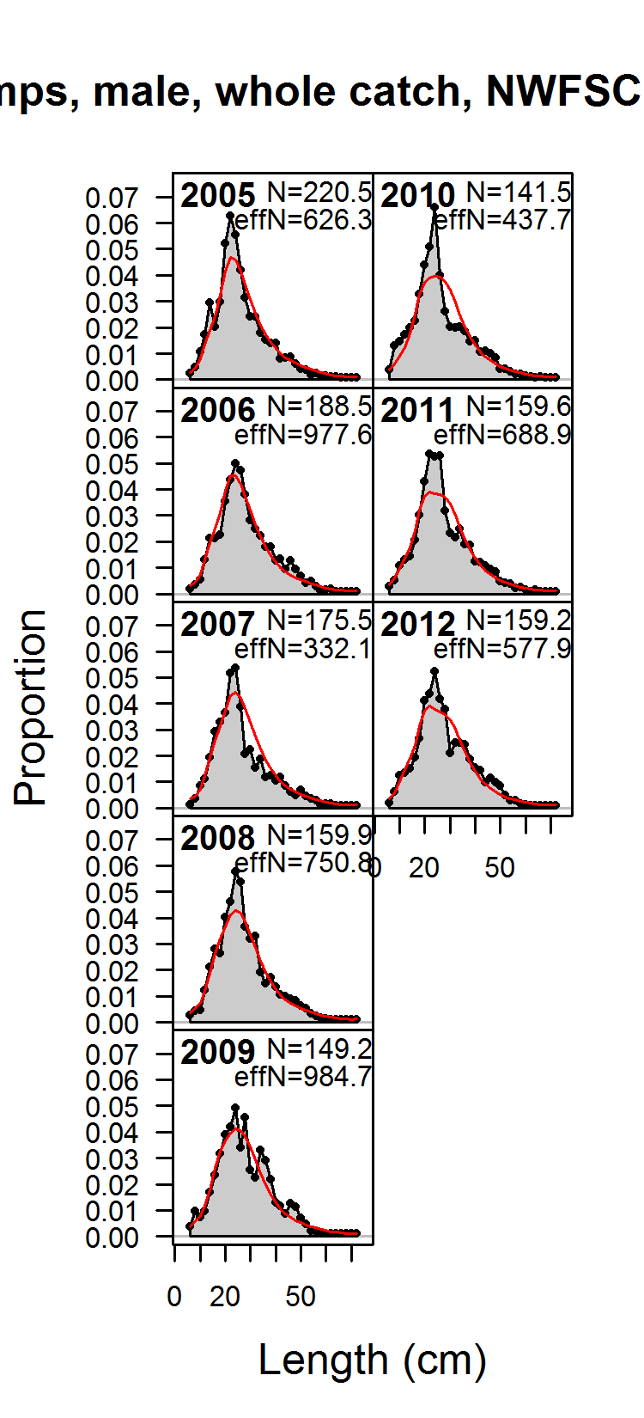



**Figure 31: Fits to survey length compositions for combined sexes (left) females (center) and males (right) for the NWFSC Combo Survey.**

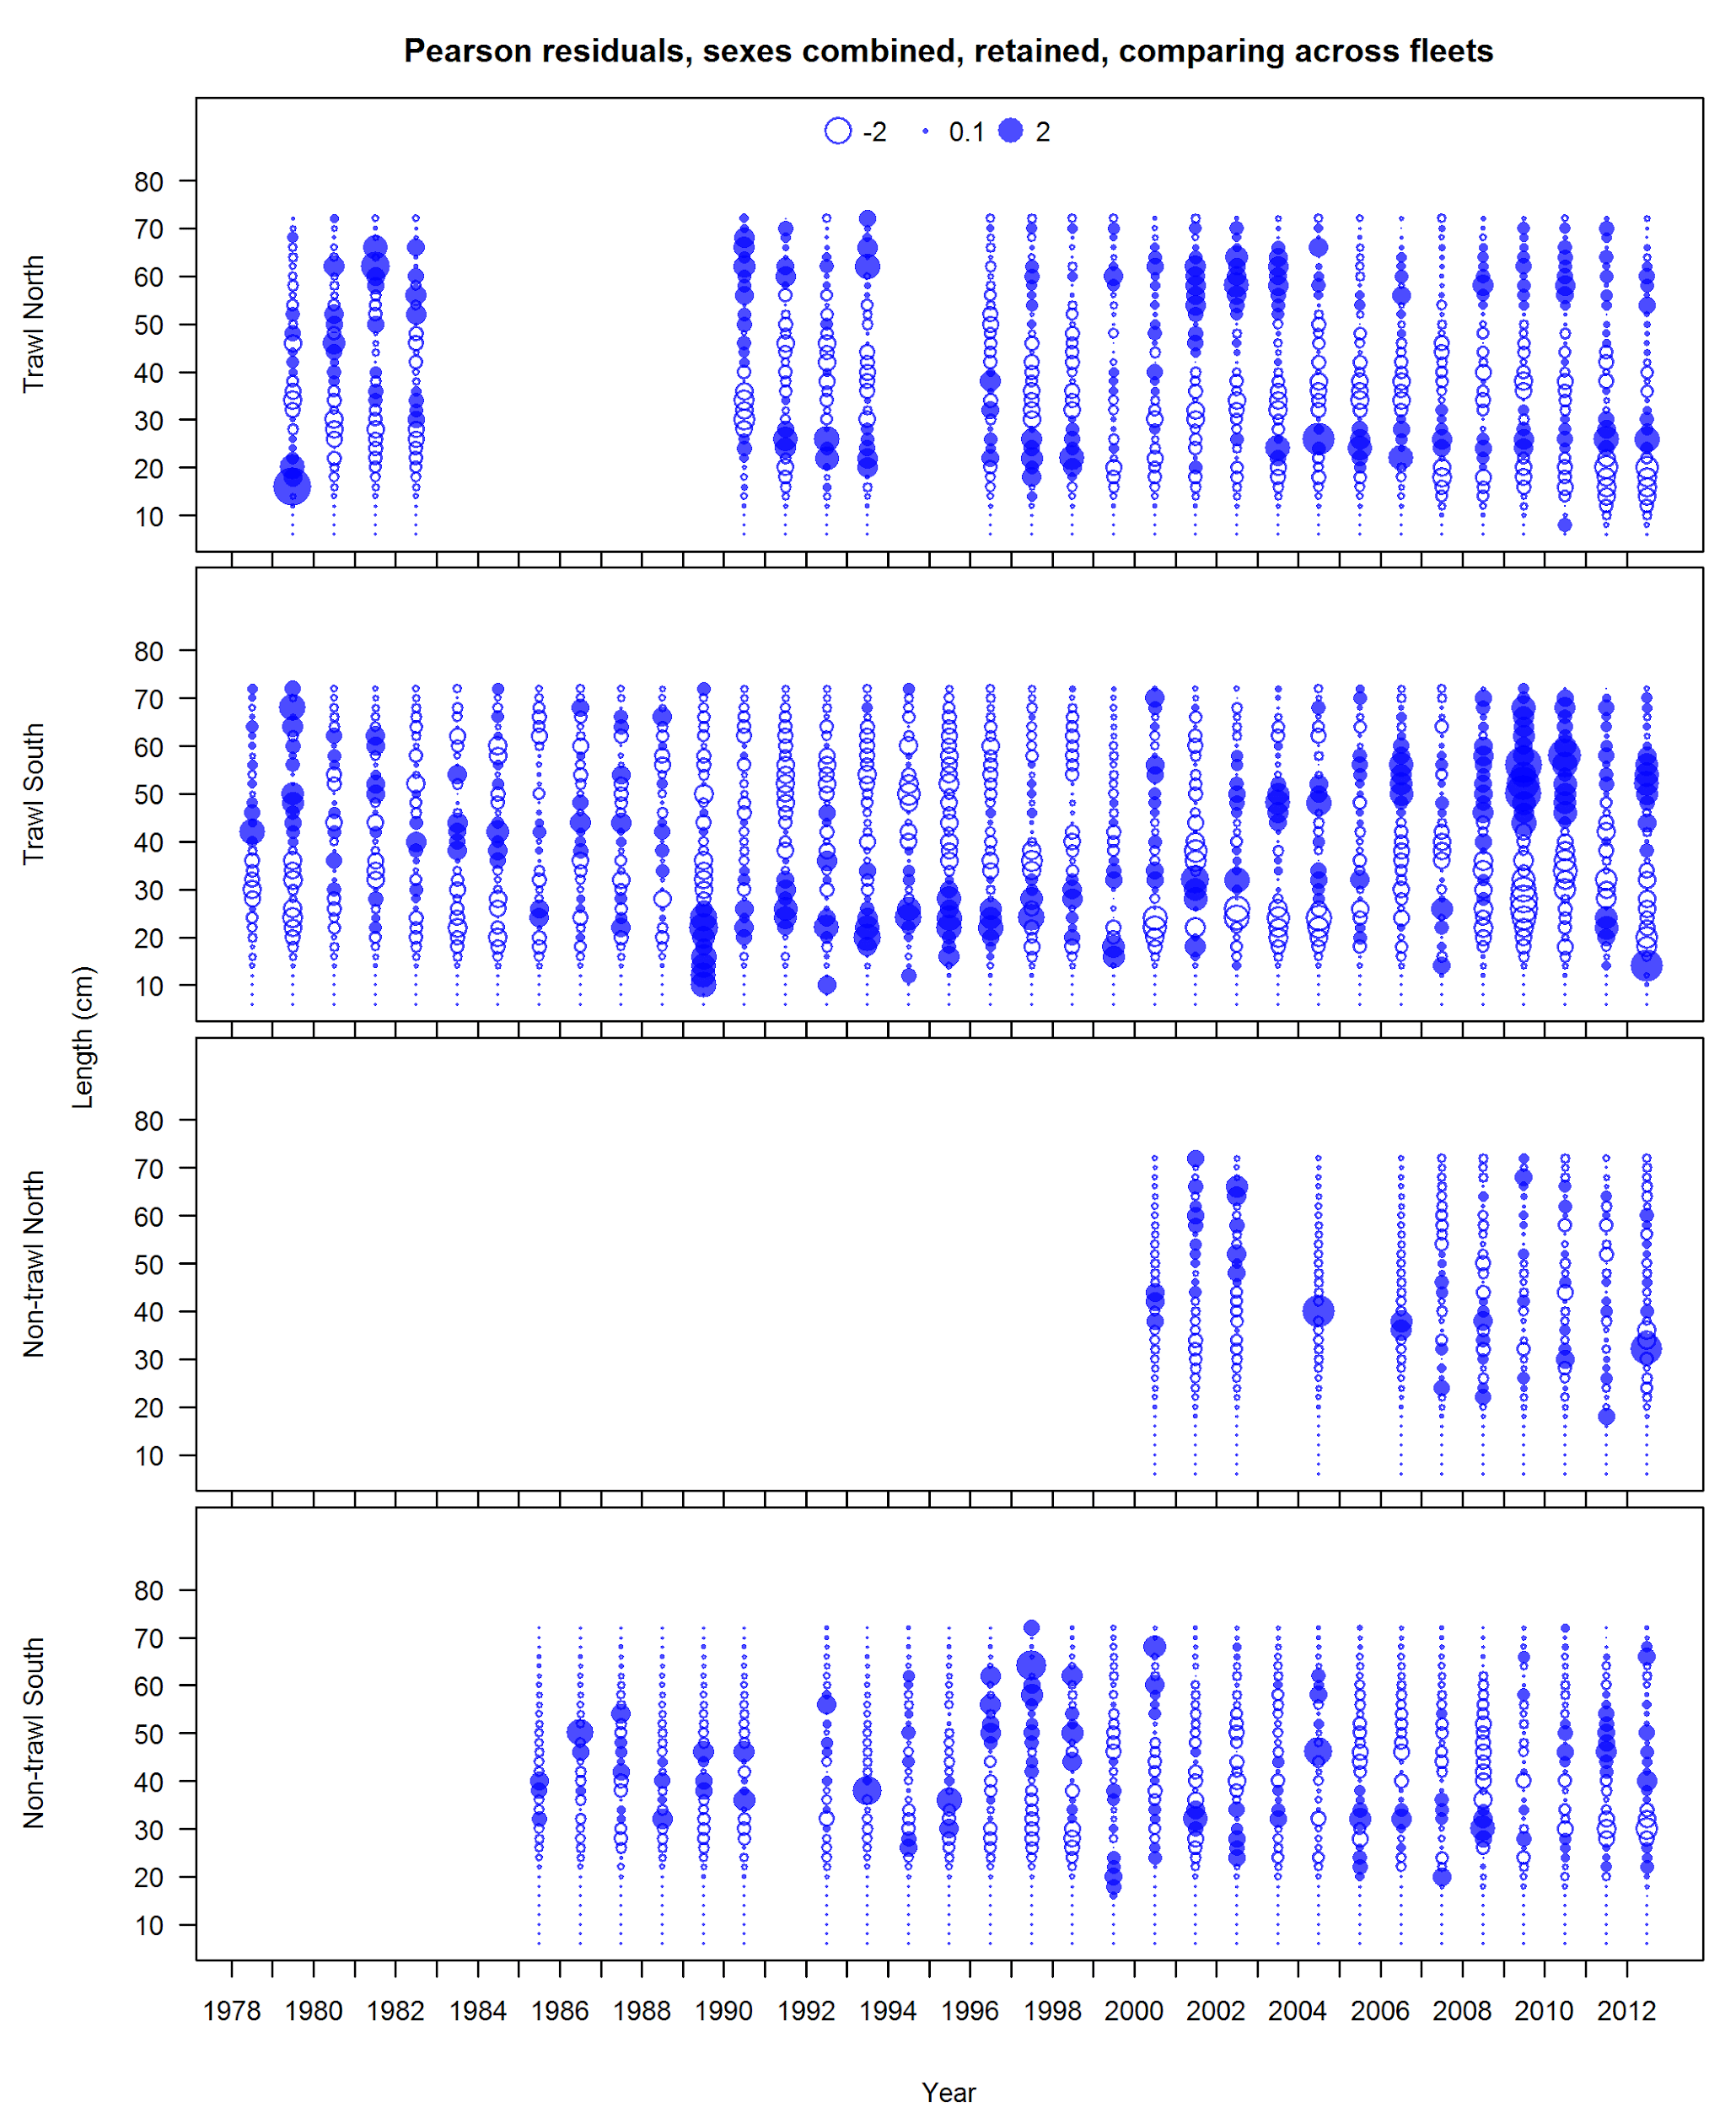

**Figure 32: Pearson residuals for fits to fishery length compositions calculated from landed catch. Bubble sizes indicate proportion in each length bin. Sexes are combined. Closed circles represent observations that are larger than the expectation.**

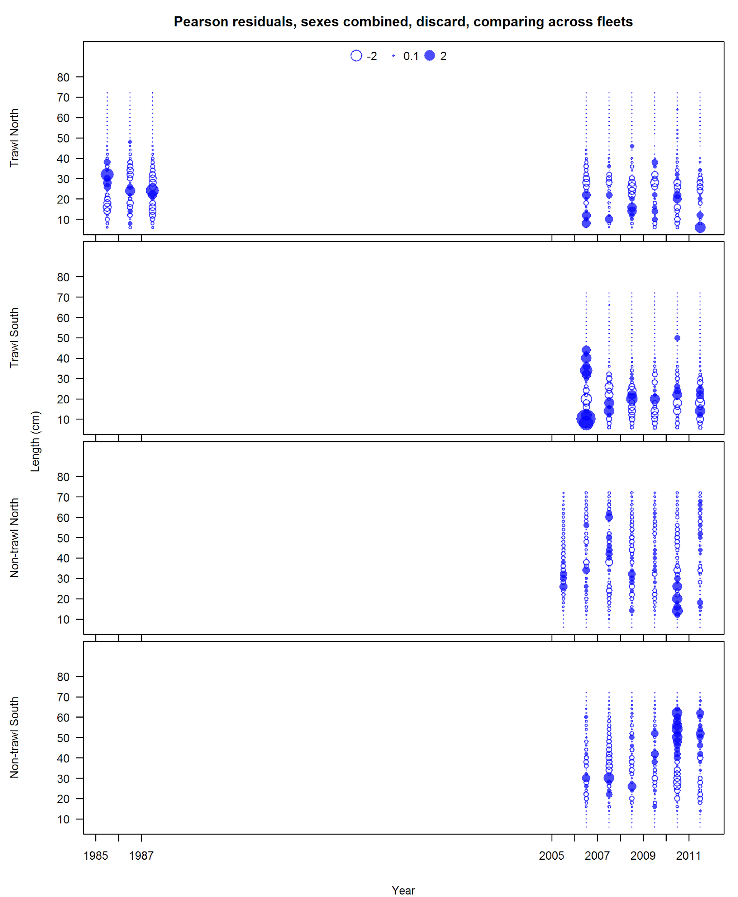

**Figure 33: Pearson residuals for fits to fishery length compositions calculated from discards. Sexes are combined. Closed circles represent observations that are larger than the expectation.**

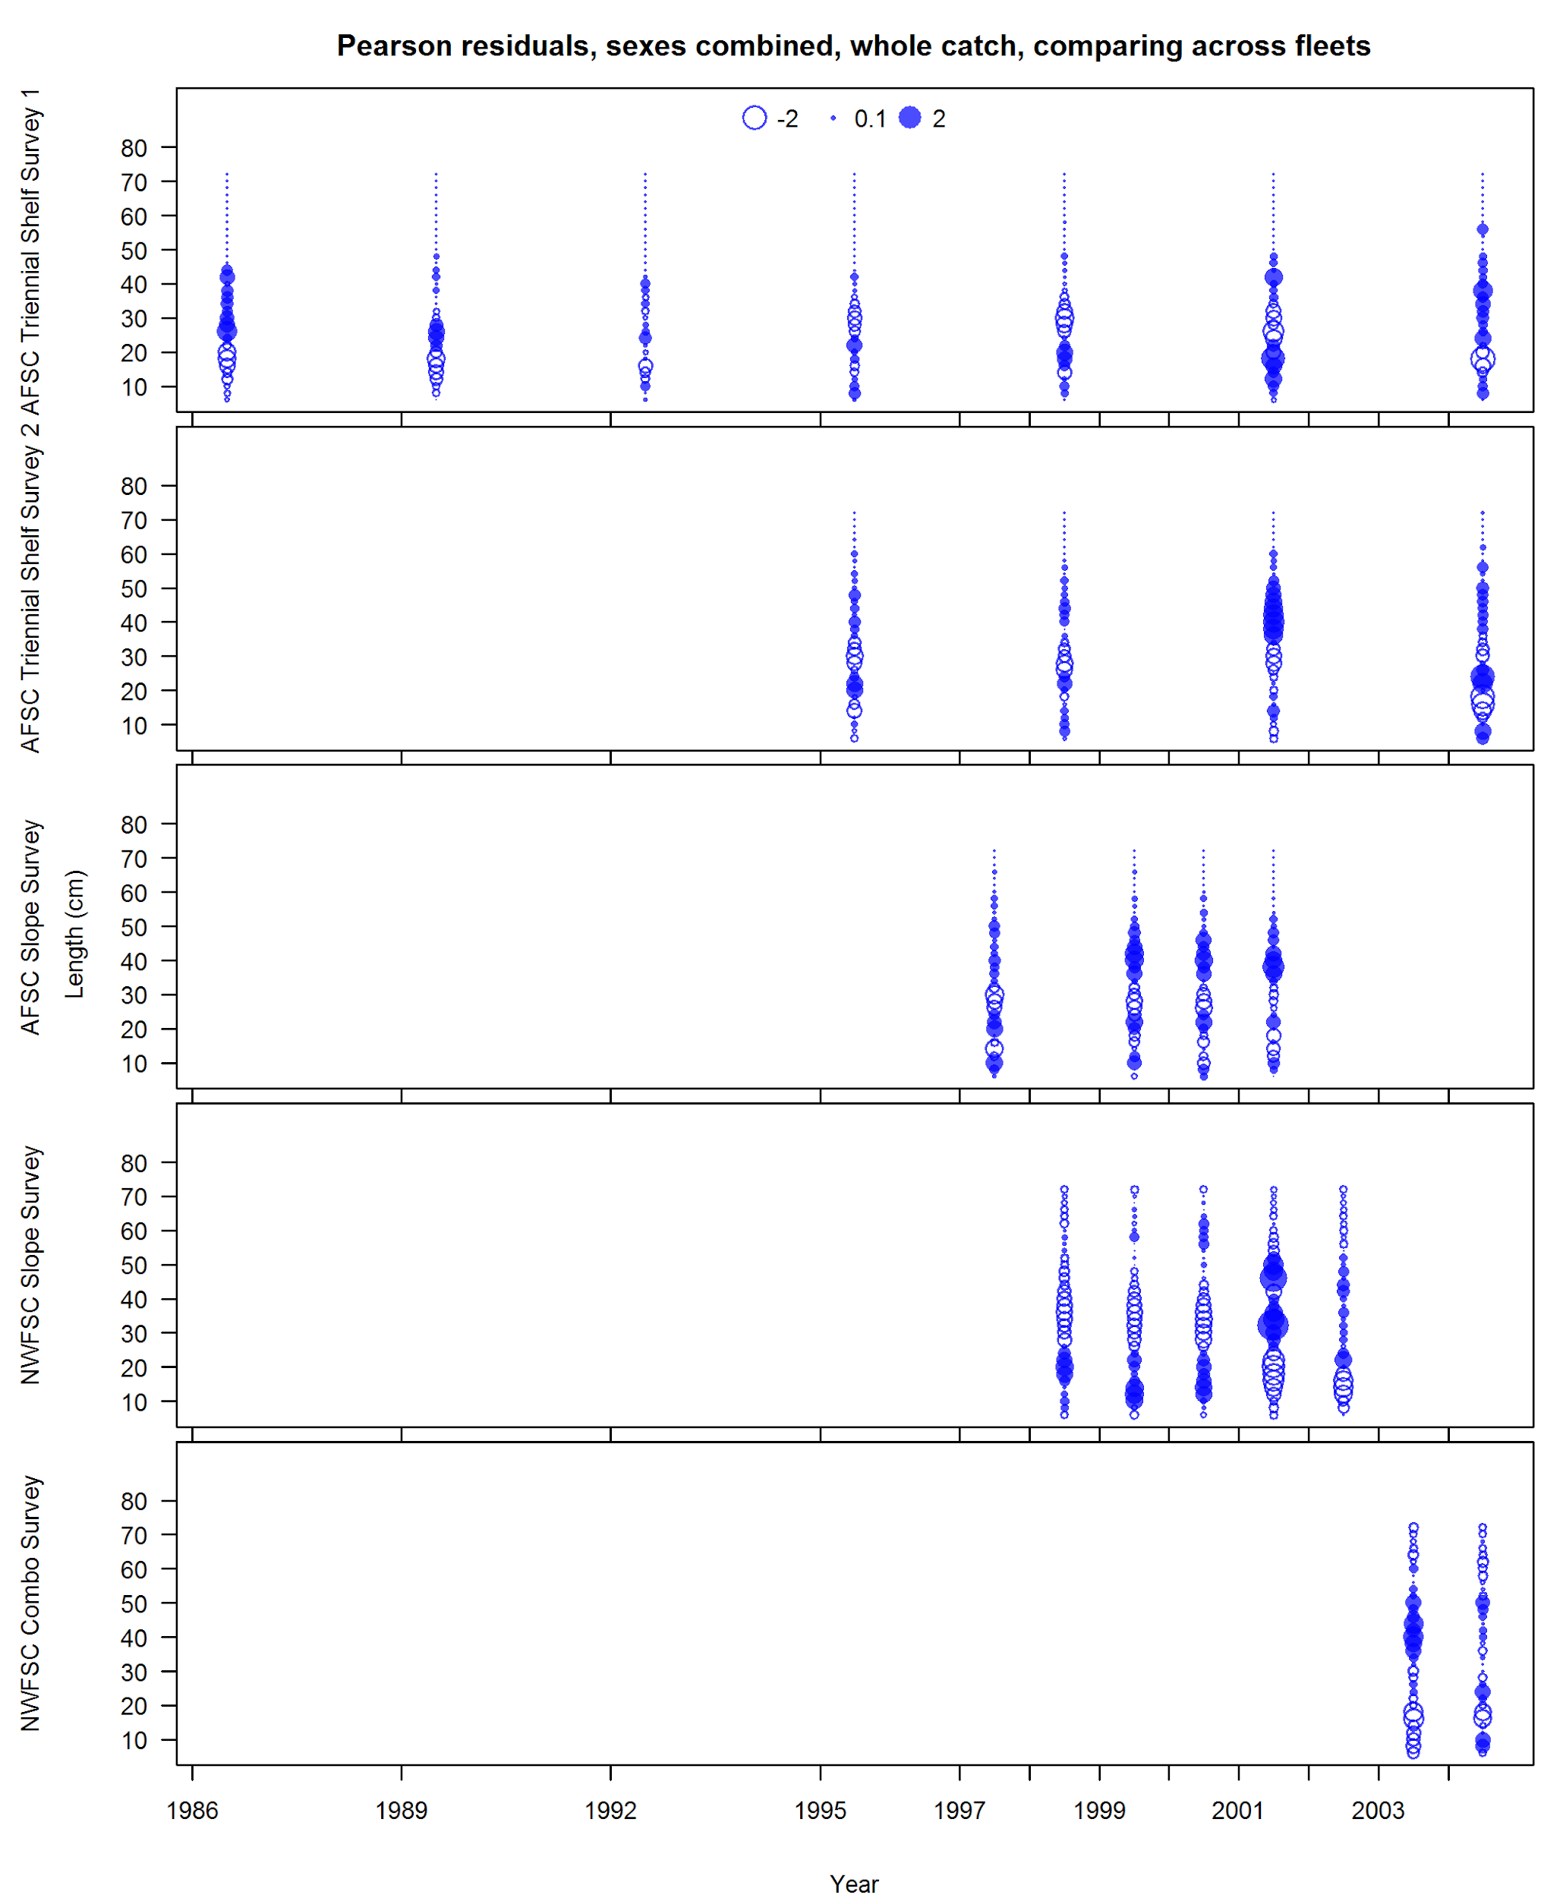

**Figure 34: Pearson residuals for fits to survey length compositions for years with combined sex data. Closed circles represent observations that are larger than the expectation.**

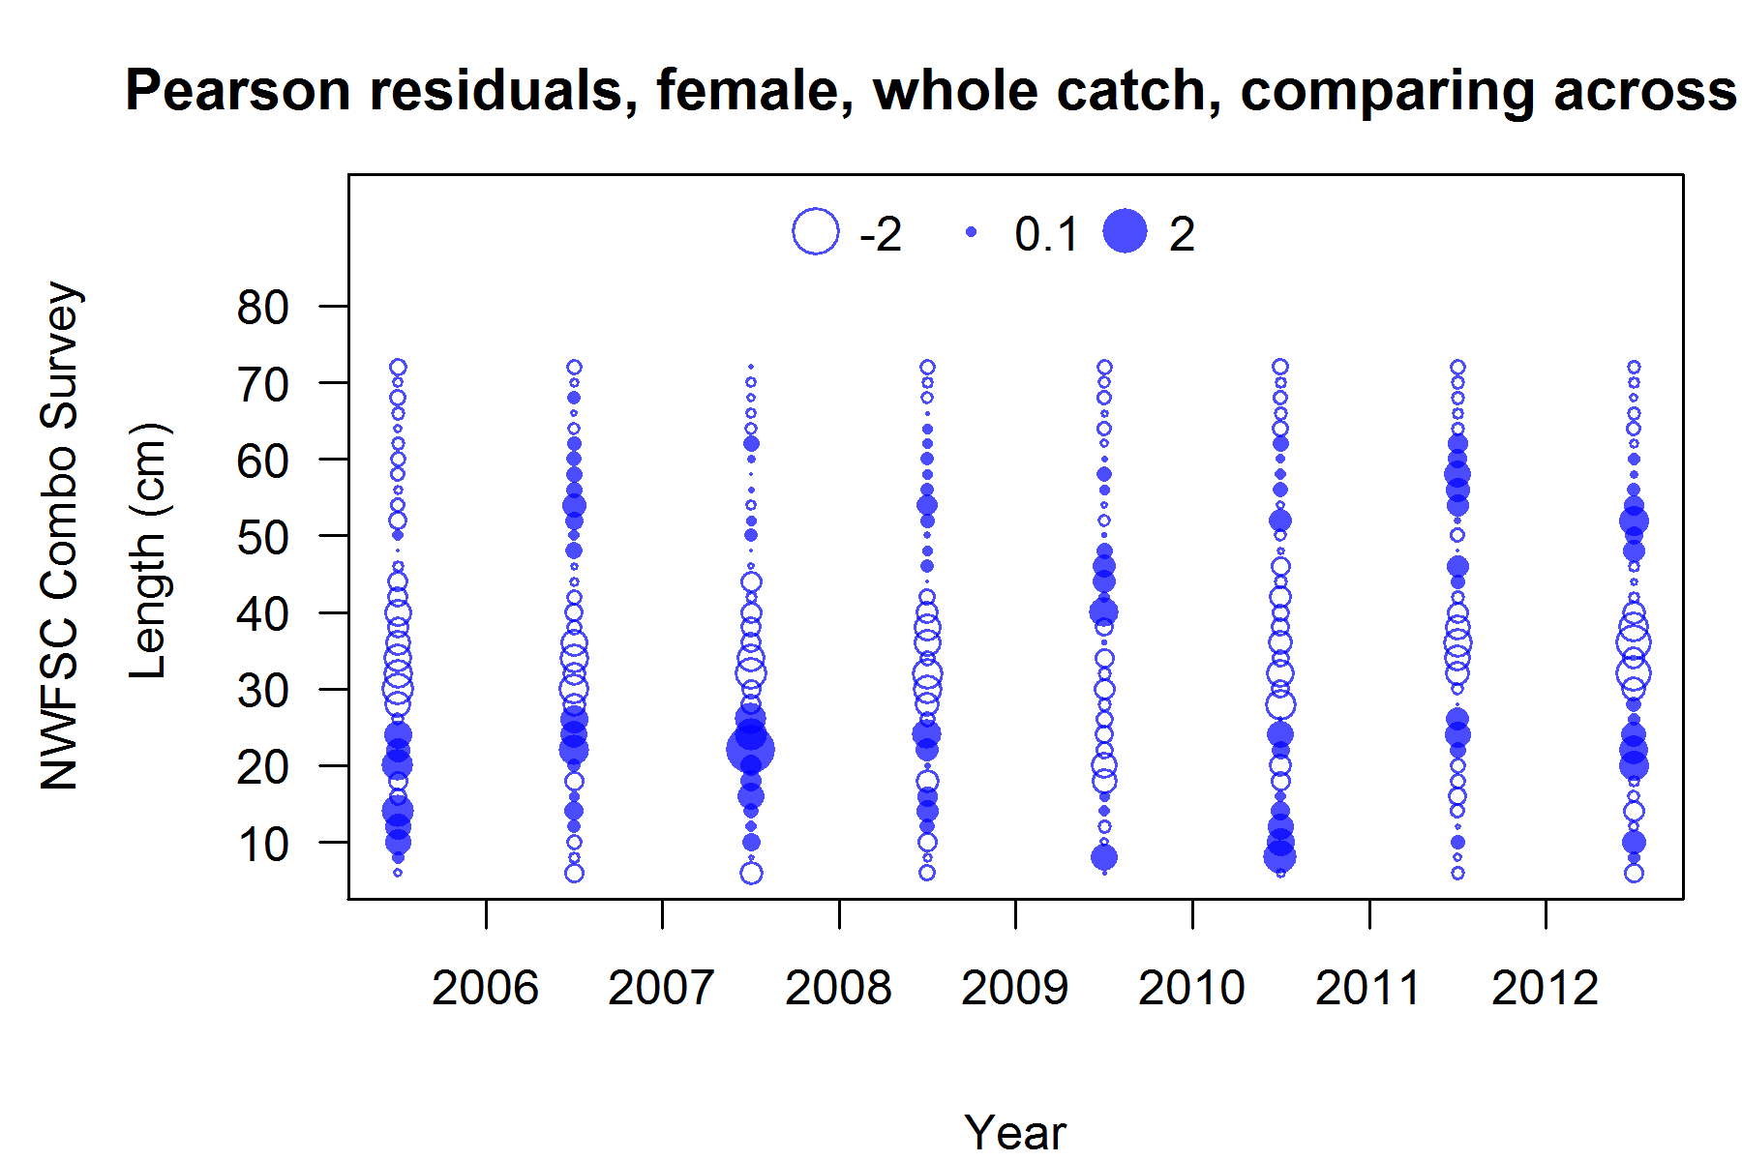

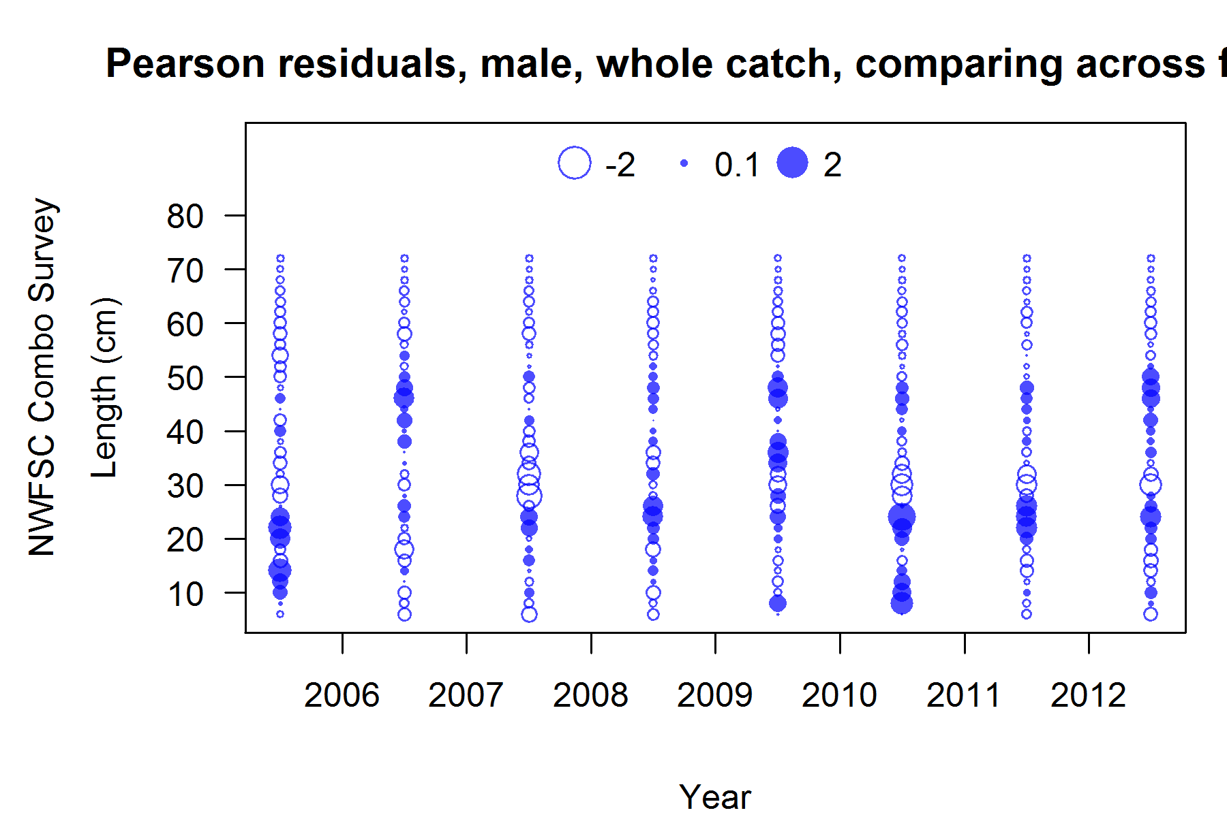

**Figure 35: Pearson residuals for fits to survey length compositions for females (top) and males (bottom) for the NWFSC Combo Survey. Closed circles represent observations that are larger than the expectation.**

## Model results

### Base model results



**Figure 36: Trajectory of spawning biomass. The disconnected point at the left represents the unfished equilibrium estimate and its associated uncertainty.**



**Figure 37: Estimated relative depletion with approximate 95% asymptotic confidence intervals (shaded area) for the base case assessment model.**



**Figure 38: Time series of recruitment. The disconnected point at the left represents the unfished equilibrium estimate and its associated uncertainty.**

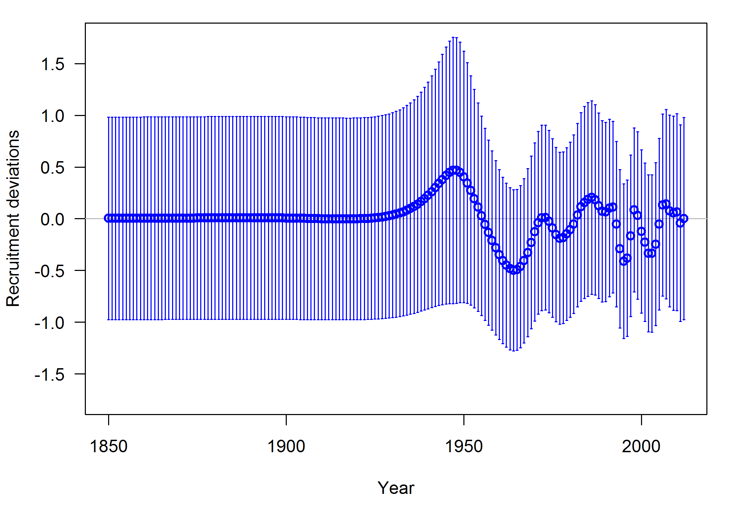

**Figure 39: Time series of recruitment deviations with 95% intervals. Circles represent the difference between estimated recruitment and the expectation associated with the stock-recruit relationship on a log scale.**

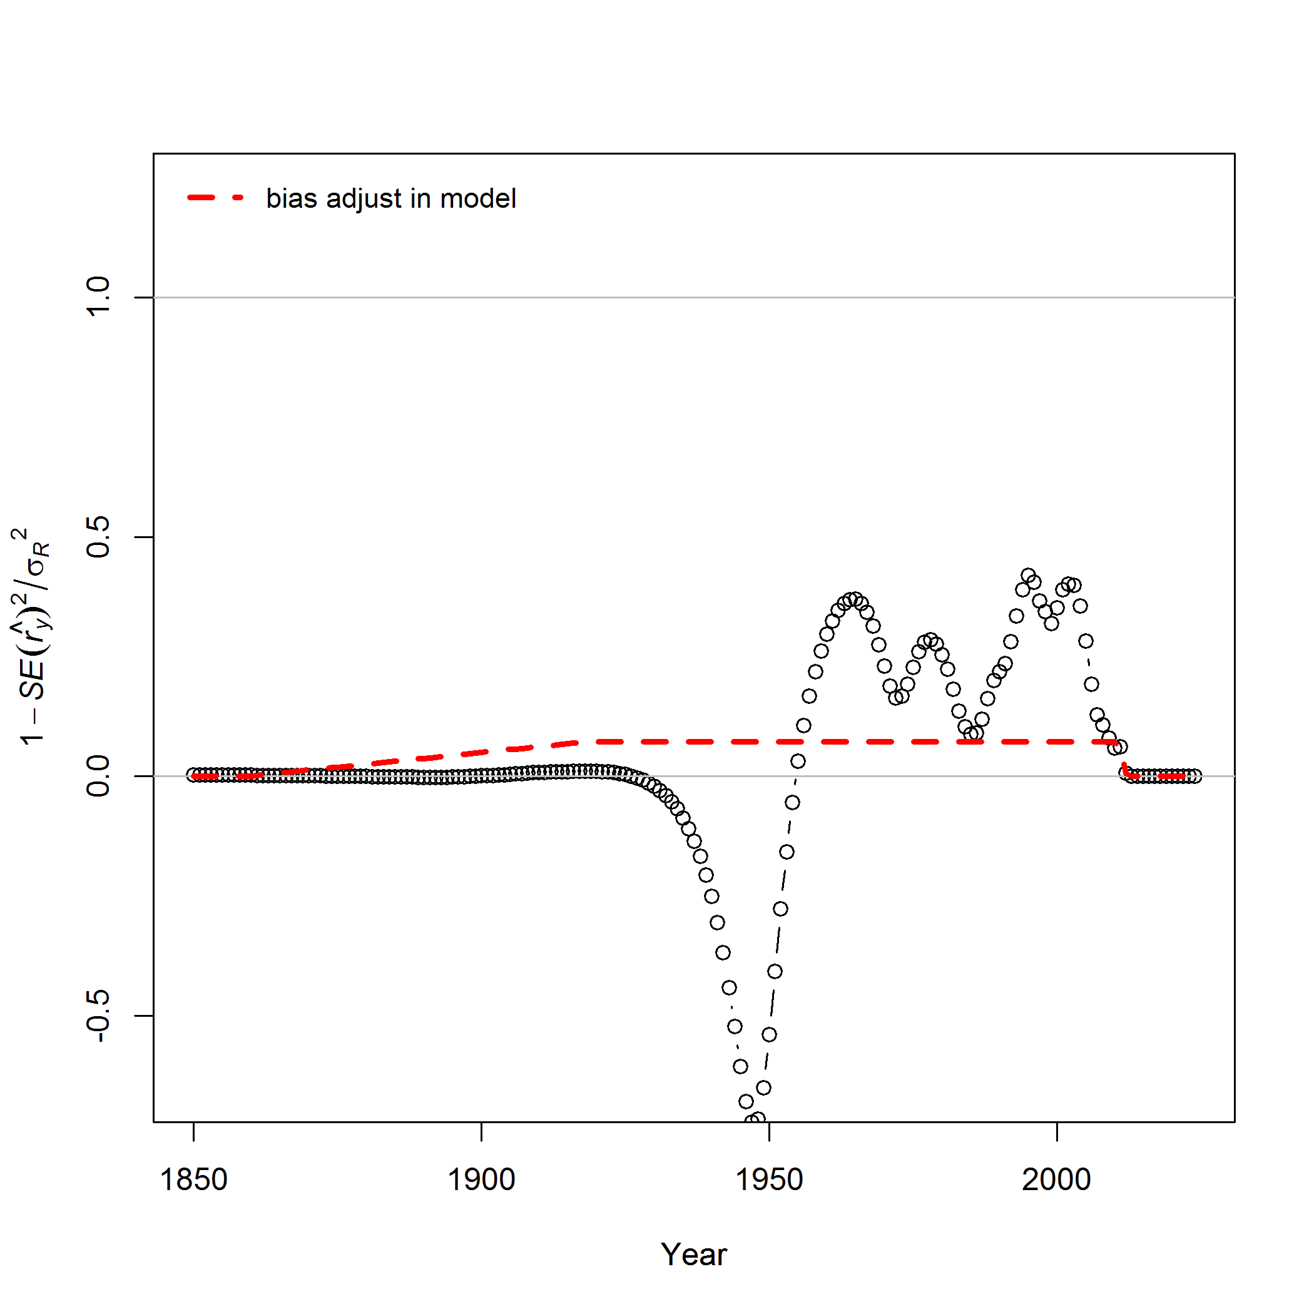

**Figure 40: Transformed recruitment deviation uncertainty estimates used to adjust for differences between median and mean of the lognormal distribution of recruitment.**



**Figure 41: Time-series of estimated summary harvest rate (total catch divided by age-1 and older biomass) for the base case model (round points) with approximate 95% asymptotic confidence intervals (grey lines).**



**Figure 42: Estimated spawning potential ratio (SPR) for the base case model with approximate 95% asymptotic confidence intervals. Both one minus SPR (right y-axis) and the ratio of this quantity to the associated target (1 - SPR50%) (left y-axis) are indicated. These quantities are chosen so that higher exploitation rates occur on the upper portion of the y-axis. The management target is plotted as red horizontal line and values above this reflect harvests in excess of the overfishing proxy based on the SPR50%.**



**Figure 43: Phase plot of estimated relative (1-SPR) vs. relative spawning biomass for the base case model. The relative (1-SPR) is (1-SPR) divided by 50% (the SPR target). Relative depletion is the annual spawning biomass divided by the spawning biomass corresponding to 50% of the unfished spawning biomass. The red point indicates the year 2012.**



**Figure 44: Equilibrium yield curve (derived from reference point values reported in Table 12) for the base case model. Values are based on 2012 relative catch among fleets. The depletion is relative to unfished spawning biomass.**

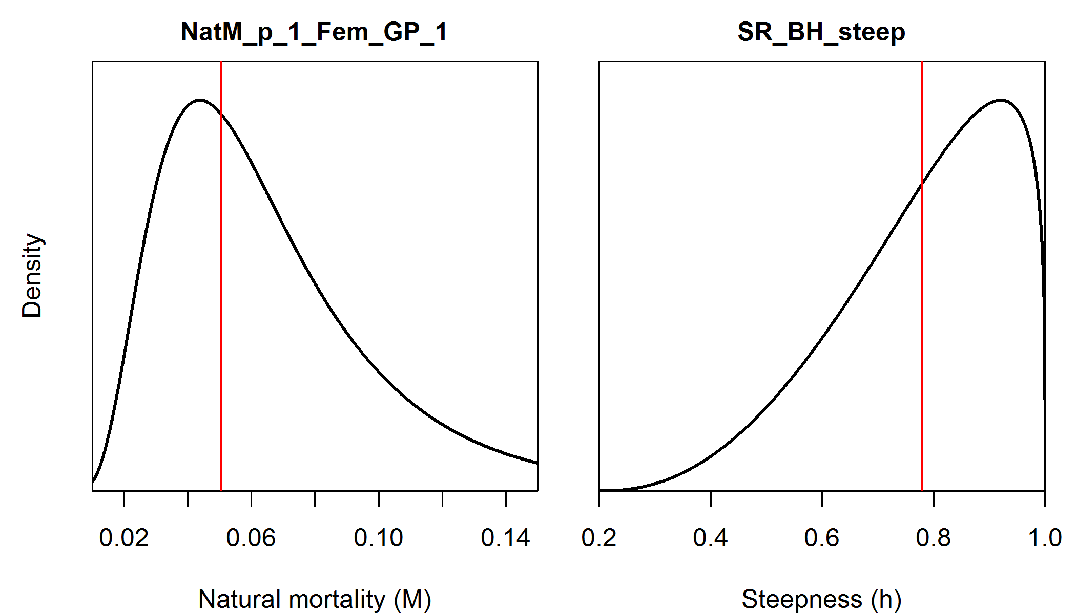

**Figure 45: Prior distributions for natural mortality (*M*). The base model has natural mortality fixed at the mean of the distribution indicated by the red vertical line (*M* = 0.0505).**

### Likelihood profiles, sensitivities, and retrospective analyses

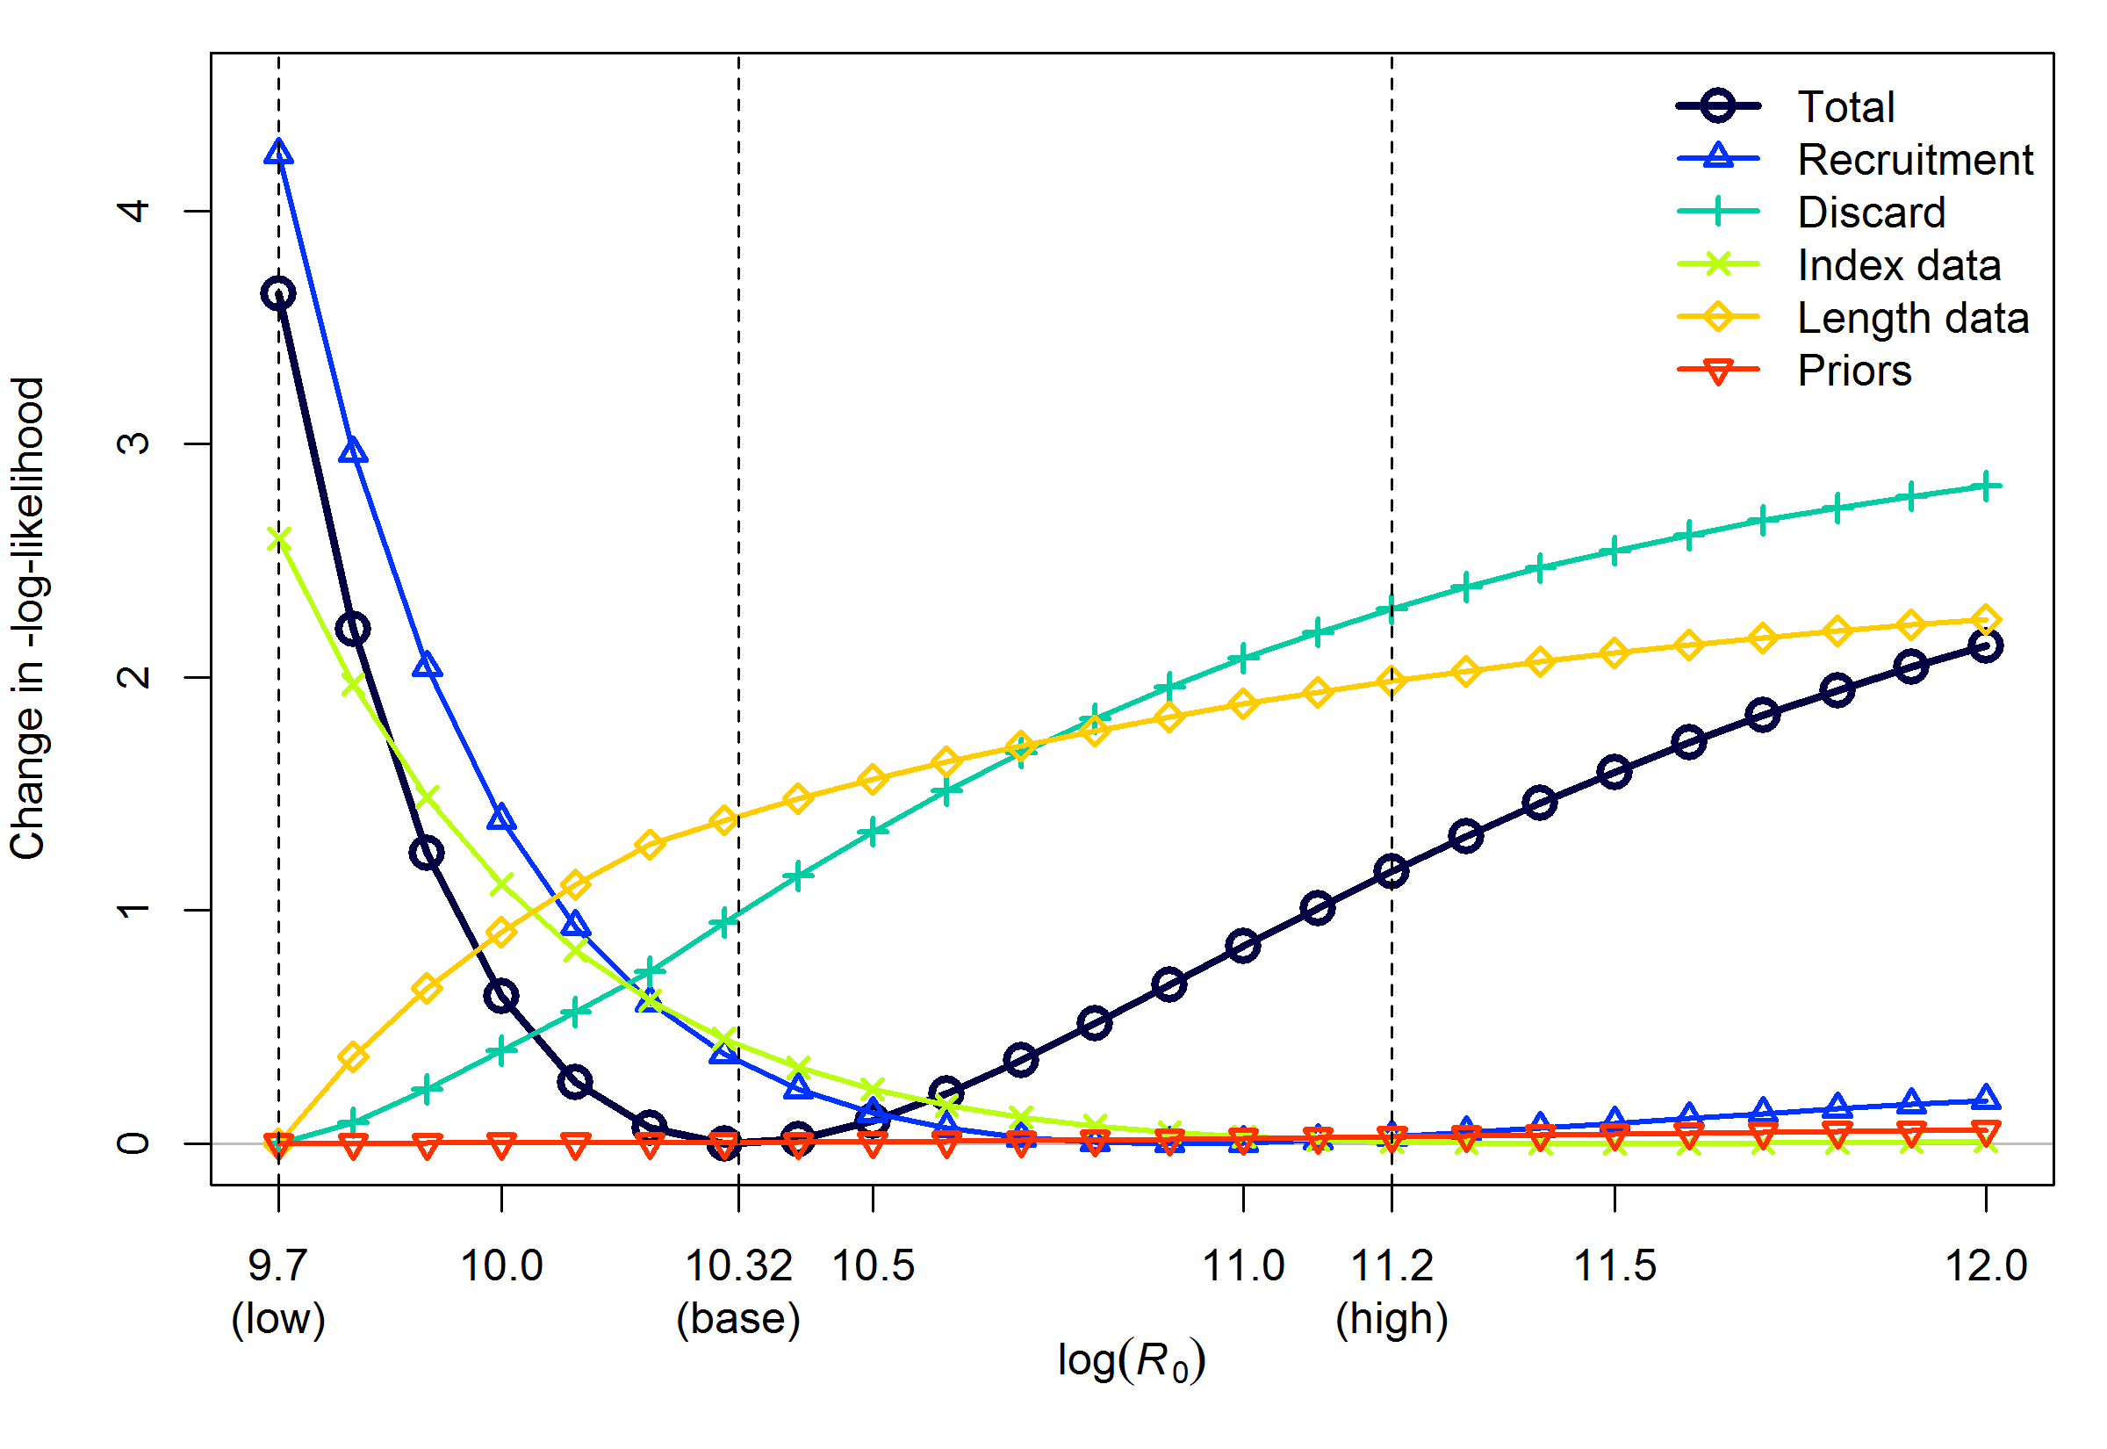

**Figure 46: Likelihood profile over the log of equilibrium recruitment, log(*R*0). Vertical lines and axis labels indicate the base model with log(R0) estimated at 10.32 and the low and high states of nature used in the decision table (Table 14).**

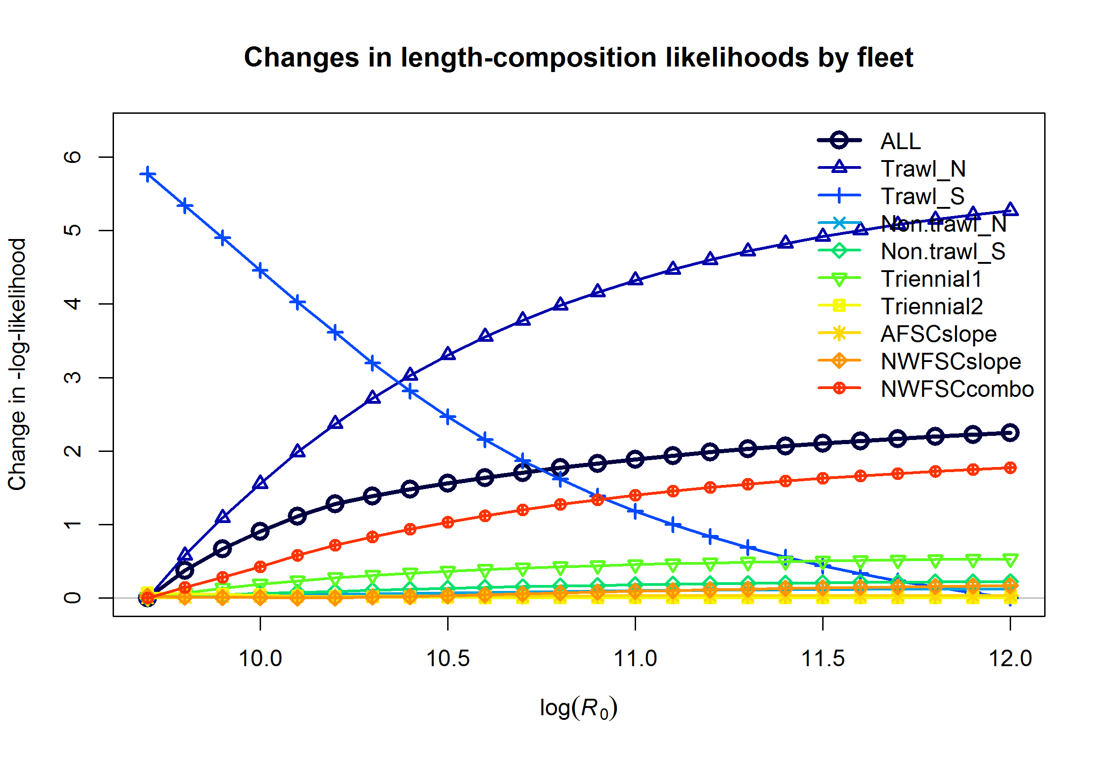

**Figure 47: Likelihood contributions by fleet to the length data likelihood component (orange line with diamonds in Figure 46) of the likelihood profile over the log of equilibrium recruitment, log(*R*0).**

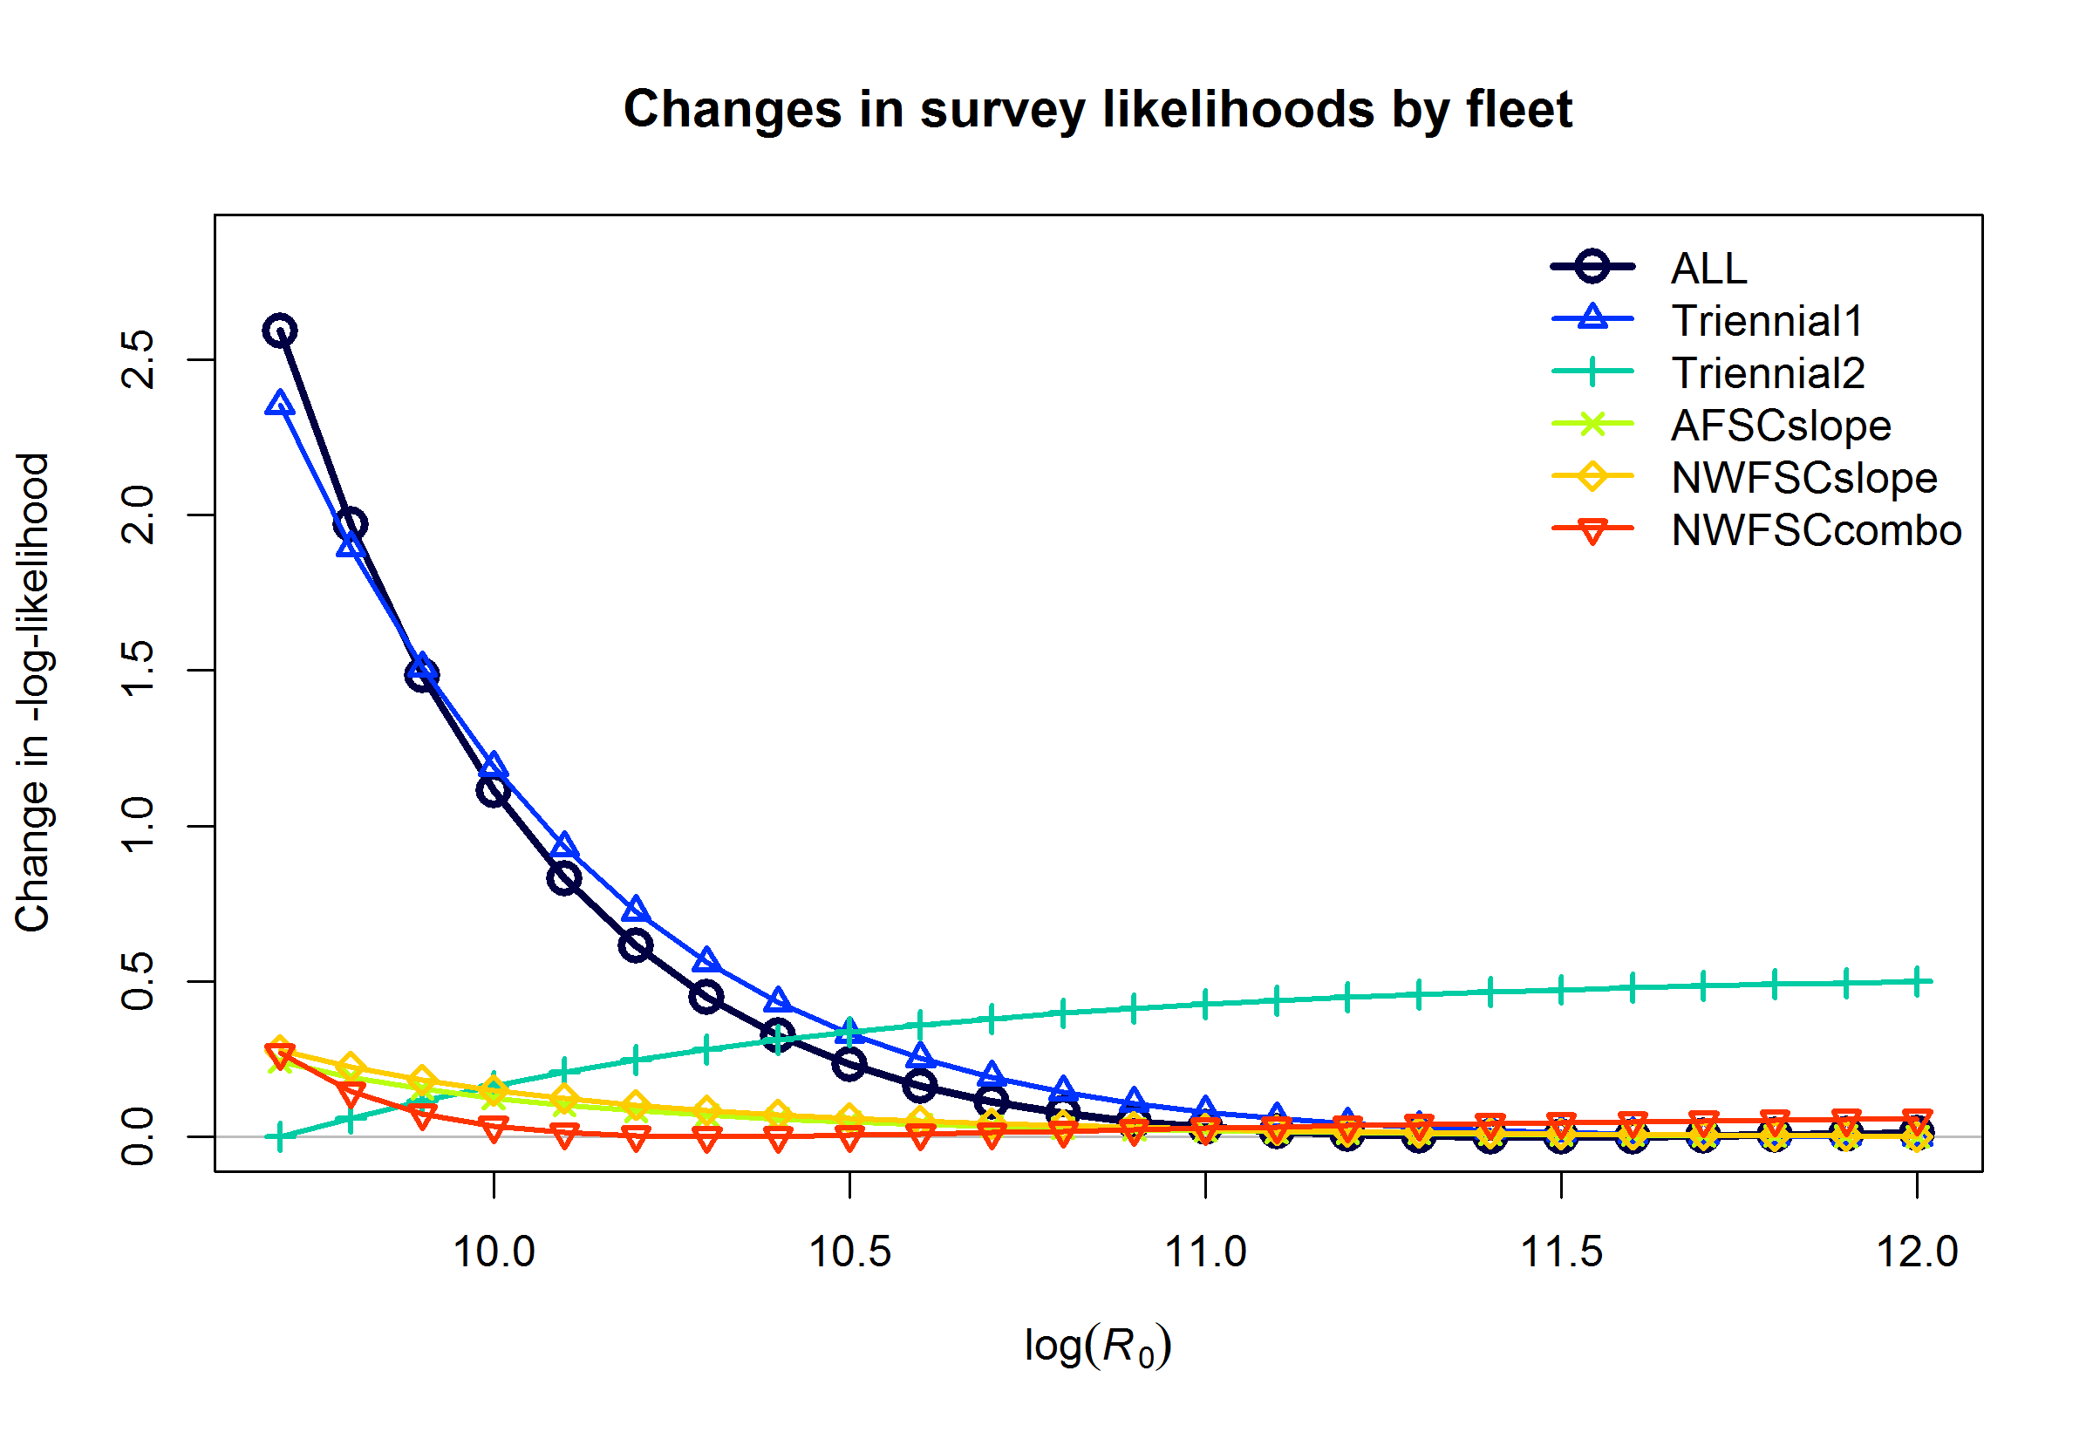

**Figure 48: Likelihood contributions by fleet to the survey data likelihood component (light green line with Xs in Figure 46) of the likelihood profile over the log of equilibrium recruitment, log(*R*0).**

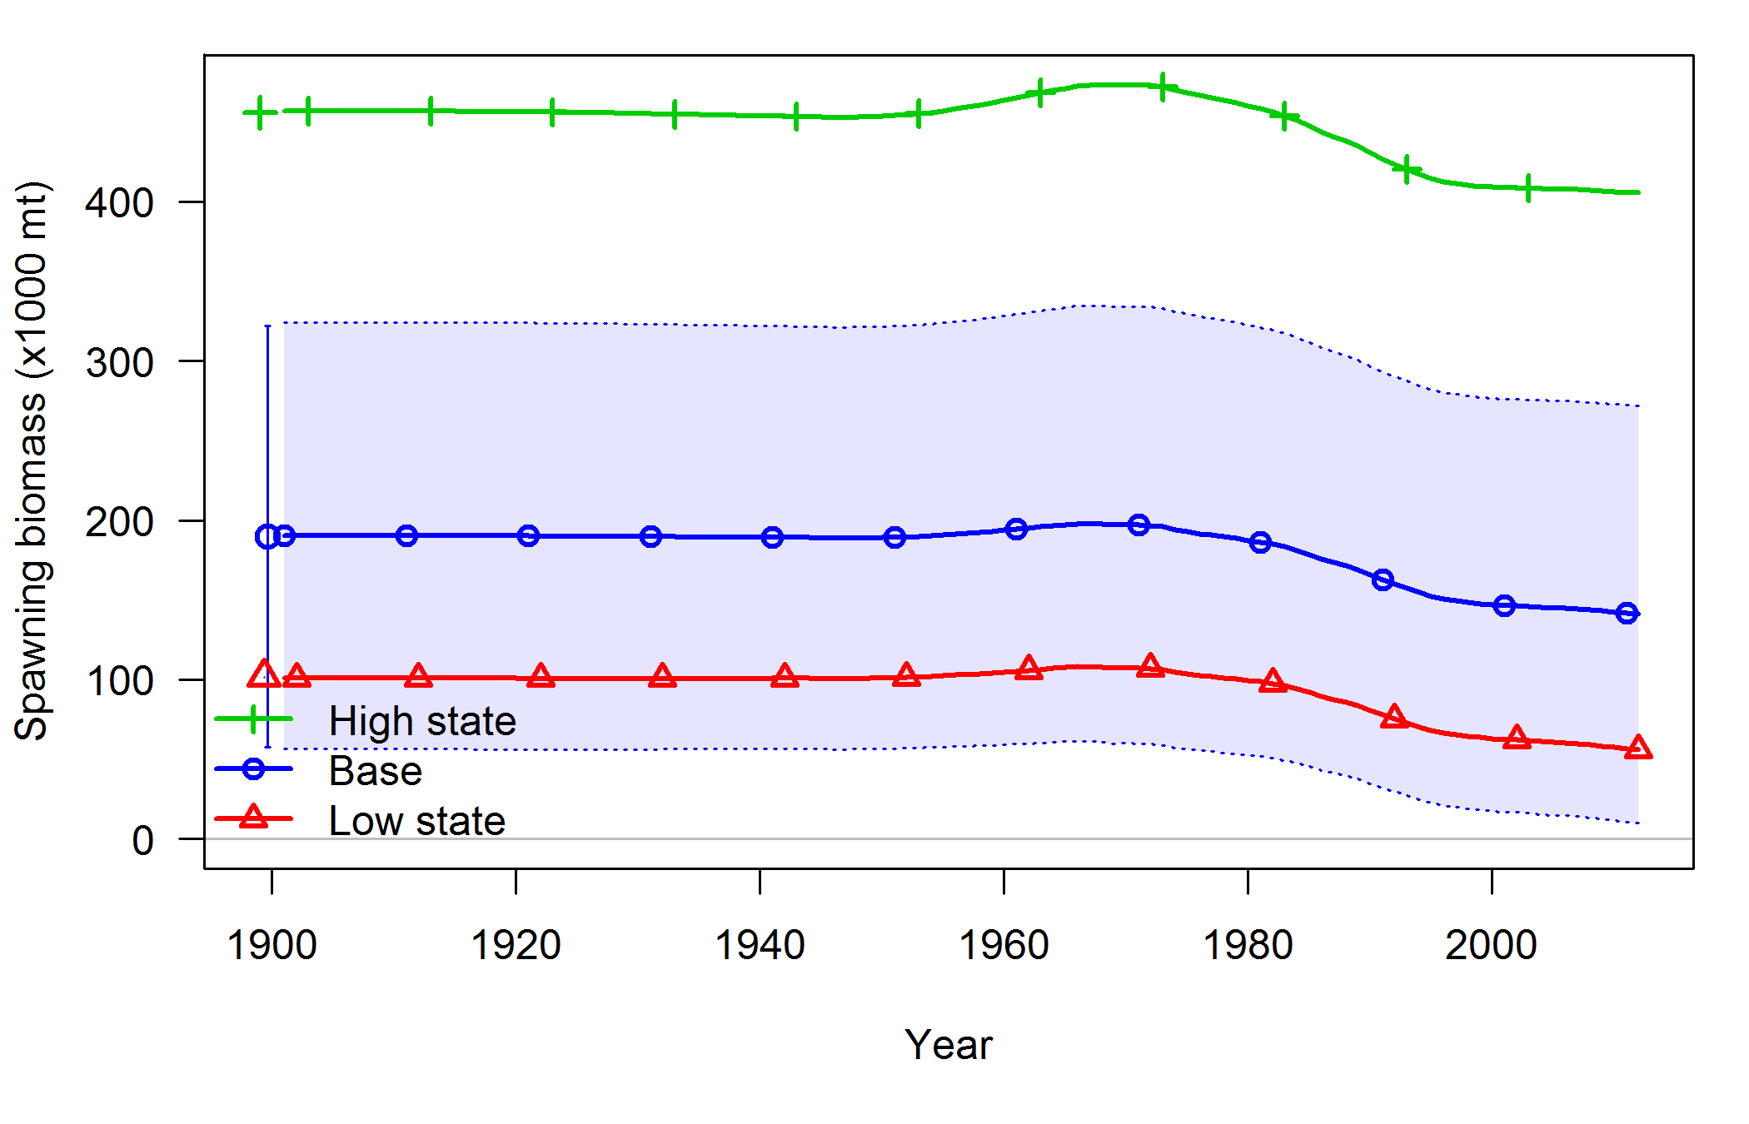

**Figure 49: Time series of spawning biomass for low and high states of nature taken from the log(*R*0) profile. The base model has log(R0) estimated at 10.32 while the low and high states of nature have log(R0) = 9.7 and 10.2 respectively. Uncertainty is only shown for the base model as the fixed log(*R*0) values in the other cases limits the portrayal of uncertainty.**

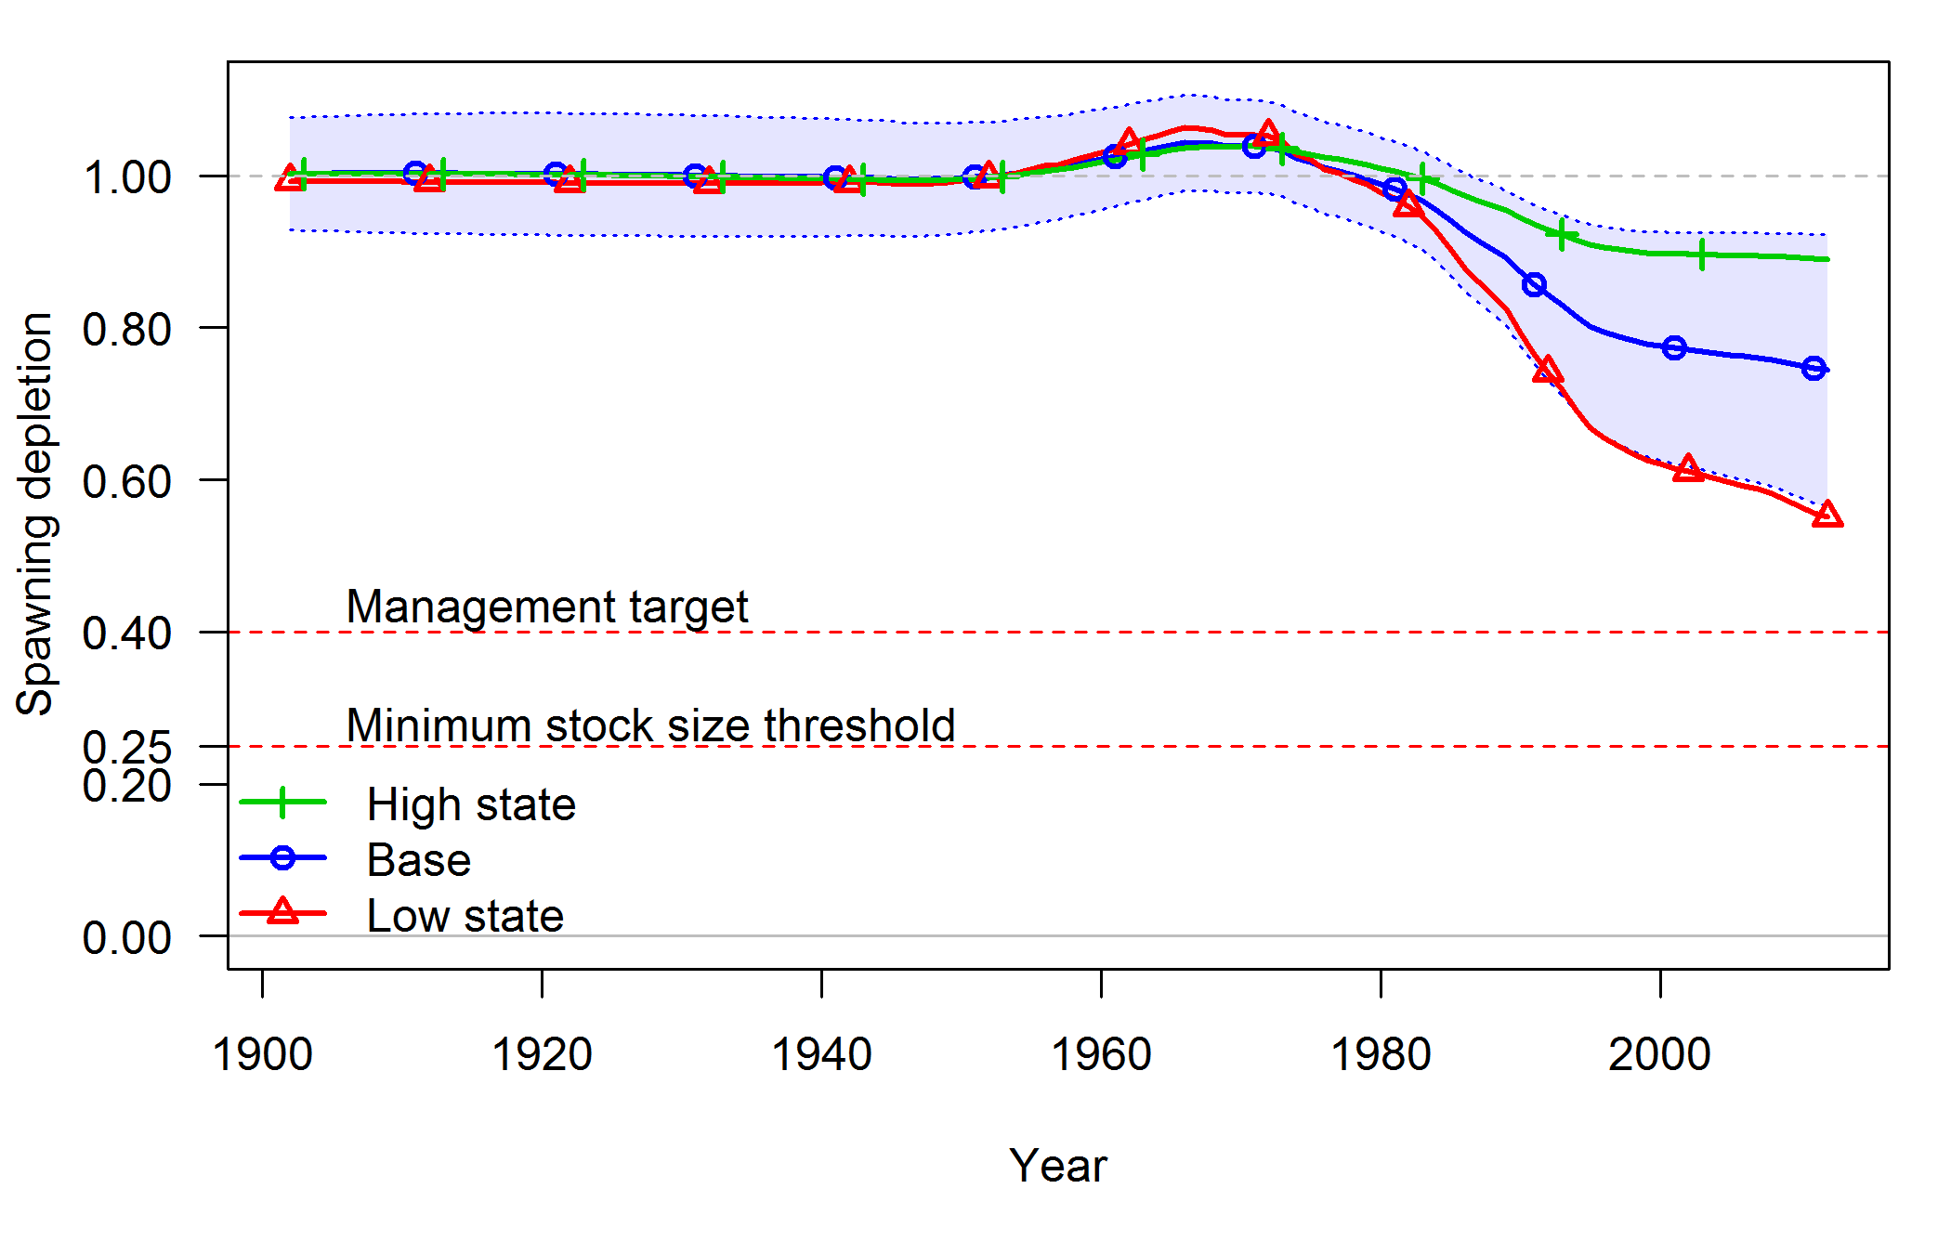

**Figure 50: Time series of spawning depletion for low and high states of nature as described in the caption for Figure 49 above.**

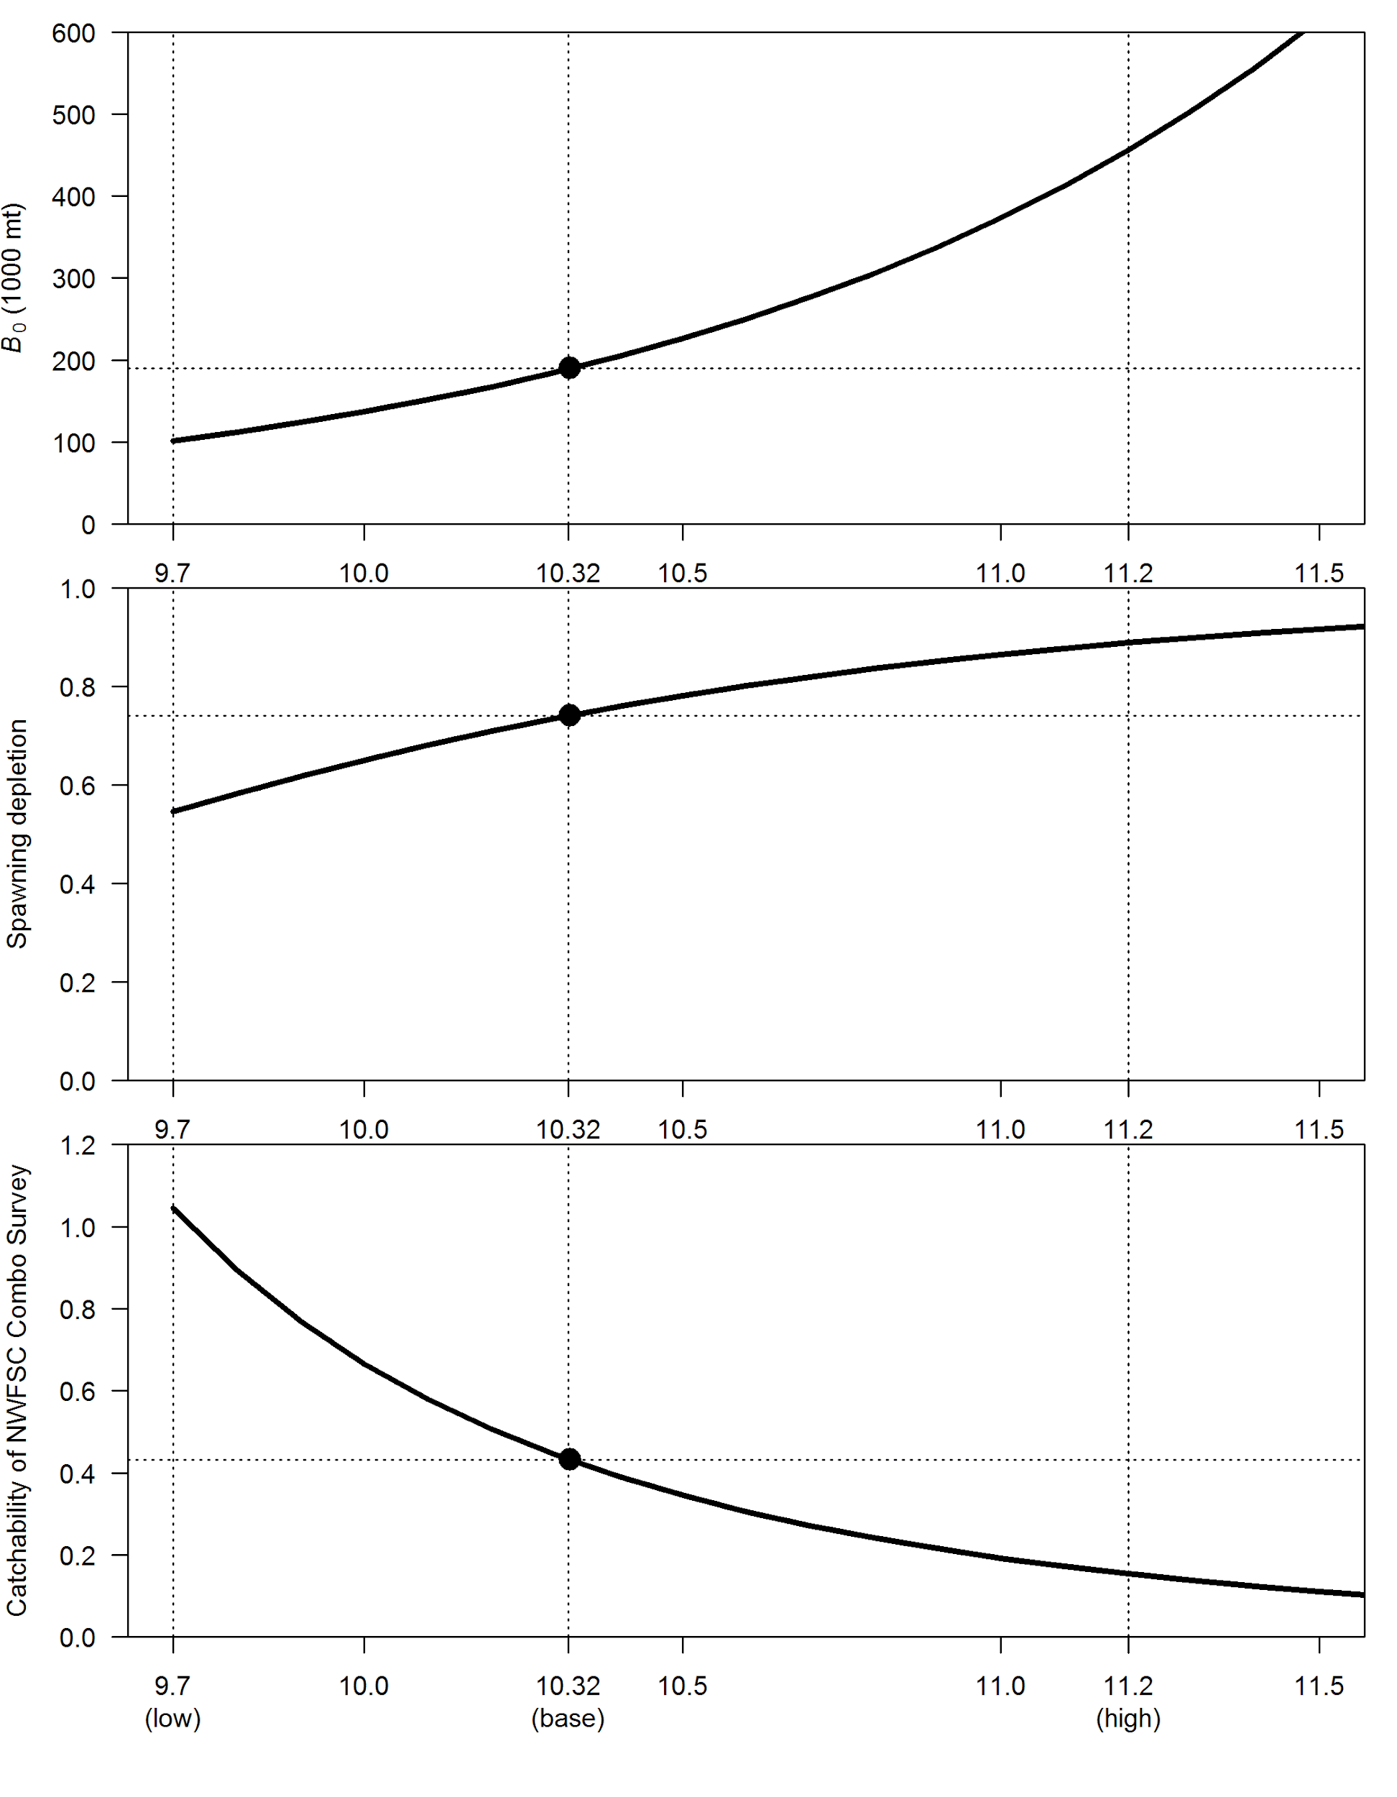

**Figure 51: Relationship between log(*R*0) and equilibrium spawning biomass (top), depletion (middle), and catchability of the NWFSC Combo Survey (bottom).**

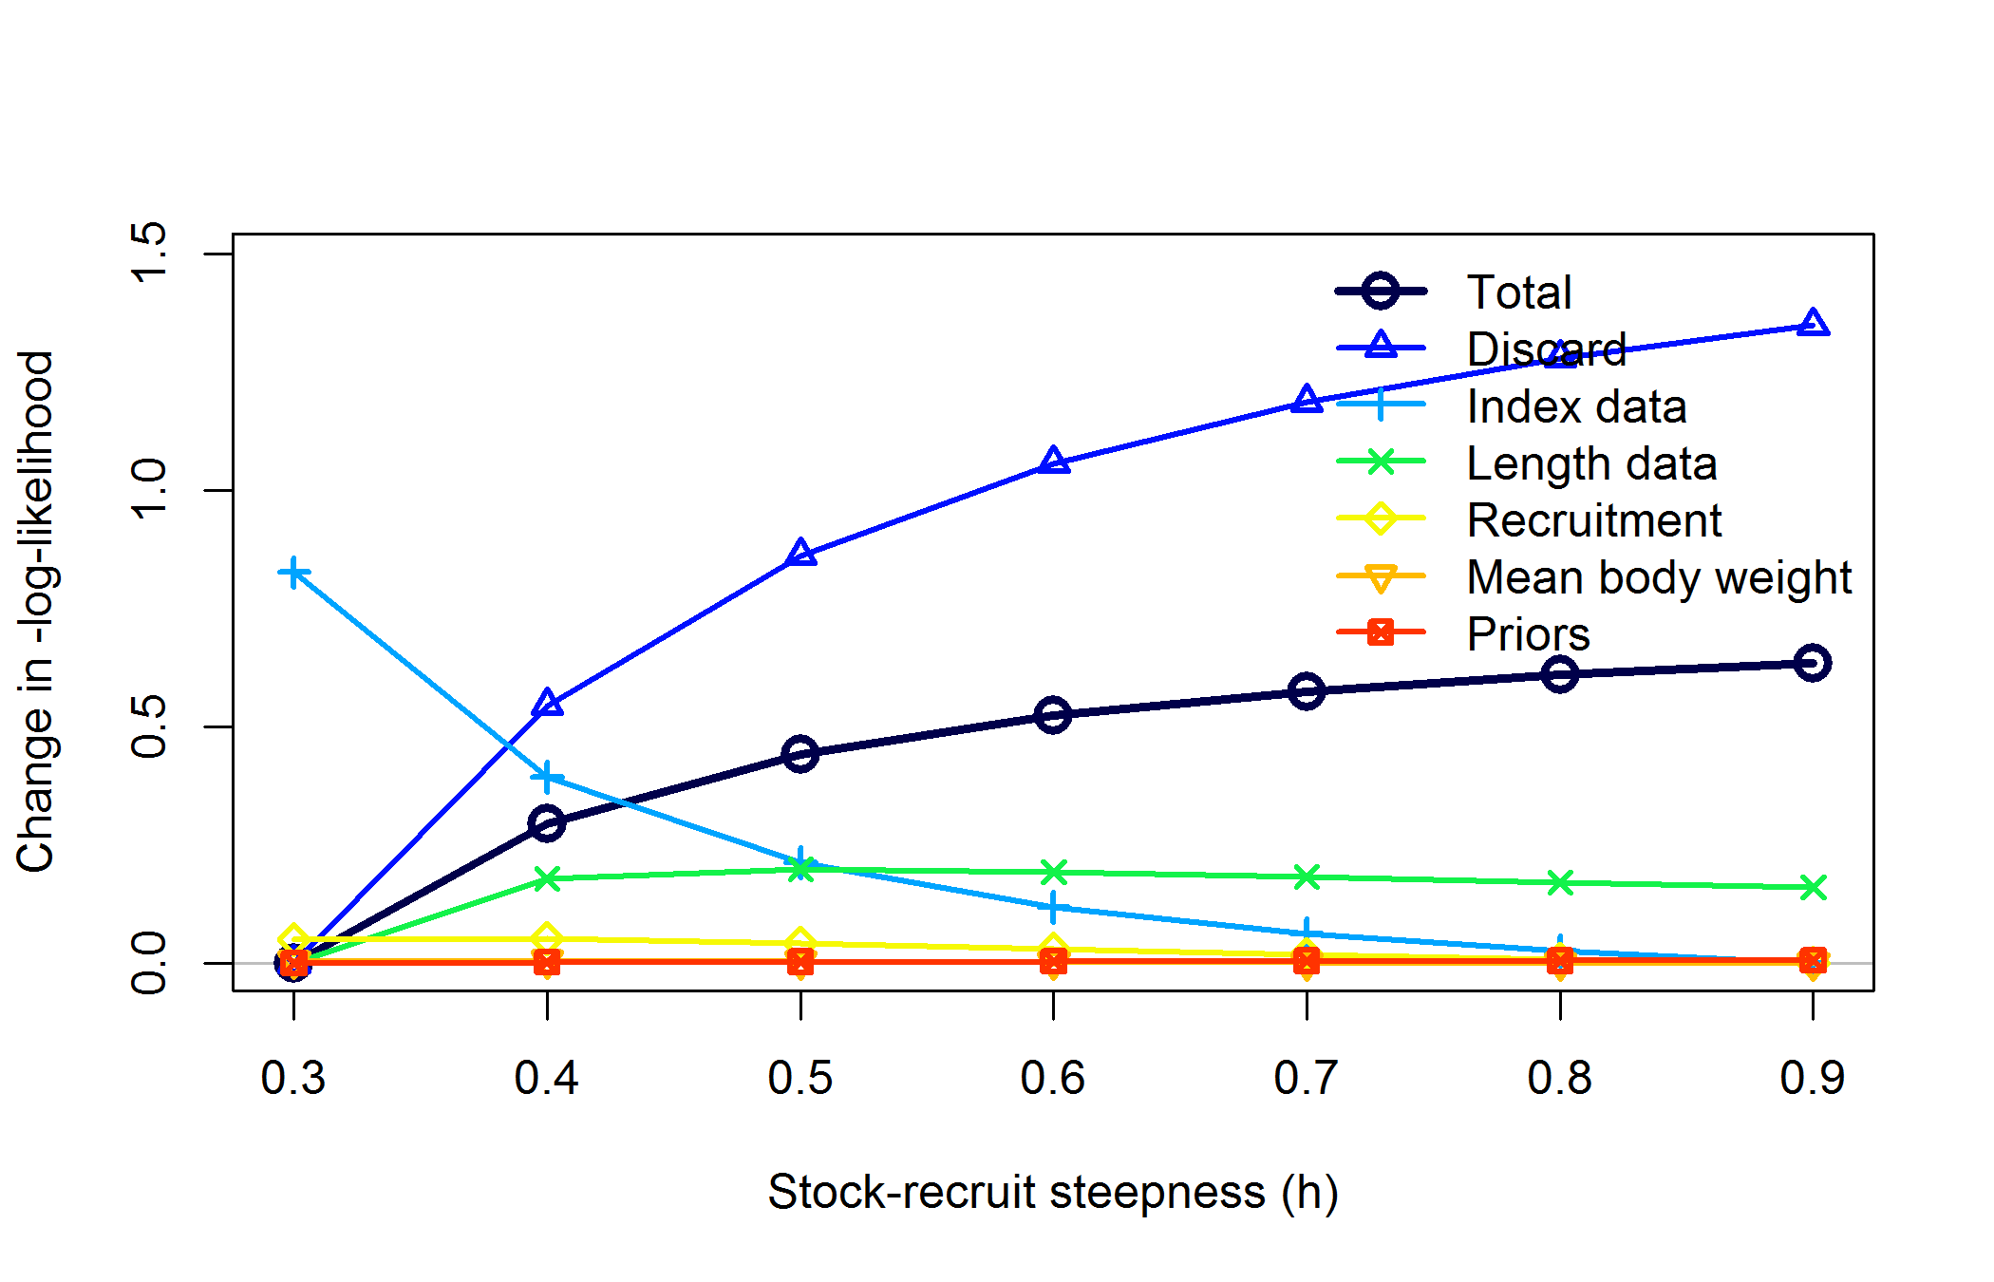

**Figure 52: Likelihood profile over steepness (*h*). The base model has steepness fixed at *h* = 0.6.**

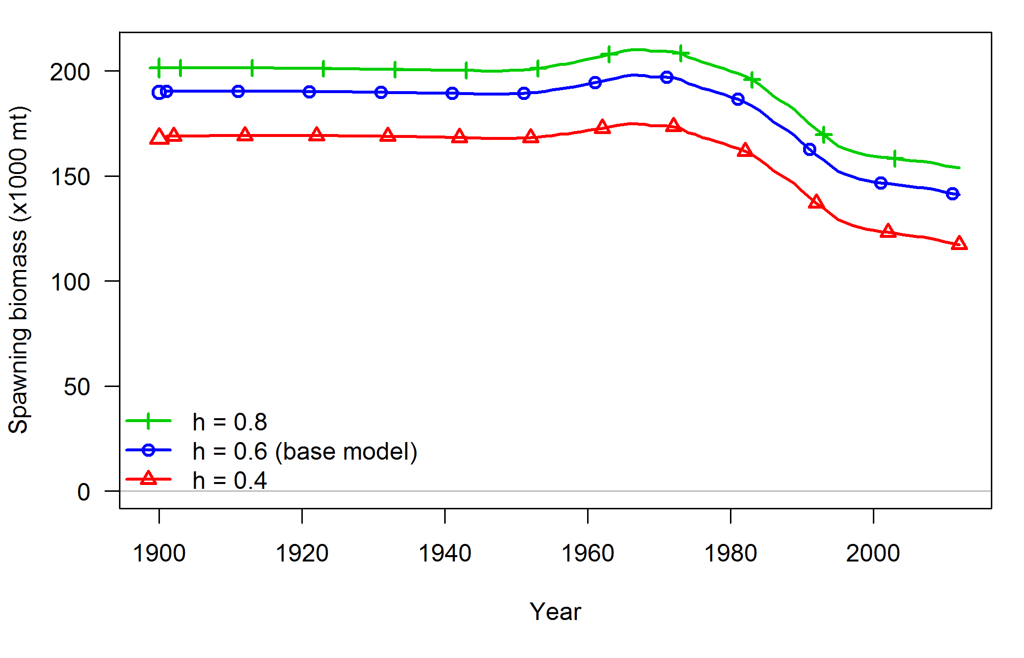

**Figure 53: Time series of spawning biomass associated with lower and higher steepness values from the likelihood profile above.**

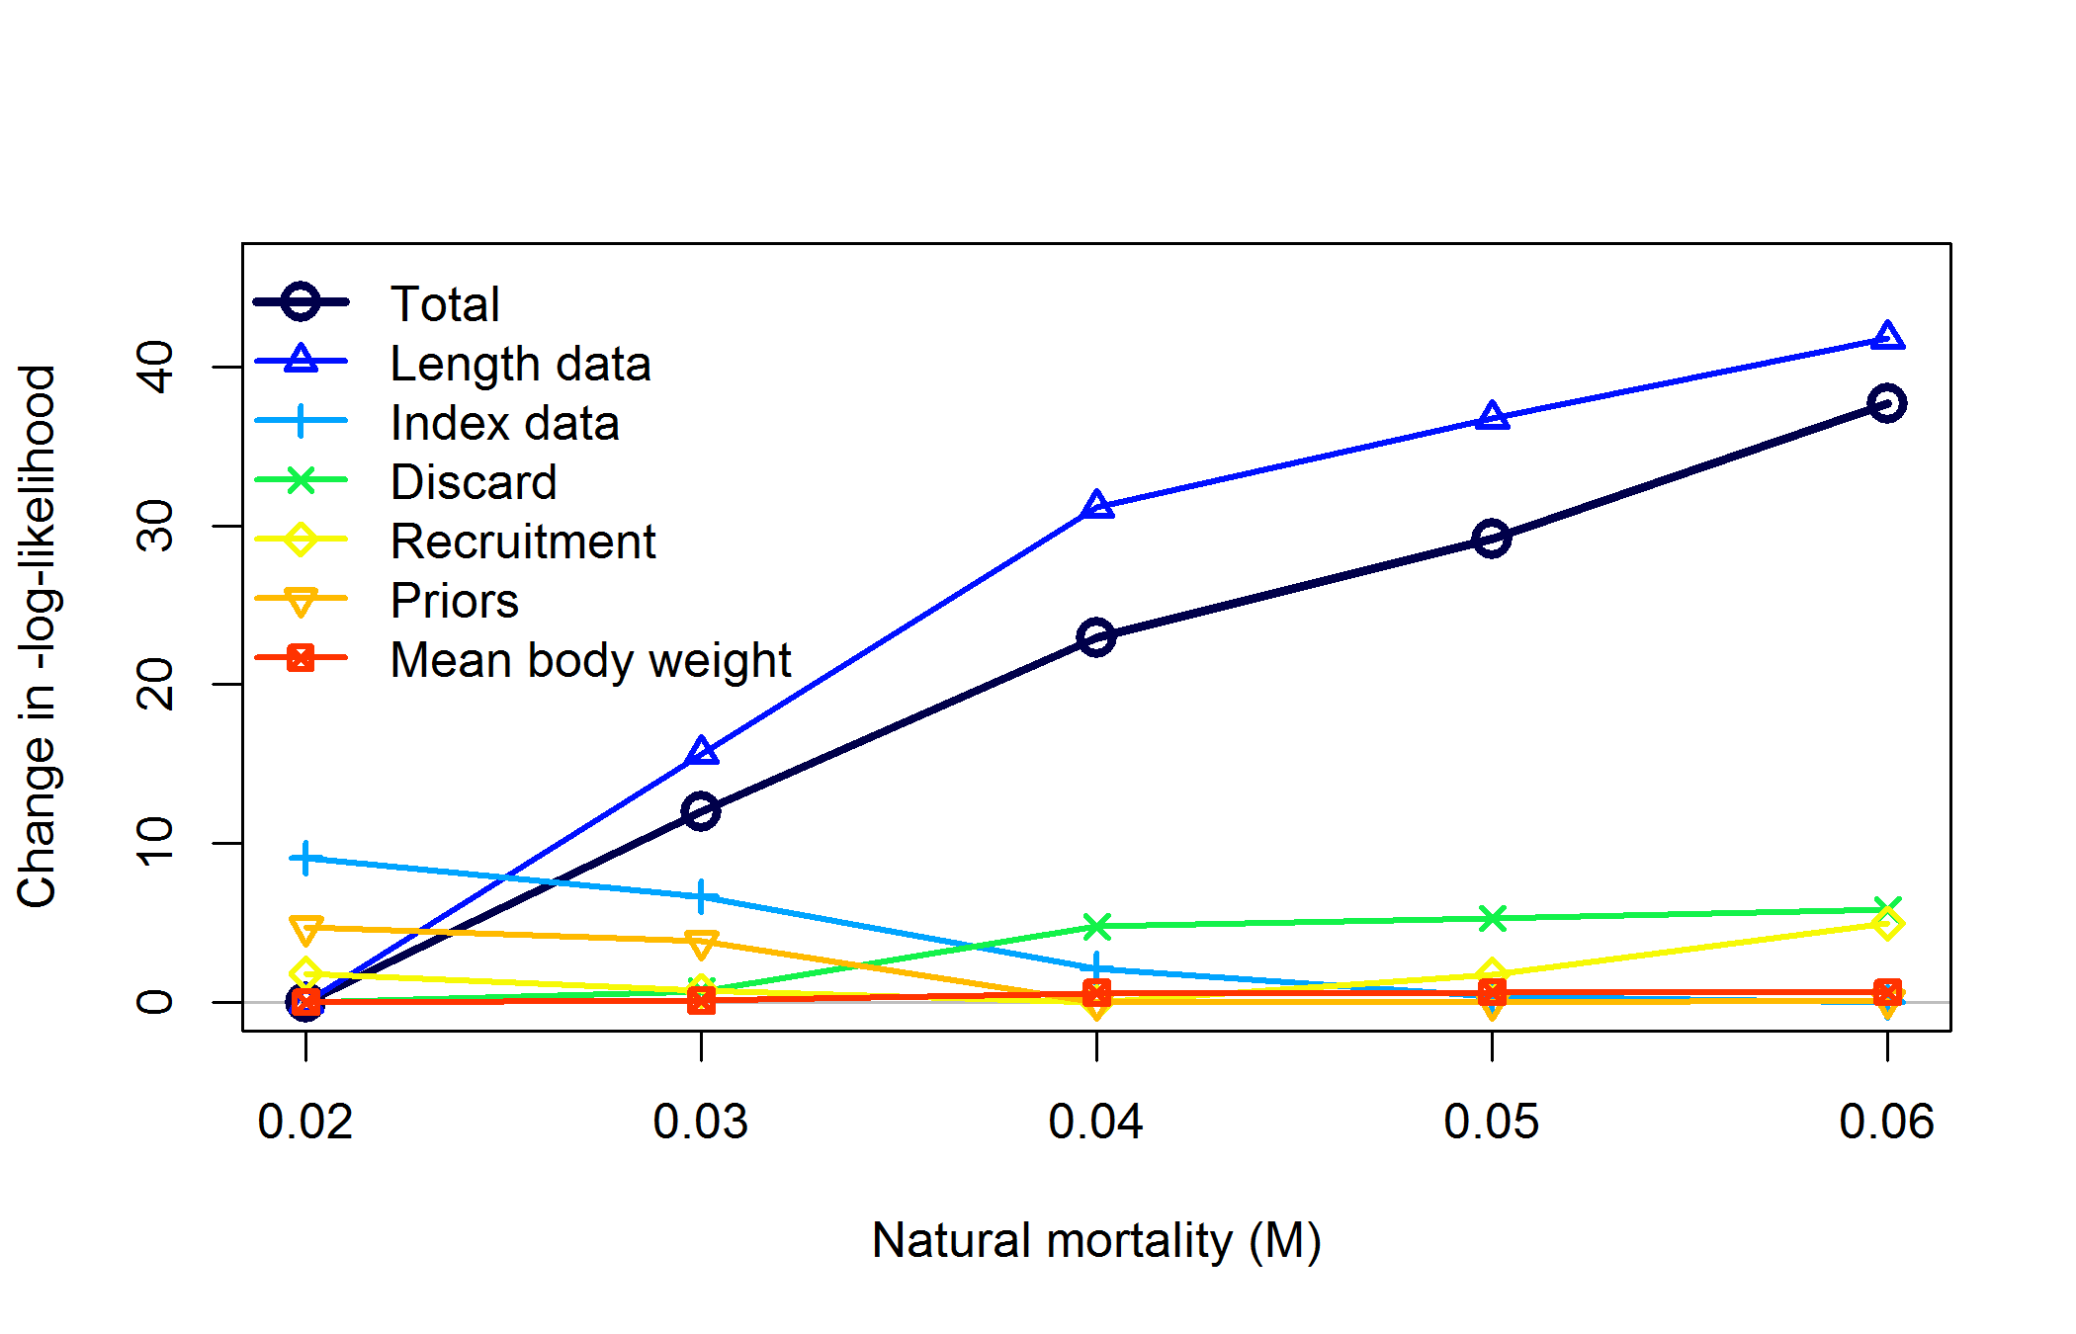

**Figure 54: Likelihood profile over natural mortality (*M*). The base model has mortality fixed at *M* = 0.0505. Models with M = 0.07 and greater did not converge with starting values used for base model.**

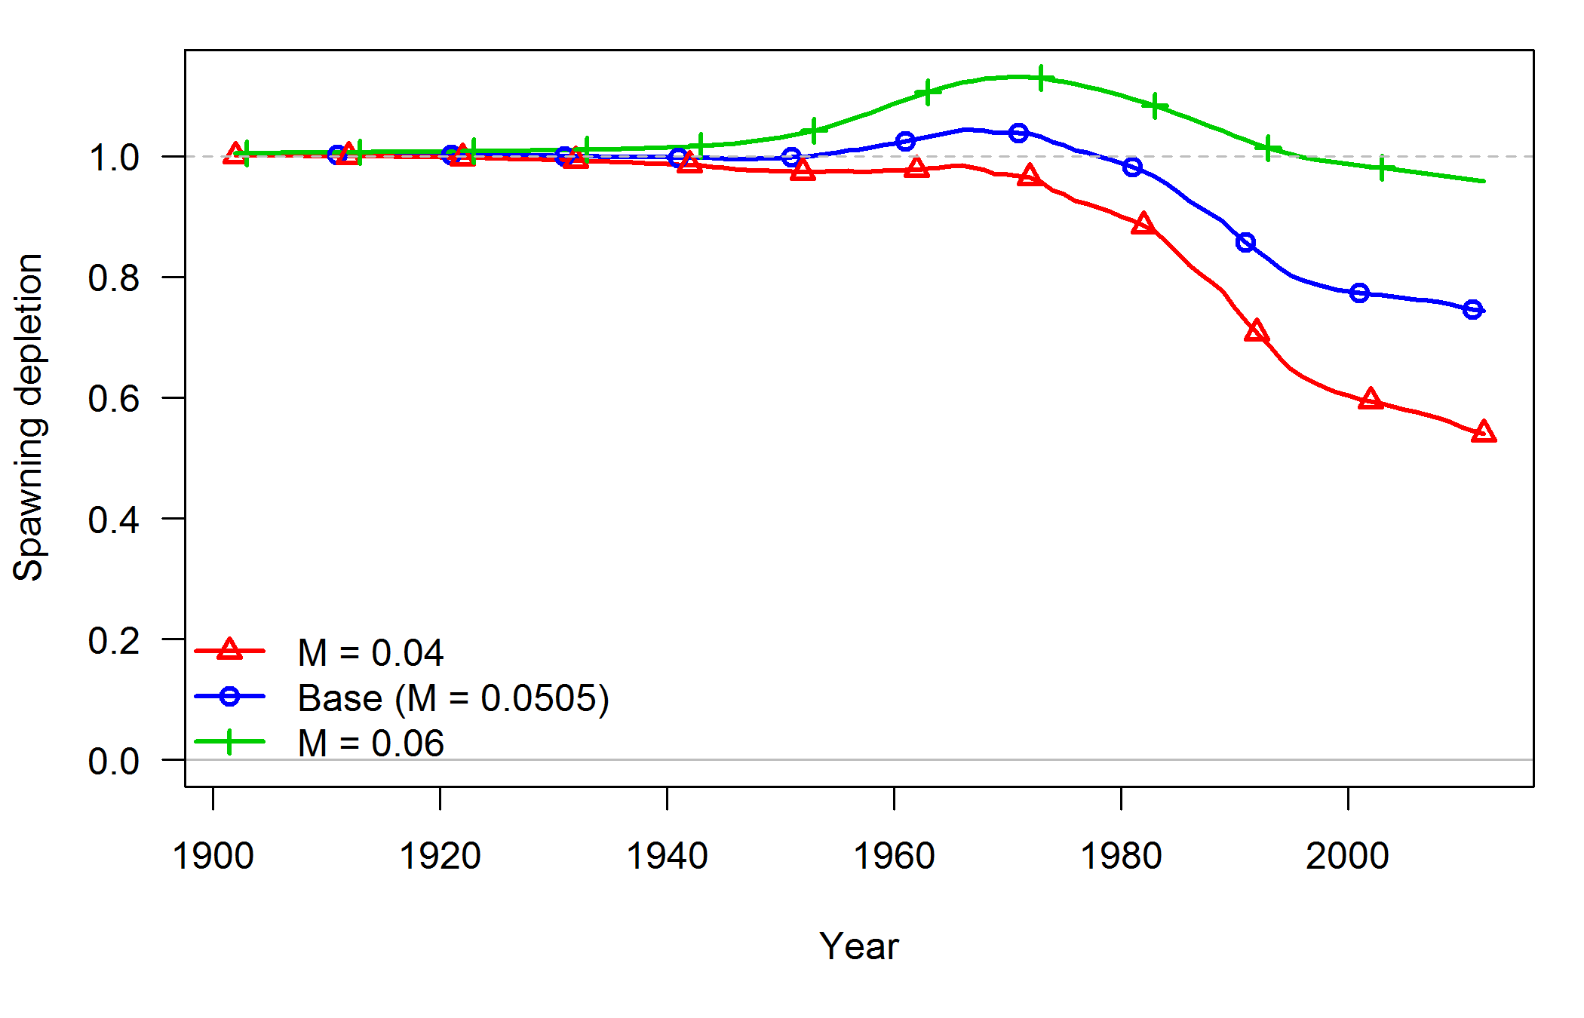

**Figure 55: Time series of spawning depletion associated with two alternative *M* values bracketing the value used in the base model.**

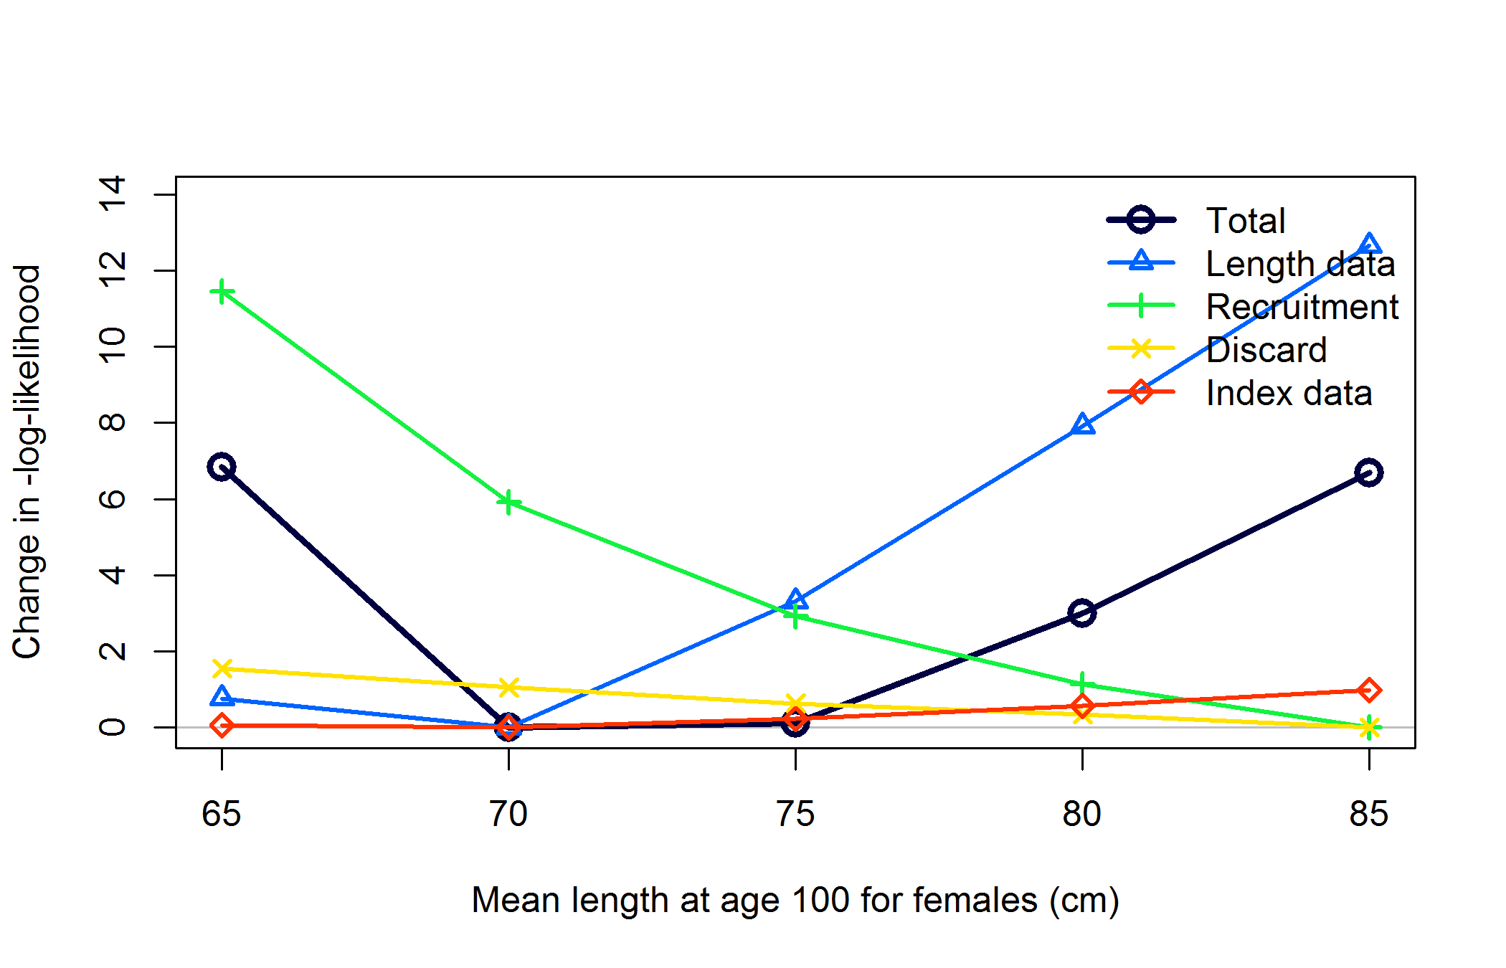

**Figure 56: Likelihood profile over length at age 100 for females. The base model has this value fixed at 75 cm. In all cases the length at age 100 for males is set to 90% of the value for females.**

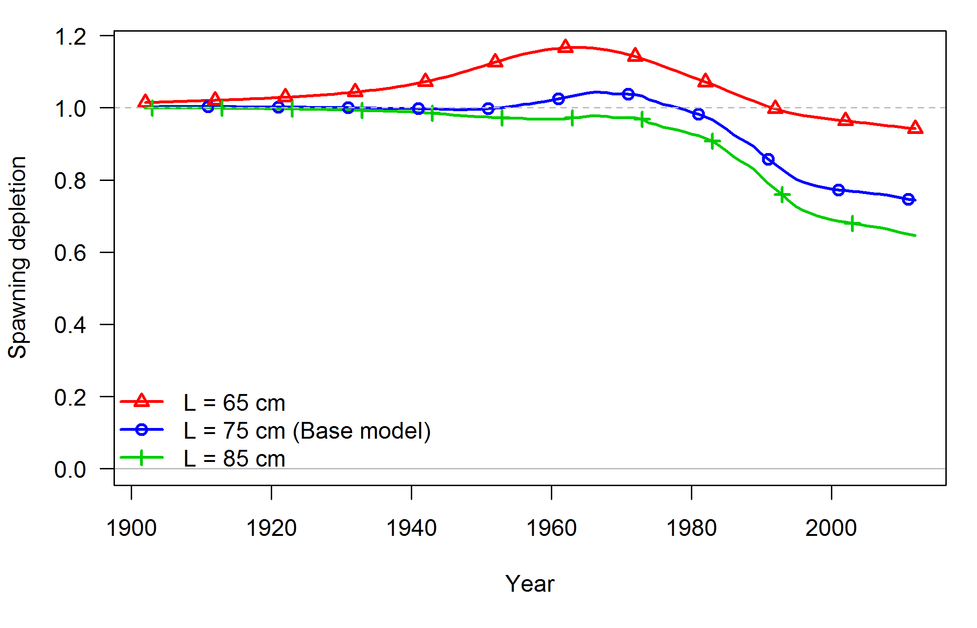

**Figure 57: Time series of spawning depletion for models with alternative values for length at age 100.**

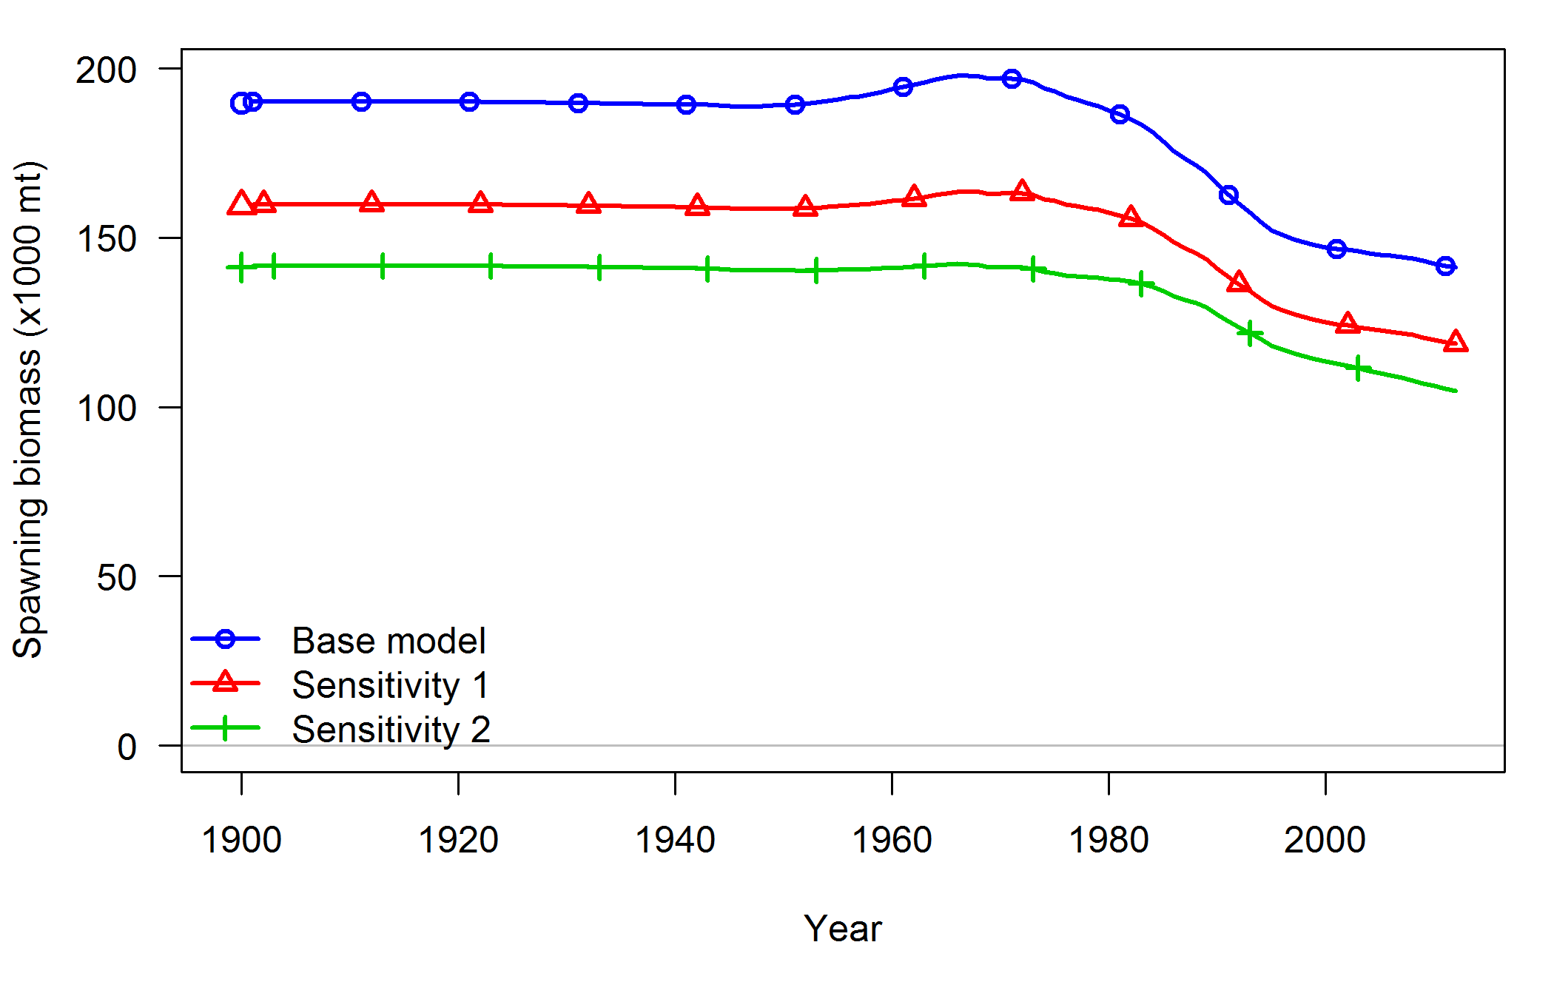

**Figure 58: Time series of spawning biomass associated with alternative assumptions about maturity. Maturity ogives are shown in Figure 12.**

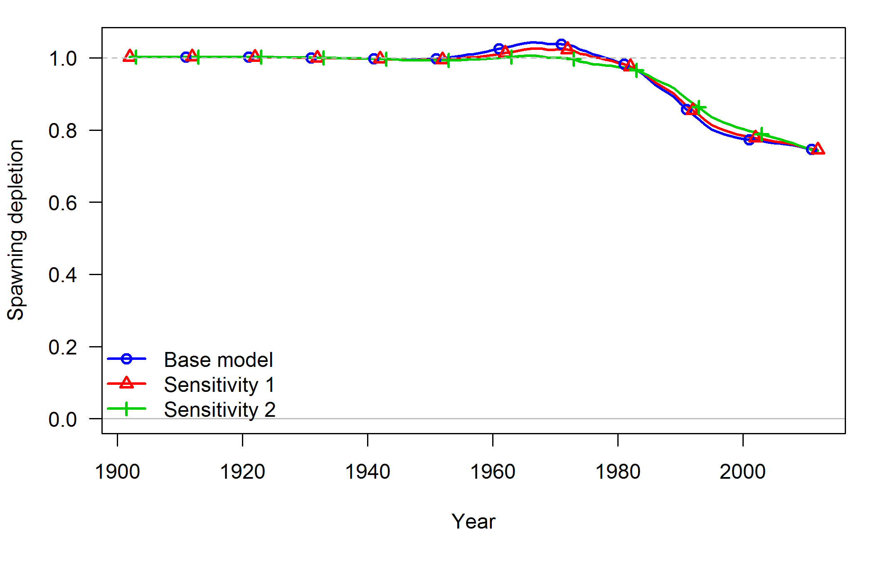

**Figure 59: Time series of depletion associated with alternative assumptions about maturity. Maturity ogives are shown in Figure 12.**

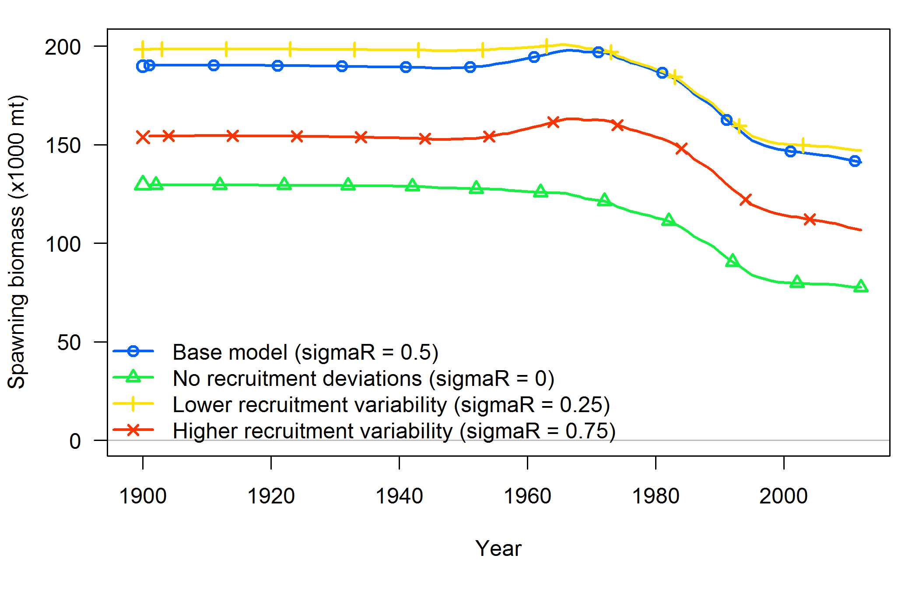

**Figure 60: Time series of spawning biomass associated with alternative values for σ*R*, the parameter controlling variability in recruitment around the stock-recruit curve.**

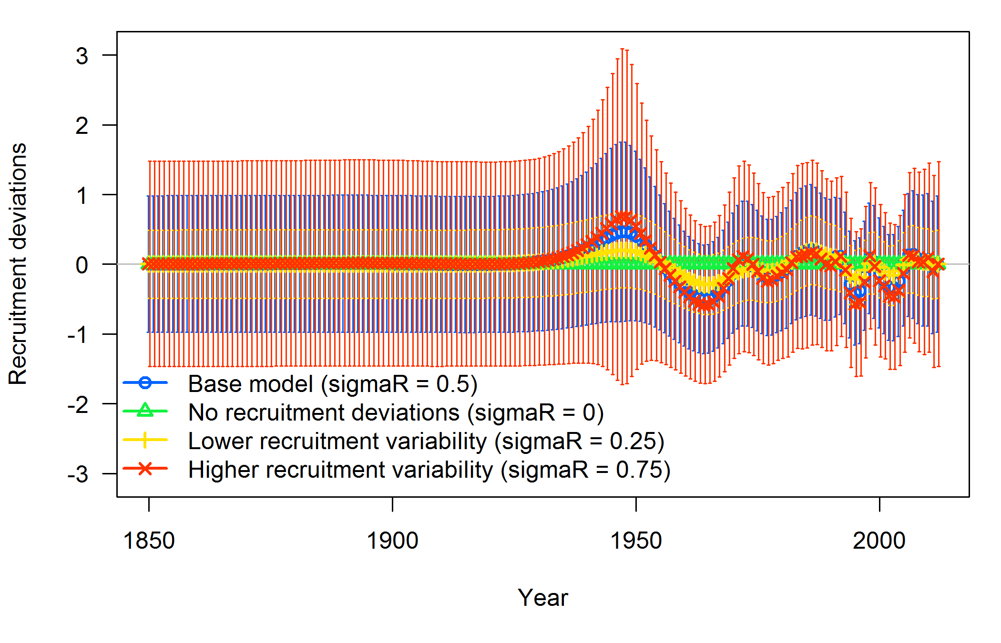

**Figure 61: Time series of estimated recruitment deviations with 95% intervals around the stock-recruit curve associated with alternative values for σ*R*.**

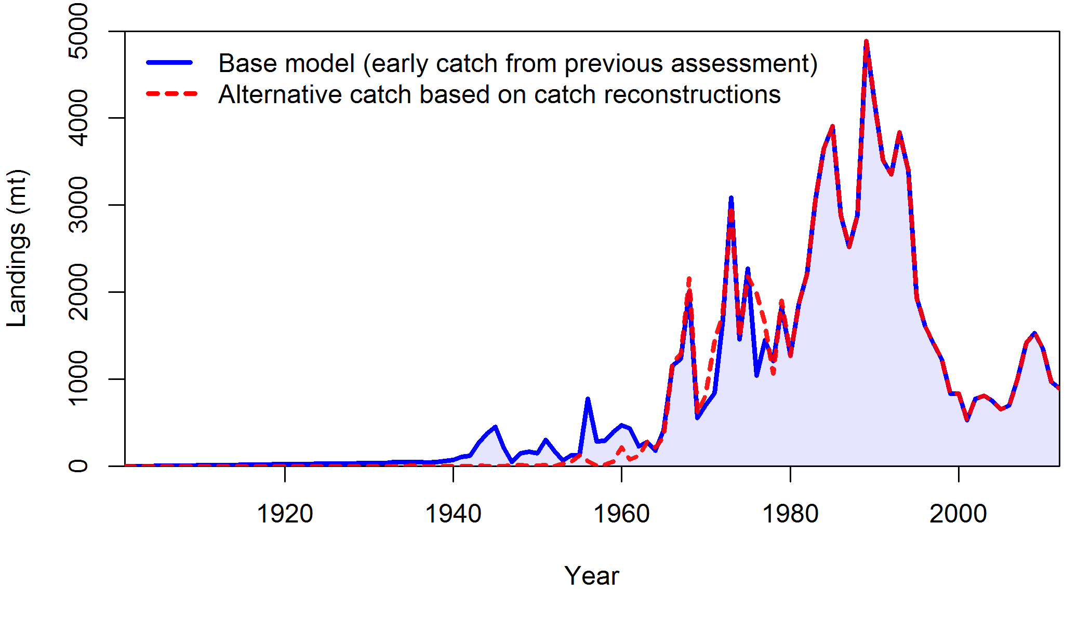

**Figure 62: Time series of catch used in the base model show along with alternative catch assembled from available catch reconstructions. Catch reconstruction estimates may include some longspine thornyheads.**

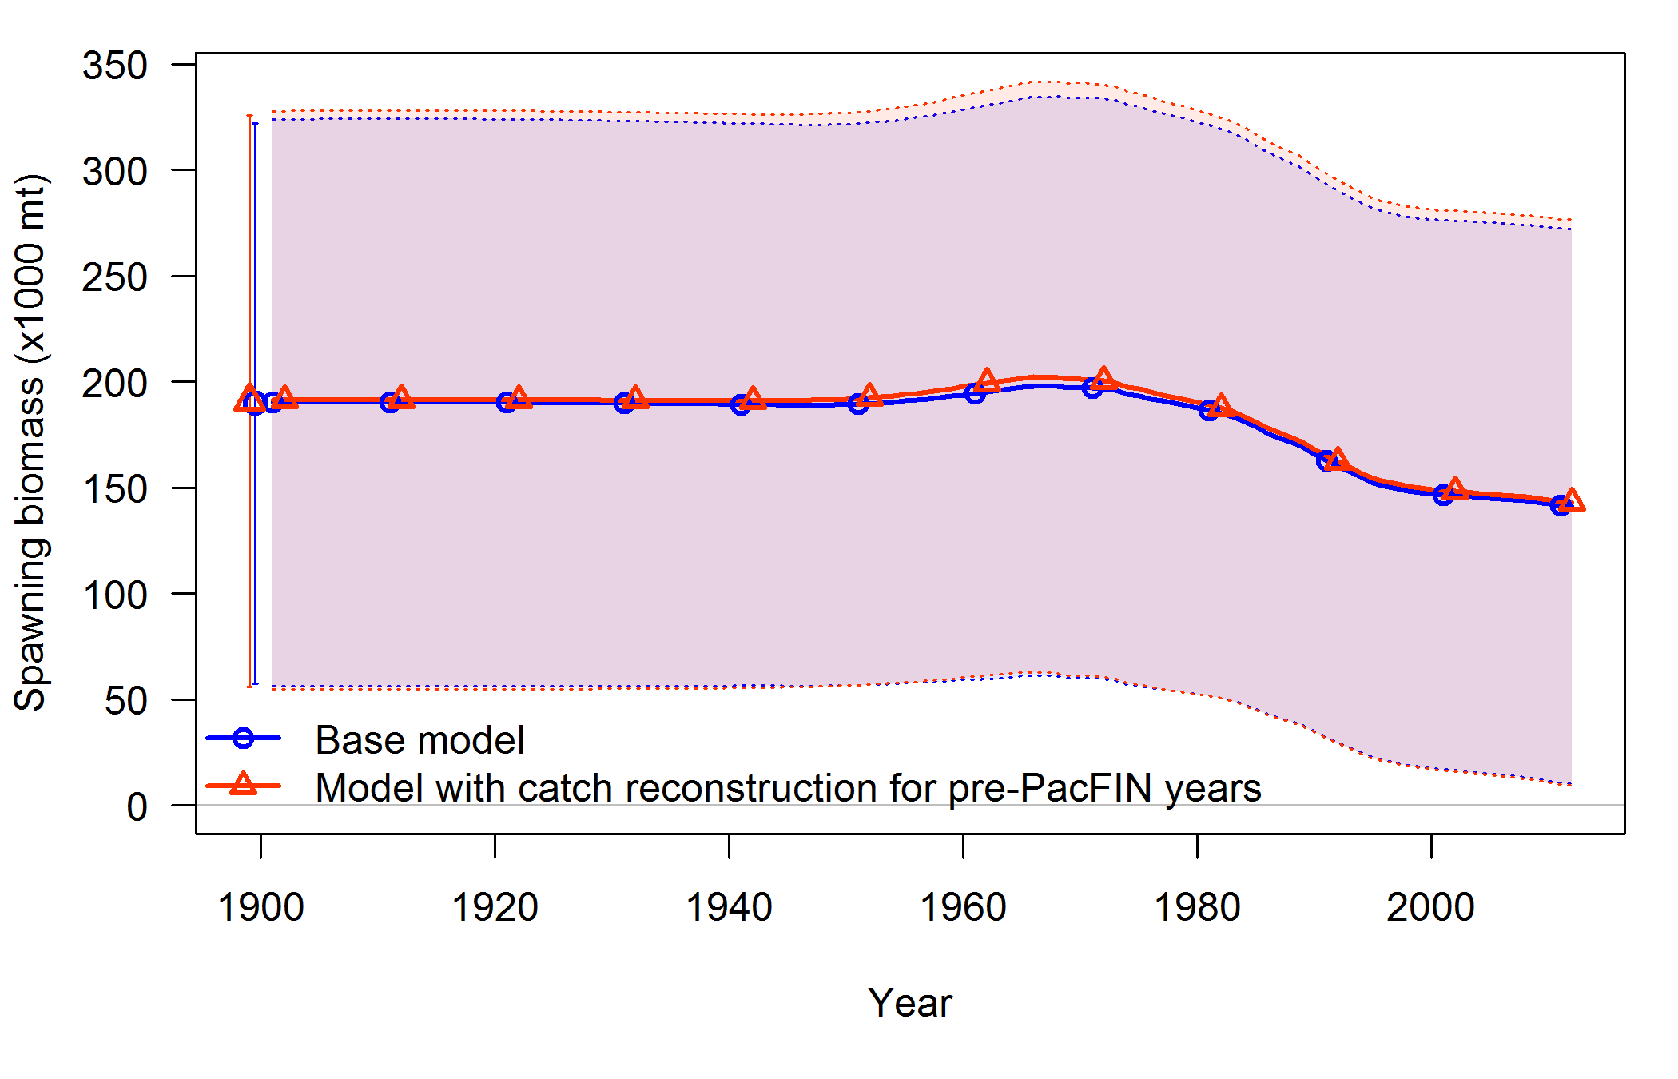

**Figure 63: Time series of spawning biomass and 95% uncertainty intervals associated with alternative catch histories.**

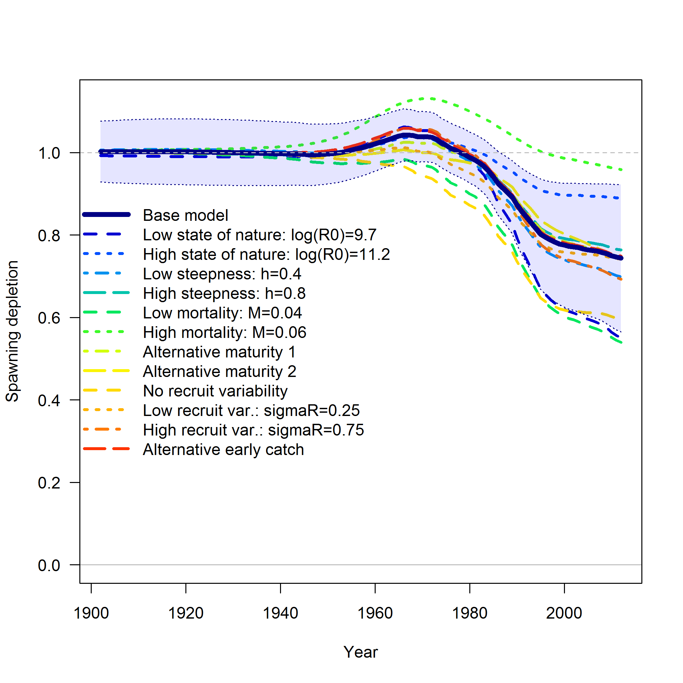

**Figure 64: Summary of spawning depletion estimates for a large set of alternative models compared to the base model with 95% uncertainty intervals (blue shaded region).**

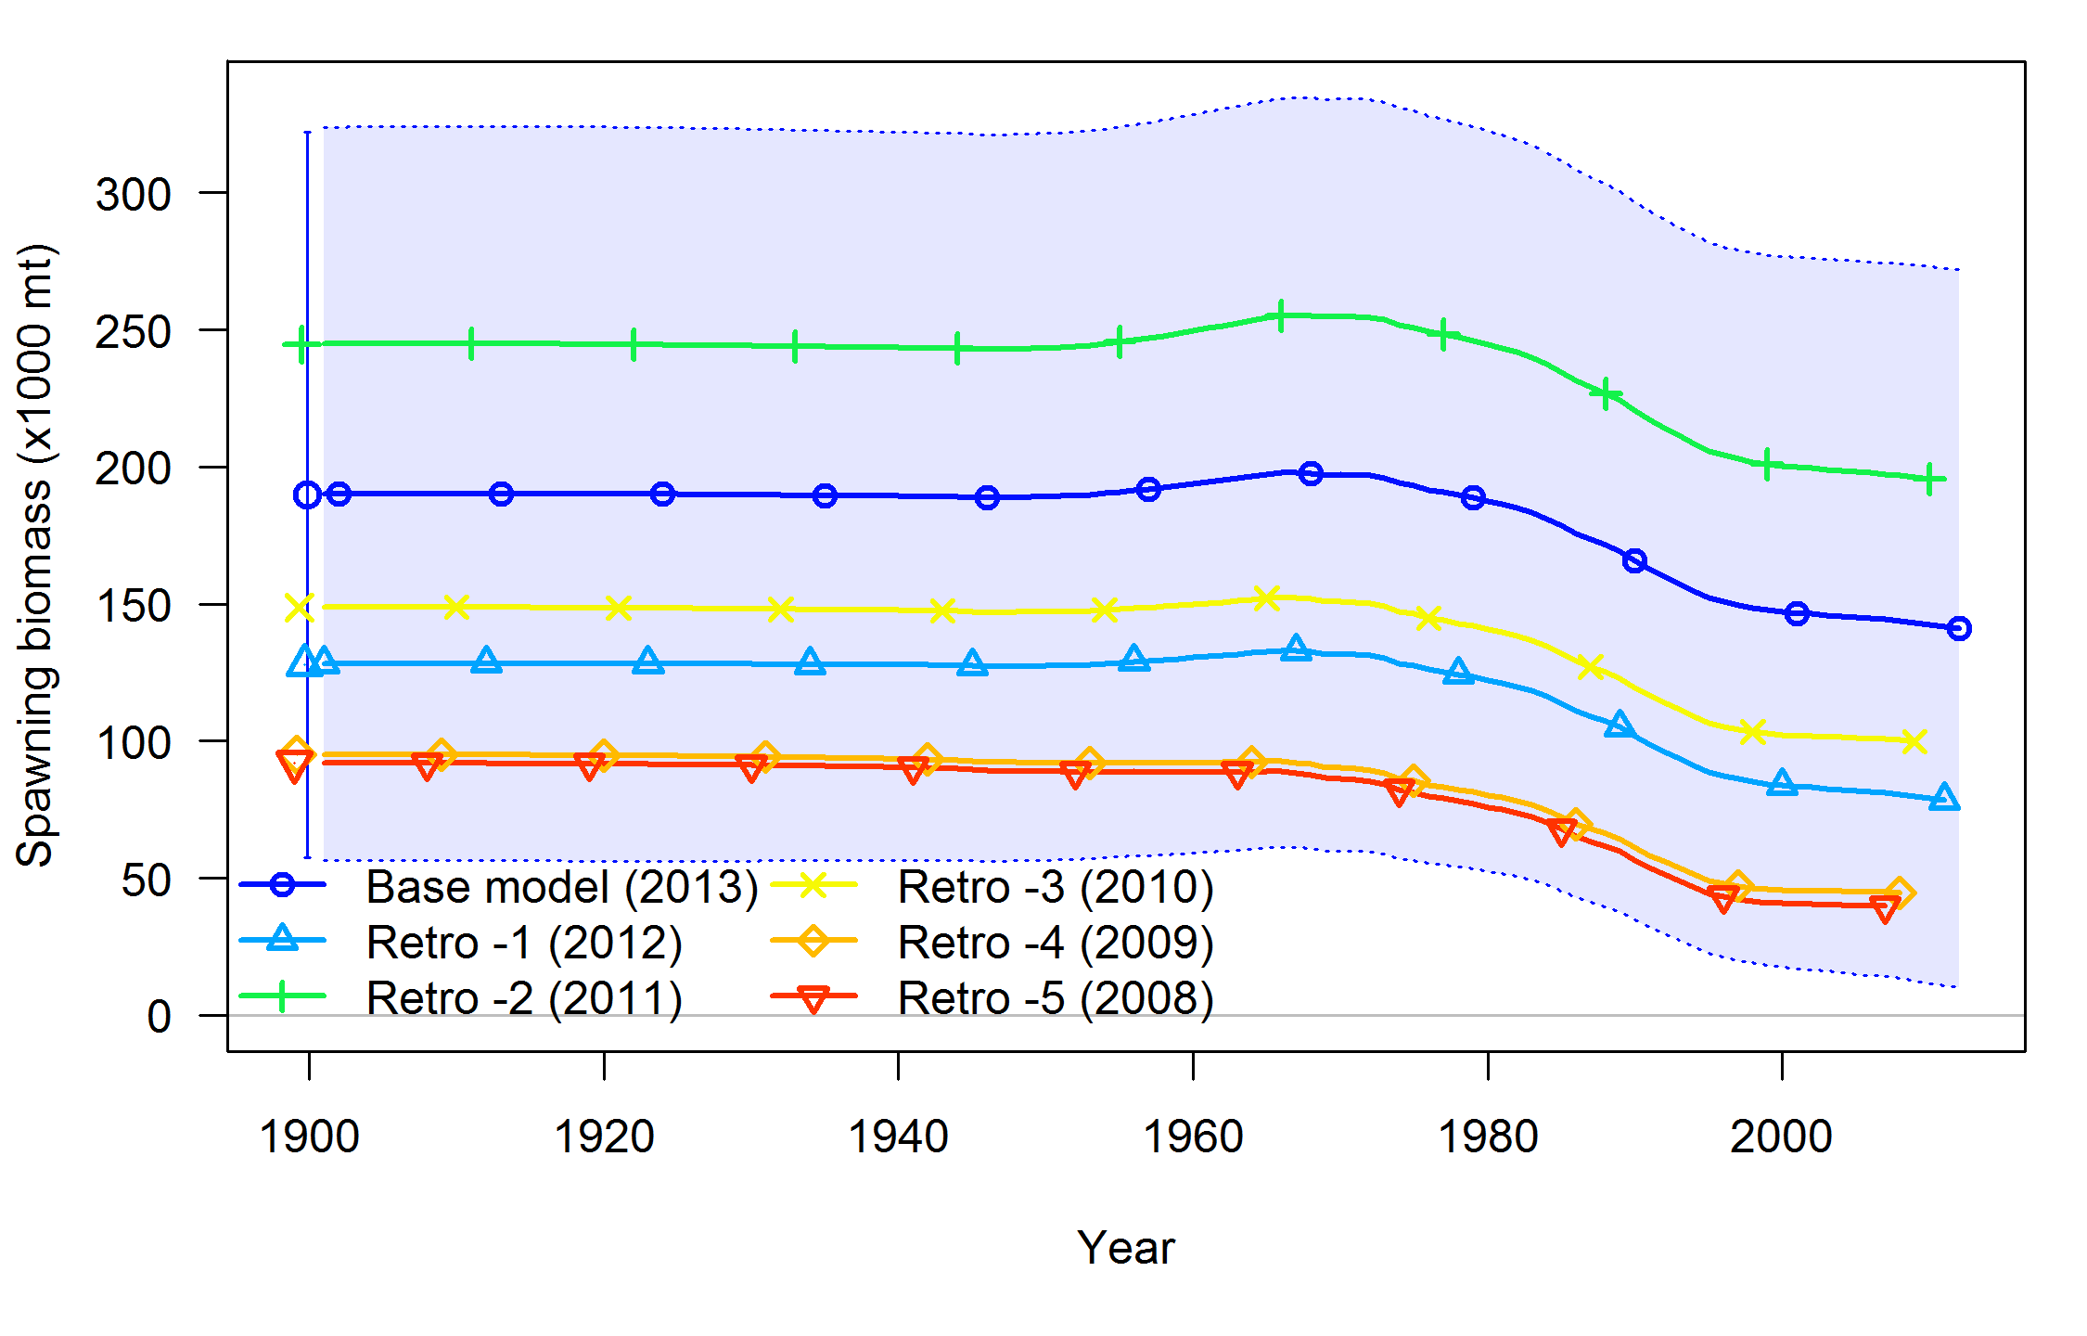

**Figure 65: Time series of spawning biomass in retrospective analysis. The shaded blue region is the 95% interval around the base model, which encompasses the models with 1–5 years of data removed.**

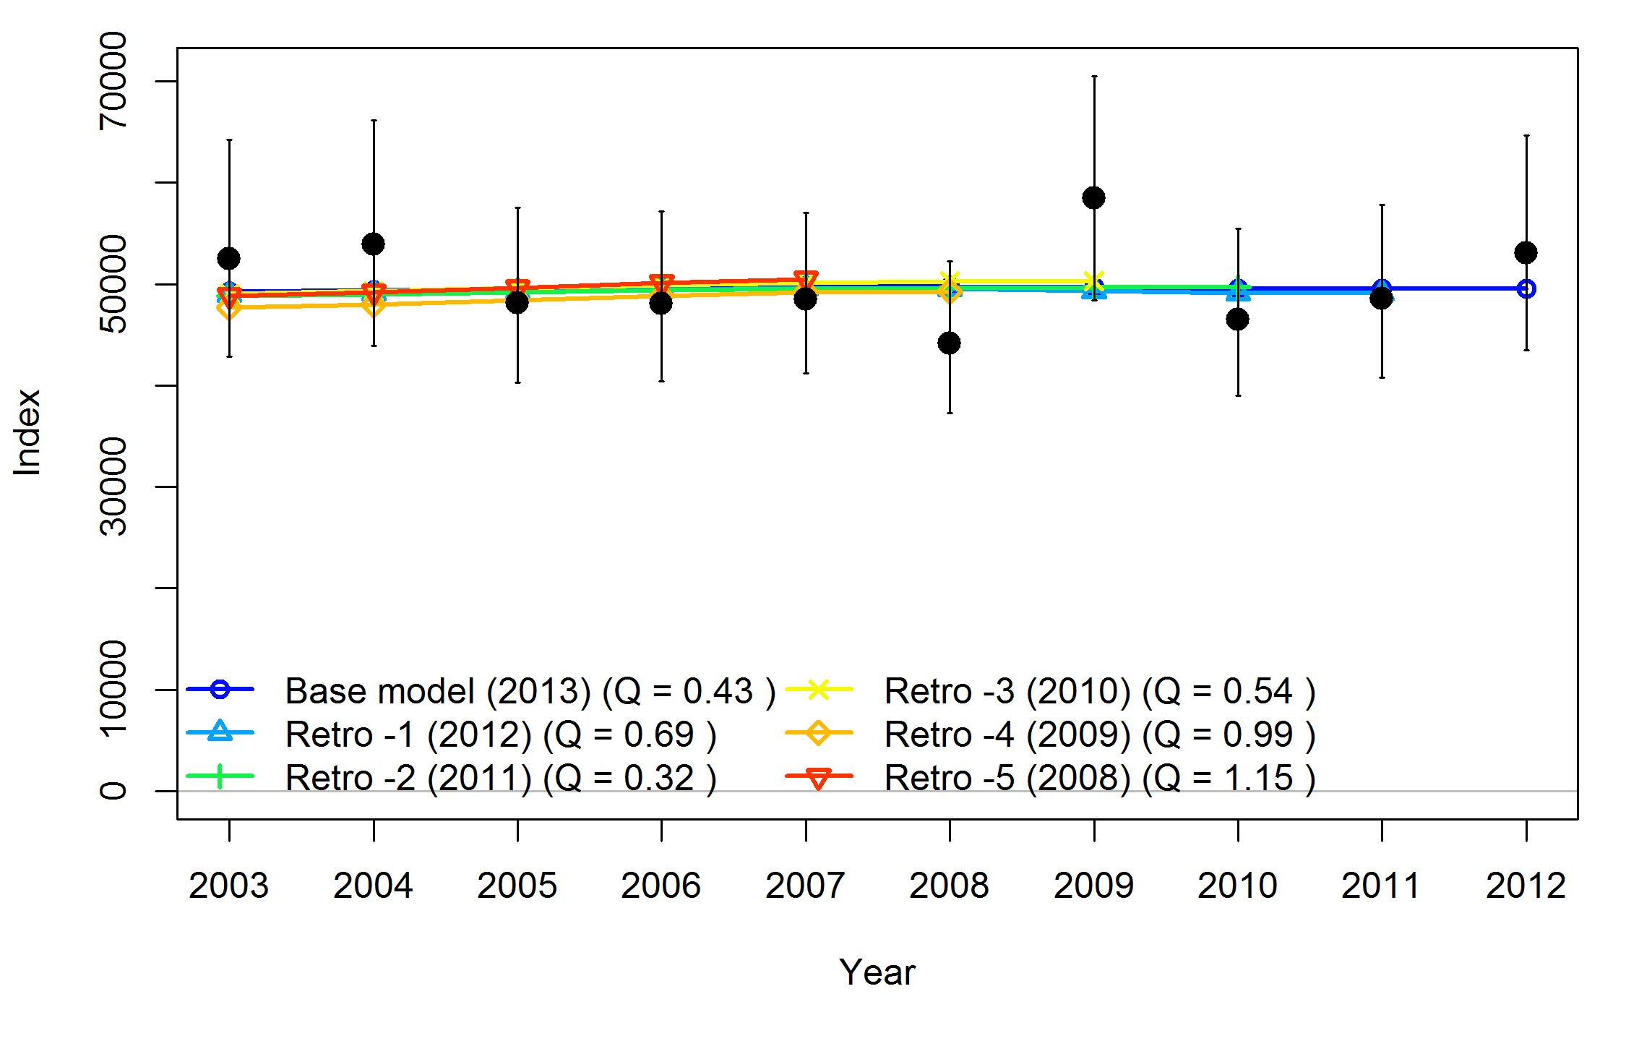

**Figure 66: Fit to NWFSC Combo survey for models in the retrospective analysis. Catchability (Q) values are shown in legend.**

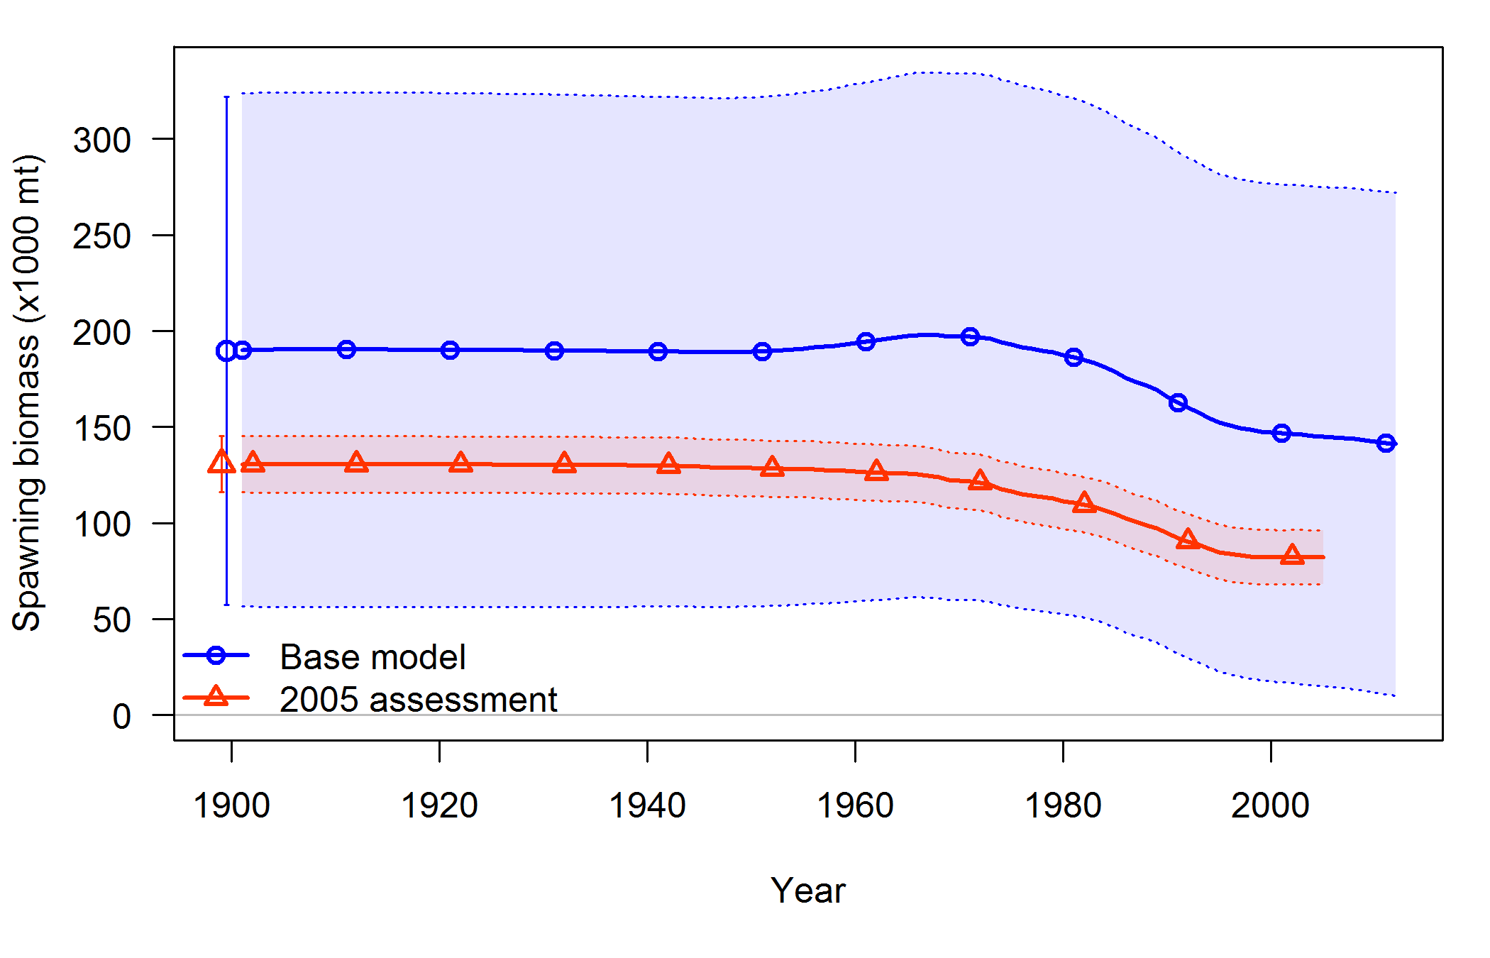

**Figure 67: Comparison of spawning biomass time series and 95% confidence intervals from 2005 assessment and base model.**

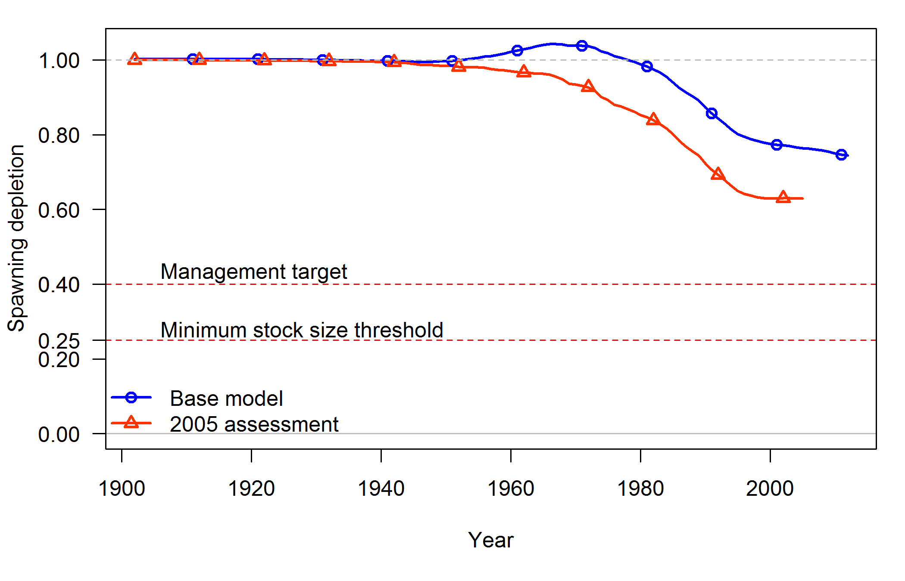

**Figure 68: Comparison of spawning depletion time series from 2005 assessment and base model.**

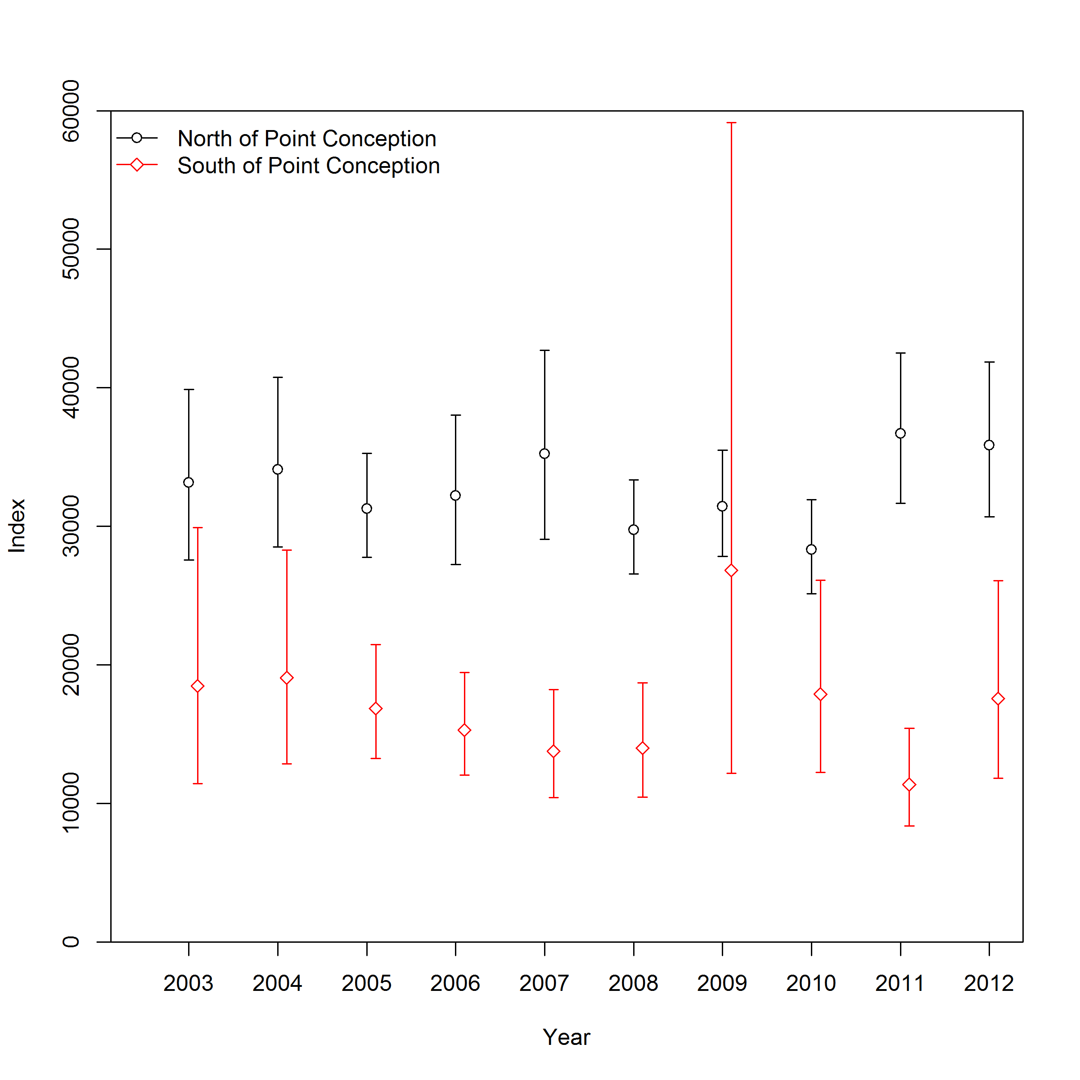

**Figure 69: Subsets of the design-based indices from the NWFSC Combo Survey associated with the strata north and south of Point Conception. The mean value of the southern portion in 34.3% of the total (similar to 34.6% for the GLMM results).**

1. **Estimated numbers at age**

**Table 17: Estimated numbers at age of females**

|  | Age(s) |  |  |  |  |  |  |  |  |  |  |  |  |  |  |  |  |  |  |
| --- | --- | --- | --- | --- | --- | --- | --- | --- | --- | --- | --- | --- | --- | --- | --- | --- | --- | --- | --- |
| Year | 0 | 1 | 2 | 3 | 4 | 5 | 6 | 7 | 8 | 9 | 10-19 | 20-29 | 30-39 | 40-49 | 50-59 | 60-69 | 70-79 | 80-89 | 90+ |
| 1901 | 15.2 | 14.5 | 13.8 | 13.1 | 12.5 | 11.9 | 11.3 | 10.7 | 10.2 | 9.7 | 74.3 | 44.8 | 27.1 | 16.3 | 9.8 | 5.9 | 3.6 | 2.2 | 3.3 |
| 1902 | 15.2 | 14.5 | 13.8 | 13.1 | 12.5 | 11.9 | 11.3 | 10.7 | 10.2 | 9.7 | 74.3 | 44.8 | 27.1 | 16.3 | 9.8 | 5.9 | 3.6 | 2.2 | 3.3 |
| 1903 | 15.2 | 14.5 | 13.8 | 13.1 | 12.5 | 11.8 | 11.3 | 10.7 | 10.2 | 9.7 | 74.3 | 44.8 | 27.1 | 16.3 | 9.8 | 5.9 | 3.6 | 2.2 | 3.3 |
| 1904 | 15.2 | 14.5 | 13.8 | 13.1 | 12.4 | 11.8 | 11.3 | 10.7 | 10.2 | 9.7 | 74.3 | 44.8 | 27.1 | 16.3 | 9.8 | 5.9 | 3.6 | 2.2 | 3.3 |
| 1905 | 15.2 | 14.4 | 13.7 | 13.1 | 12.4 | 11.8 | 11.3 | 10.7 | 10.2 | 9.7 | 74.3 | 44.8 | 27.1 | 16.3 | 9.8 | 5.9 | 3.6 | 2.2 | 3.3 |
| 1906 | 15.2 | 14.4 | 13.7 | 13.1 | 12.4 | 11.8 | 11.2 | 10.7 | 10.2 | 9.7 | 74.3 | 44.8 | 27.1 | 16.3 | 9.8 | 5.9 | 3.6 | 2.2 | 3.3 |
| 1907 | 15.1 | 14.4 | 13.7 | 13.1 | 12.4 | 11.8 | 11.2 | 10.7 | 10.2 | 9.7 | 74.2 | 44.8 | 27.1 | 16.3 | 9.8 | 5.9 | 3.6 | 2.2 | 3.3 |
| 1908 | 15.1 | 14.4 | 13.7 | 13.0 | 12.4 | 11.8 | 11.2 | 10.7 | 10.2 | 9.7 | 74.2 | 44.8 | 27.1 | 16.3 | 9.8 | 5.9 | 3.6 | 2.2 | 3.3 |
| 1909 | 15.1 | 14.4 | 13.7 | 13.0 | 12.4 | 11.8 | 11.2 | 10.7 | 10.2 | 9.7 | 74.2 | 44.8 | 27.0 | 16.3 | 9.9 | 5.9 | 3.6 | 2.2 | 3.3 |
| 1910 | 15.1 | 14.4 | 13.7 | 13.0 | 12.4 | 11.8 | 11.2 | 10.7 | 10.2 | 9.7 | 74.2 | 44.8 | 27.0 | 16.3 | 9.9 | 5.9 | 3.6 | 2.2 | 3.3 |
| 1911 | 15.1 | 14.4 | 13.7 | 13.0 | 12.4 | 11.8 | 11.2 | 10.7 | 10.2 | 9.7 | 74.1 | 44.8 | 27.0 | 16.3 | 9.9 | 5.9 | 3.6 | 2.2 | 3.3 |
| 1912 | 15.1 | 14.4 | 13.7 | 13.0 | 12.4 | 11.8 | 11.2 | 10.7 | 10.1 | 9.7 | 74.1 | 44.8 | 27.0 | 16.3 | 9.9 | 5.9 | 3.6 | 2.2 | 3.3 |
| 1913 | 15.1 | 14.4 | 13.7 | 13.0 | 12.3 | 11.8 | 11.2 | 10.6 | 10.1 | 9.6 | 74.0 | 44.8 | 27.0 | 16.3 | 9.9 | 5.9 | 3.6 | 2.2 | 3.3 |
| 1914 | 15.1 | 14.4 | 13.6 | 13.0 | 12.3 | 11.7 | 11.2 | 10.6 | 10.1 | 9.6 | 74.0 | 44.8 | 27.0 | 16.3 | 9.9 | 5.9 | 3.6 | 2.2 | 3.3 |
| 1915 | 15.1 | 14.3 | 13.6 | 13.0 | 12.3 | 11.7 | 11.2 | 10.6 | 10.1 | 9.6 | 73.9 | 44.8 | 27.0 | 16.3 | 9.9 | 5.9 | 3.6 | 2.2 | 3.3 |
| 1916 | 15.1 | 14.3 | 13.6 | 13.0 | 12.3 | 11.7 | 11.2 | 10.6 | 10.1 | 9.6 | 73.9 | 44.8 | 27.0 | 16.3 | 9.9 | 5.9 | 3.6 | 2.2 | 3.3 |
| 1917 | 15.1 | 14.3 | 13.6 | 13.0 | 12.3 | 11.7 | 11.2 | 10.6 | 10.1 | 9.6 | 73.8 | 44.8 | 27.0 | 16.3 | 9.9 | 5.9 | 3.6 | 2.2 | 3.3 |
| 1918 | 15.1 | 14.3 | 13.6 | 13.0 | 12.3 | 11.7 | 11.2 | 10.6 | 10.1 | 9.6 | 73.8 | 44.8 | 27.0 | 16.3 | 9.8 | 5.9 | 3.6 | 2.2 | 3.3 |
| 1919 | 15.1 | 14.3 | 13.6 | 13.0 | 12.3 | 11.7 | 11.1 | 10.6 | 10.1 | 9.6 | 73.7 | 44.7 | 27.0 | 16.3 | 9.8 | 5.9 | 3.6 | 2.2 | 3.3 |
| 1920 | 15.1 | 14.3 | 13.6 | 13.0 | 12.3 | 11.7 | 11.1 | 10.6 | 10.1 | 9.6 | 73.7 | 44.7 | 27.0 | 16.3 | 9.8 | 5.9 | 3.6 | 2.2 | 3.3 |
| 1921 | 15.1 | 14.3 | 13.6 | 13.0 | 12.3 | 11.7 | 11.1 | 10.6 | 10.1 | 9.6 | 73.6 | 44.7 | 27.0 | 16.3 | 9.8 | 5.9 | 3.6 | 2.2 | 3.3 |
| 1922 | 15.1 | 14.4 | 13.6 | 13.0 | 12.3 | 11.7 | 11.1 | 10.6 | 10.1 | 9.6 | 73.5 | 44.7 | 27.0 | 16.3 | 9.8 | 5.9 | 3.6 | 2.2 | 3.3 |
| 1923 | 15.1 | 14.4 | 13.6 | 13.0 | 12.3 | 11.7 | 11.1 | 10.6 | 10.1 | 9.6 | 73.5 | 44.6 | 27.0 | 16.3 | 9.8 | 5.9 | 3.6 | 2.2 | 3.3 |
| 1924 | 15.2 | 14.4 | 13.7 | 13.0 | 12.3 | 11.7 | 11.1 | 10.6 | 10.1 | 9.6 | 73.4 | 44.6 | 27.0 | 16.3 | 9.8 | 5.9 | 3.6 | 2.2 | 3.3 |
| 1925 | 15.2 | 14.4 | 13.7 | 13.0 | 12.3 | 11.7 | 11.1 | 10.6 | 10.1 | 9.6 | 73.4 | 44.6 | 27.0 | 16.3 | 9.8 | 5.9 | 3.6 | 2.2 | 3.3 |
| 1926 | 15.3 | 14.5 | 13.7 | 13.0 | 12.3 | 11.7 | 11.1 | 10.6 | 10.1 | 9.6 | 73.4 | 44.6 | 27.0 | 16.3 | 9.8 | 5.9 | 3.6 | 2.2 | 3.3 |
| 1927 | 15.3 | 14.5 | 13.7 | 13.0 | 12.4 | 11.7 | 11.1 | 10.6 | 10.1 | 9.6 | 73.3 | 44.5 | 27.0 | 16.3 | 9.8 | 5.9 | 3.6 | 2.2 | 3.3 |
| 1928 | 15.4 | 14.6 | 13.8 | 13.1 | 12.4 | 11.8 | 11.2 | 10.6 | 10.1 | 9.6 | 73.3 | 44.5 | 27.0 | 16.3 | 9.8 | 5.9 | 3.6 | 2.2 | 3.3 |
| 1929 | 15.5 | 14.6 | 13.9 | 13.1 | 12.4 | 11.8 | 11.2 | 10.6 | 10.1 | 9.6 | 73.3 | 44.4 | 27.0 | 16.3 | 9.8 | 5.9 | 3.6 | 2.2 | 3.3 |
| 1930 | 15.6 | 14.7 | 13.9 | 13.2 | 12.5 | 11.8 | 11.2 | 10.6 | 10.1 | 9.6 | 73.3 | 44.4 | 27.0 | 16.3 | 9.8 | 5.9 | 3.6 | 2.2 | 3.3 |
| 1931 | 15.8 | 14.8 | 14.0 | 13.2 | 12.5 | 11.9 | 11.2 | 10.7 | 10.1 | 9.6 | 73.3 | 44.4 | 26.9 | 16.3 | 9.8 | 5.9 | 3.6 | 2.2 | 3.3 |
| 1932 | 15.9 | 15.0 | 14.1 | 13.3 | 12.6 | 11.9 | 11.3 | 10.7 | 10.1 | 9.6 | 73.3 | 44.3 | 26.9 | 16.3 | 9.8 | 5.9 | 3.6 | 2.2 | 3.3 |
| 1933 | 16.1 | 15.1 | 14.2 | 13.4 | 12.7 | 12.0 | 11.3 | 10.7 | 10.2 | 9.6 | 73.3 | 44.3 | 26.9 | 16.3 | 9.8 | 5.9 | 3.6 | 2.2 | 3.3 |
| 1934 | 16.4 | 15.3 | 14.4 | 13.5 | 12.8 | 12.0 | 11.4 | 10.8 | 10.2 | 9.7 | 73.3 | 44.3 | 26.9 | 16.3 | 9.8 | 5.9 | 3.6 | 2.2 | 3.3 |
| 1935 | 16.6 | 15.6 | 14.6 | 13.7 | 12.9 | 12.1 | 11.4 | 10.8 | 10.2 | 9.7 | 73.4 | 44.2 | 26.9 | 16.3 | 9.8 | 5.9 | 3.6 | 2.2 | 3.3 |
| 1936 | 17.0 | 15.8 | 14.8 | 13.9 | 13.0 | 12.2 | 11.5 | 10.9 | 10.3 | 9.7 | 73.5 | 44.2 | 26.8 | 16.3 | 9.8 | 5.9 | 3.6 | 2.2 | 3.3 |
| 1937 | 17.4 | 16.1 | 15.0 | 14.1 | 13.2 | 12.4 | 11.6 | 11.0 | 10.3 | 9.8 | 73.6 | 44.2 | 26.8 | 16.3 | 9.8 | 5.9 | 3.6 | 2.2 | 3.3 |
| 1938 | 17.8 | 16.5 | 15.3 | 14.3 | 13.4 | 12.5 | 11.8 | 11.1 | 10.4 | 9.8 | 73.8 | 44.2 | 26.8 | 16.3 | 9.8 | 5.9 | 3.6 | 2.2 | 3.3 |

**Table 17: Estimated numbers at age of females (continued)**

|  | Age(s) |  |  |  |  |  |  |  |  |  |  |  |  |  |  |  |  |  |  |
| --- | --- | --- | --- | --- | --- | --- | --- | --- | --- | --- | --- | --- | --- | --- | --- | --- | --- | --- | --- |
| Year | 0 | 1 | 2 | 3 | 4 | 5 | 6 | 7 | 8 | 9 | 10-19 | 20-29 | 30-39 | 40-49 | 50-59 | 60-69 | 70-79 | 80-89 | 90+ |
| 1939 | 18.3 | 16.9 | 15.7 | 14.6 | 13.6 | 12.7 | 11.9 | 11.2 | 10.5 | 9.9 | 74.0 | 44.1 | 26.8 | 16.2 | 9.8 | 5.9 | 3.6 | 2.2 | 3.3 |
| 1940 | 18.9 | 17.4 | 16.1 | 14.9 | 13.9 | 12.9 | 12.1 | 11.3 | 10.6 | 10.0 | 74.3 | 44.1 | 26.7 | 16.2 | 9.8 | 5.9 | 3.6 | 2.2 | 3.3 |
| 1941 | 19.6 | 18.0 | 16.6 | 15.3 | 14.2 | 13.2 | 12.3 | 11.5 | 10.8 | 10.1 | 74.7 | 44.1 | 26.7 | 16.2 | 9.8 | 5.9 | 3.6 | 2.2 | 3.3 |
| 1942 | 20.3 | 18.6 | 17.1 | 15.7 | 14.5 | 13.5 | 12.5 | 11.7 | 10.9 | 10.2 | 75.1 | 44.1 | 26.7 | 16.2 | 9.8 | 5.9 | 3.6 | 2.2 | 3.3 |
| 1943 | 21.2 | 19.3 | 17.7 | 16.3 | 15.0 | 13.8 | 12.8 | 11.9 | 11.1 | 10.4 | 75.6 | 44.1 | 26.7 | 16.2 | 9.8 | 5.9 | 3.6 | 2.2 | 3.3 |
| 1944 | 22.0 | 20.1 | 18.4 | 16.8 | 15.5 | 14.2 | 13.1 | 12.2 | 11.3 | 10.6 | 76.2 | 44.1 | 26.6 | 16.2 | 9.8 | 5.9 | 3.6 | 2.2 | 3.3 |
| 1945 | 22.9 | 20.9 | 19.1 | 17.5 | 16.0 | 14.7 | 13.5 | 12.5 | 11.6 | 10.8 | 76.9 | 44.1 | 26.6 | 16.1 | 9.8 | 5.9 | 3.6 | 2.2 | 3.3 |
| 1946 | 23.6 | 21.7 | 19.9 | 18.2 | 16.6 | 15.2 | 14.0 | 12.9 | 11.9 | 11.0 | 77.7 | 44.1 | 26.5 | 16.1 | 9.8 | 5.9 | 3.6 | 2.2 | 3.3 |
| 1947 | 24.0 | 22.4 | 20.7 | 18.9 | 17.3 | 15.8 | 14.5 | 13.3 | 12.2 | 11.3 | 78.8 | 44.1 | 26.5 | 16.1 | 9.7 | 5.9 | 3.6 | 2.2 | 3.3 |
| 1948 | 24.1 | 22.9 | 21.3 | 19.7 | 18.0 | 16.4 | 15.0 | 13.8 | 12.6 | 11.6 | 80.0 | 44.2 | 26.4 | 16.0 | 9.7 | 5.9 | 3.6 | 2.2 | 3.3 |
| 1949 | 23.6 | 22.9 | 21.7 | 20.3 | 18.7 | 17.1 | 15.6 | 14.3 | 13.1 | 12.0 | 81.5 | 44.4 | 26.4 | 16.0 | 9.7 | 5.9 | 3.6 | 2.2 | 3.3 |
| 1950 | 22.6 | 22.4 | 21.8 | 20.7 | 19.3 | 17.8 | 16.3 | 14.9 | 13.6 | 12.4 | 83.2 | 44.5 | 26.4 | 16.0 | 9.7 | 5.9 | 3.6 | 2.2 | 3.3 |
| 1951 | 21.3 | 21.5 | 21.3 | 20.7 | 19.6 | 18.3 | 16.9 | 15.5 | 14.1 | 12.9 | 85.2 | 44.7 | 26.4 | 16.0 | 9.7 | 5.9 | 3.6 | 2.2 | 3.3 |
| 1952 | 19.8 | 20.3 | 20.4 | 20.3 | 19.7 | 18.7 | 17.4 | 16.1 | 14.7 | 13.4 | 87.4 | 44.9 | 26.4 | 15.9 | 9.7 | 5.9 | 3.6 | 2.2 | 3.3 |
| 1953 | 18.3 | 18.9 | 19.3 | 19.4 | 19.3 | 18.7 | 17.8 | 16.6 | 15.3 | 14.0 | 90.0 | 45.2 | 26.4 | 15.9 | 9.7 | 5.9 | 3.6 | 2.1 | 3.3 |
| 1954 | 16.9 | 17.4 | 17.9 | 18.3 | 18.5 | 18.3 | 17.8 | 16.9 | 15.7 | 14.5 | 92.9 | 45.6 | 26.4 | 15.9 | 9.7 | 5.9 | 3.6 | 2.1 | 3.3 |
| 1955 | 15.5 | 16.0 | 16.6 | 17.0 | 17.4 | 17.6 | 17.4 | 16.9 | 16.0 | 15.0 | 96.1 | 46.1 | 26.4 | 15.9 | 9.7 | 5.9 | 3.5 | 2.1 | 3.3 |
| 1956 | 14.3 | 14.8 | 15.3 | 15.8 | 16.2 | 16.5 | 16.7 | 16.6 | 16.1 | 15.3 | 99.4 | 46.6 | 26.4 | 15.9 | 9.6 | 5.9 | 3.5 | 2.1 | 3.3 |
| 1957 | 13.2 | 13.6 | 14.0 | 14.5 | 15.0 | 15.4 | 15.7 | 15.9 | 15.7 | 15.3 | 102.5 | 47.1 | 26.4 | 15.8 | 9.6 | 5.8 | 3.5 | 2.1 | 3.3 |
| 1958 | 12.3 | 12.6 | 12.9 | 13.4 | 13.8 | 14.2 | 14.6 | 15.0 | 15.1 | 15.0 | 105.5 | 47.9 | 26.4 | 15.8 | 9.6 | 5.8 | 3.5 | 2.1 | 3.3 |
| 1959 | 11.4 | 11.7 | 11.9 | 12.3 | 12.7 | 13.1 | 13.5 | 13.9 | 14.2 | 14.3 | 107.8 | 48.7 | 26.5 | 15.8 | 9.6 | 5.8 | 3.5 | 2.1 | 3.3 |
| 1960 | 10.7 | 10.9 | 11.1 | 11.4 | 11.7 | 12.1 | 12.5 | 12.9 | 13.2 | 13.5 | 109.2 | 49.7 | 26.6 | 15.8 | 9.6 | 5.8 | 3.5 | 2.1 | 3.3 |
| 1961 | 10.1 | 10.2 | 10.3 | 10.5 | 10.8 | 11.1 | 11.5 | 11.9 | 12.2 | 12.6 | 109.5 | 50.8 | 26.6 | 15.7 | 9.5 | 5.8 | 3.5 | 2.1 | 3.3 |
| 1962 | 9.7 | 9.6 | 9.7 | 9.8 | 10.0 | 10.3 | 10.6 | 10.9 | 11.3 | 11.6 | 108.6 | 52.1 | 26.8 | 15.7 | 9.5 | 5.8 | 3.5 | 2.1 | 3.3 |
| 1963 | 9.4 | 9.2 | 9.1 | 9.2 | 9.3 | 9.5 | 9.8 | 10.1 | 10.4 | 10.7 | 106.6 | 53.7 | 26.9 | 15.7 | 9.5 | 5.8 | 3.5 | 2.1 | 3.3 |
| 1964 | 9.2 | 8.9 | 8.7 | 8.7 | 8.8 | 8.9 | 9.1 | 9.3 | 9.6 | 9.9 | 103.5 | 55.4 | 27.1 | 15.7 | 9.5 | 5.8 | 3.5 | 2.1 | 3.3 |
| 1965 | 9.3 | 8.8 | 8.5 | 8.3 | 8.3 | 8.3 | 8.4 | 8.6 | 8.8 | 9.1 | 99.5 | 57.3 | 27.4 | 15.7 | 9.5 | 5.8 | 3.5 | 2.1 | 3.3 |
| 1966 | 9.6 | 8.8 | 8.3 | 8.0 | 7.9 | 7.9 | 7.9 | 8.0 | 8.2 | 8.4 | 94.6 | 59.2 | 27.7 | 15.7 | 9.4 | 5.8 | 3.5 | 2.1 | 3.3 |
| 1967 | 10.1 | 9.1 | 8.4 | 7.9 | 7.6 | 7.5 | 7.5 | 7.5 | 7.6 | 7.8 | 88.8 | 60.8 | 27.9 | 15.7 | 9.4 | 5.7 | 3.5 | 2.1 | 3.3 |
| 1968 | 11.0 | 9.6 | 8.6 | 8.0 | 7.5 | 7.3 | 7.1 | 7.1 | 7.1 | 7.2 | 82.8 | 62.3 | 28.2 | 15.6 | 9.4 | 5.7 | 3.5 | 2.1 | 3.3 |
| 1969 | 12.1 | 10.4 | 9.1 | 8.2 | 7.6 | 7.2 | 6.9 | 6.8 | 6.7 | 6.8 | 76.7 | 63.2 | 28.5 | 15.6 | 9.3 | 5.7 | 3.5 | 2.1 | 3.2 |
| 1970 | 13.4 | 11.5 | 9.9 | 8.7 | 7.8 | 7.2 | 6.8 | 6.6 | 6.4 | 6.4 | 71.2 | 63.9 | 29.1 | 15.6 | 9.3 | 5.7 | 3.5 | 2.1 | 3.2 |
| 1971 | 14.6 | 12.7 | 10.9 | 9.4 | 8.3 | 7.4 | 6.8 | 6.5 | 6.2 | 6.1 | 66.1 | 64.0 | 29.7 | 15.6 | 9.3 | 5.6 | 3.5 | 2.1 | 3.2 |
| 1972 | 15.3 | 13.9 | 12.1 | 10.4 | 8.9 | 7.9 | 7.1 | 6.5 | 6.1 | 5.9 | 61.4 | 63.3 | 30.4 | 15.7 | 9.2 | 5.6 | 3.4 | 2.1 | 3.2 |
| 1973 | 15.3 | 14.6 | 13.2 | 11.5 | 9.9 | 8.5 | 7.5 | 6.7 | 6.2 | 5.8 | 57.2 | 61.8 | 31.1 | 15.7 | 9.2 | 5.6 | 3.4 | 2.1 | 3.2 |
| 1974 | 14.8 | 14.6 | 13.8 | 12.5 | 10.9 | 9.4 | 8.1 | 7.1 | 6.4 | 5.9 | 53.5 | 59.2 | 31.7 | 15.6 | 9.1 | 5.5 | 3.4 | 2.1 | 3.2 |
| 1975 | 13.8 | 14.0 | 13.9 | 13.2 | 11.9 | 10.4 | 8.9 | 7.7 | 6.7 | 6.0 | 50.8 | 56.6 | 32.6 | 15.7 | 9.0 | 5.5 | 3.4 | 2.1 | 3.2 |
| 1976 | 13.0 | 13.2 | 13.3 | 13.2 | 12.5 | 11.3 | 9.9 | 8.5 | 7.3 | 6.4 | 48.7 | 53.4 | 33.4 | 15.7 | 9.0 | 5.5 | 3.4 | 2.1 | 3.2 |

**Table 17: Estimated numbers at age of females (continued)**

|  | Age(s) |  |  |  |  |  |  |  |  |  |  |  |  |  |  |  |  |  |  |
| --- | --- | --- | --- | --- | --- | --- | --- | --- | --- | --- | --- | --- | --- | --- | --- | --- | --- | --- | --- |
| Year | 0 | 1 | 2 | 3 | 4 | 5 | 6 | 7 | 8 | 9 | 10-19 | 20-29 | 30-39 | 40-49 | 50-59 | 60-69 | 70-79 | 80-89 | 90+ |
| 1977 | 12.5 | 12.3 | 12.5 | 12.7 | 12.5 | 11.9 | 10.8 | 9.4 | 8.0 | 6.9 | 47.7 | 50.3 | 34.4 | 15.9 | 9.0 | 5.4 | 3.4 | 2.1 | 3.2 |
| 1978 | 12.6 | 11.9 | 11.7 | 11.9 | 12.1 | 11.9 | 11.3 | 10.2 | 8.9 | 7.6 | 47.5 | 46.9 | 35.2 | 16.0 | 8.9 | 5.4 | 3.3 | 2.1 | 3.2 |
| 1979 | 13.0 | 11.9 | 11.3 | 11.1 | 11.3 | 11.5 | 11.3 | 10.7 | 9.7 | 8.5 | 48.3 | 43.5 | 35.8 | 16.2 | 8.9 | 5.4 | 3.3 | 2.1 | 3.2 |
| 1980 | 13.5 | 12.4 | 11.3 | 10.7 | 10.6 | 10.8 | 10.9 | 10.8 | 10.2 | 9.2 | 50.0 | 40.2 | 36.0 | 16.5 | 8.9 | 5.4 | 3.3 | 2.0 | 3.2 |
| 1981 | 14.3 | 12.9 | 11.8 | 10.8 | 10.2 | 10.1 | 10.2 | 10.4 | 10.2 | 9.7 | 52.7 | 37.3 | 36.0 | 16.8 | 8.9 | 5.3 | 3.3 | 2.0 | 3.2 |
| 1982 | 15.5 | 13.6 | 12.2 | 11.2 | 10.3 | 9.7 | 9.6 | 9.7 | 9.8 | 9.7 | 55.7 | 34.5 | 35.4 | 17.1 | 8.9 | 5.3 | 3.3 | 2.0 | 3.2 |
| 1983 | 16.8 | 14.8 | 12.9 | 11.6 | 10.6 | 9.7 | 9.2 | 9.1 | 9.2 | 9.3 | 58.5 | 32.1 | 34.5 | 17.4 | 8.8 | 5.3 | 3.2 | 2.0 | 3.2 |
| 1984 | 17.5 | 16.0 | 14.1 | 12.3 | 11.1 | 10.1 | 9.3 | 8.8 | 8.6 | 8.7 | 60.5 | 29.8 | 33.0 | 17.8 | 8.8 | 5.2 | 3.2 | 2.0 | 3.2 |
| 1985 | 18.0 | 16.7 | 15.2 | 13.4 | 11.7 | 10.5 | 9.6 | 8.8 | 8.3 | 8.1 | 61.7 | 27.9 | 31.2 | 18.1 | 8.8 | 5.2 | 3.2 | 2.0 | 3.1 |
| 1986 | 18.3 | 17.1 | 15.8 | 14.5 | 12.7 | 11.1 | 10.0 | 9.1 | 8.3 | 7.8 | 62.2 | 26.5 | 29.1 | 18.4 | 8.8 | 5.1 | 3.2 | 2.0 | 3.1 |
| 1987 | 17.8 | 17.4 | 16.3 | 15.1 | 13.7 | 12.1 | 10.5 | 9.5 | 8.6 | 7.9 | 62.6 | 25.6 | 27.1 | 18.7 | 8.8 | 5.1 | 3.1 | 2.0 | 3.1 |
| 1988 | 16.8 | 16.9 | 16.5 | 15.5 | 14.3 | 13.1 | 11.5 | 10.0 | 9.0 | 8.2 | 62.9 | 25.4 | 25.1 | 19.0 | 8.8 | 5.0 | 3.1 | 1.9 | 3.1 |
| 1989 | 15.9 | 16.0 | 16.1 | 15.7 | 14.7 | 13.6 | 12.4 | 10.9 | 9.5 | 8.5 | 62.9 | 25.5 | 23.0 | 19.2 | 8.9 | 5.0 | 3.1 | 1.9 | 3.1 |
| 1990 | 15.7 | 15.1 | 15.2 | 15.3 | 14.9 | 14.0 | 12.9 | 11.8 | 10.3 | 9.0 | 62.3 | 25.9 | 20.9 | 19.0 | 8.8 | 4.9 | 3.0 | 1.9 | 3.1 |
| 1991 | 16.3 | 15.0 | 14.4 | 14.4 | 14.6 | 14.2 | 13.3 | 12.2 | 11.1 | 9.7 | 61.7 | 26.7 | 18.9 | 18.6 | 8.9 | 4.9 | 3.0 | 1.9 | 3.1 |
| 1992 | 16.4 | 15.5 | 14.2 | 13.7 | 13.7 | 13.8 | 13.5 | 12.6 | 11.6 | 10.5 | 61.9 | 27.8 | 17.3 | 18.1 | 9.0 | 4.8 | 3.0 | 1.9 | 3.0 |
| 1993 | 13.8 | 15.6 | 14.7 | 13.5 | 13.0 | 13.0 | 13.1 | 12.8 | 11.9 | 10.9 | 62.9 | 28.9 | 15.9 | 17.5 | 9.1 | 4.8 | 2.9 | 1.8 | 3.0 |
| 1994 | 10.9 | 13.2 | 14.8 | 14.0 | 12.8 | 12.3 | 12.4 | 12.4 | 12.1 | 11.2 | 64.3 | 29.6 | 14.6 | 16.6 | 9.2 | 4.7 | 2.9 | 1.8 | 3.0 |
| 1995 | 9.6 | 10.3 | 12.5 | 14.1 | 13.3 | 12.2 | 11.7 | 11.7 | 11.8 | 11.4 | 66.3 | 30.0 | 13.6 | 15.7 | 9.4 | 4.7 | 2.9 | 1.8 | 3.0 |
| 1996 | 9.9 | 9.1 | 9.8 | 11.9 | 13.4 | 12.6 | 11.6 | 11.1 | 11.1 | 11.1 | 69.3 | 30.4 | 13.0 | 14.7 | 9.6 | 4.7 | 2.8 | 1.8 | 3.0 |
| 1997 | 12.2 | 9.4 | 8.7 | 9.3 | 11.3 | 12.7 | 12.0 | 11.0 | 10.5 | 10.5 | 72.1 | 30.7 | 12.6 | 13.7 | 9.8 | 4.7 | 2.8 | 1.8 | 3.0 |
| 1998 | 15.7 | 11.6 | 8.9 | 8.3 | 8.9 | 10.7 | 12.1 | 11.4 | 10.5 | 10.0 | 74.2 | 30.9 | 12.5 | 12.7 | 10.0 | 4.8 | 2.8 | 1.8 | 2.9 |
| 1999 | 14.9 | 14.9 | 11.1 | 8.5 | 7.9 | 8.4 | 10.2 | 11.5 | 10.8 | 9.9 | 75.5 | 31.1 | 12.6 | 11.8 | 10.1 | 4.8 | 2.8 | 1.8 | 2.9 |
| 2000 | 12.7 | 14.1 | 14.2 | 10.5 | 8.1 | 7.5 | 8.0 | 9.7 | 10.9 | 10.3 | 76.7 | 31.5 | 13.1 | 10.8 | 10.1 | 4.9 | 2.8 | 1.7 | 2.9 |
| 2001 | 11.5 | 12.1 | 13.5 | 13.5 | 10.0 | 7.7 | 7.1 | 7.6 | 9.2 | 10.3 | 77.9 | 31.9 | 13.8 | 10.0 | 10.1 | 4.9 | 2.8 | 1.7 | 2.9 |
| 2002 | 10.3 | 10.9 | 11.5 | 12.8 | 12.8 | 9.5 | 7.3 | 6.7 | 7.2 | 8.8 | 78.6 | 32.7 | 14.6 | 9.3 | 10.0 | 5.0 | 2.8 | 1.7 | 2.9 |
| 2003 | 10.3 | 9.8 | 10.4 | 10.9 | 12.2 | 12.2 | 9.0 | 6.9 | 6.4 | 6.9 | 77.3 | 33.9 | 15.4 | 8.7 | 9.7 | 5.1 | 2.8 | 1.7 | 2.9 |
| 2004 | 11.2 | 9.8 | 9.3 | 9.9 | 10.4 | 11.6 | 11.6 | 8.6 | 6.6 | 6.1 | 74.0 | 35.4 | 16.1 | 8.1 | 9.4 | 5.3 | 2.8 | 1.7 | 2.9 |
| 2005 | 13.6 | 10.7 | 9.3 | 8.9 | 9.4 | 9.9 | 11.0 | 11.0 | 8.2 | 6.3 | 69.8 | 37.2 | 16.7 | 7.7 | 8.9 | 5.4 | 2.8 | 1.7 | 2.9 |
| 2006 | 16.4 | 12.9 | 10.2 | 8.8 | 8.4 | 8.9 | 9.4 | 10.4 | 10.5 | 7.7 | 65.8 | 39.1 | 17.1 | 7.4 | 8.5 | 5.6 | 2.8 | 1.7 | 2.8 |
| 2007 | 16.5 | 15.6 | 12.3 | 9.7 | 8.4 | 8.0 | 8.5 | 8.9 | 9.9 | 9.9 | 63.6 | 41.0 | 17.3 | 7.2 | 7.9 | 5.7 | 2.8 | 1.7 | 2.8 |
| 2008 | 15.5 | 15.7 | 14.8 | 11.7 | 9.2 | 8.0 | 7.6 | 8.0 | 8.5 | 9.4 | 63.8 | 42.2 | 17.5 | 7.2 | 7.4 | 5.8 | 2.8 | 1.7 | 2.8 |
| 2009 | 15.1 | 14.7 | 14.9 | 14.1 | 11.1 | 8.7 | 7.6 | 7.2 | 7.6 | 8.0 | 63.6 | 42.9 | 17.7 | 7.2 | 6.8 | 5.9 | 2.8 | 1.7 | 2.8 |
| 2010 | 15.2 | 14.4 | 14.0 | 14.2 | 13.4 | 10.6 | 8.3 | 7.2 | 6.9 | 7.2 | 62.1 | 43.3 | 17.8 | 7.5 | 6.3 | 5.9 | 2.9 | 1.6 | 2.8 |
| 2011 | 13.7 | 14.5 | 13.6 | 13.3 | 13.5 | 12.7 | 10.0 | 7.9 | 6.8 | 6.5 | 59.9 | 43.7 | 17.9 | 7.8 | 5.8 | 5.9 | 2.9 | 1.6 | 2.8 |
| 2012 | 14.4 | 13.0 | 13.8 | 13.0 | 12.6 | 12.8 | 12.1 | 9.5 | 7.5 | 6.5 | 57.2 | 44.1 | 18.3 | 8.3 | 5.4 | 5.8 | 3.0 | 1.6 | 2.8 |
| 2013 | 14.4 | 13.7 | 12.4 | 13.1 | 12.3 | 12.0 | 12.2 | 11.5 | 9.1 | 7.1 | 55.6 | 43.3 | 19.0 | 8.7 | 5.0 | 5.7 | 3.0 | 1.6 | 2.7 |

**Table 18: Estimated numbers at age of males**

|  | Age(s) |  |  |  |  |  |  |  |  |  |  |  |  |  |  |  |  |  |  |
| --- | --- | --- | --- | --- | --- | --- | --- | --- | --- | --- | --- | --- | --- | --- | --- | --- | --- | --- | --- |
| Year | 0 | 1 | 2 | 3 | 4 | 5 | 6 | 7 | 8 | 9 | 10-19 | 20-29 | 30-39 | 40-49 | 50-59 | 60-69 | 70-79 | 80-89 | 90+ |
| 1901 | 15.2 | 14.5 | 13.8 | 13.1 | 12.5 | 11.9 | 11.3 | 10.7 | 10.2 | 9.7 | 74.3 | 44.8 | 27.1 | 16.3 | 9.8 | 5.9 | 3.6 | 2.2 | 3.3 |
| 1902 | 15.2 | 14.5 | 13.8 | 13.1 | 12.5 | 11.9 | 11.3 | 10.7 | 10.2 | 9.7 | 74.3 | 44.8 | 27.1 | 16.3 | 9.8 | 5.9 | 3.6 | 2.2 | 3.3 |
| 1903 | 15.2 | 14.5 | 13.8 | 13.1 | 12.5 | 11.8 | 11.3 | 10.7 | 10.2 | 9.7 | 74.3 | 44.8 | 27.1 | 16.3 | 9.8 | 5.9 | 3.6 | 2.2 | 3.3 |
| 1904 | 15.2 | 14.5 | 13.8 | 13.1 | 12.4 | 11.8 | 11.3 | 10.7 | 10.2 | 9.7 | 74.3 | 44.8 | 27.1 | 16.3 | 9.8 | 5.9 | 3.6 | 2.2 | 3.3 |
| 1905 | 15.2 | 14.4 | 13.7 | 13.1 | 12.4 | 11.8 | 11.3 | 10.7 | 10.2 | 9.7 | 74.3 | 44.8 | 27.1 | 16.3 | 9.8 | 5.9 | 3.6 | 2.2 | 3.3 |
| 1906 | 15.2 | 14.4 | 13.7 | 13.1 | 12.4 | 11.8 | 11.2 | 10.7 | 10.2 | 9.7 | 74.3 | 44.8 | 27.1 | 16.3 | 9.8 | 5.9 | 3.6 | 2.2 | 3.3 |
| 1907 | 15.1 | 14.4 | 13.7 | 13.1 | 12.4 | 11.8 | 11.2 | 10.7 | 10.2 | 9.7 | 74.2 | 44.8 | 27.1 | 16.3 | 9.8 | 5.9 | 3.6 | 2.2 | 3.3 |
| 1908 | 15.1 | 14.4 | 13.7 | 13.0 | 12.4 | 11.8 | 11.2 | 10.7 | 10.2 | 9.7 | 74.2 | 44.8 | 27.1 | 16.3 | 9.8 | 5.9 | 3.6 | 2.2 | 3.3 |
| 1909 | 15.1 | 14.4 | 13.7 | 13.0 | 12.4 | 11.8 | 11.2 | 10.7 | 10.2 | 9.7 | 74.2 | 44.8 | 27.0 | 16.3 | 9.9 | 5.9 | 3.6 | 2.2 | 3.3 |
| 1910 | 15.1 | 14.4 | 13.7 | 13.0 | 12.4 | 11.8 | 11.2 | 10.7 | 10.2 | 9.7 | 74.2 | 44.8 | 27.0 | 16.3 | 9.9 | 5.9 | 3.6 | 2.2 | 3.3 |
| 1911 | 15.1 | 14.4 | 13.7 | 13.0 | 12.4 | 11.8 | 11.2 | 10.7 | 10.2 | 9.7 | 74.1 | 44.8 | 27.0 | 16.3 | 9.9 | 5.9 | 3.6 | 2.2 | 3.3 |
| 1912 | 15.1 | 14.4 | 13.7 | 13.0 | 12.4 | 11.8 | 11.2 | 10.7 | 10.1 | 9.7 | 74.1 | 44.8 | 27.0 | 16.3 | 9.9 | 5.9 | 3.6 | 2.2 | 3.3 |
| 1913 | 15.1 | 14.4 | 13.7 | 13.0 | 12.3 | 11.8 | 11.2 | 10.6 | 10.1 | 9.6 | 74.0 | 44.8 | 27.0 | 16.3 | 9.9 | 5.9 | 3.6 | 2.2 | 3.3 |
| 1914 | 15.1 | 14.4 | 13.6 | 13.0 | 12.3 | 11.7 | 11.2 | 10.6 | 10.1 | 9.6 | 74.0 | 44.8 | 27.0 | 16.3 | 9.9 | 5.9 | 3.6 | 2.2 | 3.3 |
| 1915 | 15.1 | 14.3 | 13.6 | 13.0 | 12.3 | 11.7 | 11.2 | 10.6 | 10.1 | 9.6 | 74.0 | 44.8 | 27.0 | 16.3 | 9.9 | 5.9 | 3.6 | 2.2 | 3.3 |
| 1916 | 15.1 | 14.3 | 13.6 | 13.0 | 12.3 | 11.7 | 11.2 | 10.6 | 10.1 | 9.6 | 73.9 | 44.8 | 27.0 | 16.3 | 9.9 | 5.9 | 3.6 | 2.2 | 3.3 |
| 1917 | 15.1 | 14.3 | 13.6 | 13.0 | 12.3 | 11.7 | 11.2 | 10.6 | 10.1 | 9.6 | 73.8 | 44.8 | 27.0 | 16.3 | 9.8 | 5.9 | 3.6 | 2.2 | 3.3 |
| 1918 | 15.1 | 14.3 | 13.6 | 13.0 | 12.3 | 11.7 | 11.2 | 10.6 | 10.1 | 9.6 | 73.8 | 44.8 | 27.0 | 16.3 | 9.8 | 5.9 | 3.6 | 2.2 | 3.3 |
| 1919 | 15.1 | 14.3 | 13.6 | 13.0 | 12.3 | 11.7 | 11.1 | 10.6 | 10.1 | 9.6 | 73.7 | 44.7 | 27.0 | 16.3 | 9.8 | 5.9 | 3.6 | 2.2 | 3.3 |
| 1920 | 15.1 | 14.3 | 13.6 | 13.0 | 12.3 | 11.7 | 11.1 | 10.6 | 10.1 | 9.6 | 73.7 | 44.7 | 27.0 | 16.3 | 9.8 | 5.9 | 3.6 | 2.2 | 3.3 |
| 1921 | 15.1 | 14.3 | 13.6 | 13.0 | 12.3 | 11.7 | 11.1 | 10.6 | 10.1 | 9.6 | 73.6 | 44.7 | 27.0 | 16.3 | 9.8 | 5.9 | 3.6 | 2.2 | 3.3 |
| 1922 | 15.1 | 14.4 | 13.6 | 13.0 | 12.3 | 11.7 | 11.1 | 10.6 | 10.1 | 9.6 | 73.5 | 44.7 | 27.0 | 16.3 | 9.8 | 5.9 | 3.6 | 2.2 | 3.3 |
| 1923 | 15.1 | 14.4 | 13.6 | 13.0 | 12.3 | 11.7 | 11.1 | 10.6 | 10.1 | 9.6 | 73.5 | 44.7 | 27.0 | 16.3 | 9.8 | 5.9 | 3.6 | 2.2 | 3.3 |
| 1924 | 15.2 | 14.4 | 13.7 | 13.0 | 12.3 | 11.7 | 11.1 | 10.6 | 10.1 | 9.6 | 73.4 | 44.6 | 27.0 | 16.3 | 9.8 | 5.9 | 3.6 | 2.2 | 3.3 |
| 1925 | 15.2 | 14.4 | 13.7 | 13.0 | 12.3 | 11.7 | 11.1 | 10.6 | 10.1 | 9.6 | 73.4 | 44.6 | 27.0 | 16.3 | 9.8 | 5.9 | 3.6 | 2.2 | 3.3 |
| 1926 | 15.3 | 14.5 | 13.7 | 13.0 | 12.3 | 11.7 | 11.1 | 10.6 | 10.1 | 9.6 | 73.4 | 44.6 | 27.0 | 16.3 | 9.8 | 5.9 | 3.6 | 2.2 | 3.3 |
| 1927 | 15.3 | 14.5 | 13.7 | 13.0 | 12.4 | 11.7 | 11.1 | 10.6 | 10.1 | 9.6 | 73.3 | 44.5 | 27.0 | 16.3 | 9.8 | 5.9 | 3.6 | 2.2 | 3.3 |
| 1928 | 15.4 | 14.6 | 13.8 | 13.1 | 12.4 | 11.8 | 11.2 | 10.6 | 10.1 | 9.6 | 73.3 | 44.5 | 27.0 | 16.3 | 9.8 | 5.9 | 3.6 | 2.2 | 3.3 |
| 1929 | 15.5 | 14.6 | 13.9 | 13.1 | 12.4 | 11.8 | 11.2 | 10.6 | 10.1 | 9.6 | 73.3 | 44.4 | 27.0 | 16.3 | 9.8 | 5.9 | 3.6 | 2.2 | 3.3 |
| 1930 | 15.6 | 14.7 | 13.9 | 13.2 | 12.5 | 11.8 | 11.2 | 10.6 | 10.1 | 9.6 | 73.3 | 44.4 | 27.0 | 16.3 | 9.8 | 5.9 | 3.6 | 2.2 | 3.3 |
| 1931 | 15.8 | 14.8 | 14.0 | 13.2 | 12.5 | 11.9 | 11.2 | 10.7 | 10.1 | 9.6 | 73.3 | 44.4 | 26.9 | 16.3 | 9.8 | 5.9 | 3.6 | 2.2 | 3.3 |
| 1932 | 15.9 | 15.0 | 14.1 | 13.3 | 12.6 | 11.9 | 11.3 | 10.7 | 10.1 | 9.6 | 73.3 | 44.3 | 26.9 | 16.3 | 9.8 | 5.9 | 3.6 | 2.2 | 3.3 |
| 1933 | 16.1 | 15.1 | 14.2 | 13.4 | 12.7 | 12.0 | 11.3 | 10.7 | 10.2 | 9.6 | 73.3 | 44.3 | 26.9 | 16.3 | 9.8 | 5.9 | 3.6 | 2.2 | 3.3 |
| 1934 | 16.4 | 15.3 | 14.4 | 13.5 | 12.8 | 12.0 | 11.4 | 10.8 | 10.2 | 9.7 | 73.3 | 44.3 | 26.9 | 16.3 | 9.8 | 5.9 | 3.6 | 2.2 | 3.3 |
| 1935 | 16.6 | 15.6 | 14.6 | 13.7 | 12.9 | 12.1 | 11.4 | 10.8 | 10.2 | 9.7 | 73.4 | 44.2 | 26.9 | 16.3 | 9.8 | 5.9 | 3.6 | 2.2 | 3.3 |
| 1936 | 17.0 | 15.8 | 14.8 | 13.9 | 13.0 | 12.2 | 11.5 | 10.9 | 10.3 | 9.7 | 73.5 | 44.2 | 26.8 | 16.3 | 9.8 | 5.9 | 3.6 | 2.2 | 3.3 |
| 1937 | 17.4 | 16.1 | 15.0 | 14.1 | 13.2 | 12.4 | 11.6 | 11.0 | 10.3 | 9.8 | 73.7 | 44.2 | 26.8 | 16.3 | 9.8 | 5.9 | 3.6 | 2.2 | 3.3 |
| 1938 | 17.8 | 16.5 | 15.3 | 14.3 | 13.4 | 12.5 | 11.8 | 11.1 | 10.4 | 9.8 | 73.8 | 44.2 | 26.8 | 16.3 | 9.8 | 5.9 | 3.6 | 2.2 | 3.3 |

**Table 18: Estimated numbers at age of males (continued)**

|  | Age(s) |  |  |  |  |  |  |  |  |  |  |  |  |  |  |  |  |  |  |
| --- | --- | --- | --- | --- | --- | --- | --- | --- | --- | --- | --- | --- | --- | --- | --- | --- | --- | --- | --- |
| Year | 0 | 1 | 2 | 3 | 4 | 5 | 6 | 7 | 8 | 9 | 10-19 | 20-29 | 30-39 | 40-49 | 50-59 | 60-69 | 70-79 | 80-89 | 90+ |
| 1939 | 18.3 | 16.9 | 15.7 | 14.6 | 13.6 | 12.7 | 11.9 | 11.2 | 10.5 | 9.9 | 74.1 | 44.2 | 26.8 | 16.2 | 9.8 | 5.9 | 3.6 | 2.2 | 3.3 |
| 1940 | 18.9 | 17.4 | 16.1 | 14.9 | 13.9 | 12.9 | 12.1 | 11.3 | 10.6 | 10.0 | 74.3 | 44.1 | 26.7 | 16.2 | 9.8 | 5.9 | 3.6 | 2.2 | 3.3 |
| 1941 | 19.6 | 18.0 | 16.6 | 15.3 | 14.2 | 13.2 | 12.3 | 11.5 | 10.8 | 10.1 | 74.7 | 44.1 | 26.7 | 16.2 | 9.8 | 5.9 | 3.6 | 2.2 | 3.3 |
| 1942 | 20.3 | 18.6 | 17.1 | 15.7 | 14.5 | 13.5 | 12.5 | 11.7 | 10.9 | 10.2 | 75.1 | 44.1 | 26.7 | 16.2 | 9.8 | 5.9 | 3.6 | 2.2 | 3.3 |
| 1943 | 21.2 | 19.3 | 17.7 | 16.3 | 15.0 | 13.8 | 12.8 | 11.9 | 11.1 | 10.4 | 75.6 | 44.1 | 26.7 | 16.2 | 9.8 | 5.9 | 3.6 | 2.2 | 3.3 |
| 1944 | 22.0 | 20.1 | 18.4 | 16.8 | 15.5 | 14.2 | 13.1 | 12.2 | 11.3 | 10.6 | 76.2 | 44.1 | 26.6 | 16.2 | 9.8 | 5.9 | 3.6 | 2.2 | 3.3 |
| 1945 | 22.9 | 20.9 | 19.1 | 17.5 | 16.0 | 14.7 | 13.5 | 12.5 | 11.6 | 10.8 | 76.9 | 44.1 | 26.6 | 16.1 | 9.8 | 5.9 | 3.6 | 2.2 | 3.3 |
| 1946 | 23.6 | 21.7 | 19.9 | 18.2 | 16.6 | 15.2 | 14.0 | 12.9 | 11.9 | 11.0 | 77.8 | 44.1 | 26.5 | 16.1 | 9.8 | 5.9 | 3.6 | 2.2 | 3.3 |
| 1947 | 24.0 | 22.4 | 20.7 | 18.9 | 17.3 | 15.8 | 14.5 | 13.3 | 12.2 | 11.3 | 78.8 | 44.1 | 26.5 | 16.1 | 9.7 | 5.9 | 3.6 | 2.1 | 3.3 |
| 1948 | 24.1 | 22.9 | 21.3 | 19.7 | 18.0 | 16.4 | 15.0 | 13.8 | 12.6 | 11.6 | 80.1 | 44.3 | 26.4 | 16.0 | 9.7 | 5.9 | 3.6 | 2.1 | 3.3 |
| 1949 | 23.6 | 22.9 | 21.7 | 20.3 | 18.7 | 17.1 | 15.6 | 14.3 | 13.1 | 12.0 | 81.5 | 44.4 | 26.4 | 16.0 | 9.7 | 5.9 | 3.6 | 2.1 | 3.3 |
| 1950 | 22.6 | 22.4 | 21.8 | 20.7 | 19.3 | 17.8 | 16.3 | 14.9 | 13.6 | 12.4 | 83.2 | 44.5 | 26.4 | 16.0 | 9.7 | 5.9 | 3.5 | 2.1 | 3.3 |
| 1951 | 21.3 | 21.5 | 21.3 | 20.7 | 19.6 | 18.3 | 16.9 | 15.5 | 14.1 | 12.9 | 85.2 | 44.8 | 26.4 | 16.0 | 9.7 | 5.9 | 3.5 | 2.1 | 3.3 |
| 1952 | 19.8 | 20.3 | 20.4 | 20.3 | 19.7 | 18.7 | 17.4 | 16.1 | 14.7 | 13.4 | 87.5 | 45.0 | 26.4 | 15.9 | 9.7 | 5.9 | 3.5 | 2.1 | 3.3 |
| 1953 | 18.3 | 18.9 | 19.3 | 19.4 | 19.3 | 18.7 | 17.8 | 16.6 | 15.3 | 14.0 | 90.1 | 45.3 | 26.4 | 15.9 | 9.7 | 5.9 | 3.5 | 2.1 | 3.3 |
| 1954 | 16.9 | 17.4 | 17.9 | 18.3 | 18.5 | 18.3 | 17.8 | 16.9 | 15.7 | 14.5 | 93.0 | 45.7 | 26.4 | 15.9 | 9.7 | 5.9 | 3.5 | 2.1 | 3.3 |
| 1955 | 15.5 | 16.0 | 16.6 | 17.0 | 17.4 | 17.6 | 17.4 | 16.9 | 16.0 | 15.0 | 96.1 | 46.1 | 26.4 | 15.9 | 9.7 | 5.9 | 3.5 | 2.1 | 3.3 |
| 1956 | 14.3 | 14.8 | 15.3 | 15.8 | 16.2 | 16.5 | 16.7 | 16.6 | 16.1 | 15.3 | 99.4 | 46.7 | 26.4 | 15.9 | 9.6 | 5.8 | 3.5 | 2.1 | 3.3 |
| 1957 | 13.2 | 13.6 | 14.0 | 14.5 | 15.0 | 15.4 | 15.7 | 15.9 | 15.7 | 15.3 | 102.6 | 47.2 | 26.4 | 15.8 | 9.6 | 5.8 | 3.5 | 2.1 | 3.3 |
| 1958 | 12.3 | 12.6 | 12.9 | 13.4 | 13.8 | 14.2 | 14.6 | 15.0 | 15.1 | 15.0 | 105.6 | 47.9 | 26.4 | 15.8 | 9.6 | 5.8 | 3.5 | 2.1 | 3.3 |
| 1959 | 11.4 | 11.7 | 11.9 | 12.3 | 12.7 | 13.1 | 13.5 | 13.9 | 14.2 | 14.3 | 107.9 | 48.8 | 26.5 | 15.8 | 9.6 | 5.8 | 3.5 | 2.1 | 3.3 |
| 1960 | 10.7 | 10.9 | 11.1 | 11.4 | 11.7 | 12.1 | 12.5 | 12.9 | 13.2 | 13.5 | 109.3 | 49.8 | 26.6 | 15.8 | 9.5 | 5.8 | 3.5 | 2.1 | 3.2 |
| 1961 | 10.1 | 10.2 | 10.3 | 10.5 | 10.8 | 11.1 | 11.5 | 11.9 | 12.2 | 12.6 | 109.6 | 50.9 | 26.7 | 15.7 | 9.5 | 5.8 | 3.5 | 2.1 | 3.2 |
| 1962 | 9.7 | 9.6 | 9.7 | 9.8 | 10.0 | 10.3 | 10.6 | 10.9 | 11.3 | 11.6 | 108.7 | 52.2 | 26.8 | 15.7 | 9.5 | 5.8 | 3.5 | 2.1 | 3.2 |
| 1963 | 9.4 | 9.2 | 9.1 | 9.2 | 9.3 | 9.5 | 9.8 | 10.1 | 10.4 | 10.7 | 106.7 | 53.7 | 27.0 | 15.7 | 9.5 | 5.8 | 3.5 | 2.1 | 3.2 |
| 1964 | 9.2 | 8.9 | 8.7 | 8.7 | 8.8 | 8.9 | 9.1 | 9.3 | 9.6 | 9.9 | 103.6 | 55.5 | 27.2 | 15.7 | 9.5 | 5.8 | 3.5 | 2.1 | 3.2 |
| 1965 | 9.3 | 8.8 | 8.5 | 8.3 | 8.3 | 8.3 | 8.4 | 8.6 | 8.8 | 9.1 | 99.6 | 57.4 | 27.4 | 15.7 | 9.5 | 5.7 | 3.5 | 2.1 | 3.2 |
| 1966 | 9.6 | 8.8 | 8.3 | 8.0 | 7.9 | 7.9 | 7.9 | 8.0 | 8.2 | 8.4 | 94.7 | 59.3 | 27.7 | 15.7 | 9.4 | 5.7 | 3.5 | 2.1 | 3.2 |
| 1967 | 10.1 | 9.1 | 8.4 | 7.9 | 7.6 | 7.5 | 7.5 | 7.5 | 7.6 | 7.8 | 88.9 | 60.9 | 28.0 | 15.7 | 9.4 | 5.7 | 3.5 | 2.1 | 3.2 |
| 1968 | 11.0 | 9.6 | 8.6 | 8.0 | 7.5 | 7.3 | 7.1 | 7.1 | 7.1 | 7.2 | 82.9 | 62.4 | 28.3 | 15.6 | 9.3 | 5.7 | 3.5 | 2.1 | 3.2 |
| 1969 | 12.1 | 10.4 | 9.1 | 8.2 | 7.6 | 7.2 | 6.9 | 6.8 | 6.7 | 6.8 | 76.9 | 63.3 | 28.6 | 15.5 | 9.3 | 5.6 | 3.4 | 2.1 | 3.2 |
| 1970 | 13.4 | 11.5 | 9.9 | 8.7 | 7.8 | 7.2 | 6.8 | 6.6 | 6.4 | 6.4 | 71.4 | 64.1 | 29.1 | 15.6 | 9.2 | 5.6 | 3.4 | 2.1 | 3.2 |
| 1971 | 14.6 | 12.7 | 10.9 | 9.4 | 8.3 | 7.4 | 6.8 | 6.5 | 6.2 | 6.1 | 66.3 | 64.2 | 29.7 | 15.6 | 9.2 | 5.6 | 3.4 | 2.1 | 3.2 |
| 1972 | 15.3 | 13.9 | 12.1 | 10.4 | 8.9 | 7.9 | 7.1 | 6.5 | 6.1 | 5.9 | 61.6 | 63.5 | 30.4 | 15.6 | 9.2 | 5.6 | 3.4 | 2.1 | 3.2 |
| 1973 | 15.3 | 14.6 | 13.2 | 11.5 | 9.9 | 8.5 | 7.5 | 6.7 | 6.2 | 5.8 | 57.4 | 61.9 | 31.1 | 15.6 | 9.1 | 5.5 | 3.4 | 2.1 | 3.2 |
| 1974 | 14.8 | 14.6 | 13.8 | 12.5 | 10.9 | 9.4 | 8.1 | 7.1 | 6.4 | 5.9 | 53.7 | 59.4 | 31.7 | 15.6 | 9.0 | 5.5 | 3.4 | 2.0 | 3.2 |
| 1975 | 13.8 | 14.0 | 13.9 | 13.2 | 11.9 | 10.4 | 8.9 | 7.7 | 6.7 | 6.1 | 51.0 | 56.8 | 32.6 | 15.6 | 9.0 | 5.4 | 3.3 | 2.0 | 3.2 |
| 1976 | 13.0 | 13.2 | 13.3 | 13.2 | 12.5 | 11.3 | 9.9 | 8.5 | 7.3 | 6.4 | 49.0 | 53.7 | 33.4 | 15.7 | 8.9 | 5.4 | 3.3 | 2.0 | 3.1 |

**Table 18: Estimated numbers at age of males (continued)**

|  | Age(s) |  |  |  |  |  |  |  |  |  |  |  |  |  |  |  |  |  |  |
| --- | --- | --- | --- | --- | --- | --- | --- | --- | --- | --- | --- | --- | --- | --- | --- | --- | --- | --- | --- |
| Year | 0 | 1 | 2 | 3 | 4 | 5 | 6 | 7 | 8 | 9 | 10-19 | 20-29 | 30-39 | 40-49 | 50-59 | 60-69 | 70-79 | 80-89 | 90+ |
| 1977 | 12.5 | 12.3 | 12.5 | 12.7 | 12.5 | 11.9 | 10.8 | 9.4 | 8.0 | 6.9 | 47.9 | 50.5 | 34.4 | 15.8 | 8.9 | 5.4 | 3.3 | 2.0 | 3.1 |
| 1978 | 12.6 | 11.9 | 11.7 | 11.9 | 12.1 | 11.9 | 11.3 | 10.2 | 8.9 | 7.6 | 47.7 | 47.1 | 35.2 | 16.0 | 8.9 | 5.3 | 3.3 | 2.0 | 3.1 |
| 1979 | 13.0 | 11.9 | 11.3 | 11.1 | 11.3 | 11.5 | 11.3 | 10.8 | 9.7 | 8.5 | 48.5 | 43.8 | 35.8 | 16.2 | 8.9 | 5.3 | 3.3 | 2.0 | 3.1 |
| 1980 | 13.5 | 12.4 | 11.3 | 10.7 | 10.6 | 10.8 | 10.9 | 10.8 | 10.2 | 9.2 | 50.3 | 40.5 | 36.1 | 16.4 | 8.8 | 5.3 | 3.2 | 2.0 | 3.1 |
| 1981 | 14.3 | 12.9 | 11.8 | 10.8 | 10.2 | 10.1 | 10.2 | 10.4 | 10.2 | 9.7 | 52.9 | 37.6 | 36.0 | 16.7 | 8.8 | 5.2 | 3.2 | 2.0 | 3.1 |
| 1982 | 15.5 | 13.6 | 12.2 | 11.2 | 10.3 | 9.7 | 9.6 | 9.7 | 9.8 | 9.7 | 55.9 | 34.8 | 35.5 | 17.0 | 8.8 | 5.2 | 3.2 | 2.0 | 3.1 |
| 1983 | 16.8 | 14.8 | 12.9 | 11.6 | 10.6 | 9.7 | 9.2 | 9.1 | 9.2 | 9.3 | 58.8 | 32.4 | 34.5 | 17.4 | 8.8 | 5.2 | 3.2 | 2.0 | 3.1 |
| 1984 | 17.5 | 16.0 | 14.1 | 12.3 | 11.1 | 10.1 | 9.3 | 8.8 | 8.6 | 8.7 | 60.9 | 30.1 | 33.0 | 17.7 | 8.7 | 5.1 | 3.1 | 1.9 | 3.0 |
| 1985 | 18.0 | 16.7 | 15.2 | 13.4 | 11.7 | 10.5 | 9.6 | 8.8 | 8.3 | 8.2 | 62.2 | 28.2 | 31.2 | 18.0 | 8.7 | 5.0 | 3.1 | 1.9 | 3.0 |
| 1986 | 18.3 | 17.1 | 15.8 | 14.5 | 12.7 | 11.1 | 10.0 | 9.1 | 8.3 | 7.9 | 62.8 | 26.7 | 29.1 | 18.2 | 8.6 | 5.0 | 3.0 | 1.9 | 3.0 |
| 1987 | 17.8 | 17.4 | 16.3 | 15.1 | 13.7 | 12.1 | 10.5 | 9.5 | 8.6 | 7.9 | 63.3 | 25.9 | 27.1 | 18.6 | 8.6 | 4.9 | 3.0 | 1.9 | 3.0 |
| 1988 | 16.8 | 16.9 | 16.5 | 15.5 | 14.3 | 13.1 | 11.5 | 10.0 | 9.0 | 8.2 | 63.5 | 25.6 | 25.1 | 18.9 | 8.7 | 4.9 | 3.0 | 1.9 | 3.0 |
| 1989 | 15.9 | 16.0 | 16.1 | 15.7 | 14.7 | 13.6 | 12.4 | 10.9 | 9.5 | 8.5 | 63.6 | 25.8 | 23.1 | 19.0 | 8.7 | 4.8 | 2.9 | 1.8 | 2.9 |
| 1990 | 15.7 | 15.1 | 15.2 | 15.3 | 14.9 | 14.0 | 12.9 | 11.8 | 10.3 | 9.0 | 63.1 | 26.2 | 20.9 | 18.8 | 8.7 | 4.7 | 2.9 | 1.8 | 2.9 |
| 1991 | 16.3 | 15.0 | 14.4 | 14.4 | 14.6 | 14.2 | 13.3 | 12.3 | 11.2 | 9.8 | 62.6 | 27.1 | 19.0 | 18.4 | 8.7 | 4.7 | 2.8 | 1.8 | 2.9 |
| 1992 | 16.4 | 15.5 | 14.2 | 13.7 | 13.7 | 13.8 | 13.5 | 12.6 | 11.6 | 10.5 | 62.8 | 28.2 | 17.3 | 17.9 | 8.8 | 4.6 | 2.8 | 1.8 | 2.9 |
| 1993 | 13.8 | 15.6 | 14.7 | 13.5 | 13.0 | 13.0 | 13.1 | 12.8 | 11.9 | 11.0 | 63.9 | 29.3 | 15.9 | 17.2 | 8.9 | 4.6 | 2.8 | 1.7 | 2.8 |
| 1994 | 10.9 | 13.2 | 14.8 | 14.0 | 12.8 | 12.3 | 12.4 | 12.5 | 12.1 | 11.3 | 65.3 | 30.0 | 14.6 | 16.4 | 9.0 | 4.5 | 2.7 | 1.7 | 2.8 |
| 1995 | 9.6 | 10.3 | 12.5 | 14.1 | 13.3 | 12.2 | 11.7 | 11.7 | 11.8 | 11.5 | 67.4 | 30.5 | 13.6 | 15.4 | 9.1 | 4.5 | 2.7 | 1.7 | 2.8 |
| 1996 | 9.9 | 9.1 | 9.8 | 11.9 | 13.4 | 12.6 | 11.6 | 11.1 | 11.1 | 11.2 | 70.4 | 31.0 | 13.0 | 14.5 | 9.3 | 4.5 | 2.7 | 1.7 | 2.8 |
| 1997 | 12.2 | 9.4 | 8.7 | 9.3 | 11.3 | 12.7 | 12.0 | 11.0 | 10.6 | 10.6 | 73.2 | 31.3 | 12.6 | 13.5 | 9.5 | 4.5 | 2.6 | 1.6 | 2.7 |
| 1998 | 15.7 | 11.6 | 8.9 | 8.3 | 8.9 | 10.8 | 12.1 | 11.4 | 10.5 | 10.0 | 75.2 | 31.5 | 12.5 | 12.5 | 9.6 | 4.5 | 2.6 | 1.6 | 2.7 |
| 1999 | 14.9 | 14.9 | 11.1 | 8.5 | 7.9 | 8.4 | 10.2 | 11.5 | 10.8 | 9.9 | 76.5 | 31.8 | 12.7 | 11.6 | 9.8 | 4.6 | 2.6 | 1.6 | 2.7 |
| 2000 | 12.7 | 14.1 | 14.2 | 10.5 | 8.1 | 7.5 | 8.0 | 9.7 | 10.9 | 10.3 | 77.6 | 32.2 | 13.1 | 10.7 | 9.8 | 4.6 | 2.6 | 1.6 | 2.7 |
| 2001 | 11.5 | 12.1 | 13.5 | 13.5 | 10.0 | 7.7 | 7.1 | 7.6 | 9.2 | 10.4 | 78.7 | 32.7 | 13.9 | 9.9 | 9.8 | 4.7 | 2.6 | 1.6 | 2.7 |
| 2002 | 10.3 | 10.9 | 11.5 | 12.8 | 12.8 | 9.5 | 7.3 | 6.7 | 7.3 | 8.8 | 79.3 | 33.5 | 14.7 | 9.2 | 9.7 | 4.8 | 2.6 | 1.6 | 2.7 |
| 2003 | 10.3 | 9.8 | 10.4 | 10.9 | 12.2 | 12.2 | 9.0 | 6.9 | 6.4 | 6.9 | 77.9 | 34.7 | 15.6 | 8.6 | 9.4 | 4.9 | 2.6 | 1.6 | 2.6 |
| 2004 | 11.2 | 9.8 | 9.3 | 9.9 | 10.4 | 11.6 | 11.6 | 8.6 | 6.6 | 6.1 | 74.5 | 36.2 | 16.4 | 8.0 | 9.1 | 5.0 | 2.6 | 1.6 | 2.6 |
| 2005 | 13.6 | 10.7 | 9.3 | 8.9 | 9.4 | 9.9 | 11.0 | 11.0 | 8.2 | 6.3 | 70.2 | 38.0 | 16.9 | 7.6 | 8.7 | 5.2 | 2.6 | 1.6 | 2.6 |
| 2006 | 16.4 | 12.9 | 10.2 | 8.8 | 8.4 | 8.9 | 9.4 | 10.4 | 10.5 | 7.8 | 66.2 | 40.0 | 17.4 | 7.3 | 8.2 | 5.3 | 2.6 | 1.6 | 2.6 |
| 2007 | 16.5 | 15.6 | 12.3 | 9.7 | 8.4 | 8.0 | 8.5 | 8.9 | 9.9 | 9.9 | 63.9 | 41.8 | 17.7 | 7.2 | 7.7 | 5.5 | 2.6 | 1.5 | 2.6 |
| 2008 | 15.5 | 15.7 | 14.8 | 11.7 | 9.2 | 8.0 | 7.6 | 8.1 | 8.5 | 9.4 | 64.1 | 43.0 | 17.9 | 7.1 | 7.2 | 5.6 | 2.6 | 1.5 | 2.6 |
| 2009 | 15.1 | 14.7 | 14.9 | 14.1 | 11.1 | 8.7 | 7.6 | 7.2 | 7.6 | 8.0 | 63.9 | 43.6 | 18.0 | 7.2 | 6.6 | 5.7 | 2.7 | 1.5 | 2.6 |
| 2010 | 15.2 | 14.4 | 14.0 | 14.2 | 13.4 | 10.6 | 8.3 | 7.2 | 6.9 | 7.2 | 62.4 | 44.0 | 18.1 | 7.4 | 6.1 | 5.7 | 2.7 | 1.5 | 2.5 |
| 2011 | 13.7 | 14.5 | 13.6 | 13.3 | 13.5 | 12.7 | 10.0 | 7.9 | 6.8 | 6.5 | 60.2 | 44.4 | 18.3 | 7.8 | 5.6 | 5.7 | 2.7 | 1.5 | 2.5 |
| 2012 | 14.4 | 13.0 | 13.8 | 13.0 | 12.6 | 12.8 | 12.1 | 9.5 | 7.5 | 6.5 | 57.6 | 44.6 | 18.7 | 8.3 | 5.2 | 5.6 | 2.8 | 1.5 | 2.5 |
| 2013 | 14.4 | 13.7 | 12.4 | 13.1 | 12.3 | 12.0 | 12.2 | 11.5 | 9.1 | 7.1 | 56.0 | 43.8 | 19.4 | 8.8 | 4.9 | 5.4 | 2.9 | 1.5 | 2.5 |

1. **SS data file**

# Shortspine Thornyhead data file

# Ian Taylor and Andi Stephens, 2013

#

# uses SSv3.24o (April 10, 2013)

#

### Global model specifications ###

#

1901 # Start_year

2012 # End_year

1 # N seasons per year

12 # Months per season

1 # Spawning season - spawning will occur at beginning of this season

4 # N fishing fleets

5 # N surveys

1 # N areas

#

# Fishery/Survey Names

#

Trawl_N%Trawl_S%Non-trawl_N%Non-trawl_S%Triennial1%Triennial2%AFSCslope%NWFSCslope%NWFSCcombo

#

# Further specifications

#

0.5 0.5 0.5 0.5 0.5 0.5 0.5 0.5 0.5 # Timing of each fishery/survey

1 1 1 1 1 1 1 1 1 # Area of each fleet

1 1 1 1 # Units for catch per fleet: 1=Biomass(mt), 2=Numbers(1000s)

0.01 0.01 0.01 0.01 # SE of log(catch) per fleet for equilibrium and continuous options

2 # Number of genders

100 # Number of ages

#

### Catch section ###

#

# Initial equilibrium catch (landings + discard) by fishing fleet

0 0 0 0

#

# Nyears Catch

# Nyears Catch

112

#NTrawl STrawl NOther SOther Year Season

0 2 0 0 1901 1

0 2 0 0 1902 1

0 4 0 0 1903 1

0 5 0 0 1904 1

0 6 0 0 1905 1

0 8 0 0 1906 1

0 9 0 0 1907 1

0 10 0 0 1908 1

0 11 0 0 1909 1

0 13 0 0 1910 1

0 14 0 0 1911 1

0 15 0 0 1912 1

0 17 0 0 1913 1

0 17 0 0 1914 1

0 19 0 0 1915 1

0 20 0 0 1916 1

0 21 0 0 1917 1

0 23 0 0 1918 1

0 24 0 0 1919 1

0 25 0 0 1920 1

0 26 0 0 1921 1

0 28 0 0 1922 1

0 29 0 0 1923 1

0 30 0 0 1924 1

0 32 0 0 1925 1

0 32 0 0 1926 1

0 34 0 0 1927 1

0 35 0 0 1928 1

0 36 0 0 1929 1

0 38 0 0 1930 1

0 39 0 0 1931 1

0 40 0 0 1932 1

0 49 0 0 1933 1

0 49 0 0 1934 1

0 49 0 0 1935 1

0 51 0 0 1936 1

0 47 0 0 1937 1

0 53 0 0 1938 1

0 63 0 0 1939 1

0 76 0 0 1940 1

0 109 0 0 1941 1

0 122 0 0 1942 1

0 269 0 0 1943 1

0 380 0 0 1944 1

0 453 0 0 1945 1

0 216 0 0 1946 1

0 48 0 0 1947 1

0 152 0 0 1948 1

0 168 0 0 1949 1

0 153 0 0 1950 1

0 305 0 0 1951 1

0 176 0 0 1952 1

0 68 0 0 1953 1

0 128 0 0 1954 1

0 128 0 0 1955 1

0 776 0 0 1956 1

0 286 0 0 1957 1

0 296 0 0 1958 1

0 398 0 0 1959 1

0 472 0 0 1960 1

0 437 0 0 1961 1

0 230 0 0 1962 1

0 285 0 0 1963 1

12 172 0 0 1964 1

20 400 0 0 1965 1

612 543 0 0 1966 1

369 864 0 0 1967 1

168 1835 0 0 1968 1

155 400 0 0 1969 1

149 557 0 0 1970 1

260 582 0 0 1971 1

389 1297 0 0 1972 1

712 2377 0 0 1973 1

215 1244 0 0 1974 1

405 1867 0 0 1975 1

52 992 0 0 1976 1

91 1359 0 0 1977 1

76 1136 0 0 1978 1

109 1720 0 0 1979 1

87 1192 0 0 1980 1

242.3 1622.8 0 0.5 1981 1

553.7 1655.4 0 0.5 1982 1

1492.8 1562.1 0 0.5 1983 1

1681.4 1961.2 0 0.5 1984 1

1345.9 2559.9 0 1.7 1985 1

457.7 2422.3 0 2.6 1986 1

558.3 1953.0 4.2 3.2 1987 1

696.4 2163.1 23.1 2.1 1988 1

1340.4 3506.4 29.3 9.9 1989 1

1917.7 2227.5 27 3.3 1990 1

2157.0 1306.4 53.8 1.5 1991 1

1669.2 1625.1 51.9 9.3 1992 1

2037.1 1773.9 24.4 1.1 1993 1

1835.3 1537.8 20.3 2.9 1994 1

815.0 1064.2 28.1 32.4 1995 1

686.2 830.9 21.2 80.6 1996 1

579.5 771.3 23 40.2 1997 1

504.7 668.9 17 47.3 1998 1

318.9 398.1 17.6 99.3 1999 1

281.9 489.8 13.9 53.3 2000 1

236.2 241.2 12.6 45.6 2001 1

231.4 428.2 10.4 104.1 2002 1

270.2 374.4 10.7 155.2 2003 1

294.6 319.4 10.5 128.8 2004 1

254.7 252.4 10.7 138.9 2005 1

295.7 246.8 15.4 143.7 2006 1

562.4 278.9 16.2 142.5 2007 1

902.0 325.3 19.8 175.4 2008 1

947.7 382.1 28.5 172.2 2009 1

770.3 356.7 22.2 206.1 2010 1

424.3 286.5 24.3 237 2011 1

380.5 322.5 35.7 155.1 2012 1

#

#

### Abundance Indices ###

#

32 # N observations

#

# Units: 0=numbers; 1=biomass; 2=F

# Errtype: -1=normal; 0=lognormal; >0=T

#_Fleet Units Errtype

1 1 0 #_NorthTrawl

2 1 0 #_SouthTrawl

3 1 0 #_NorthOther

4 1 0 #_SouthOther

5 1 0 #_Triennial1

6 1 0 #_Triennial2

7 1 0 #_AFSCslope

8 1 0 #_NWFSCslope

9 1 0 #_NWFSCcombo

### AFSC triennial survey

### Shallow/Deep alternative: Shallow triennial for all years

#Year Seas Fishery Value sd_log

1980 1 5 2660 0.14397

1983 1 5 3415 0.11794

1986 1 5 1636 0.13302

1989 1 5 2010 0.13880

1992 1 5 2064 0.17697

1995 1 5 3480 0.15198

1998 1 5 3076 0.15184

2001 1 5 3698 0.14188

2004 1 5 4117 0.18055

### Shallow/Deep alternative: Deep triennial only for 1995+

#Year Seas Fishery Value sd_log

1995 1 6 3523 0.12239

1998 1 6 2815 0.12634

2001 1 6 3384 0.12357

2004 1 6 3504 0.12889

### AFSC slope survey

#Year Seas Fishery Value sd_log

1997 1 7 27148 0.08413

1999 1 7 25641 0.08243

2000 1 7 31971 0.08342

2001 1 7 31567 0.08090

### NWFSC slope survey

### calculations are in \GLMM_results\NWSurveys_2e5_iter\SSPN_Early\

#Year Seas Fishery Value sd_log

1998 1 8 27416 0.08592

1999 1 8 28311 0.07894

2000 1 8 30897 0.08111

2001 1 8 26376 0.08015

2002 1 8 32404 0.07977

### NWFSC combo survey

### calculations are in \GLMM_results\NWSurveys_2e5_iter\SSPN_Late\

#Year Seas Fishery Value sd_log

2003 1 9 52474 0.10313

2004 1 9 53885 0.10477

2005 1 9 48155 0.09085

2006 1 9 48076 0.08847

2007 1 9 48499 0.08276

2008 1 9 44137 0.08622

2009 1 9 58430 0.09584

2010 1 9 46489 0.09002

2011 1 9 48556 0.08926

2012 1 9 53045 0.10120

#

#

# N fleets with discard

4

#_Fleet Units Errtype

1 2 30

2 2 30

3 2 30

4 2 30

#

# N observations

48

### Pikitch data from John Wallace

### code is in c:/SS/Thornyheads/Data/Pikitch/Pikitch_discard_rates_code.R, which references stuff from John

#Year Seas Fishery Value CV

1985 1 1 0.3007437 0.875096968

1986 1 1 0.3057904 0.871989114

1987 1 1 0.390653 0.755043223

### Discard rates from ECDP taken from 2005 shortspine assessment

#Year Seas Fishery Value CV

1995 1 1 0.132 0.40

1996 1 1 0.155 0.20

1997 1 1 0.201 0.21

1998 1 1 0.136 0.22

1999 1 1 0.252 0.30

### WCGOP data based on code from Jason Jannot

#Year Seas Fishery Value CV #_note

2002 1 1 0.335245159 0.086828889 #_Bottom_Trawl_WAOR

2003 1 1 0.432544649 0.077544931 #_Bottom_Trawl_WAOR

2004 1 1 0.241343211 0.104530141 #_Bottom_Trawl_WAOR

2005 1 1 0.199355761 0.168445593 #_Bottom_Trawl_WAOR

2006 1 1 0.179544612 0.168130911 #_Bottom_Trawl_WAOR

2007 1 1 0.108599973 0.180051291 #_Bottom_Trawl_WAOR

2008 1 1 0.046659398 0.230100051 #_Bottom_Trawl_WAOR

2009 1 1 0.101435957 0.191825142 #_Bottom_Trawl_WAOR

2010 1 1 0.087443339 0.222646136 #_Bottom_Trawl_WAOR

2011 1 1 0.006739797 0.001 #_Bottom_Trawl_WAOR_catch-shares_fully_observed_has_assumed_tiny_CV

2002 1 2 0.279645087 0.151118174 #_Bottom_Trawl_CA

2003 1 2 0.201024932 0.141541966 #_Bottom_Trawl_CA

2004 1 2 0.209662602 0.237090534 #_Bottom_Trawl_CA

2005 1 2 0.151047698 0.205977662 #_Bottom_Trawl_CA

2006 1 2 0.095571796 0.314441499 #_Bottom_Trawl_CA

2007 1 2 0.028857912 0.266351701 #_Bottom_Trawl_CA

2008 1 2 0.025042737 0.244805907 #_Bottom_Trawl_CA

2009 1 2 0.024825575 0.186500398 #_Bottom_Trawl_CA

2010 1 2 0.02119381 0.223866125 #_Bottom_Trawl_CA

2011 1 2 0.008817099 0.001 #_Bottom_Trawl_CA_catch-shares_fully_observed_has_assumed_tiny_CV

2002 1 3 0.04212257 0.363439925 #_H&L_WAOR

2003 1 3 0.115775182 0.378023795 #_H&L_WAOR

2004 1 3 0.137199236 0.562925392 #_H&L_WAOR

2005 1 3 0.086555528 0.24160193 #_H&L_WAOR

2006 1 3 0.145679196 0.739064372 #_H&L_WAOR

2007 1 3 0.229120952 0.320967658 #_H&L_WAOR

2008 1 3 0.111293876 0.426373646 #_H&L_WAOR

2009 1 3 0.063697859 2.135161651 #_H&L_WAOR

2010 1 3 0.100494748 0.306851214 #_H&L_WAOR

2011 1 3 0.098921828 0.419172661 #_H&L_WAOR

2002 1 4 0.209165098 0.286389385 #_H&L_CA

2003 1 4 0.172752926 0.161447006 #_H&L_CA

2004 1 4 0.123425508 0.207194228 #_H&L_CA

2005 1 4 0.063810176 0.232701577 #_H&L_CA

2006 1 4 0.112808086 0.302538535 #_H&L_CA

2007 1 4 0.063235119 0.115288264 #_H&L_CA

2008 1 4 0.051092247 0.167925949 #_H&L_CA

2009 1 4 0.062246542 0.145575545 #_H&L_CA

2010 1 4 0.087162496 0.210516003 #_H&L_CA

2011 1 4 0.04912734 0.101605531 #_H&L_CA_combination_of_catch-shares_and_non-catch-shares

##

### Average weight of discards

# Value is from Wghtd_AVG_W

# CV is ratio of AVG_WEIGHT.SD/AVG_WEIGHT.MEAN

40 #N observations

30 #Degrees of freedom for Student's T distribution used to evaluate mean body weight deviations.

# (Not conditional, must be here even if no mean body wt observations.)

#Year Seas Fleet Partition Value CV # Gear State

2002 1 1 1 0.364642072 2.118749079 # ALL TRAWL WA-OR

2003 1 1 1 0.431779002 1.264625597 # ALL TRAWL WA-OR

2004 1 1 1 0.372344756 1.025736743 # ALL TRAWL WA-OR

2005 1 1 1 0.343027331 0.814245184 # ALL TRAWL WA-OR

2006 1 1 1 0.310969633 12.62000381 # ALL TRAWL WA-OR

2007 1 1 1 0.256335672 0.743340316 # ALL TRAWL WA-OR

2008 1 1 1 0.181144246 1.006699102 # ALL TRAWL WA-OR

2009 1 1 1 0.228195667 0.621404079 # ALL TRAWL WA-OR

2010 1 1 1 0.230299418 1.63260079 # ALL TRAWL WA-OR

2011 1 1 1 0.132364976 2.519562237 # ALL TRAWL WA-OR

2002 1 2 1 1.203992327 0.939911162 # ALL TRAWL CA

2003 1 2 1 0.951036879 0.924020709 # ALL TRAWL CA

2004 1 2 1 0.866807099 0.931865538 # ALL TRAWL CA

2005 1 2 1 0.859717225 1.04266895 # ALL TRAWL CA

2006 1 2 1 0.606677363 1.088379327 # ALL TRAWL CA

2007 1 2 1 0.233209182 2.866227179 # ALL TRAWL CA

2008 1 2 1 0.240984699 1.573568927 # ALL TRAWL CA

2009 1 2 1 0.283314819 1.347244662 # ALL TRAWL CA

2010 1 2 1 0.289119393 1.843418882 # ALL TRAWL CA

2011 1 2 1 0.241109466 1.218321567 # ALL TRAWL CA

2002 1 3 1 0.935587086 0.796707154 # OTHER GEAR WA-OR

2003 1 3 1 1.362731591 0.794783992 # OTHER GEAR WA-OR

2004 1 3 1 1.289451512 0.640189562 # OTHER GEAR WA-OR

2005 1 3 1 1.230766218 0.75118062 # OTHER GEAR WA-OR

2006 1 3 1 1.70271943 0.485157236 # OTHER GEAR WA-OR

2007 1 3 1 1.941936392 0.603611928 # OTHER GEAR WA-OR

2008 1 3 1 1.4616857 0.603113256 # OTHER GEAR WA-OR

2009 1 3 1 1.538109678 0.581701899 # OTHER GEAR WA-OR

2010 1 3 1 1.515242478 0.733887181 # OTHER GEAR WA-OR

2011 1 3 1 1.929418253 0.866996647 # OTHER GEAR WA-OR

2002 1 4 1 0.773613445 0.866608059 # OTHER GEAR CA

2003 1 4 1 0.938616528 0.665412757 # OTHER GEAR CA

2004 1 4 1 0.863882591 0.680271218 # OTHER GEAR CA

2005 1 4 1 0.940173578 0.956812123 # OTHER GEAR CA

2006 1 4 1 0.617362917 0.555537579 # OTHER GEAR CA

2007 1 4 1 0.232538998 0.688254613 # OTHER GEAR CA

2008 1 4 1 0.411108216 1.06005575 # OTHER GEAR CA

2009 1 4 1 0.280832591 0.799593801 # OTHER GEAR CA

2010 1 4 1 1.044745397 0.706886658 # OTHER GEAR CA

2011 1 4 1 0.927216543 0.547415781 # OTHER GEAR CA

#

# Length data

2 # length bin method: 1=use databins; 2=generate from binwidth,min,max below; 3=read vector

# no additional input for option 1

# read binwidth, minsize, lastbin size for option 2

2 # width

4 # minsize

90 # maxsize

# read N poplen bins, then vector of bin lower boundaries, for option 3

-0.001 #_comp_tail_compression

0.001 #_add_to_comp

0 #_combine males into females at or below this bin number

34 #_N_LengthBins

6 8 10 12 14 16 18 20 22 24 26 28 30 32 34 36 38 40 42 44 46 48 50 52 54 56 58 60 62 64 66 68 70 72

#

161 # number of observations

### multiplier for inputN = N^p : p = 0.6 # this multiplier is applied to column "CC" which is number of fish

### PacFIN comps

# created by Andi's excellent code

# Fully expanded combined sexes from "SSPN_Fully_Expanded_Comps.csv"

### Trawl North

#_year Season Fleet gender partition inputN U6 U8 U10 U12 U14 U16 U18 U20 U22 U24 U26 U28 U30 U32 U34 U36 U38 U40 U42 U44 U46 U48 U50 U52 U54 U56 U58 U60 U62 U64 U66 U68 U70 U72 M6 M8 M10 M12 M14 M16 M18 M20 M22 M24 M26 M28 M30 M32 M34 M36 M38 M40 M42 M44 M46 M48 M50 M52 M54 M56 M58 M60 M62 M64 M66 M68 M70 M72

1979 1 1 0 2 38.9 0 0 0 0 0 626.405277 245.2673267 613.1683168 367.9009901 382.1549086 543.2271306 441.1096005 855.4398016 492.7851167 324.285983 485.330046 657.8250564 947.9139122 960.1600227 700.4440979 30.04661492 663.1640505 172.6142808 419.0054398 46.65726309 85.52705684 14.23926427 25.55222486 25.55222486 0 0 64.34140985 1.002304147 25.55222486 0 0 0 0 0 0 0 0 0 0 0 0 0 0 0 0 0 0 0 0 0 0 0 0 0 0 0 0 0 0 0 0 0 0

1980 1 1 0 2 28.6 0 0 0 0 0 0 0 21.21710526 0 122.6336634 21.21710526 21.21710526 40.11976048 282.4445531 203.8220521 260.5324311 467.6516855 496.4119063 331.7925783 407.8986385 517.7768373 48.12972771 251.4923642 256.4891968 10.22187005 28.28491771 11.22187005 11.79527632 122.6336634 1 1 10.22187005 0 20.4437401 0 0 0 0 0 0 0 0 0 0 0 0 0 0 0 0 0 0 0 0 0 0 0 0 0 0 0 0 0 0 0 0 0 0

1981 1 1 0 2 22.6 0 0 0 0 0 0 0 0 0 0 277.971774 0 1348.552644 2062.147007 5650.532506 6084.687444 2394.169716 4559.779356 2785.345084 1810.685872 1573.630928 1295.659154 2844.990843 12.12532049 24.25064097 12.14961973 1307.760175 1283.509534 2579.168689 12.12532049 1283.509534 12.12532049 24.29923945 0 0 0 0 0 0 0 0 0 0 0 0 0 0 0 0 0 0 0 0 0 0 0 0 0 0 0 0 0 0 0 0 0 0 0

1982 1 1 0 2 22.6 0 0 0 0 0 0 0 0 141.0262467 523.7816039 141.0262467 423.07874 10593.11699 9648.898821 11532.73854 9160.438533 5642.774642 5319.226579 2553.118058 4054.820602 465.1924954 334.0209858 2170.362701 5783.838837 416.4581239 4423.16254 82.43713818 2077.45264 334.0209858 223.4633848 1525.550574 82.43713818 141.0262467 0 0 0 0 0 0 0 0 0 0 0 0 0 0 0 0 0 0 0 0 0 0 0 0 0 0 0 0 0 0 0 0 0 0 0

1990 1 1 0 2 42.1 0 0 0 0 0 1924.947776 1924.947776 5774.843327 14905.72696 27666.4423 27568.48558 9864.88148 1847.069815 9069.830075 3772.017591 6735.382671 23359.59467 13018.97501 26320.15453 25028.71237 26662.50566 12421.50806 20480.45837 15608.68916 7337.181167 14522.01441 8209.002571 6600.967396 10315.25531 3668.590584 7106.252976 5593.538359 1310.278071 1924.947776 0 0 0 0 0 0 0 0 0 0 0 0 0 0 0 0 0 0 0 0 0 0 0 0 0 0 0 0 0 0 0 0 0 0

1991 1 1 0 2 65.3 0 0 0 0 0 0 333.0456247 88.90879198 21413.24098 95250.41859 136595.7272 112333.1227 63427.36283 67626.86423 81490.72307 48402.43843 49514.35549 38630.29679 48288.54562 31287.06857 13839.40397 27694.53994 14511.73812 18100.01391 20159.8324 3823.740062 14620.92732 27283.52312 18611.36944 3510.248662 4349.627476 5017.623552 6831.453701 2482.803179 0 0 0 0 0 0 0 0 0 0 0 0 0 0 0 0 0 0 0 0 0 0 0 0 0 0 0 0 0 0 0 0 0 0

1992 1 1 0 2 71.3 0 0 0 0 0 4283.744261 5365.500935 15786.07435 54077.76801 45113.94088 99010.53391 53393.14192 42060.32429 47565.41457 34056.01912 35960.07155 22932.44589 45892.84618 15861.34611 19599.85997 9312.347789 16244.28191 31189.5984 9706.523002 12366.41858 4476.463287 9724.578872 6652.978035 9464.414855 5092.78775 2658.936613 1706.325623 1145.240451 338.6720152 0 0 0 0 0 0 0 0 0 0 0 0 0 0 0 0 0 0 0 0 0 0 0 0 0 0 0 0 0 0 0 0 0 0

1993 1 1 0 2 30.2 0 0 0 0 0 0 5416.211353 39546.82712 52125.0825 52115.5363 57267.77154 63774.80354 14586.66515 37637.42123 49721.20008 16917.67653 14122.83002 8063.225695 12965.58343 6993.775095 27168.29731 23347.55616 10045.06738 9457.51208 2973.246148 11090.42812 9460.622373 2973.246148 26305.33322 1971.631769 13184.11758 3329.746643 1971.631769 8485.702754 0 0 0 0 0 0 0 0 0 0 0 0 0 0 0 0 0 0 0 0 0 0 0 0 0 0 0 0 0 0 0 0 0 0

# next two values turned off after investigation of outliers

1994 1 -1 0 2 9.1 0 0 12713.39147 38140.1744 0 76280.34879 63566.95733 88993.74026 25426.78293 12713.39147 0 0 0 0 0 0 0 0 0 0 0 0 0 0 0 0 0 0 0 0 0 0 0 0 0 0 0 0 0 0 0 0 0 0 0 0 0 0 0 0 0 0 0 0 0 0 0 0 0 0 0 0 0 0 0 0 0 0

1995 1 -1 0 2 6.7 0 0 0 0 0 0 0 0 0 0 0 0 0 622.5845188 0 622.5845188 622.5845188 622.5845188 1245.169038 622.5845188 2490.338075 622.5845188 0 1245.169038 0 0 622.5845188 11422.21299 0 5711.106497 5711.106497 5711.106497 0 0 0 0 0 0 0 0 0 0 0 0 0 0 0 0 0 0 0 0 0 0 0 0 0 0 0 0 0 0 0 0 0 0 0 0

1996 1 1 0 2 41.5 0 0 0 0 0 0 1654.26599 2424.662486 27660.50029 23466.08213 32985.46835 28967.09679 22002.39485 48447.13798 15307.46481 26874.7827 44070.24734 22224.84517 7997.711487 8774.533502 7183.915352 6620.098545 1305.839118 626.1648094 3929.045226 1612.34413 2042.524985 2150.031018 0 1198.299426 0 0 1198.299426 0 0 0 0 0 0 0 0 0 0 0 0 0 0 0 0 0 0 0 0 0 0 0 0 0 0 0 0 0 0 0 0 0 0 0

1997 1 1 0 2 104.6 0 0 0 0 635.1738665 640.5539514 5445.218045 7073.243147 15270.90073 14909.45973 21221.76311 15992.63334 9975.498658 10462.8571 10228.1183 7864.847433 9055.687749 6689.867269 5458.986106 7636.338759 4152.832393 5469.863328 6534.989123 4186.716302 5239.854646 3614.080987 3242.603434 3246.350192 2414.441641 556.5159002 733.1062255 88.80798926 734.472811 88.80798926 0 0 0 0 0 0 0 0 0 0 0 0 0 0 0 0 0 0 0 0 0 0 0 0 0 0 0 0 0 0 0 0 0 0

1998 1 1 0 2 53.4 0 0 0 0 0 0 6695.932686 21202.13222 43547.93777 30340.33423 39605.16146 40890.86669 35235.81211 15335.56476 18521.83533 15062.30927 20943.48222 15149.56165 8689.484335 7862.757955 8115.447606 4713.698503 8927.532915 4263.478204 4517.327663 4988.636735 4295.649537 5138.374729 735.1896078 1535.326124 794.5993269 968.8591766 1605.980917 0 0 0 0 0 0 0 0 0 0 0 0 0 0 0 0 0 0 0 0 0 0 0 0 0 0 0 0 0 0 0 0 0 0 0

1999 1 1 0 2 56 0 0 0 0 0 0 284.2626852 568.5253705 6696.922718 13356.3953 10408.70391 16148.00183 16960.76337 12954.29842 11622.35575 15145.2801 13471.35841 12133.86768 7330.49254 7065.859455 6246.046354 3751.049233 4582.173221 3657.343824 2418.061644 2243.937905 3873.707222 5021.455746 1872.267058 521.7329404 773.2022583 702.0059588 997.6469031 67.41086536 0 0 0 0 0 0 0 0 0 0 0 0 0 0 0 0 0 0 0 0 0 0 0 0 0 0 0 0 0 0 0 0 0 0

2000 1 1 0 2 49.2 0 0 0 0 0 0 0 1638.429484 2102.196242 6162.208956 9181.985259 14403.85118 6281.298891 8778.052288 9300.03407 11527.23672 10165.13913 11958.56879 6209.975413 3528.248 5128.884231 6909.749538 4897.094214 3221.659307 3451.945944 2437.368143 2381.868326 1670.981282 2820.286896 1674.2899 839.3506021 111.4432515 80.08084897 272.5284633 0 0 0 0 0 0 0 0 0 0 0 0 0 0 0 0 0 0 0 0 0 0 0 0 0 0 0 0 0 0 0 0 0 0

2001 1 1 0 2 84.7 0 0 0 0 0 15.11692596 232.9897173 3597.255614 3942.158152 3952.050931 5540.840173 7142.354854 5057.200388 4614.118306 7306.099677 4497.135176 4729.396794 3887.309812 4160.380501 4500.160838 5048.766867 4384.068209 2444.298217 3277.014306 3774.857303 2917.975266 2851.207554 2287.438972 2053.979954 958.7921025 420.343676 88.69178368 447.5078842 31.88475175 0 0 0 0 0 0 0 0 0 0 0 0 0 0 0 0 0 0 0 0 0 0 0 0 0 0 0 0 0 0 0 0 0 0

2002 1 1 0 2 104.4 0 0 0 0 0 120.4216394 356.2034501 1444.796666 4629.748049 5591.501051 10542.64296 8305.624839 8042.06163 6685.555972 5170.757884 6467.521198 4650.582875 4833.777764 4504.360034 4307.13274 3977.628303 2224.562619 2465.407951 3012.686677 2939.352487 3157.73827 4014.815091 2318.104067 1588.342782 2015.095195 494.1096029 437.3030948 561.5000384 202.1618673 0 0 0 0 0 0 0 0 0 0 0 0 0 0 0 0 0 0 0 0 0 0 0 0 0 0 0 0 0 0 0 0 0 0

2003 1 1 0 2 108.3 0 0 0 0 0 26.00615009 106.1969125 879.0673461 7241.16543 14402.38266 10085.09096 8576.775295 9525.500191 6332.217275 5696.1953 5413.446741 5445.437504 5066.963855 5579.154612 3850.481684 3023.184481 3255.901097 1850.689566 3259.15061 2885.984191 2681.099285 3031.984828 2124.090631 2129.611021 1540.925673 828.0948394 206.8154171 215.3130931 174.2923358 0 0 0 0 0 0 0 0 0 0 0 0 0 0 0 0 0 0 0 0 0 0 0 0 0 0 0 0 0 0 0 0 0 0

2004 1 1 0 2 80.8 0 0 0 0 0 44.72459162 44.72459162 2442.066316 4696.770148 13206.45432 35544.37189 17921.0061 15882.22489 10568.6648 9779.82033 6509.929639 4955.240031 8062.953975 4015.46027 6205.379543 2911.104475 2956.875875 1426.584331 2059.922552 2560.00969 2817.440252 3239.432611 1905.5808 1214.247748 665.5772482 2268.84844 403.3372719 572.5414381 73.87245305 0 0 0 0 0 0 0 0 0 0 0 0 0 0 0 0 0 0 0 0 0 0 0 0 0 0 0 0 0 0 0 0 0 0

2005 1 1 0 2 85.2 0 0 0 0 0 0 361.7306212 5567.6808 11864.25195 23431.729 24682.18201 24800.55441 19870.7376 13681.46981 8541.964174 8525.631951 6424.794651 8121.55857 4937.129422 6606.852918 4345.915421 2666.012003 4014.389674 2730.644437 4088.028014 3103.858716 1957.711343 705.0552482 540.4111413 385.1897696 228.9609973 296.7184702 217.9086997 217.9086997 0 0 0 0 0 0 0 0 0 0 0 0 0 0 0 0 0 0 0 0 0 0 0 0 0 0 0 0 0 0 0 0 0 0

2006 1 1 0 2 82.8 0 0 0 0 0 417.0722112 722.8554348 2779.754551 19949.43444 12956.98218 19992.40135 27629.94469 24102.57829 15661.84764 10472.68587 11547.54747 6198.497479 7946.271149 5682.005215 5701.598707 4146.088097 6145.232832 3482.942862 4744.363154 2463.040935 6114.920761 1525.33405 2982.386843 1771.138248 1450.003411 736.8622521 474.3013382 267.8045569 345.0098562 0 0 0 0 0 0 0 0 0 0 0 0 0 0 0 0 0 0 0 0 0 0 0 0 0 0 0 0 0 0 0 0 0 0

2007 1 1 0 2 107.5 0 0 0 0 0 1010.553717 855.1458853 10812.76067 33093.84511 61277.51499 71419.89007 57227.8135 49767.86627 47827.35553 30746.57294 22494.95902 15911.95285 12850.15214 10770.70153 5272.643638 3868.164363 6611.333375 4611.186164 4963.221993 2664.407333 4193.280581 2561.392392 2030.053814 1985.950206 1549.609198 1419.712486 381.1498601 799.5635423 43.65259447 0 0 0 0 0 0 0 0 0 0 0 0 0 0 0 0 0 0 0 0 0 0 0 0 0 0 0 0 0 0 0 0 0 0

2008 1 1 0 2 112.7 0 0 0 0 0 2822.675361 6806.953086 32787.88889 54884.036 75205.03903 74054.31005 62013.93597 59699.26549 44773.19126 31428.73642 29471.82858 31410.31836 12527.87184 15786.70307 10558.85931 12780.05099 6413.571433 7289.542705 7611.141593 7869.938415 8418.737788 12742.94786 6695.436041 3825.08436 3412.175507 2243.121159 255.1146995 388.9583397 1296.949036 0 0 0 0 0 0 0 0 0 0 0 0 0 0 0 0 0 0 0 0 0 0 0 0 0 0 0 0 0 0 0 0 0 0

2009 1 1 0 2 118.4 0 0 0 0 1400.678782 1890.520785 5985.91883 15832.00962 35448.64763 76738.83823 89311.32958 77999.04987 51893.68149 62442.2377 45705.31733 23144.40299 14276.02441 16915.76381 18021.09038 10082.53389 7379.78673 8310.292534 6086.549522 7219.197722 8333.988661 7930.084971 7303.262041 3997.579795 6075.500971 3979.356778 2143.374211 1660.86691 2168.673576 695.2491494 0 0 0 0 0 0 0 0 0 0 0 0 0 0 0 0 0 0 0 0 0 0 0 0 0 0 0 0 0 0 0 0 0 0

2010 1 1 0 2 121.5 0 1224.614098 0 421.0423793 0 343.6613544 7502.097021 15142.15131 27265.27503 46564.40952 59370.12095 56992.89354 51224.33344 36234.50581 29840.83268 22890.75901 15268.87761 16092.87463 18005.10015 8624.615266 10398.48301 5548.743737 6827.859089 5593.928672 6170.500383 8755.267901 9020.80915 5686.015271 3883.693465 3791.299976 2891.158491 900.4421385 1456.237206 310.3441406 0 0 0 0 0 0 0 0 0 0 0 0 0 0 0 0 0 0 0 0 0 0 0 0 0 0 0 0 0 0 0 0 0 0

2011 1 1 0 2 106.2 0 0 0 0 29.58870069 1549.342467 7094.992452 6580.115029 15553.78583 32332.15638 45614.79276 33375.86619 29712.39783 18346.75466 16075.69976 15852.44029 6722.53307 8220.895806 3488.351502 3022.64833 5676.401642 4465.919701 3523.768886 2428.929543 2977.771665 2916.687313 1132.425754 2279.353763 1121.807348 1788.962384 455.0349641 782.1807648 1223.174395 479.8141142 0 0 0 0 0 0 0 0 0 0 0 0 0 0 0 0 0 0 0 0 0 0 0 0 0 0 0 0 0 0 0 0 0 0

2012 1 1 0 2 103 0 0 0 101.6627008 298.4610652 1614.624706 5402.386866 6556.107868 18404.02171 26479.75381 38529.81258 24178.10021 24556.81338 19413.08991 16107.16338 9530.474869 9807.949217 5800.608162 5812.669596 6041.480794 4768.641256 3671.403154 3171.190949 2502.780242 4287.013191 1705.043626 2416.527054 2644.553641 1266.201081 154.3935112 610.4114642 220.0680214 217.8908102 146.4815835 0 0 0 0 0 0 0 0 0 0 0 0 0 0 0 0 0 0 0 0 0 0 0 0 0 0 0 0 0 0 0 0 0 0

2013 1 1 0 2 38.2 0 0 0 28.10654121 49.8528637 166.1263083 270.1858285 326.258699 604.4893471 1223.891687 1494.058926 802.3087505 845.2864681 635.2751607 468.2287912 278.2953003 261.3512914 404.2793402 67.78783308 294.8580716 352.1774391 181.8060228 116.7693402 290.6166281 240.5802721 50.39676975 16.3847937 79.11460085 56.38579775 92.65095425 11.33732535 5.047468354 5.047468354 0 0 0 0 0 0 0 0 0 0 0 0 0 0 0 0 0 0 0 0 0 0 0 0 0 0 0 0 0 0 0 0 0 0 0

### Trawl South

#_year Season Fleet gender partition inputN U6 U8 U10 U12 U14 U16 U18 U20 U22 U24 U26 U28 U30 U32 U34 U36 U38 U40 U42 U44 U46 U48 U50 U52 U54 U56 U58 U60 U62 U64 U66 U68 U70 U72 M6 M8 M10 M12 M14 M16 M18 M20 M22 M24 M26 M28 M30 M32 M34 M36 M38 M40 M42 M44 M46 M48 M50 M52 M54 M56 M58 M60 M62 M64 M66 M68 M70 M72

1978 1 2 0 2 70 0 0 0 0 0 2.653061224 74.89361702 149.787234 415.266745 750.2559864 1596.723185 1146.187746 1152.170794 1497.752536 1701.891325 1511.512383 1775.748642 2138.145439 3400.89629 1604.914076 1795.025143 1315.726296 861.5114278 957.9346999 590.0853863 754.7092559 427.6076328 441.9237861 316.7417898 315.9829595 131.6872827 34.46327684 61.39516129 73.02586207 0 0 0 0 0 0 0 0 0 0 0 0 0 0 0 0 0 0 0 0 0 0 0 0 0 0 0 0 0 0 0 0 0 0

1979 1 2 0 2 48.7 0 0 0 0 0 0 0 0 30.42553191 68.57142857 400.9721065 1104.111577 1102.825377 673.3393267 865.8765705 707.5491286 1258.794053 1573.310434 1577.759227 1642.538269 1314.992865 1625.95247 1521.10635 623.3254729 543.0711951 711.7250716 429.5737057 512.353877 89.04903448 452.5417667 110.647171 413.6618597 0 122.6336634 0 0 0 0 0 0 0 0 0 0 0 0 0 0 0 0 0 0 0 0 0 0 0 0 0 0 0 0 0 0 0 0 0 0

1980 1 2 0 2 30.5 0 0 0 0 0 0 3.809108911 55.83333333 55.83333333 167.5 182.2761056 248.6780664 635.2327714 490.9139223 498.4393745 727.7940023 481.5778368 378.2163434 564.890827 138.2378517 439.1309098 297.8135841 241.6325568 74.04440303 50.24592157 210.2475965 219.9313501 108.1052632 160.4576634 3.809108911 3.809108911 0 0 0 0 0 0 0 0 0 0 0 0 0 0 0 0 0 0 0 0 0 0 0 0 0 0 0 0 0 0 0 0 0 0 0 0 0

1981 1 2 0 2 14.7 0 0 0 0 0 0 0 0 12713.39147 14880.08758 11175.59047 32040.9079 21380.17591 2166.696112 2166.696112 6263.721488 17160.82033 18977.11295 27521.56719 2280.73275 17274.85696 8430.4176 27707.51568 25426.78293 12713.39147 6263.721488 2166.696112 14994.12422 12713.39147 0 0 0 0 0 0 0 0 0 0 0 0 0 0 0 0 0 0 0 0 0 0 0 0 0 0 0 0 0 0 0 0 0 0 0 0 0 0 0

1982 1 2 0 2 36.7 0 0 0 0 0 0 0 1533.056215 8195.217329 14129.67695 40163.1434 50055.84707 61264.57 34761.71615 47438.75694 56366.94117 70860.85684 86194.29472 45737.53879 58542.19544 27179.26 21161.86951 33411.14745 3066.483002 16670.19815 19016.27457 4795.310206 8688.710194 4256.127999 0 0 0 0 0 0 0 0 0 0 0 0 0 0 0 0 0 0 0 0 0 0 0 0 0 0 0 0 0 0 0 0 0 0 0 0 0 0 0

1983 1 2 0 2 71.4 0 0 0 0 0 0 0 2607.346463 2597.923744 15005.34121 23325.71085 30736.07963 23297.28416 30261.50038 36257.04597 43069.71336 62553.95275 54914.13058 54988.18844 55510.03043 27109.81401 27989.10264 23824.05984 16061.6872 31687.59291 14510.1425 10578.93394 4603.616646 485.5920405 3919.319871 824.1270178 0 824.1270178 0 0 0 0 0 0 0 0 0 0 0 0 0 0 0 0 0 0 0 0 0 0 0 0 0 0 0 0 0 0 0 0 0 0 0

1984 1 2 0 2 115.9 0 0 0 0 0 0 325.5856508 1840.942996 16355.94262 37205.07336 31274.4734 31016.06652 45573.14851 48929.65993 47754.9188 71074.85261 78912.88875 65117.04951 82122.85558 57879.87738 41933.92347 29750.89093 24289.60158 36141.31945 24077.69439 25120.05738 6838.602394 2863.900093 10716.21523 4976.131408 6481.97326 567.9836263 532.5744411 2586.413675 0 0 0 0 0 0 0 0 0 0 0 0 0 0 0 0 0 0 0 0 0 0 0 0 0 0 0 0 0 0 0 0 0 0

1985 1 2 0 2 126.2 0 0 0 0 0 0 1020.533564 7970.328976 35802.96984 79028.23262 91213.84688 62351.62921 62716.34759 53537.87321 60815.68493 73467.8369 77980.55856 70741.18597 84397.61731 71040.84701 62851.36467 53093.83383 37994.33059 39306.50431 34279.30247 28130.46863 24090.93928 14318.82792 3856.877512 4459.799323 399.7887583 254.7874185 486.0979963 565.849313 0 0 0 0 0 0 0 0 0 0 0 0 0 0 0 0 0 0 0 0 0 0 0 0 0 0 0 0 0 0 0 0 0 0

1986 1 2 0 2 62.3 0 0 0 0 0 0 688.1585733 18335.81724 24521.47746 30867.12315 67143.53062 66264.27865 53053.01693 47942.32508 43125.70567 34052.68576 80983.40151 72215.81908 65483.33885 94169.86665 46755.86203 66476.98892 36809.17559 26636.67365 17750.2039 19634.1792 25016.45949 3354.716966 7099.3368 5319.898814 0 9718.64989 0 0 0 0 0 0 0 0 0 0 0 0 0 0 0 0 0 0 0 0 0 0 0 0 0 0 0 0 0 0 0 0 0 0 0 0

1987 1 2 0 2 33.2 0 0 0 0 0 0 1324.007327 1324.007327 43252.8691 45262.04431 28921.16335 54352.08645 27117.91904 12078.59015 31979.25502 26939.75746 35197.92012 47704.07521 43283.87916 68887.23637 26013.67593 18998.67338 13229.9142 10472.8602 41309.22051 15186.11642 12374.60151 10612.87427 0 11804.58002 8197.212798 1481.033135 0 0 0 0 0 0 0 0 0 0 0 0 0 0 0 0 0 0 0 0 0 0 0 0 0 0 0 0 0 0 0 0 0 0 0 0

1988 1 2 0 2 19.4 0 0 0 0 0 0 0 0 10202.31521 33632.88038 38734.03798 8408.220094 35244.25925 29529.83165 46273.07514 28812.85052 49138.47585 33118.02189 53193.19205 38140.1744 18566.01833 27014.93986 17814.54907 28733.84542 12713.39147 0 0 12713.39147 0 0 12713.39147 0 0 0 0 0 0 0 0 0 0 0 0 0 0 0 0 0 0 0 0 0 0 0 0 0 0 0 0 0 0 0 0 0 0 0 0 0

1989 1 2 0 2 52.7 0 0 10496.83796 10496.83796 10496.83796 15745.25693 15745.25693 45697.04249 112914.6791 149110.946 109254.6735 50816.13993 34251.86416 26739.48542 27931.07449 23587.14473 49008.75389 49272.70134 70137.2531 34091.29886 62909.18112 40380.50223 11295.71122 38923.23797 26192.75073 14705.49148 10692.85068 15745.25693 5248.418978 3320.233067 0 0 0 5248.418978 0 0 0 0 0 0 0 0 0 0 0 0 0 0 0 0 0 0 0 0 0 0 0 0 0 0 0 0 0 0 0 0 0 0

1990 1 2 0 2 42.5 0 0 0 0 0 0 3928.737254 18047.68593 40558.05324 42189.85218 71807.45961 43272.09513 28875.20612 48592.6356 41917.0814 26056.04687 26857.87568 28409.87488 26752.94131 36050.19334 17898.53927 18976.28483 23017.85138 19226.22473 18358.80974 9221.27185 16799.00425 11438.60375 0 0 0 0 0 0 0 0 0 0 0 0 0 0 0 0 0 0 0 0 0 0 0 0 0 0 0 0 0 0 0 0 0 0 0 0 0 0 0 0

1991 1 2 0 2 43.2 0 0 0 0 0 0 4489.778296 11786.50935 48392.99198 101194.7791 123863.3528 89133.95324 103655.1939 86095.82625 43225.23432 51102.48809 20510.92105 32530.41206 48334.04742 29159.25445 25103.05946 14567.31151 14140.6992 7314.938483 7741.550793 4907.103659 11929.37646 3816.819035 0 0 0 0 0 0 0 0 0 0 0 0 0 0 0 0 0 0 0 0 0 0 0 0 0 0 0 0 0 0 0 0 0 0 0 0 0 0 0 0

1992 1 2 0 2 39 0 0 2874.070243 0 0 1458.18436 729.0921802 13455.36836 50378.07097 50074.28777 41620.32143 41136.5306 24675.9092 37896.87297 23512.02367 51399.66453 11739.03243 23362.56047 15314.14776 30713.78645 40589.18434 21849.80474 10237.92882 4862.757195 7538.521215 2387.271748 2760.483116 10227.31227 3412.642939 0 1886.903876 0 0 0 0 0 0 0 0 0 0 0 0 0 0 0 0 0 0 0 0 0 0 0 0 0 0 0 0 0 0 0 0 0 0 0 0 0

1993 1 2 0 2 62.8 0 0 0 0 0 1592.477277 13986.57534 43811.00146 57970.2464 72242.91168 72806.16581 62089.38134 42371.21142 37385.86068 63974.46521 36711.75325 34836.62911 20642.19495 31141.08854 31828.87988 30198.07663 25202.48836 23720.88013 16249.83795 8018.437331 13557.03641 7385.690298 4339.86109 1852.567371 258.7879089 2366.586876 4224.027587 258.7879089 0 0 0 0 0 0 0 0 0 0 0 0 0 0 0 0 0 0 0 0 0 0 0 0 0 0 0 0 0 0 0 0 0 0 0

1994 1 2 0 2 76.1 0 0 0 2351.248701 713.7422496 813.7885741 4562.756393 16847.20298 38719.48359 93353.83003 96888.62555 50595.42536 52244.07742 61061.3201 55505.87949 41466.45507 42515.92027 20820.13743 19164.79872 32285.30432 35216.86612 15451.57969 5219.95938 9157.795996 16285.96339 24227.03022 20057.41013 1159.786918 5467.358224 5951.917558 381.2965522 565.8065405 0 2944.571349 0 0 0 0 0 0 0 0 0 0 0 0 0 0 0 0 0 0 0 0 0 0 0 0 0 0 0 0 0 0 0 0 0 0

1995 1 2 0 2 102.6 0 0 0 0 0 6853.700267 8632.540553 19222.26099 55916.60418 74305.24851 72949.40309 88378.16005 69527.57413 51016.00426 35729.66317 22268.95563 22582.72941 18317.82735 27091.30883 17210.2813 22925.66842 17317.67773 22874.74615 9678.697227 12248.55246 11159.47775 6227.208804 5780.037648 2470.585932 1633.275247 262.527396 80.39116432 0 239.7588426 0 0 0 0 0 0 0 0 0 0 0 0 0 0 0 0 0 0 0 0 0 0 0 0 0 0 0 0 0 0 0 0 0 0

1996 1 2 0 2 97.4 0 0 0 0 0 1529.979353 5092.635853 15679.76176 39236.14182 49475.94409 57937.97252 37461.08346 33339.9367 36317.60361 21345.01374 17580.47634 20785.9256 17585.35858 18110.70781 22217.57441 24140.136 16661.61064 14443.55131 12959.59873 9860.08808 8931.682088 8021.814338 2337.619206 4054.461098 1690.517985 1426.119691 757.8744077 60.6456159 66.20574521 0 0 0 0 0 0 0 0 0 0 0 0 0 0 0 0 0 0 0 0 0 0 0 0 0 0 0 0 0 0 0 0 0 0

1997 1 2 0 2 87.4 0 0 0 0 0 0 0 5330.169113 10088.31325 47997.9711 22719.60402 47302.36341 33020.73708 31160.95693 13333.852 8394.580382 9330.718121 14719.84695 16244.8935 15024.9123 17619.96352 13490.52874 16239.42605 15132.28022 11083.92103 11903.09237 5614.426321 4908.866989 3133.34635 1802.701517 2323.575708 198.8527758 180.2550699 128.5384342 0 0 0 0 0 0 0 0 0 0 0 0 0 0 0 0 0 0 0 0 0 0 0 0 0 0 0 0 0 0 0 0 0 0

1998 1 2 0 2 67.9 0 0 0 0 0 42.95146387 0 15293.81364 21688.73567 37491.13419 34890.06962 55441.4935 51190.5926 38561.84154 21471.77822 23404.31028 16454.27393 10803.34095 11820.28861 17350.80927 16332.2216 15504.72458 15590.89129 15291.11495 8665.262374 8056.59976 5774.216722 4239.643443 1602.861102 1370.364328 66.99036597 347.5464255 435.8233742 910.0001224 0 0 0 0 0 0 0 0 0 0 0 0 0 0 0 0 0 0 0 0 0 0 0 0 0 0 0 0 0 0 0 0 0 0

1999 1 2 0 2 56.1 0 0 0 0 0 2962.626135 5830.704647 2326.931623 5925.25227 16323.00321 18996.84864 19341.62151 17391.76407 23539.1687 19730.89875 15288.80174 8654.161599 7486.525514 5605.961881 10546.97825 7034.775059 9612.864549 6104.412386 6281.787524 5611.916001 5526.823849 3984.441032 3067.654955 2403.562747 1496.518407 849.2041875 331.6494891 211.0302338 395.562368 0 0 0 0 0 0 0 0 0 0 0 0 0 0 0 0 0 0 0 0 0 0 0 0 0 0 0 0 0 0 0 0 0 0

2000 1 2 0 2 64.1 0 0 0 0 0 0 0 262.9155924 262.9155924 2867.182174 17383.43883 14870.97282 16637.97943 19834.6993 18279.20238 9386.088312 8086.71565 11929.69732 7149.669515 6446.97514 8359.198911 9174.408649 8728.636149 6080.319121 9399.940418 9678.515083 4741.762094 2618.984782 1435.682657 2144.082234 597.3504839 1373.986576 1695.421336 375.9755127 0 0 0 0 0 0 0 0 0 0 0 0 0 0 0 0 0 0 0 0 0 0 0 0 0 0 0 0 0 0 0 0 0 0

2001 1 2 0 2 77.6 0 0 0 0 0 529.6752942 2963.828527 3299.277467 2381.552234 10896.01115 13860.3991 21310.5414 19159.7576 22315.70692 7834.679305 3250.628383 1692.891032 3007.986954 5741.444559 2956.799623 4156.692526 4978.815071 2930.353389 3006.337456 3107.476614 3882.969225 2180.612293 857.0450041 680.0134001 1223.248013 58.5397636 584.2904397 103.4319488 108.7991307 0 0 0 0 0 0 0 0 0 0 0 0 0 0 0 0 0 0 0 0 0 0 0 0 0 0 0 0 0 0 0 0 0 0

2002 1 2 0 2 104.5 0 0 0 0 253.5533988 0 507.1067976 3146.494025 6414.582055 4979.866433 6732.067209 16892.76671 17118.8663 23099.96862 13273.83334 11415.81757 10373.40473 6588.09917 6665.705776 6106.05766 7457.708016 8274.388288 8354.817541 7351.409353 4945.974451 5798.55408 4975.059042 3092.039027 1619.2846 953.7017618 583.5609382 73.08929211 257.3107877 137.806538 0 0 0 0 0 0 0 0 0 0 0 0 0 0 0 0 0 0 0 0 0 0 0 0 0 0 0 0 0 0 0 0 0 0

2003 1 2 0 2 93 0 0 0 0 0 0 131.1140143 317.7897971 3327.568233 5469.940266 10398.10871 14203.93946 14791.25551 12449.91879 11832.3569 10259.81243 6843.76691 7440.37762 6868.293398 9150.739115 9988.617808 11616.71124 9258.463199 6733.455524 3905.129515 3754.10576 3665.564267 3153.081322 888.566269 469.1462719 516.725972 391.8301581 323.9692658 323.9692658 0 0 0 0 0 0 0 0 0 0 0 0 0 0 0 0 0 0 0 0 0 0 0 0 0 0 0 0 0 0 0 0 0 0

2004 1 2 0 2 65.8 0 0 0 0 0 0 0 157.3265332 938.9623961 1095.13939 8649.57993 14331.60756 13779.26779 13759.03407 11972.19738 7374.321698 5619.874724 7162.76002 3993.074895 3406.207019 3605.373815 9376.058653 6114.25859 6152.620752 2795.122118 2934.388653 1922.964783 1996.73865 288.2274061 363.9098178 465.6984532 979.6350417 97.49304855 0 0 0 0 0 0 0 0 0 0 0 0 0 0 0 0 0 0 0 0 0 0 0 0 0 0 0 0 0 0 0 0 0 0 0

2005 1 2 0 2 77 0 0 0 0 0 142.0233735 51.19084231 2809.304713 5396.549189 6032.57598 7435.762801 11625.45427 9769.735283 13319.63645 6811.012392 5082.379271 5459.227585 4792.958867 3627.364097 4416.759201 4119.282822 2241.041893 3552.075286 3610.439439 4099.840963 4220.346182 3460.855915 1530.004321 1342.856022 275.9088299 324.5754847 378.9386189 530.8027251 275.9088299 0 0 0 0 0 0 0 0 0 0 0 0 0 0 0 0 0 0 0 0 0 0 0 0 0 0 0 0 0 0 0 0 0 0

2006 1 2 0 2 124.6 0 0 0 0 0 7.886967802 178.5083713 1369.222581 4198.976638 5386.652503 9252.79752 8861.514931 7290.875234 7575.059876 6368.429611 4668.663001 3836.384572 3535.430252 3062.345217 3125.211207 3790.184729 4048.534687 5450.087658 5003.468802 4414.165985 4806.993087 3216.816863 2496.464824 1311.763712 515.0989494 679.3113411 320.8571475 26.42495917 42.45758146 0 0 0 0 0 0 0 0 0 0 0 0 0 0 0 0 0 0 0 0 0 0 0 0 0 0 0 0 0 0 0 0 0 0

2007 1 2 0 2 92.5 0 0 0 0 637.570685 0 1324.757149 2648.423251 8098.808883 10015.2781 20487.70861 14860.12927 11818.55994 12124.27555 10068.12626 5780.543482 4246.081469 3515.434484 3625.573271 4164.855303 5054.740693 5493.856469 3854.064365 3921.721165 2342.322634 4104.898875 3101.909761 2228.008584 1505.604651 272.4055664 476.9050913 400.5081921 10.72723172 10.72723172 0 0 0 0 0 0 0 0 0 0 0 0 0 0 0 0 0 0 0 0 0 0 0 0 0 0 0 0 0 0 0 0 0 0

2008 1 2 0 2 101.6 0 0 0 0 8.953503828 238.4367672 438.2205802 1099.664418 2476.918298 6784.578409 7888.086812 14861.06627 8635.190787 12534.41438 5203.596334 4501.310257 7387.536462 8325.929066 4281.412388 3173.916621 7014.01334 5174.150697 5548.951721 5125.452815 3957.957729 4285.882355 4350.669373 3394.203487 1005.890759 1262.108798 677.0625755 824.1748192 692.8685518 97.23505157 0 0 0 0 0 0 0 0 0 0 0 0 0 0 0 0 0 0 0 0 0 0 0 0 0 0 0 0 0 0 0 0 0 0

2009 1 2 0 2 99.5 0 0 0 20.35186895 20.35186895 61.05560685 372.4593859 2554.401604 6719.55579 9084.111088 9463.190967 11407.36577 15622.12003 15125.83551 24686.53986 13223.63139 19100.84087 13781.26378 9457.138011 29179.40802 21431.5334 22569.38913 38088.24271 31550.20218 22391.03665 33633.68605 13869.27366 10201.22933 9898.073162 7262.383101 5617.396085 5264.715428 1546.322414 1142.024947 0 0 0 0 0 0 0 0 0 0 0 0 0 0 0 0 0 0 0 0 0 0 0 0 0 0 0 0 0 0 0 0 0 0

2010 1 2 0 2 87.4 0 0 0 0 0 0 0 1967.341464 3382.55936 6144.485129 8096.879354 10124.35393 5780.602361 6300.795773 2948.010593 3201.989097 3322.032697 3630.376602 4304.228068 5514.710048 7714.568106 6774.69409 6155.883352 6145.94948 3719.729147 6419.53172 8021.226768 3806.618584 1878.621242 1712.790108 1070.898377 1306.81912 704.4629649 140.7500403 0 0 0 0 0 0 0 0 0 0 0 0 0 0 0 0 0 0 0 0 0 0 0 0 0 0 0 0 0 0 0 0 0 0

2011 1 2 0 2 120.8 0 0 14.33483846 59.98426112 469.9359486 801.4190182 2023.409813 7856.665729 13463.28852 16021.24899 12261.50645 7939.114201 8543.103021 6196.311159 9416.077463 7804.777114 5557.039706 7153.762281 2884.648248 3032.816205 3695.412465 2688.393483 3440.466219 4241.691429 3912.194818 2802.542355 3389.194192 2354.03108 1336.18046 1237.781666 780.1451139 916.8431474 307.8718339 137.1454959 0 0 0 0 0 0 0 0 0 0 0 0 0 0 0 0 0 0 0 0 0 0 0 0 0 0 0 0 0 0 0 0 0 0

2012 1 2 0 2 107.3 0 0 0 43.34520692 2912.346741 564.3254348 263.1977886 1510.004876 5581.841191 8063.626372 7980.082369 8107.599647 11231.81357 7543.212005 7549.876634 8273.83138 9446.255969 6288.452158 4737.82415 7410.658047 3524.185868 5082.864709 6146.621751 6952.091656 6019.671594 5265.980935 3754.646031 1926.75136 1029.244567 1013.450407 340.2804811 545.3626 401.247972 87.06448892 0 0 0 0 0 0 0 0 0 0 0 0 0 0 0 0 0 0 0 0 0 0 0 0 0 0 0 0 0 0 0 0 0 0

### Non-trawl North

#_year Season Fleet gender partition inputN U6 U8 U10 U12 U14 U16 U18 U20 U22 U24 U26 U28 U30 U32 U34 U36 U38 U40 U42 U44 U46 U48 U50 U52 U54 U56 U58 U60 U62 U64 U66 U68 U70 U72 M6 M8 M10 M12 M14 M16 M18 M20 M22 M24 M26 M28 M30 M32 M34 M36 M38 M40 M42 M44 M46 M48 M50 M52 M54 M56 M58 M60 M62 M64 M66 M68 M70 M72

2000 1 3 0 2 1.9 0 0 0 0 0 0 0 0 0 0 0 0 0 0 0 0 103.6696704 0 103.6696704 103.6696704 0 0 0 0 0 0 0 0 0 0 0 0 0 0 0 0 0 0 0 0 0 0 0 0 0 0 0 0 0 0 0 0 0 0 0 0 0 0 0 0 0 0 0 0 0 0 0 0

2001 1 3 0 2 7.7 0 0 0 0 0 0 0 0 0 0 0 0 0 0 0 213.5257156 213.5257156 213.5257156 213.5257156 640.5771467 427.0514311 213.5257156 427.0514311 427.0514311 427.0514311 213.5257156 427.0514311 427.0514311 213.5257156 0 213.5257156 0 0 213.5257156 0 0 0 0 0 0 0 0 0 0 0 0 0 0 0 0 0 0 0 0 0 0 0 0 0 0 0 0 0 0 0 0 0 0

2002 1 3 0 2 4 0 0 0 0 0 0 0 0 0 0 0 0 0 0 0 103.6696704 0 0 0 0 103.6696704 207.3393409 103.6696704 207.3393409 0 0 103.6696704 0 0 103.6696704 103.6696704 0 0 0 0 0 0 0 0 0 0 0 0 0 0 0 0 0 0 0 0 0 0 0 0 0 0 0 0 0 0 0 0 0 0 0 0 0

2004 1 3 0 2 1 0 0 0 0 0 0 0 0 0 0 0 0 0 0 0 0 0 2716.026494 0 0 0 0 0 0 0 0 0 0 0 0 0 0 0 0 0 0 0 0 0 0 0 0 0 0 0 0 0 0 0 0 0 0 0 0 0 0 0 0 0 0 0 0 0 0 0 0 0 0

2006 1 3 0 2 1.5 0 0 0 0 0 0 0 0 0 0 0 0 0 0 0 103.6696704 103.6696704 0 0 0 0 0 0 0 0 0 0 0 0 0 0 0 0 0 0 0 0 0 0 0 0 0 0 0 0 0 0 0 0 0 0 0 0 0 0 0 0 0 0 0 0 0 0 0 0 0 0 0

2007 1 3 0 2 17.2 0 0 0 0 0 0 0 0 0 230.5538952 161.2787921 338.07309 338.07309 729.9057773 284.3134926 584.142491 499.351882 284.3134926 353.5885958 584.142491 637.9020884 353.5885958 353.5885958 284.3134926 0 53.75959736 0 0 0 0 0 0 0 0 0 0 0 0 0 0 0 0 0 0 0 0 0 0 0 0 0 0 0 0 0 0 0 0 0 0 0 0 0 0 0 0 0 0

2008 1 3 0 2 27.5 0 0 0 0 0 0 0 0 115.0193601 115.0193601 43.57729975 185.4075621 473.9385626 195.34715 804.3940823 330.9070987 1040.05841 671.5968928 516.6606404 150.8209089 314.1407012 167.5873063 43.57729975 124.958948 160.6042867 97.19910431 43.57729975 43.57729975 90.21608471 115.0193601 46.63878496 0 0 0 0 0 0 0 0 0 0 0 0 0 0 0 0 0 0 0 0 0 0 0 0 0 0 0 0 0 0 0 0 0 0 0 0 0

2009 1 3 0 2 18.6 0 0 0 0 0 0 0 0 0 103.6696704 311.0090113 207.3393409 311.0090113 207.3393409 518.3483522 725.6876931 622.0180226 414.6786817 829.3573635 311.0090113 311.0090113 207.3393409 207.3393409 414.6786817 207.3393409 207.3393409 207.3393409 207.3393409 103.6696704 103.6696704 103.6696704 207.3393409 0 103.6696704 0 0 0 0 0 0 0 0 0 0 0 0 0 0 0 0 0 0 0 0 0 0 0 0 0 0 0 0 0 0 0 0 0 0

2010 1 3 0 2 24.7 0 0 0 0 0 0 0 0 0 83.45187317 54.4280004 54.4280004 850.228351 790.1436854 518.8758764 921.3435601 558.6355896 475.1837164 500.1517476 90.5679685 584.0397172 253.8519697 139.4806971 311.8997152 163.2840012 181.135937 0 137.8798736 221.3317467 54.4280004 137.8798736 0 0 0 0 0 0 0 0 0 0 0 0 0 0 0 0 0 0 0 0 0 0 0 0 0 0 0 0 0 0 0 0 0 0 0 0 0

2011 1 3 0 2 42.4 0 0 0 0 0 0 59.62168154 0 23.94272424 31.53973549 228.8542166 304.1401787 462.3179131 477.5119356 676.6507408 721.9591564 584.9186974 878.9295959 699.6360057 499.9107101 526.5436483 275.1061997 308.1844586 92.74165307 155.3925785 190.0510735 23.94272424 161.5405819 31.53973549 137.5978577 44.85620459 23.94272424 23.94272424 23.94272424 0 0 0 0 0 0 0 0 0 0 0 0 0 0 0 0 0 0 0 0 0 0 0 0 0 0 0 0 0 0 0 0 0 0

2012 1 3 0 2 43.5 0 0 0 0 0 0 0 0 0 0 66.6053925 242.0613033 253.19343 2310.573692 307.4200782 371.3589588 819.1632006 1144.496253 629.9911686 507.9286046 663.935428 341.3634289 259.0017509 379.1448574 359.9801523 105.9051111 254.1739052 301.1672901 75.81914983 16.65134812 0 16.65134812 0 19.50874616 0 0 0 0 0 0 0 0 0 0 0 0 0 0 0 0 0 0 0 0 0 0 0 0 0 0 0 0 0 0 0 0 0 0

### Non-trawl South

#_year Season Fleet gender partition inputN U6 U8 U10 U12 U14 U16 U18 U20 U22 U24 U26 U28 U30 U32 U34 U36 U38 U40 U42 U44 U46 U48 U50 U52 U54 U56 U58 U60 U62 U64 U66 U68 U70 U72 M6 M8 M10 M12 M14 M16 M18 M20 M22 M24 M26 M28 M30 M32 M34 M36 M38 M40 M42 M44 M46 M48 M50 M52 M54 M56 M58 M60 M62 M64 M66 M68 M70 M72

1985 1 4 0 2 1.9 0 0 0 0 0 0 0 0 0 0 0 0 0 3099.723146 0 0 3674.175085 4448.737314 0 0 0 0 0 0 0 0 0 0 0 0 0 0 0 0 0 0 0 0 0 0 0 0 0 0 0 0 0 0 0 0 0 0 0 0 0 0 0 0 0 0 0 0 0 0 0 0 0 0

1986 1 4 0 2 3.7 0 0 0 0 0 0 0 0 0 0 0 0 348.82136 0 1058.092517 0 2083.096071 121.8639723 0 576.1313754 2964.655448 0 4915.75031 0 0 0 0 0 0 0 0 0 0 0 0 0 0 0 0 0 0 0 0 0 0 0 0 0 0 0 0 0 0 0 0 0 0 0 0 0 0 0 0 0 0 0 0 0

1987 1 4 0 2 11 0 0 0 0 0 0 0 0 0 366.9858758 183.4929379 91.74646896 458.7323448 1986.217815 2065.864433 1451.015389 223.2311591 60.76606204 3600.597026 1754.425278 2120.255993 1846.171747 0 0 1846.171747 0 0 0 0 91.74646896 0 0 0 0 0 0 0 0 0 0 0 0 0 0 0 0 0 0 0 0 0 0 0 0 0 0 0 0 0 0 0 0 0 0 0 0 0 0

1988 1 4 0 2 3.5 0 0 0 0 0 0 0 0 0 0 0 0 0 10048.23795 0 4289.812566 592.9905149 7861.969293 1024.734819 4126.628826 0 0 0 0 0 0 0 0 0 0 0 0 0 0 0 0 0 0 0 0 0 0 0 0 0 0 0 0 0 0 0 0 0 0 0 0 0 0 0 0 0 0 0 0 0 0 0 0

1989 1 4 0 2 5.7 0 0 0 0 0 0 0 0 0 0 0 0 0 0 415.5931108 293.2583695 4381.882177 4270.183994 1107.912869 2535.944344 5164.385854 0 0 0 0 0 0 0 0 0 0 0 0 0 0 0 0 0 0 0 0 0 0 0 0 0 0 0 0 0 0 0 0 0 0 0 0 0 0 0 0 0 0 0 0 0 0 0

1990 1 4 0 2 6.7 0 0 0 0 0 0 0 0 0 0 1658.714727 0 0 0 1969.723738 9686.894006 3656.987498 3172.723872 0 2653.943563 7737.664964 0 0 0 0 0 0 0 0 0 0 0 0 0 0 0 0 0 0 0 0 0 0 0 0 0 0 0 0 0 0 0 0 0 0 0 0 0 0 0 0 0 0 0 0 0 0 0

1992 1 4 0 2 13.3 0 0 0 0 0 0 0 0 0 0 404.2118419 1269.306432 2643.01733 202.105921 2425.06793 953.6555768 1285.149911 2456.754888 1600.800767 735.7061766 2020.856088 2020.856088 735.7061766 1067.200511 533.6002557 1802.906688 533.6002557 0 0 0 0 0 0 0 0 0 0 0 0 0 0 0 0 0 0 0 0 0 0 0 0 0 0 0 0 0 0 0 0 0 0 0 0 0 0 0 0 0

1993 1 4 0 2 1.9 0 0 0 0 0 0 0 0 0 0 0 0 0 0 323.1405685 0 4928.628915 940.3572126 0 0 0 0 0 0 0 0 0 0 0 0 0 0 0 0 0 0 0 0 0 0 0 0 0 0 0 0 0 0 0 0 0 0 0 0 0 0 0 0 0 0 0 0 0 0 0 0 0 0

1994 1 4 0 2 9.9 0 0 0 0 0 0 0 0 0 0 6672.044768 7882.050117 608.0624901 1186.686866 868.361794 2516.423086 2928.076934 1744.42747 2055.04866 5210.170764 868.361794 1736.723588 4278.029279 1736.723588 1736.723588 0 0 868.361794 868.361794 0 0 0 0 0 0 0 0 0 0 0 0 0 0 0 0 0 0 0 0 0 0 0 0 0 0 0 0 0 0 0 0 0 0 0 0 0 0 0

1995 1 4 0 2 8.6 0 0 0 0 0 0 0 0 0 0 0 0 2467.788894 106.7797605 106.7797605 3199.135743 427.1190422 985.8985658 320.3392816 106.7797605 213.5595211 106.7797605 106.7797605 213.5595211 213.5595211 0 0 0 0 0 0 0 0 0 0 0 0 0 0 0 0 0 0 0 0 0 0 0 0 0 0 0 0 0 0 0 0 0 0 0 0 0 0 0 0 0 0 0

1996 1 4 0 2 7.1 0 0 0 0 0 0 0 0 0 0 0 0 0 1353.686658 676.8433291 1353.686658 0 0 676.8433291 0 676.8433291 1353.686658 2030.529987 1353.686658 0 1353.686658 0 0 676.8433291 0 0 0 0 0 0 0 0 0 0 0 0 0 0 0 0 0 0 0 0 0 0 0 0 0 0 0 0 0 0 0 0 0 0 0 0 0 0 0

1997 1 4 0 2 8.6 0 0 0 0 0 0 0 0 0 0 0 0 0 0 528.1530582 0 528.1530582 1409.737056 4229.211169 3347.627171 528.1530582 3347.627171 3347.627171 1937.890114 1056.306116 1409.737056 2819.474113 1409.737056 0 2819.474113 0 0 0 528.1530582 0 0 0 0 0 0 0 0 0 0 0 0 0 0 0 0 0 0 0 0 0 0 0 0 0 0 0 0 0 0 0 0 0 0

1998 1 4 0 2 18.6 0 0 0 0 0 0 0 0 0 0 0 0 369.9370345 2071.210889 2115.952537 1565.957653 279.9081102 1004.395418 1021.855573 2458.717205 266.2673641 506.4455382 2108.697681 792.880998 896.5506684 103.6696704 0 0 679.612284 0 0 0 0 0 0 0 0 0 0 0 0 0 0 0 0 0 0 0 0 0 0 0 0 0 0 0 0 0 0 0 0 0 0 0 0 0 0 0

1999 1 4 0 2 91.3 0 0 0 0 0 66.00327334 300.8065709 597.9896766 999.3725875 2550.521239 3739.433633 5268.98741 7770.93427 6163.155051 5660.254566 6936.781818 6899.225902 3926.463022 3250.327501 4070.749745 1506.297769 1458.558869 1137.923876 1082.463814 721.1689054 1093.776556 396.3646392 360.3738148 75.87100837 52.28216275 0 0 0 0 0 0 0 0 0 0 0 0 0 0 0 0 0 0 0 0 0 0 0 0 0 0 0 0 0 0 0 0 0 0 0 0 0 0

2000 1 4 0 2 38.8 0 0 0 0 0 0 0 49.06515175 225.2536512 1375.641477 2303.603233 1969.82795 2115.312636 3562.591645 3685.25519 1561.083382 942.2735005 2355.796909 987.3705256 610.7549346 740.4545638 604.1169988 952.9913985 643.8164378 1082.642157 643.8164378 528.7020433 885.1353376 0 0 0 528.7020433 0 0 0 0 0 0 0 0 0 0 0 0 0 0 0 0 0 0 0 0 0 0 0 0 0 0 0 0 0 0 0 0 0 0 0 0

2001 1 4 0 2 16 0 0 0 0 0 0 0 0 0 103.6696704 311.0090113 311.0090113 5547.536848 9272.215324 6112.363769 127.0789509 1909.327795 254.1579017 127.0789509 1655.169893 2036.406746 127.0789509 230.7486213 254.1579017 0 127.0789509 0 0 127.0789509 0 0 0 0 0 0 0 0 0 0 0 0 0 0 0 0 0 0 0 0 0 0 0 0 0 0 0 0 0 0 0 0 0 0 0 0 0 0 0

2002 1 4 0 2 64.1 0 0 0 0 0 0 0 51.66615963 440.5251727 4492.036889 8022.58685 13150.87951 11771.51885 9128.403533 11992.2681 6098.141662 3995.1944 1874.090342 3401.935321 1936.626017 3471.698543 1616.285664 477.334686 569.2460648 573.2956559 747.0864248 345.7313852 450.0760487 51.66615963 51.66615963 256.765157 256.765157 0 0 0 0 0 0 0 0 0 0 0 0 0 0 0 0 0 0 0 0 0 0 0 0 0 0 0 0 0 0 0 0 0 0 0 0

2003 1 4 0 2 56.6 0 0 0 0 0 0 0 0 386.7527581 1205.020065 5118.212322 8756.975176 10609.31929 16973.24082 13892.56287 9710.540675 10202.13242 4062.675471 5628.037472 7208.926612 2772.63333 2925.497136 1846.544761 1900.523004 859.683984 490.5663932 0 1163.292616 0 0 0 0 0 0 0 0 0 0 0 0 0 0 0 0 0 0 0 0 0 0 0 0 0 0 0 0 0 0 0 0 0 0 0 0 0 0 0 0

2004 1 4 0 2 18.7 0 0 0 0 0 0 0 0 0 0 518.3483522 890.2069527 1036.696704 311.0090113 944.8363616 737.4970207 719.4675128 408.4585015 475.5282709 164.5192596 2371.331027 207.3393409 207.3393409 408.4585015 207.3393409 0 469.3080907 164.5192596 207.3393409 0 0 0 0 0 0 0 0 0 0 0 0 0 0 0 0 0 0 0 0 0 0 0 0 0 0 0 0 0 0 0 0 0 0 0 0 0 0 0

2005 1 4 0 2 47.4 0 0 0 0 0 0 0 414.6786817 2253.472943 5125.853818 7740.402906 5404.685358 9245.380828 23241.34456 16163.11486 10870.76333 10553.26754 7304.726034 3174.788386 1598.827119 487.5892192 1801.260524 669.8655628 280.2498783 1126.695649 311.0090113 103.6696704 0 176.5802079 0 0 176.5802079 0 176.5802079 0 0 0 0 0 0 0 0 0 0 0 0 0 0 0 0 0 0 0 0 0 0 0 0 0 0 0 0 0 0 0 0 0 0

2006 1 4 0 2 46.2 0 0 0 0 0 0 0 93.1990681 0 1355.312845 8062.489559 9960.385132 15233.22707 22512.44341 15032.85005 10226.43485 7880.794878 3222.537009 6132.647375 4619.730382 553.6024645 987.9101219 1360.706394 441.6825401 186.3981362 376.5242351 93.1990681 93.1990681 93.1990681 0 0 0 0 0 0 0 0 0 0 0 0 0 0 0 0 0 0 0 0 0 0 0 0 0 0 0 0 0 0 0 0 0 0 0 0 0 0 0

2007 1 4 0 2 29.3 0 0 0 0 0 0 0 1479.286451 338.9200764 792.8337411 5605.40579 6640.042391 7324.203145 9878.464333 9080.532761 8443.280318 4177.645527 3945.75774 1732.14741 539.9462002 815.8803063 1399.540551 103.6696704 0 1700.950519 0 0 103.6696704 0 0 0 0 0 0 0 0 0 0 0 0 0 0 0 0 0 0 0 0 0 0 0 0 0 0 0 0 0 0 0 0 0 0 0 0 0 0 0 0

2008 1 4 0 2 89.4 0 0 0 0 0 0 0 302.2391429 2298.591023 5787.895625 8250.199021 24276.18557 35691.60444 25183.38891 17716.4917 5322.618301 9250.617463 4154.533399 3446.12426 2895.377164 1514.775272 1244.84228 1072.556029 129.8414064 648.0169862 376.5301691 272.4511504 47.44727518 47.44727518 271.7430472 141.9016409 82.41891433 129.8661895 82.41891433 0 0 0 0 0 0 0 0 0 0 0 0 0 0 0 0 0 0 0 0 0 0 0 0 0 0 0 0 0 0 0 0 0 0

2009 1 4 0 2 69.3 0 0 0 0 0 0 0 291.8866994 1438.377936 3402.817112 15987.13201 31657.98309 21196.2792 22748.48287 23043.08058 17686.70045 14461.75028 6141.960412 11259.26827 8356.059523 4388.694946 3548.094685 4399.859585 1928.053683 1883.798666 831.8850166 2998.550806 1033.041106 536.3867281 0 1010.822357 0 0 0 0 0 0 0 0 0 0 0 0 0 0 0 0 0 0 0 0 0 0 0 0 0 0 0 0 0 0 0 0 0 0 0 0 0

2010 1 4 0 2 68.1 0 0 0 0 0 0 0 103.6696704 1240.025016 5367.433716 11211.77927 16824.88995 9214.140245 11861.73219 9332.492298 10908.16293 8478.729608 4416.696579 5977.956454 7077.705238 7984.371554 3150.072777 5187.873027 3043.576963 978.6034828 890.9112303 311.0090113 103.6696704 207.3393409 103.6696704 0 258.680511 103.6696704 258.680511 0 0 0 0 0 0 0 0 0 0 0 0 0 0 0 0 0 0 0 0 0 0 0 0 0 0 0 0 0 0 0 0 0 0

2011 1 4 0 2 116.1 0 0 0 0 0 0 84.02163747 133.9433737 2336.444158 4829.976904 9371.501661 8688.910435 8154.603331 8974.57535 10455.69793 10098.81277 7436.426222 5874.132332 8478.76696 7295.513461 8310.057857 5712.798535 5019.107548 3528.883557 2993.673204 1591.195461 1061.357427 157.0272121 199.5732241 37.22329439 284.2237138 68.5709177 43.48445872 66.2906176 0 0 0 0 0 0 0 0 0 0 0 0 0 0 0 0 0 0 0 0 0 0 0 0 0 0 0 0 0 0 0 0 0 0

2012 1 4 0 2 92.2 0 0 0 0 0 15.6118345 15.6118345 385.3000756 1920.151565 3633.498363 6925.513865 5583.112419 3333.589209 5017.222926 5771.82751 8071.548645 7702.683417 9655.809044 5005.616069 4423.135415 4180.134399 2394.401436 3260.085873 1498.662284 1142.115479 1100.514776 458.7929234 228.6587279 41.13117937 23.41775176 701.2038859 280.8326764 0 15.6118345 0 0 0 0 0 0 0 0 0 0 0 0 0 0 0 0 0 0 0 0 0 0 0 0 0 0 0 0 0 0 0 0 0 0

### Length comps from Pikitch discard study, produced by John Wallace and process by code in file c:/SS/Thornyheads/comps/WCGOP_discard_comps_calcs.R

# discards (partition 1)

#_year season fleet gender partition inputN U6 U8 U10 U12 U14 U16 U18 U20 U22 U24 U26 U28 U30 U32 U34 U36 U38 U40 U42 U44 U46 U48 U50 U52 U54 U56 U58 U60 U62 U64 U66 U68 U70 U72 M6 M8 M10 M12 M14 M16 M18 M20 M22 M24 M26 M28 M30 M32 M34 M36 M38 M40 M42 M44 M46 M48 M50 M52 M54 M56 M58 M60 M62 M64 M66 M68 M70 M72

1985 1 1 0 1 24.6 0 0 0 0.037037037 0 0 0.111111111 0.228148148 0.268148148 0.234074074 0.308148148 0.274074074 0.157037037 0.302222222 0.04 0 0.04 0 0 0 0 0 0 0 0 0 0 0 0 0 0 0 0 0 0 0 0 0 0 0 0 0 0 0 0 0 0 0 0 0 0 0 0 0 0 0 0 0 0 0 0 0 0 0 0 0 0 0

1986 1 1 0 1 110.7 0 0.011196934 0.016371154 0.027992336 0.122199232 0.138701595 0.209066732 0.321333718 0.358829277 0.395181773 0.223827751 0.109103203 0.044104469 0.013699636 0.002797396 0 0 0.002797396 0 0 0 0.002797396 0 0 0 0 0 0 0 0 0 0 0 0 0 0 0 0 0 0 0 0 0 0 0 0 0 0 0 0 0 0 0 0 0 0 0 0 0 0 0 0 0 0 0 0 0 0

1987 1 1 0 1 38.3 0 0 0 0 0.022995126 0.07301728 0.184997785 0.385963669 0.551998228 0.686973859 0.067027027 0.027027027 0 0 0 0 0 0 0 0 0 0 0 0 0 0 0 0 0 0 0 0 0 0 0 0 0 0 0 0 0 0 0 0 0 0 0 0 0 0 0 0 0 0 0 0 0 0 0 0 0 0 0 0 0 0 0 0

# utilized (partition 2) Setting these to have negative fleet number because they are less complete than the PacFIN comps from the same years

1986 1 -1 0 2 84.5 0 0 0 0 0 0 0 0 0 0.022733002 0.294802768 0.541127103 0.24573112 0.324863838 0.199027435 0.124678584 0.079245034 2.49E-05 0.022732078 0.122252459 1.91E-06 8.08E-06 1.52E-05 0.022735008 6.34E-06 0 2.22E-06 4.43E-06 4.43E-06 1.91E-06 0 0 2.22E-06 0 0 0 0 0 0 0 0 0 0 0 0 0 0 0 0 0 0 0 0 0 0 0 0 0 0 0 0 0 0 0 0 0 0 0

1987 1 -1 0 2 43.1 0 0 0 0 0 0 0 0 0 0.139704291 0.344175983 0.488207717 0.27847097 0.156653444 0.137468446 0.12917418 0.112225027 0.072124053 0.055174901 0.033898305 0.016949153 0.03577353 0 0 0 0 0 0 0 0 0 0 0 0 0 0 0 0 0 0 0 0 0 0 0 0 0 0 0 0 0 0 0 0 0 0 0 0 0 0 0 0 0 0 0 0 0 0

### Length comps from WCGOP discard observations, calculated by Andi and processed by code in file c:/SS/Thornyheads/comps/WCGOP_discard_comps_calcs.R # zero values in columns for males

#_year season fleet gender partition inputN U6 U8 U10 U12 U14 U16 U18 U20 U22 U24 U26 U28 U30 U32 U34 U36 U38 U40 U42 U44 U46 U48 U50 U52 U54 U56 U58 U60 U62 U64 U66 U68 U70 U72 M6 M8 M10 M12 M14 M16 M18 M20 M22 M24 M26 M28 M30 M32 M34 M36 M38 M40 M42 M44 M46 M48 M50 M52 M54 M56 M58 M60 M62 M64 M66 M68 M70 M72

2006 1 1 0 1 51.3 0.000933932 0.015161679 0.012005045 0.050769397 0.053931026 0.084047756 0.090596621 0.166508506 0.255341033 0.127799546 0.075849983 0.029087037 0.017532184 0.012596764 0.005744453 0 0 0.000361794 0 0.001085381 0.000361794 0 0 0 0 0 0 0 0.000286069 0 0 0 0 0 0 0 0 0 0 0 0 0 0 0 0 0 0 0 0 0 0 0 0 0 0 0 0 0 0 0 0 0 0 0 0 0 0 0

2007 1 1 0 1 67.7 0.001067326 0.001643666 0.031115581 0.036043099 0.073717228 0.124285788 0.159795053 0.17702998 0.195964989 0.101012841 0.061427015 0.017096874 0.006741339 0.001754351 0.004698943 0.004763693 0.001754351 0 8.79E-05 0 0 0 0 0 0 0 0 0 0 0 0 0 0 0 0 0 0 0 0 0 0 0 0 0 0 0 0 0 0 0 0 0 0 0 0 0 0 0 0 0 0 0 0 0 0 0 0 0

2008 1 1 0 1 87.1 0.001107168 0.002338281 0.016359105 0.043666045 0.128098353 0.202661027 0.172928682 0.204723937 0.107396943 0.063723615 0.018383228 0.011955122 0.008811853 0.010135815 0.005653147 0 0.000252333 0 0.000252333 0 0.001528746 0 0 0 0 0 0 2.43E-05 0 0 0 0 0 0 0 0 0 0 0 0 0 0 0 0 0 0 0 0 0 0 0 0 0 0 0 0 0 0 0 0 0 0 0 0 0 0 0 0

2009 1 1 0 1 107.3 0.000252304 0.001369352 0.022276413 0.030028139 0.094250058 0.145231947 0.16748135 0.190248263 0.170985004 0.100076117 0.042795192 0.008788839 0.011225837 0.000156292 0.004916114 0.004019242 0.005237976 0.000229954 0.000186802 0.000131301 0 0.000101375 1.21E-05 0 0 0 0 0 0 0 0 0 0 0 0 0 0 0 0 0 0 0 0 0 0 0 0 0 0 0 0 0 0 0 0 0 0 0 0 0 0 0 0 0 0 0 0 0

2010 1 1 0 1 73.2 0 0.000183245 0.003243669 0.028111525 0.051682189 0.084699148 0.177316396 0.273746854 0.20759716 0.079217725 0.035267762 0.010088923 0.026121325 0.017156476 0.001565449 0.001646141 0 0 0 0.000471203 0 0 0.000471203 0.000471203 0.000471203 0 0 0 0 0.000471203 0 0 0 0 0 0 0 0 0 0 0 0 0 0 0 0 0 0 0 0 0 0 0 0 0 0 0 0 0 0 0 0 0 0 0 0 0 0

2011 1 1 0 1 78.7 0.032543195 0.017293142 0.054742982 0.143047386 0.145733482 0.171153188 0.153781032 0.157166783 0.08188635 0.024466363 0.009600741 0.001082426 0.000830115 0.000987164 0.004217882 0.000874986 0 0 0.000112178 0.000112178 0 0 0 0 0 0 0.000368427 0 0 0 0 0 0 0 0 0 0 0 0 0 0 0 0 0 0 0 0 0 0 0 0 0 0 0 0 0 0 0 0 0 0 0 0 0 0 0 0 0

2006 1 2 0 1 27.3 0.0010017 0.049248688 0.13325481 0.080501719 0.037463569 0.043558037 0.082139376 0.031319811 0.17167437 0.109452562 0.078227243 0.049113088 0.029717846 0.032080361 0.035953599 0.010718187 0 0.012487856 0.003205439 0.008881737 0 0 0 0 0 0 0 0 0 0 0 0 0 0 0 0 0 0 0 0 0 0 0 0 0 0 0 0 0 0 0 0 0 0 0 0 0 0 0 0 0 0 0 0 0 0 0 0

2007 1 2 0 1 32.9 0 0 0.000268938 0.037493764 0.137677474 0.12373167 0.261339775 0.167770291 0.106131305 0.112209982 0.020747518 0.028057342 0.001774989 0.000268938 0.002259077 0 0 0 0 0 0 0 0 0 0 0 0 0 0 0 0.000268938 0 0 0 0 0 0 0 0 0 0 0 0 0 0 0 0 0 0 0 0 0 0 0 0 0 0 0 0 0 0 0 0 0 0 0 0 0

2008 1 2 0 1 32.2 0 0 0 0.007054186 0.018218684 0.061902752 0.111101608 0.35467914 0.282040172 0.05439221 0.046347912 0.030936476 0.023550982 0.008942708 0.000277724 0 0 0 0 0.000277724 0 0 0 0 0.000277724 0 0 0 0 0 0 0 0 0 0 0 0 0 0 0 0 0 0 0 0 0 0 0 0 0 0 0 0 0 0 0 0 0 0 0 0 0 0 0 0 0 0 0

2009 1 2 0 1 41.4 0 0 0 0.005429989 0.020108646 0.087175105 0.133371075 0.29582215 0.192799489 0.14750025 0.082574819 0.019992076 0.014994351 0.000232051 0 0 0 0 0 0 0 0 0 0 0 0 0 0 0 0 0 0 0 0 0 0 0 0 0 0 0 0 0 0 0 0 0 0 0 0 0 0 0 0 0 0 0 0 0 0 0 0 0 0 0 0 0 0

2010 1 2 0 1 24.1 0 0 0.007894996 0.02166063 0.005870638 0.071851023 0.064066248 0.187822418 0.302850225 0.188602769 0.108525731 0.030011383 0.006073074 0.001012179 0 0 0 0 0 0 0 0 0.003758688 0 0 0 0 0 0 0 0 0 0 0 0 0 0 0 0 0 0 0 0 0 0 0 0 0 0 0 0 0 0 0 0 0 0 0 0 0 0 0 0 0 0 0 0 0

2011 1 2 0 1 38.6 0.001946921 0.005690998 0.006346212 0.093801736 0.20062451 0.132293785 0.088690075 0.120623316 0.182580318 0.117206525 0.04420508 0.002620855 0.000374408 0.001198105 0.001797157 0 0 0 0 0 0 0 0 0 0 0 0 0 0 0 0 0 0 0 0 0 0 0 0 0 0 0 0 0 0 0 0 0 0 0 0 0 0 0 0 0 0 0 0 0 0 0 0 0 0 0 0 0

2005 1 3 0 1 3.2 0 0 0 0 0 0 0 0 0 0 0.285714286 0 0.285714286 0.285714286 0 0 0.142857143 0 0 0 0 0 0 0 0 0 0 0 0 0 0 0 0 0 0 0 0 0 0 0 0 0 0 0 0 0 0 0 0 0 0 0 0 0 0 0 0 0 0 0 0 0 0 0 0 0 0 0

2006 1 3 0 1 17 0 0 0 0 0 0 0.005870703 0.005870703 0.02348281 0.0686499 0.106977248 0.099560788 0.110443123 0.095105382 0.186179519 0.04520441 0.018786248 0.051324622 0.037572497 0.02714008 0.043053879 0 0.010063452 0.010063452 0.015656237 0.038994948 0 0 0 0 0 0 0 0 0 0 0 0 0 0 0 0 0 0 0 0 0 0 0 0 0 0 0 0 0 0 0 0 0 0 0 0 0 0 0 0 0 0

2007 1 3 0 1 27.1 0 0 0.001424816 0 0 0.001424816 0.001424816 0.005414302 0.014533127 0.014755754 0.047321713 0.076022858 0.092076017 0.093121124 0.108515493 0.072277857 0.008833861 0.08403406 0.088477041 0.072195206 0.05172105 0.010258678 0.048319631 0.006596185 0.015925632 0.014289895 0.014927202 0.034276007 0.021832857 0 0 0 0 0 0 0 0 0 0 0 0 0 0 0 0 0 0 0 0 0 0 0 0 0 0 0 0 0 0 0 0 0 0 0 0 0 0 0

2008 1 3 0 1 12.5 0 0 0 0 0.0117638 0 0.0117638 0 0 0.070582798 0.0176457 0.14436388 0.168222336 0.214358488 0.122992977 0.075545651 0.035291399 0.080413974 0.023527599 0 0.0117638 0 0 0.0117638 0 0 0 0 0 0 0 0 0 0 0 0 0 0 0 0 0 0 0 0 0 0 0 0 0 0 0 0 0 0 0 0 0 0 0 0 0 0 0 0 0 0 0 0

2009 1 3 0 1 10.5 0 0 0 0 0 0 0 0 0 0.01754386 0.076023392 0.111111111 0.111111111 0.052631579 0.14619883 0.111111111 0.052631579 0.087719298 0.070175439 0.055555556 0.038011696 0.01754386 0.01754386 0 0 0 0 0.01754386 0.01754386 0 0 0 0 0 0 0 0 0 0 0 0 0 0 0 0 0 0 0 0 0 0 0 0 0 0 0 0 0 0 0 0 0 0 0 0 0 0 0

2010 1 3 0 1 13.1 0 0 0 0.009515395 0.038061578 0.028546184 0.019030789 0.10466934 0 0.019030789 0.20933868 0.10466934 0.174457962 0.063508462 0.009515395 0.05233467 0.05551553 0.038061578 0.042819275 0.019030789 0 0 0 0 0 0 0.011894243 0 0 0 0 0 0 0 0 0 0 0 0 0 0 0 0 0 0 0 0 0 0 0 0 0 0 0 0 0 0 0 0 0 0 0 0 0 0 0 0 0

2011 1 3 0 1 26.5 0 0 0 0 0 0.00942247 0.024498423 0.018844941 0.027040994 0.045856022 0.057288218 0.059182087 0.096265306 0.089704161 0.059675645 0.070318853 0.068941074 0.060146769 0.056534822 0.056277725 0.027639246 0.027011082 0.035496796 0.035502287 0.007490268 0.02256622 0 0.013982155 0 0.011469496 0.0106788 0.008166141 0 0 0 0 0 0 0 0 0 0 0 0 0 0 0 0 0 0 0 0 0 0 0 0 0 0 0 0 0 0 0 0 0 0 0 0

2006 1 4 0 1 24 0 0 0 0 0 0 0.00152866 0.006216551 0.040237733 0.137142051 0.251804304 0.128980704 0.244229672 0.084687775 0.039962453 0.008050944 0.001974519 0.00076433 0.020827995 0.002687894 0.011872594 0 0.007477696 0.005299355 0.000955413 0 0 0.005299355 0 0 0 0 0 0 0 0 0 0 0 0 0 0 0 0 0 0 0 0 0 0 0 0 0 0 0 0 0 0 0 0 0 0 0 0 0 0 0 0

2007 1 4 0 1 29 0 0 0 0 0 0 0.008079789 0.036199841 0.126470582 0.148515314 0.111406714 0.186143627 0.29681398 0.063523855 0.014487897 0.002786134 0.004179201 0 0 0 0 0 0.001393067 0 0 0 0 0 0 0 0 0 0 0 0 0 0 0 0 0 0 0 0 0 0 0 0 0 0 0 0 0 0 0 0 0 0 0 0 0 0 0 0 0 0 0 0 0

2008 1 4 0 1 22.3 0 0 0 0 0 0.004679868 0.003509901 0.008336015 0.071046243 0.136886133 0.290517418 0.116777326 0.100909649 0.053050689 0.028042645 0.026762994 0.013162128 0.009323174 0.032576267 0.006581064 0.03115037 0.017988242 0.032466583 0 0.009652227 0 0.002193688 0 0.004387376 0 0 0 0 0 0 0 0 0 0 0 0 0 0 0 0 0 0 0 0 0 0 0 0 0 0 0 0 0 0 0 0 0 0 0 0 0 0 0

2009 1 4 0 1 16.6 0 0 0 0 0 0.011622839 0 0.036466657 0.063925614 0.133662647 0.096469563 0.086009008 0.039517652 0.058114194 0.039517652 0.037193084 0.094144995 0.058114194 0.09879413 0.032543949 0.023245678 0.023245678 0.005811419 0.047653639 0.013947407 0 0 0 0 0 0 0 0 0 0 0 0 0 0 0 0 0 0 0 0 0 0 0 0 0 0 0 0 0 0 0 0 0 0 0 0 0 0 0 0 0 0 0

2010 1 4 0 1 24 0 0 0 0 0 0 0.013968052 0.002971926 0.054980629 0.041904155 0.036851881 0.023973536 0.027957332 0.024228272 0.014336005 0.061179218 0.016076704 0.086369828 0.078211184 0.059084718 0.055957119 0.066613597 0.080737321 0.03930372 0.073364114 0.045937483 0.030016452 0.020209096 0.037743459 0.0080242 0 0 0 0 0 0 0 0 0 0 0 0 0 0 0 0 0 0 0 0 0 0 0 0 0 0 0 0 0 0 0 0 0 0 0 0 0 0

2011 1 4 0 1 22.8 0 0 0 0 0.002472025 0.002472025 0 0.004944049 0.028675486 0.083554434 0.097438973 0.075643955 0.069711096 0.085367252 0.082236021 0.05504375 0.062295022 0.002472025 0.064272642 0.028869952 0.052489324 0.024225842 0.04210682 0.05384409 0.025255852 0.013843338 0.006798068 0.012360123 0.021135811 0 0 0.002472025 0 0 0 0 0 0 0 0 0 0 0 0 0 0 0 0 0 0 0 0 0 0 0 0 0 0 0 0 0 0 0 0 0 0 0 0

### Length comps from AK triennial survey, calculated in file c:/SS/Thornyheads/comps/AK_survey_comps.R

### note: combining males and females due to lack of trust is sex determination from this survey # zero values in columns for males

### Shallow/Deep alternative: Shallow triennial for all years # zero values in columns for males

#_year season fleet gender partition Nsamp U6 U8 U10 U12 U14 U16 U18 U20 U22 U24 U26 U28 U30 U32 U34 U36 U38 U40 U42 U44 U46 U48 U50 U52 U54 U56 U58 U60 U62 U64 U66 U68 U70 U72 M6 M8 M10 M12 M14 M16 M18 M20 M22 M24 M26 M28 M30 M32 M34 M36 M38 M40 M42 M44 M46 M48 M50 M52 M54 M56 M58 M60 M62 M64 M66 M68 M70 M72

## 1980 1 5 0 0 20.5 0 0.326797386 0.326797386 1.307189542 0.980392157 2.287581699 3.094033312 7.397744044 12.00716846 5.840185537 17.52055661 8.760278305 10.95034788 3.65011596 8.760278305 3.65011596 5.110162345 3.65011596 2.190069576 0.730023192 0.730023192 0.730023192 0 0 0 0 0 0 0 0 0 0 0 0 0 0 0 0 0 0 0 0 0 0 0 0 0 0 0 0 0 0 0 0 0 0 0 0 0 0 0 0 0 0 0 0 0 0

## 1983 1 5 0 0 13.7 0 0 0 0 6.41025641 7.692307692 12.82051282 14.1025641 26.92307692 12.82051282 6.41025641 7.692307692 5.128205128 0 0 0 0 0 0 0 0 0 0 0 0 0 0 0 0 0 0 0 0 0 0 0 0 0 0 0 0 0 0 0 0 0 0 0 0 0 0 0 0 0 0 0 0 0 0 0 0 0 0 0 0 0 0 0

1986 1 5 0 0 27.2 0 0 0.423988083 0.408995349 2.467453146 1.950485296 3.315429313 5.633143805 12.90542178 16.07820742 22.18746142 13.38474179 8.760379785 4.735650502 3.497593867 1.946658371 1.151891483 0 0.765301949 0.387196642 0 0 0 0 0 0 0 0 0 0 0 0 0 0 0 0 0 0 0 0 0 0 0 0 0 0 0 0 0 0 0 0 0 0 0 0 0 0 0 0 0 0 0 0 0 0 0 0

1989 1 5 0 0 92.1 0.063954122 0.075106871 0.568128067 0.9662749 2.441352775 5.12658233 6.823767936 12.23061743 17.77825092 18.21727841 15.96489334 10.52257638 4.21251583 2.287042298 1.340242924 0.579139866 0.379572853 0.111159013 0.155771865 0.084279017 0 0.071492848 0 0 0 0 0 0 0 0 0 0 0 0 0 0 0 0 0 0 0 0 0 0 0 0 0 0 0 0 0 0 0 0 0 0 0 0 0 0 0 0 0 0 0 0 0 0

1992 1 5 0 0 72.3 0.031460261 0.200534546 1.282114112 1.662539687 3.88444415 5.985344078 12.3496482 14.0402569 13.99088707 16.32364135 12.06371113 8.59909058 4.696272698 2.115173891 1.725629577 0.318560247 0.427862322 0.302829202 0 0 0 0 0 0 0 0 0 0 0 0 0 0 0 0 0 0 0 0 0 0 0 0 0 0 0 0 0 0 0 0 0 0 0 0 0 0 0 0 0 0 0 0 0 0 0 0 0 0

1995 1 5 0 0 145.5 0.024249528 0.496147078 1.05235154 2.243802985 4.201711386 8.217641106 14.7316106 16.45438075 18.17738699 13.38830499 8.842614359 5.896153768 3.050810693 1.587813445 0.810092011 0.389292621 0.227485565 0.097510714 0.110639874 0 0 0 0 0 0 0 0 0 0 0 0 0 0 0 0 0 0 0 0 0 0 0 0 0 0 0 0 0 0 0 0 0 0 0 0 0 0 0 0 0 0 0 0 0 0 0 0 0

1998 1 5 0 0 155.9 0.029825636 0.237628709 0.81746814 1.908443599 2.883653155 9.744713983 16.02256648 20.04595434 17.33504234 13.13747015 8.668105015 4.861663393 1.995817097 1.095531826 0.651459098 0.251197523 0.115247028 0.031430524 0.030049216 0.031430524 0.029138748 0.061370941 0 0 0 0 0.014792535 0 0 0 0 0 0 0 0 0 0 0 0 0 0 0 0 0 0 0 0 0 0 0 0 0 0 0 0 0 0 0 0 0 0 0 0 0 0 0 0 0

2001 1 5 0 0 150.4 0 0.299922432 0.848457183 2.582640027 4.299389123 10.29481135 19.67591978 12.7337098 18.47485517 10.53804784 6.550858741 6.93012039 2.823139297 1.244046789 0.850581015 0.734826875 0.310988803 0.149836032 0.453424995 0.038064379 0.092918161 0.073441819 0 0 0 0 0 0 0 0 0 0 0 0 0 0 0 0 0 0 0 0 0 0 0 0 0 0 0 0 0 0 0 0 0 0 0 0 0 0 0 0 0 0 0 0 0 0

2004 1 5 0 0 131.5 0.02798798 0.422514571 0.870510673 1.865749358 2.505487415 3.83377209 3.303566033 12.1258476 15.26888313 19.16243968 13.98166069 10.152021 7.228956775 3.961467949 2.413689575 0.968993244 1.026974482 0.220497045 0.108327345 0.127345173 0.135003546 0.085980724 0 0 0.019044475 0.183279447 0 0 0 0 0 0 0 0 0 0 0 0 0 0 0 0 0 0 0 0 0 0 0 0 0 0 0 0 0 0 0 0 0 0 0 0 0 0 0 0 0 0

### Shallow/Deep alternative: Deep triennial only for 1995+ # zero values in columns for males

#_year season fleet gender partition Nsamp U6 U8 U10 U12 U14 U16 U18 U20 U22 U24 U26 U28 U30 U32 U34 U36 U38 U40 U42 U44 U46 U48 U50 U52 U54 U56 U58 U60 U62 U64 U66 U68 U70 U72 M6 M8 M10 M12 M14 M16 M18 M20 M22 M24 M26 M28 M30 M32 M34 M36 M38 M40 M42 M44 M46 M48 M50 M52 M54 M56 M58 M60 M62 M64 M66 M68 M70 M72

1995 1 6 0 0 206.9 0.112455446 0.668440799 2.200681798 4.401920823 6.085164281 10.87135676 14.18583461 17.21083961 15.11888439 11.05643533 7.370611555 4.103138889 2.064308079 1.457264992 0.712303265 0.803455616 0.514197789 0.377112836 0.108918348 0.120844056 0.060999759 0.161000176 0.033897284 0.044966264 0.051035572 0 0.025582417 0.059515293 0 0.018833974 0 0 0 0 0 0 0 0 0 0 0 0 0 0 0 0 0 0 0 0 0 0 0 0 0 0 0 0 0 0 0 0 0 0 0 0 0 0

1998 1 6 0 0 186.9 0.147521512 0.784045777 1.920244293 4.181413576 7.9362766 10.98733643 13.39728466 15.53374365 15.97249594 12.3419091 5.798747269 3.412499618 2.782394868 1.566631139 1.02947579 0.774626021 0.310723034 0.306440521 0.193947301 0.212340267 0.113026457 0.05699428 0.045868576 0.080436962 0.009980623 0.05232957 0.023478717 0.009262482 0 0 0.009262482 0 0.009262482 0 0 0 0 0 0 0 0 0 0 0 0 0 0 0 0 0 0 0 0 0 0 0 0 0 0 0 0 0 0 0 0 0 0 0

2001 1 6 0 0 188.9 0.091979539 0.349738679 1.210957508 3.110440774 7.239928032 10.36352239 14.50642672 13.93855775 13.65358246 11.28004613 8.294121614 4.533425082 2.491260158 1.538303615 1.217463152 1.796825067 1.238299904 0.861412357 0.632679885 0.43587965 0.357098887 0.292038303 0.234692992 0.13879367 0.017166563 0.054105974 0.043296339 0.077956807 0 0 0 0 0 0 0 0 0 0 0 0 0 0 0 0 0 0 0 0 0 0 0 0 0 0 0 0 0 0 0 0 0 0 0 0 0 0 0 0

2004 1 6 0 0 167.9 0.519770778 1.323687489 1.655067394 2.690494248 2.941535981 3.13513326 5.167696633 13.69057991 19.26990873 20.75598261 12.39785584 7.313428525 3.44528155 1.835766926 1.159000169 0.501843501 0.65503411 0.339819809 0.234305995 0.143474215 0.172657297 0.161031251 0.19555598 0.020653615 0.041334214 0.154250483 0 0.011616667 0.046579196 0 0 0 0 0.020653615 0 0 0 0 0 0 0 0 0 0 0 0 0 0 0 0 0 0 0 0 0 0 0 0 0 0 0 0 0 0 0 0 0 0

### Length comps from AK slope survey, calculated in file c:/SS/Thornyheads/comps/AK_survey_comps.R

### note: combining males and females due to lack of trust is sex determination from this survey # zero values in columns for males

#_year season fleet gender partition inputN U6 U8 U10 U12 U14 U16 U18 U20 U22 U24 U26 U28 U30 U32 U34 U36 U38 U40 U42 U44 U46 U48 U50 U52 U54 U56 U58 U60 U62 U64 U66 U68 U70 U72 M6 M8 M10 M12 M14 M16 M18 M20 M22 M24 M26 M28 M30 M32 M34 M36 M38 M40 M42 M44 M46 M48 M50 M52 M54 M56 M58 M60 M62 M64 M66 M68 M70 M72

1997 1 7 0 0 210.6 0.030386654 0.369562218 1.804653004 2.757247317 4.942339502 11.89074365 16.48339926 18.9390944 15.88222381 12.16100635 6.225180361 3.646951966 1.443751181 1.166680808 0.845981201 0.478373068 0.218968131 0.185644309 0.054925958 0.074103429 0.02070116 0.097120933 0.109658155 0.030501764 0.015537486 0.044561245 0.044464033 0.015537486 0 0 0.02070116 0 0 0 0 0 0 0 0 0 0 0 0 0 0 0 0 0 0 0 0 0 0 0 0 0 0 0 0 0 0 0 0 0 0 0 0 0

1999 1 7 0 0 198.5 0.019095526 0.195653984 1.281515857 3.118860815 6.504941305 10.98437758 14.67758907 18.0146668 17.65895756 10.39036528 6.724947841 3.669172649 2.325368094 1.169345388 0.824962954 0.734027803 0.301482516 0.390871841 0.341922216 0.206555462 0.101443027 0.155621262 0.074859406 0.048615552 0 0.024986015 0.036850548 0 0 0 0.022943661 0 0 0 0 0 0 0 0 0 0 0 0 0 0 0 0 0 0 0 0 0 0 0 0 0 0 0 0 0 0 0 0 0 0 0 0 0

2000 1 7 0 0 203.1 0.123295768 0.43611988 0.355917511 2.021318246 6.217659489 10.37440467 15.10487062 17.25871678 17.64141568 13.3953186 6.563098983 3.97764435 2.256182198 1.386027972 0.772824157 0.690743879 0.304106406 0.383496035 0.200152614 0.115567782 0.212498183 0.061517877 0.020728465 0.019651226 0.05570012 0 0.041407781 0.009614732 0 0 0 0 0 0 0 0 0 0 0 0 0 0 0 0 0 0 0 0 0 0 0 0 0 0 0 0 0 0 0 0 0 0 0 0 0 0 0 0

2001 1 7 0 0 186.2 0.05596268 0.355900227 1.172479391 1.56290144 4.491634356 10.83139185 13.50069213 16.27651529 17.12002454 12.97070003 8.743981154 5.231906564 2.772091448 1.395948164 0.954810176 0.825242662 0.760772963 0.348527414 0.247568579 0.021965721 0.118374294 0.115576025 0.035173305 0.063087587 0.010542592 0 0.016229422 0 0 0 0 0 0 0 0 0 0 0 0 0 0 0 0 0 0 0 0 0 0 0 0 0 0 0 0 0 0 0 0 0 0 0 0 0 0 0 0 0

### Length comps from NWFSC surveys, calculated in file c:/SS/Thornyheads/comps/NWFSC_survey_comps.R

### sex determination seems to have been sorted out in 2005, so combining earlier years. Note that only one 2000 from early survey had length measurements

#_year Season Fleet gender partition inputN U6 U8 U10 U12 U14 U16 U18 U20 U22 U24 U26 U28 U30 U32 U34 U36 U38 U40 U42 U44 U46 U48 U50 U52 U54 U56 U58 U60 U62 U64 U66 U68 U70 U72 M6 M8 M10 M12 M14 M16 M18 M20 M22 M24 M26 M28 M30 M32 M34 M36 M38 M40 M42 M44 M46 M48 M50 M52 M54 M56 M58 M60 M62 M64 M66 M68 M70 M72

1998 1 8 0 0 216.8 0.077385619 0.562559509 1.452053501 2.942848139 4.93316692 8.47024576 12.5792311 14.24343412 12.69464717 10.06514512 6.881429906 4.344328936 3.726125238 3.087467881 2.131982052 1.505967871 1.195737446 1.078422416 1.061613175 1.205601824 0.978878903 0.814347047 0.823087113 0.660923277 0.834741009 0.543072387 0.537254678 0.349862766 0.075708391 0.070804629 0.021934738 0.024332606 0.014952919 0.010705835 0.06709767 0.562559509 1.452053501 2.942848139 4.93316692 8.47024576 12.5792311 14.24343412 12.69464717 10.06514512 6.881429906 4.344328936 3.726125238 3.087467881 2.131982052 1.505967871 1.195737446 1.078422416 1.061613175 1.205601824 0.978878903 0.814347047 0.823087113 0.660923277 0.834741009 0.543072387 0.537254678 0.349862766 0.075708391 0.070804629 0.021934738 0.024332606 0.014952919 0.010705835

1999 1 8 0 0 251.8 0.081420433 0.327487784 2.04159955 4.251857901 6.950471531 8.190062058 9.924976613 12.01655931 12.19940723 9.32009787 6.355568216 4.772094952 3.969518824 2.925607606 2.481167198 1.702473341 1.483334535 1.279911178 1.240803927 1.249845675 1.229726221 1.005106678 1.058876913 0.940778584 0.717090165 0.559183367 0.673730904 0.380593842 0.186203292 0.2062691 0.161785847 0.081125386 0.035263966 0 0.066641218 0.327487784 2.04159955 4.251857901 6.950471531 8.190062058 9.924976613 12.01655931 12.19940723 9.32009787 6.355568216 4.772094952 3.969518824 2.925607606 2.481167198 1.702473341 1.483334535 1.279911178 1.240803927 1.249845675 1.229726221 1.005106678 1.058876913 0.940778584 0.717090165 0.559183367 0.673730904 0.380593842 0.186203292 0.2062691 0.161785847 0.081125386 0.035263966 0

2000 1 8 0 0 218.6 0.164528453 0.539098982 1.120001142 3.591558761 6.450336041 9.189806561 10.84458331 13.15235178 11.96461731 9.531239623 6.65871878 4.173857393 3.17118773 2.555598714 1.773805477 1.578028903 1.342395365 1.378107143 1.419331512 1.182996578 1.305916474 1.214968844 1.184044248 0.825487023 0.6627089 0.878333075 0.688085519 0.522117626 0.475394568 0.235418696 0.117982324 0.061125047 0.046268098 0 0.158357435 0.539098982 1.120001142 3.591558761 6.450336041 9.189806561 10.84458331 13.15235178 11.96461731 9.531239623 6.65871878 4.173857393 3.17118773 2.555598714 1.773805477 1.578028903 1.342395365 1.378107143 1.419331512 1.182996578 1.305916474 1.214968844 1.184044248 0.825487023 0.6627089 0.878333075 0.688085519 0.522117626 0.475394568 0.235418696 0.117982324 0.061125047 0.046268098 0

2001 1 8 0 0 221 0.08340262 0.252148515 0.773731016 0.926781316 1.733228858 2.867890298 4.333804124 5.254866118 5.179084321 7.185020564 8.958302658 8.408198152 7.738211704 12.49244624 7.107492284 5.399626842 3.436326789 2.906515555 0.673467244 1.542634205 4.811830371 2.614923301 2.541119193 1.485460042 0.302648374 0.238328498 0.170395556 0.174763086 0.249157643 0.06398497 0.046427554 0.024225372 0.010447152 0.013109467 0.05564037 0.252148515 0.773731016 0.926781316 1.733228858 2.867890298 4.333804124 5.254866118 5.179084321 7.185020564 8.958302658 8.408198152 7.738211704 12.49244624 7.107492284 5.399626842 3.436326789 2.906515555 0.673467244 1.542634205 4.811830371 2.614923301 2.541119193 1.485460042 0.302648374 0.238328498 0.170395556 0.174763086 0.249157643 0.06398497 0.046427554 0.024225372 0.010447152 0.013109467

2002 1 8 0 0 276.9 0.214600951 0.228894555 0.754943583 0.569936498 1.346196334 3.336462522 6.741876127 10.53227114 13.07223084 10.63398096 8.02123752 7.581790263 6.248759351 5.327210713 4.16801842 3.999473079 2.862267755 2.539138826 2.606058483 2.238744703 1.40861612 1.563226584 1.075733187 1.024466677 0.670017433 0.368746938 0.34996398 0.170734514 0.149206763 0.080530276 0.054164959 0.024651136 0.022898394 0.01295042 0.196543627 0.228894555 0.754943583 0.569936498 1.346196334 3.336462522 6.741876127 10.53227114 13.07223084 10.63398096 8.02123752 7.581790263 6.248759351 5.327210713 4.16801842 3.999473079 2.862267755 2.539138826 2.606058483 2.238744703 1.40861612 1.563226584 1.075733187 1.024466677 0.670017433 0.368746938 0.34996398 0.170734514 0.149206763 0.080530276 0.054164959 0.024651136 0.022898394 0.01295042

# first two years of combo survey have sexes combined

2003 1 9 0 0 214.5 0.143799623 0.303030821 1.00886991 1.552529703 2.733674168 2.711281081 4.653827445 8.573039547 9.114363609 9.799368709 8.99916528 6.765106372 5.44838546 5.255839708 4.753114027 4.788233596 4.284893607 4.133505529 2.806905142 3.052344575 1.972814648 1.519303603 1.734155933 1.02344612 0.900260813 0.601089829 0.474600672 0.502784002 0.211589304 0.051274318 0.056983885 0.05682642 0.00679627 0.00679627 0.143799623 0.303030821 1.00886991 1.552529703 2.733674168 2.711281081 4.653827445 8.573039547 9.114363609 9.799368709 8.99916528 6.765106372 5.44838546 5.255839708 4.753114027 4.788233596 4.284893607 4.133505529 2.806905142 3.052344575 1.972814648 1.519303603 1.734155933 1.02344612 0.900260813 0.601089829 0.474600672 0.502784002 0.211589304 0.051274318 0.056983885 0.05682642 0.00679627 0.00679627

2004 1 9 0 0 197.4 0.284421675 1.275670187 2.330140848 2.62799238 3.27603371 2.865826962 4.779280901 8.13971663 10.18595315 11.3923255 8.916513857 6.994560536 6.370330491 5.37858658 4.61821747 3.211580902 2.917892446 2.779435509 2.289229678 1.760643759 1.689574398 1.579577814 1.61326729 0.69856653 0.68253191 0.534697668 0.263024676 0.202657342 0.0602913 0.085490799 0.066784004 0.081580911 0.008344963 0.039257227 0.232610946 1.275670187 2.330140848 2.62799238 3.27603371 2.865826962 4.779280901 8.13971663 10.18595315 11.3923255 8.916513857 6.994560536 6.370330491 5.37858658 4.61821747 3.211580902 2.917892446 2.779435509 2.289229678 1.760643759 1.689574398 1.579577814 1.61326729 0.69856653 0.68253191 0.534697668 0.263024676 0.202657342 0.0602913 0.085490799 0.066784004 0.081580911 0.008344963 0.039257227

# later years with split sexes

#_year Season Fleet gender partition inputN F6 F8 F10 F12 F14 F16 F18 F20 F22 F24 F26 F28 F30 F32 F34 F36 F38 F40 F42 F44 F46 F48 F50 F52 F54 F56 F58 F60 F62 F64 F66 F68 F70 F72 M6 M8 M10 M12 M14 M16 M18 M20 M22 M24 M26 M28 M30 M32 M34 M36 M38 M40 M42 M44 M46 M48 M50 M52 M54 M56 M58 M60 M62 M64 M66 M68 M70 M72

2005 1 9 3 0 220.5 0.165219888 0.391179319 1.045602577 1.744514078 2.854431141 2.030474945 2.501615491 5.023090253 5.140685657 5.530326293 4.077813649 3.088587305 2.269765555 2.055897311 1.697043966 1.450142513 1.277907727 0.831412667 0.839880087 0.659158495 0.671067308 0.614036973 0.58218919 0.291063721 0.277940045 0.274412491 0.17445629 0.126233709 0.099647459 0.09690612 0.044320947 0 0.021195476 0 0.16521917 0.391180037 1.045601141 1.756255597 3.02607501 2.043752274 3.066169786 5.465771995 6.595070856 5.808356088 4.393535061 3.252502579 2.478873434 2.474638647 1.799214491 1.527226699 1.380543519 1.395905213 0.775420565 0.80424627 0.814236576 0.540910425 0.339159933 0.286172678 0.098164781 0.16385568 0.070062825 0.044982229 0.033917788 0.014760007 0 0 0 0

2006 1 9 3 0 188.5 0.088609235 0.273637597 0.489992025 1.290087237 2.202994339 2.565415979 2.514004341 3.755947566 5.54876593 5.376022352 5.381263848 3.253156349 2.435983711 2.424403619 1.648649453 1.375443411 1.487668968 1.137113304 0.97521508 0.864114847 0.721238783 0.802528861 0.590241441 0.608088203 0.632146096 0.416302435 0.360057185 0.287146035 0.230613992 0.070501172 0.073279885 0.11400732 0.023089168 0.016024939 0.088607414 0.273635776 0.489994756 1.298819422 2.159271503 2.170494696 2.323006117 3.683894977 4.545772833 5.221575302 4.933452347 3.969249234 2.910494339 2.548114581 2.271120131 1.824018786 1.822109559 1.251030488 1.337271627 0.896340442 1.272152161 0.910861308 0.619316859 0.333616628 0.424711408 0.196342601 0.038352055 0.059611206 0.084640556 0.008366182 0 0 0 0

2007 1 9 3 0 175.5 0.041957756 0.346588527 0.798602057 1.157670402 2.029950746 3.369944316 3.631248056 4.055623468 7.529969295 5.838477674 5.745110462 3.395262057 3.114022184 1.904980062 1.725892945 1.768435993 1.375584731 1.061050198 1.072485731 0.634821874 0.739621538 0.63156734 0.614996638 0.48410911 0.30246134 0.313108268 0.245315249 0.220483454 0.254688397 0.065265481 0.053218471 0.04496893 0.01908977 0.090175058 0.041957756 0.299378544 0.812375679 1.09340993 1.958280166 3.029341172 3.393736447 3.798788742 5.40020388 5.61558605 4.044513696 2.101054517 2.278060766 1.531974829 1.885222597 1.158286499 1.221089131 1.011862542 1.15271082 0.813507757 0.560827837 0.409468942 0.64368058 0.381011415 0.297846772 0.206243139 0.051149925 0.061828429 0.069853864 0 0 0 0 0

2008 1 9 3 0 159.9 0.16817772 0.377076712 0.407486527 1.195803317 2.179333577 3.005851658 2.487498475 3.573173933 4.556520695 5.3178613 3.638676135 3.082198519 2.459638423 1.952533404 2.445583023 1.444066077 1.135501517 1.042168085 0.972965172 0.957052691 0.903123377 0.707727369 0.552016011 0.533422148 0.586905685 0.375845063 0.281304961 0.266801862 0.194342093 0.157348432 0.091370672 0.021832466 0.010043415 0.013277214 0.168176759 0.377075751 0.407487488 1.215891107 2.164854497 2.880805668 2.707755153 4.204490073 4.809726383 6.047223225 5.640221864 3.794570031 3.312789711 3.433272259 1.937004252 1.492888179 1.725571829 1.339579593 1.021240621 0.952736155 0.86362895 0.773110441 0.574349976 0.46134859 0.242501295 0.159261235 0.096229056 0.035091426 0.022833541 0 0.021878581 0.021878581 0 0

2009 1 9 3 0 149.2 0.295651499 0.915246111 0.674950614 0.915792304 1.737411529 2.538219786 2.33402868 2.684946293 3.31468548 3.277824645 3.389802723 3.53407631 2.958254892 2.989421448 2.349559777 2.310315344 1.574624492 2.520985358 1.354723272 1.434656465 1.192884646 0.826152556 0.506570614 0.344472223 0.325176428 0.338157097 0.338464093 0.205611057 0.125503417 0.043037317 0.067196293 0 0 0.00955039 0.295650738 0.915246111 0.669151972 0.925724344 1.718016703 2.408323967 3.295179434 4.046206368 4.378415515 5.140702265 3.546911479 4.774173569 2.629668753 2.314746597 3.428446114 3.003521928 2.224738149 1.280536158 1.144481376 0.807227746 1.235870924 1.102947044 0.647991348 0.397715058 0.112110627 0.089399026 0.009945752 0.005573156 0.012415431 0.011009192 0 0 0 0

2010 1 9 3 0 141.5 0.240348547 1.267577937 1.445387287 1.748523674 1.967413409 2.445875264 2.633988443 2.978043129 4.34737625 4.839500733 3.694144767 2.236770008 3.029775272 2.149194257 2.4515024 1.684387393 1.614424552 1.312413422 0.839804434 0.878415361 0.541959981 0.610335921 0.438275906 0.740612054 0.308956158 0.40227785 0.28606489 0.220006506 0.247641506 0.026519926 0.029297428 0 0.00724289 0 0.300092421 1.281319486 1.445388136 1.748522826 2.019727698 2.314395802 3.376993578 4.580924033 5.340219094 6.951017534 4.175171123 2.685942921 2.071178102 2.032887101 2.042058883 1.899526269 1.453974377 1.494840911 1.02419985 1.073259718 0.97024944 0.786532063 0.338304502 0.34704519 0.244956502 0.114920526 0.135629167 0.062796326 0.01658694 0 0.007281926 0 0 0

2011 1 9 3 0 159.6 0.198108409 0.453811688 1.03588376 1.274100315 1.492426204 1.884473196 2.690469983 3.32425248 4.253313616 4.701386415 4.317007143 3.505980932 3.21026105 2.446197796 2.012238326 1.478631447 1.378161973 1.204883027 1.160268172 1.20043033 1.200103518 0.664024953 0.408783971 0.456026136 0.59207874 0.540211774 0.54119221 0.336394685 0.292211918 0.055236698 0.046648961 0.008898986 0 0.013098107 0.198105663 0.453812604 1.035882844 1.286054123 1.439100028 2.09283178 3.136656061 4.476446477 5.612590075 5.512855699 5.536084973 3.307778232 2.372318175 2.19354293 2.548681236 1.935508942 1.901164402 1.206895163 1.172171631 1.032336432 0.890587049 0.801416844 0.415662582 0.333862579 0.299231507 0.146385168 0.164804724 0.051389106 0.008287473 0.049943627 0.010414954 0 0 0

2012 1 9 3 0 159.2 0.098347569 0.570364482 1.331728727 1.318142849 1.433770593 2.126543885 2.72031459 4.7871209 5.14118312 4.672895712 3.708811807 3.68297547 2.541007705 1.506799288 2.231835456 0.967251732 1.097629646 1.168723583 1.234449654 1.024781899 0.751340843 0.999591572 0.721824127 0.904709863 0.553748331 0.359322009 0.255536159 0.238382894 0.10889826 0.044187466 0.029868788 0.042497521 0.010169143 0.025246003 0.098347569 0.577009632 1.23584566 1.328596925 1.526092003 1.960653391 2.742030051 4.28628077 4.582783347 5.495255165 4.351691614 3.951748709 2.141049243 2.571467646 2.555355039 2.494803605 1.898484063 1.558431025 1.457356128 0.934350214 1.136587617 0.964565342 0.797529386 0.41285084 0.203349295 0.206903582 0.068011263 0.029217046 0.015428932 0 0 0.007923253 0 0

#

0 # N age' bins

0 # number of ageerr matrices to generate

0 # N age observations

2 # Length bins range method

0 # Combine males into females below this age bin number.

0 # N size@age observations; values on row1; N on row2

0 # environmental data N variables

0 # environmental data N observations

0 # No WtFrequency methods

0 # No Tagging data

0 # No Morph data

999 # end of file

1. **SS control file**

# Shortspine Thornyhead control file

# Ian Taylor and Andi Stephens, 2013

#

# uses SSv3.24o (April 10, 2013)

#

1 # N growthmorphs

1 # N submorphs within growth patterns

#

3 # Block designs

2 2 1 # Blocks in each design

# design 1 (trawl north)

2007 2010 # design 1, block 1

2011 2012 # design 1, block 2

# design 2 (trawl south)

2007 2010 # design 2, block 1

2011 2012 # design 2, block 2

# design 3 (non-trawl south)

2007 2012 # design 3, block 1

#

# Natural mortality and growth parameters for each morph

0.5 #_fracfemale

1 #_natM_type:_0=1Parm; 1=N_breakpoints;_2=Lorenzen;_3=agespecific;_4=agespec_withseasinterpolate

2 #_N_breakpoints

20 40 # age(real) at M breakpoints

1 # GrowthModel: 1=vonBert with L1&L2; 2=Richards with L1&L2; 3=age_speciific_K; 4=not implemented

2 #_Growth_Age_for_L1

100 #_Growth_Age_for_L2 (999 to use as Linf)

0.1 #_SD_add_to_LAA (set to 0.1 for SS2 V1.x compatibility)

0 #_CV_Growth_Pattern: 0 CV=f(LAA); 1 CV=F(A); 2 SD=F(LAA); 3 SD=F(A); 4 logSD=F(A)

1 #_maturity_option: 1=length logistic; 2=age logistic; 3=read age-maturity by GP; 4=read age-fecundity by GP; 5=read fec and wt from wtatage.ss; 6=read length-maturity by GP

#_two alternative empirical age- or length- maturity by growth patterns (use option 6 above)

#0 0 0 0 0 0.001 0.060 0.863 0.998 1 1 1 1 1 1 1 1 1 1 1 1 1 1 1 1 1 1 1 1 1 1 1 1 1 1 1 1 1 1 1 1 1 1 1

#0 0 0 0 0 0 0.027 0.414 0.499 0.520 0.540 0.560 0.580 0.600 0.620 0.640 0.660 0.680 0.700 0.720 0.740 0.760 0.780 0.800 0.820 0.840 0.860 0.880 0.900 0.920 0.940 0.960 0.980 1 1 1 1 1 1 1 1 1 1 1

1 #_First_Mature_Age

1 #_fecundity option:(1)eggs=Wt*(a+b*Wt);(2)eggs=a*L^b;(3)eggs=a*Wt^b; (4)eggs=a+b*L; (5)eggs=a+b*W

0 #_hermaphroditism option: 0=none; 1=age-specific fxn

3 #_parameter_offset_approach (1=none, 2= M, G, CV_G as offset from female-GP1, 3=like SS2 V1.x)

1 #_env/block/dev_adjust_method (1=standard; 2=logistic transform keeps in base parm bounds; 3=standard w/ no bound check)

#

#_LO HI INIT PRIOR PR_type SD PHASE env-var use_dev dev_min dev_max dev_SD Block Block_Fxn

0.01 0.15 0.05050 -3.129 3 0.5361 -3 0 0 0 0 0 0 0 #F_natM_young (Owen prior)

-3 3 0 0 -1 0.2 -3 0 0 0 0 0 0 0 #F_natM_old_as_exponential_offset(rel_young)

3 10 7 9 -1 2 -2 0 0 0 0 0 0 0 #F_Lmin

55 95 75 70 -1 5 -2 0 0 0 0 0 0 0 #F_Lmax

0.01 0.03 0.018 0.017 -1 0.8 -3 0 0 0 0 0 0 0 #F_VBK

0.05 0.25 0.125 0.1 -1 0.8 -3 0 0 0 0 0 0 0 #F_CV-young

-3 3 0 0 -1 0.8 -3 0 0 0 0 0 0 0 #F_CV-old_as_exponential_offset(rel_young)

-3 3 0 0 -1 0.8 -3 0 0 0 0 0 0 0 #M_natM_young_as_exponential_offset(rel_morph_1)

-3 3 0 0 -1 0.8 -3 0 0 0 0 0 0 0 #M_natM_old_as_exponential_offset(rel_young)

-3 3 0 0 -1 0.8 -3 0 0 0 0 0 0 0 #M_Lmin_as_exponential_offset

-3 3 -0.1053605 -0.1 -1 0.8 -2 0 0 0 0 0 0 0 #M_Lmax_as_exponential_offset

-3 3 0 0 -1 0.8 -3 0 0 0 0 0 0 0 #M_VBK_as_exponential_offset

-3 3 0 0 -1 0.8 -3 0 0 0 0 0 0 0 #M_CV-young_as_exponential_offset(rel_CV-young_for_morph_1)

-3 3 0 0 -1 0.8 -3 0 0 0 0 0 0 0 #M_CV-old_as_exponential_offset(rel_CV-young)

#_LO HI INIT PRIOR PR_type SD PHASE env-var use_dev dev_min dev_max dev_SD Block Block_Fxn

0 100 4.770654e-06 0 -1 0.8 -3 0 0 0 0 0 0 0 #Female_wt-len-1

0 100 3.262977 0 -1 0.8 -3 0 0 0 0 0 0 0 #Female_wt-len-2

0 100 18.2 22 -1 0.8 -3 0 0 0 0 0 0 0 #Female_mat-len-1

-3 100 -2.3 -0.4 -1 0.8 -3 0 0 0 0 0 0 0 #Female_mat-len-2

0 100 1 1 -1 0.8 -3 0 0 0 0 0 0 0 #Female_eggs/gm_intercept

0 100 0 0 -1 0.8 -3 0 0 0 0 0 0 0 #Female_eggs/gm_slope

0 100 4.770654e-06 0 -1 0.8 -3 0 0 0 0 0 0 0 #Male_wt-len-1

0 100 3.262977 0 -1 0.8 -3 0 0 0 0 0 0 0 #Male_wt-len-2

#_LO HI INIT PRIOR PR_type SD PHASE env-var use_dev dev_min dev_max dev_SD Block Block_Fxn

0 0 0 0 -1 0 -4 0 0 0 0 0 0 0 #RecrDist_GP_1

0 0 0 0 -1 0 -4 0 0 0 0 0 0 0 #RecrDist_Area_1

0 0 0 0 -1 0 -4 0 0 0 0 0 0 0 #RecrDist_Seas_1

0 0 0 0 -1 0 -4 0 0 0 0 0 0 0 #CohortGrowDev

#

# Seasonal effects on biology parameters (0=none)

0 0 0 0 0 0 0 0 0 0

#

#

#_Spawner-Recruitment

3 #_SR_function: 2=Ricker; 3=std_B-H; 4=SCAA; 5=Hockey; 6=B-H_flattop; 7=survival_3Parm

#

#_LO HI INIT PRIOR PR_type SD PHASE

7 13 10.3 10 -1 10 4 #_SR_LN(R0)

#0.2 1 0.6 0.6 -1 0.2 -4 #_SR_BH_steep (old model)

0.2 1 0.6 0.779 -2 0.152 -2 #_SR_BH_steep (Thorson prior turned off)

0 2 0.5 0.5 -1 0.8 -4 #_SR_sigmaR

-5 5 0 0 -1 1 -3 #_SR_envlink

-5 5 0 0 -1 1 -4 #_SR_R1_offset

-1 1 0 0 -1 100 -1 #_SR_autocorr

#

0 #_SR_env_link

0 #_SR_env_target_0=none;1=devs;_2=R0;_3=steepness

1 #_do_recdev: 0=none; 1=devvector; 2=simple deviations

1850 # first year of main recr_devs; early devs can preceed this era

2012 # last year of main recr_devs; forecast devs start in following year

6 #_recdev phase

1 # (0/1) to read 13 advanced options

0 #_recdev_early_start (0=none; neg value makes relative to recdev_start)

-4 #_recdev_early_phase

5 #_forecast_recruitment phase (incl. late recr) (0 value resets to maxphase+1)

1 #_lambda for Fcast_recr_like occurring before endyr+1

1859.5 #_last_early_yr_nobias_adj_in_MPD

1918.4 #_first_yr_fullbias_adj_in_MPD

2010.7 #_last_yr_fullbias_adj_in_MPD

2012.1 #_first_recent_yr_nobias_adj_in_MPD

0.072 #_max_bias_adj_in_MPD (1.0 to mimic pre-2009 models)

0 #_period of cycles in recruitment (N parms read below)

-5 #min rec_dev

5 #max rec_dev

0 #_read_recdevs

#_end of advanced SR options

#

#Fishing Mortality info

0.06 # F ballpark for annual F (=Z-M) for specified year

1999 # F ballpark year (neg value to disable)

1 # F_Method: 1=Pope; 2=instan. F; 3=hybrid (hybrid is recommended)

0.9 # max F or harvest rate, depends on F_Method

#

# init F setupforeachfleet

#_LO HI INIT PRIOR PR_type SD PHASE

0 1 0.00 0.01 -1 99 -1

0 1 0.00 0.01 -1 99 -1

0 1 0.00 0.01 -1 99 -1

0 1 0.00 0.01 -1 99 -1

#

#_Q_setup

# Q_type options: <0=mirror, 0=float_nobiasadj, 1=float_biasadj, 2=parm_nobiasadj, 3=parm_w_random_dev, 4=parm_w_randwalk, 5=mean_unbiased_float_assign_to_parm

#_for_env-var:_enter_index_of_the_env-var_to_be_linked

#_Den-dep env-var extra_se Q_type

0 0 0 0 # 1 NorthTrawl

0 0 0 0 # 2 SouthTrawl

0 0 0 0 # 3 NorthOther

0 0 0 0 # 4 SouthOther

0 0 1 0 # 5 Triennial1

0 0 0 0 # 6 Triennial2

0 0 0 0 # 7 AFSCslope

0 0 0 0 # 8 NWFSCslope

0 0 0 0 # 9 NWFSCcombo

#

#LO HI INIT PRIOR PR_type SD PHASE

0.01 0.5 0.05 0.05 -1 0.1 4 # additive value for triennial survey

## #LO HI INIT PRIOR PR_type SD PHASE

## -3 3 -0.5 -0.5 -1 2 2 #_Q_for_triennial_early

## -3 3 -0.5 -0.5 -1 2 2 #_Q_for_triennial_late

## -3 3 0 0.01 -1 2 2 #_Q_for_AFSC_slope_survey

## -3 3 0 0.01 -1 2 2 #_Q_for_NWFSC_slope_survey

## -3 3 0 0.01 -1 2 -2 #_Q_for_NWFSC_combo_survey

#### -3 3 -0.2231 0.01 -1 2 -2 #_Q_for_NWFSC_combo_survey

#

# SELEX & RETENTION PARAMETERS

#Pattern Retention(0/1) Male(0/1) Special

# Size selex

24 1 0 0 # North Trawl

24 1 0 0 # South Trawl

24 1 0 0 # North Other

24 1 0 0 # South Other

24 0 0 0 # Triennial1

24 0 0 0 # Triennial2

24 0 0 0 # AFSC Slope survey

24 0 0 0 # NWFSC Slope survey

24 0 0 0 # NWFSC combo survey

# Age selex

10 0 0 0 # North Trawl

10 0 0 0 # South Trawl

10 0 0 0 # North Other

10 0 0 0 # South Other

10 0 0 0 # Triennial1

10 0 0 0 # Triennial2

10 0 0 0 # AFSC Slope survey

10 0 0 0 # NWFSC Slope survey

10 0 0 0 # NWFSC combo survey

#

#LO HI INIT PRIOR PR type SD PHASE env-variable use dev dev minyr dev maxyr dev stddev Block Pattern

#Size-Selectivity for North Trawl (double normal)

#_LO HI INIT PRIOR PR_type SD PHASE env-var use_dev dev_min dev_max dev_SD Block Block_Fxn

10 60 30 30 -1 5 1 0 0 0 0 0 0 0 # SizeSel_3P_1_Type24_size_double-normal

-7 7 0 -0.5 -1 2 3 0 0 0 0 0 0 0 # SizeSel_3P_2_Type24_size_double-normal

-5 10 3 1.75 -1 5 3 0 0 0 0 0 0 0 # SizeSel_3P_3_Type24_size_double-normal

-5 10 5 0.1 -1 2 4 0 0 0 0 0 0 0 # SizeSel_3P_4_Type24_size_double-normal

-999 15 -999 0 -1 5 -99 0 0 0 0 0 0 0 # SizeSel_3P_5_Type24_size_double-normal

-999 15 -999 0 -1 5 -99 0 0 0 0 0 0 0 # SizeSel_3P_6_Type24_size_double-normal

#Retention for North Trawl

5 70 23 27 -1 99 3 0 0 0 0 0 1 3 # infl_for_logistic

0.1 40 2 15 -1 99 3 0 0 0 0 0 0 0 # 95%width_for_logistic

0.0001 1 0.9 0.9 -1 99 3 0 0 0 0 0 1 3 # final

-3 3 0 0 -1 3 -4 0 0 0 0 0 0 0 # male_offset

#Size-Selectivity for South Trawl (double normal)

#_LO HI INIT PRIOR PR_type SD PHASE env-var use_dev dev_min dev_max dev_SD Block Block_Fxn

10 60 30 30 -1 5 1 0 0 0 0 0 0 0 # SizeSel_3P_1_Type24_size_double-normal

-7 7 0 -0.5 -1 2 3 0 0 0 0 0 0 0 # SizeSel_3P_2_Type24_size_double-normal

-5 10 3 1.75 -1 5 3 0 0 0 0 0 0 0 # SizeSel_3P_3_Type24_size_double-normal

-5 10 5 0.1 -1 2 4 0 0 0 0 0 0 0 # SizeSel_3P_4_Type24_size_double-normal

-999 15 -999 0 -1 5 -99 0 0 0 0 0 0 0 # SizeSel_3P_5_Type24_size_double-normal

-999 15 -999 0 -1 5 -99 0 0 0 0 0 0 0 # SizeSel_3P_6_Type24_size_double-normal

#Retention for South Trawl

5 70 23 27 -1 99 3 0 0 0 0 0 2 3 # infl_for_logistic

0.1 40 2 15 -1 99 3 0 0 0 0 0 0 0 # 95%width_for_logistic

0.0001 1 0.9 0.9 -1 99 3 0 0 0 0 0 2 3 # final

-3 3 0 0 -1 3 -4 0 0 0 0 0 0 0 # male_offset

#Size-Selectivity for North non-trawl (double normal)

#_LO HI INIT PRIOR PR_type SD PHASE env-var use_dev dev_min dev_max dev_SD Block Block_Fxn

10 60 30 30 -1 5 2 0 0 0 0 0 0 0 # SizeSel_3P_1_Type24_size_double-normal

-7 7 0 -0.5 -1 2 3 0 0 0 0 0 0 0 # SizeSel_3P_2_Type24_size_double-normal

-5 10 3 1.75 -1 5 3 0 0 0 0 0 0 0 # SizeSel_3P_3_Type24_size_double-normal

-5 10 5 0.1 -1 2 4 0 0 0 0 0 0 0 # SizeSel_3P_4_Type24_size_double-normal

-999 15 -999 0 -1 5 -99 0 0 0 0 0 0 0 # SizeSel_3P_5_Type24_size_double-normal

-999 15 -999 0 -1 5 -99 0 0 0 0 0 0 0 # SizeSel_3P_6_Type24_size_double-normal

#Retention for North non-trawl

5 70 23 27 -1 99 3 0 0 0 0 0 0 0 # infl_for_logistic

0.1 40 2 15 -1 99 3 0 0 0 0 0 0 0 # 95%width_for_logistic

0.0001 1 0.9 0.9 -1 99 3 0 0 0 0 0 0 0 # final

-3 3 0 0 -1 3 -4 0 0 0 0 0 0 0 # male_offset

#Size-Selectivity for South non-trawl (double normal)

#_LO HI INIT PRIOR PR_type SD PHASE env-var use_dev dev_min dev_max dev_SD Block Block_Fxn

10 60 30 30 -1 5 2 0 0 0 0 0 0 0 # SizeSel_3P_1_Type24_size_double-normal

-7 7 0 -0.5 -1 2 3 0 0 0 0 0 0 0 # SizeSel_3P_2_Type24_size_double-normal

-5 10 3 1.75 -1 5 3 0 0 0 0 0 0 0 # SizeSel_3P_3_Type24_size_double-normal

-5 10 5 0.1 -1 2 4 0 0 0 0 0 0 0 # SizeSel_3P_4_Type24_size_double-normal

-999 15 -999 0 -1 5 -99 0 0 0 0 0 0 0 # SizeSel_3P_5_Type24_size_double-normal

-999 15 -999 0 -1 5 -99 0 0 0 0 0 0 0 # SizeSel_3P_6_Type24_size_double-normal

#Retention for South non-trawl

5 70 23 27 -1 99 3 0 0 0 0 0 3 3 # infl_for_logistic

0.1 40 2 15 -1 99 3 0 0 0 0 0 0 0 # 95%width_for_logistic

0.0001 1 0.9 0.9 -1 99 3 0 0 0 0 0 3 3 # final

-3 3 0 0 -1 3 -4 0 0 0 0 0 0 0 # male_offset

#Size-Selectivity for Triennial1

#_LO HI INIT PRIOR PR_type SD PHASE env-var use_dev dev_min dev_max dev_SD Block Block_Fxn

10 60 30 30 -1 5 2 0 0 0 0 0 0 0 # SizeSel_3P_1_Type24_size_double-normal

-7 7 -7 -0.5 -1 2 3 0 0 0 0 0 0 0 # SizeSel_3P_2_Type24_size_double-normal

-5 10 3 1.75 -1 5 3 0 0 0 0 0 0 0 # SizeSel_3P_3_Type24_size_double-normal

-5 10 5 0.1 -1 2 4 0 0 0 0 0 0 0 # SizeSel_3P_4_Type24_size_double-normal

-999 15 -999 0 -1 5 -99 0 0 0 0 0 0 0 # SizeSel_3P_5_Type24_size_double-normal

-999 15 -999 0 -1 5 -99 0 0 0 0 0 0 0 # SizeSel_3P_6_Type24_size_double-normal

#Size-Selectivity for Triennial2

#_LO HI INIT PRIOR PR_type SD PHASE env-var use_dev dev_min dev_max dev_SD Block Block_Fxn

10 60 30 30 -1 5 2 0 0 0 0 0 0 0 # SizeSel_3P_1_Type24_size_double-normal

-7 7 0 -0.5 -1 2 3 0 0 0 0 0 0 0 # SizeSel_3P_2_Type24_size_double-normal

-5 10 3 1.75 -1 5 3 0 0 0 0 0 0 0 # SizeSel_3P_3_Type24_size_double-normal

-5 10 5 0.1 -1 2 4 0 0 0 0 0 0 0 # SizeSel_3P_4_Type24_size_double-normal

-999 15 -999 0 -1 5 -99 0 0 0 0 0 0 0 # SizeSel_3P_5_Type24_size_double-normal

-999 15 -999 0 -1 5 -99 0 0 0 0 0 0 0 # SizeSel_3P_6_Type24_size_double-normal

#Size-Selectivity for AK slope

#_LO HI INIT PRIOR PR_type SD PHASE env-var use_dev dev_min dev_max dev_SD Block Block_Fxn

10 60 30 30 -1 5 2 0 0 0 0 0 0 0 # SizeSel_3P_1_Type24_size_double-normal

-7 7 -7 -0.5 -1 2 3 0 0 0 0 0 0 0 # SizeSel_3P_2_Type24_size_double-normal

-5 10 3 1.75 -1 5 3 0 0 0 0 0 0 0 # SizeSel_3P_3_Type24_size_double-normal

-5 10 5 0.1 -1 2 4 0 0 0 0 0 0 0 # SizeSel_3P_4_Type24_size_double-normal

-999 15 -999 0 -1 5 -99 0 0 0 0 0 0 0 # SizeSel_3P_5_Type24_size_double-normal

-999 15 -999 0 -1 5 -99 0 0 0 0 0 0 0 # SizeSel_3P_6_Type24_size_double-normal

#Size-Selectivity for NW slope

#_LO HI INIT PRIOR PR_type SD PHASE env-var use_dev dev_min dev_max dev_SD Block Block_Fxn

10 60 30 30 -1 5 2 0 0 0 0 0 0 0 # SizeSel_3P_1_Type24_size_double-normal

-7 7 0 -0.5 -1 2 3 0 0 0 0 0 0 0 # SizeSel_3P_2_Type24_size_double-normal

-5 10 3 1.75 -1 5 3 0 0 0 0 0 0 0 # SizeSel_3P_3_Type24_size_double-normal

-5 10 5 0.1 -1 2 4 0 0 0 0 0 0 0 # SizeSel_3P_4_Type24_size_double-normal

-999 15 -999 0 -1 5 -99 0 0 0 0 0 0 0 # SizeSel_3P_5_Type24_size_double-normal

-999 15 -999 0 -1 5 -99 0 0 0 0 0 0 0 # SizeSel_3P_6_Type24_size_double-normal

#Size-Selectivity for NW combo

#_LO HI INIT PRIOR PR_type SD PHASE env-var use_dev dev_min dev_max dev_SD Block Block_Fxn

10 60 30 30 -1 5 2 0 0 0 0 0 0 0 # SizeSel_3P_1_Type24_size_double-normal

-7 7 0 -0.5 -1 2 3 0 0 0 0 0 0 0 # SizeSel_3P_2_Type24_size_double-normal

-5 10 3 1.75 -1 5 3 0 0 0 0 0 0 0 # SizeSel_3P_3_Type24_size_double-normal

-5 10 5 0.1 -1 2 4 0 0 0 0 0 0 0 # SizeSel_3P_4_Type24_size_double-normal

-999 15 -999 0 -1 5 -99 0 0 0 0 0 0 0 # SizeSel_3P_5_Type24_size_double-normal

-999 15 -999 0 -1 5 -99 0 0 0 0 0 0 0 # SizeSel_3P_6_Type24_size_double-normal

#

1 #_custom_sel-blk_setup (0/1)

#### BLOCK PARAMETERS FOR EACH FLEET

#_LO HI INIT PRIOR PR_type SD PHASE

-10 10 0 0 0 5 4 # Retain_1P_1_Trawl_N_BLK1delta_2007

-10 10 0 0 0 5 4 # Retain_1P_1_Trawl_N_BLK1delta_2011

-0.5 0.5 0 0 0 0.2 4 # Retain_1P_3_Trawl_N_BLK1delta_2007

-0.5 0.5 0 0 0 0.2 4 # Retain_1P_3_Trawl_N_BLK1delta_2011

#

-10 10 0 0 0 5 4 # Retain_2P_1_Trawl_S_BLK2delta_2007

-10 10 0 0 0 5 4 # Retain_2P_1_Trawl_S_BLK2delta_2011

-0.5 0.5 0 0 0 0.2 4 # Retain_2P_3_Trawl_S_BLK2delta_2007

-0.5 0.5 0 0 0 0.2 4 # Retain_2P_3_Trawl_S_BLK2delta_2011

#

-10 10 0 0 0 5 4 # Retain_4P_1_Non-trawl_S_BLK3delta_2007

-0.5 0.5 0 0 0 0.2 4 # Retain_4P_3_Non-trawl_S_BLK3delta_2007

#

2 #_env/block/dev_adjust_method (1=standard; 2=logistic trans to keep in base parm bounds; 3=standard w/ no bound check)

#

0 # TG_custom

1 #_Variance_adjustments_to_input_values

#_fleet:

#1 2 3 4 5 6 7 8 9

0 0 0 0 0 0 0 0 0 #_add_to_survey_CV

0 0 0 0 0 0 0 0 0 #_add_to_discard_stddev

0 0 0 0 0 0 0 0 0 #_add_to_bodywt_CV

0.5595 0.9773 0.5422 0.4024 0.6812 0.6494 1 0.5126 1 #_mult_by_lencomp_N

1 1 1 1 1 1 1 1 1 #_mult_by_agecomp_N

1 1 1 1 1 1 1 1 1 #_mult_by_size-at-age_N

#

5 # max lambda phases: read this Number of values for each componentxtype below

1 # include (1) or not (0) the constant offset For Log(s) in the Log(like) calculation

#

3 # number of changes to make to default Lambdas (default value is 1.0)

# lambdas below are to mimic the old ballpark F approach of phasing out that component

#

# Like_comp codes: 1=surv; 2=disc; 3=mnwt; 4=length; 5=age; 6=SizeFreq; 7=sizeage; 8=catch; 9=init_equ_catch;

# 10=recrdev; 11=parm_prior; 12=parm_dev; 13=CrashPen; 14=Morphcomp; 15=Tag-comp; 16=Tag-negbin; 17=F_ballpark

#like_comp fleet/survey phase value sizefreq_method

17 999 2 0.1 999

17 999 3 0.01 999

17 999 5 0 999

#

0 # extra SD pointer

#

999 # end-of-file

1. **SS starter file**

# Shortspine Thornyhead starter file

# Ian Taylor and Andi Stephens, 2013

#

# uses SSv3.24o (April 10, 2013)

#

SST_data.SS

SST_control.SS

0 # 0=use init values in control file; 1=use ss3.par

1 # run display detail (0,1,2)

1 # detailed age-structured reports in REPORT.SSO (0,1)

0 # write detailed info from first call to echoinput.sso (0,1)

0 # write parm values to ParmTrace.sso (0=no,1=good,active; 2=good,all; 3=every_iter,all_parms; 4=every,active)

0 # write to cumreport.sso (0=no,1=like&timeseries; 2=add survey fits)

1 # Include prior_like for non-estimated parameters (0,1)

0 # Use Soft Boundaries to aid convergence (0,1) (recommended)

3 # Number of datafiles to produce: 1st is input, 2nd is estimates, 3rd and higher are bootstrap

25 # Turn off estimation for parameters entering after this phase

0 # MCeval burn interval

1 # MCeval thin interval

0 # jitter initial parm value by this fraction

-1 # min yr for sdreport outputs (-1 for styr)

-2 # max yr for sdreport outputs (-1 for endyr; -2 for endyr+Nforecastyrs

0 # N individual STD years

0.0001 # final convergence criteria (e.g. 1.0e-04)

0 # retrospective year relative to end year (e.g. -4)

1 # min age for calc of summary biomass

1 # Depletion basis: denom is: 0=skip; 1=rel X*B0; 2=rel X*Bmsy; 3=rel X*B_styr

1 # Fraction (X) for Depletion denominator (e.g. 0.4)

1 # SPR_report_basis: 0=skip; 1=(1-SPR)/(1-SPR_tgt); 2=(1-SPR)/(1-SPR_MSY); 3=(1-SPR)/(1-SPR_Btarget); 4=rawSPR

1 # F_report_units: 0=skip; 1=exploitation(Bio); 2=exploitation(Num); 3=sum(Frates); 4=true F for range of ages

0 # F_report_basis: 0=raw; 1=F/Fspr; 2=F/Fmsy ; 3=F/Fbtgt

999 # check value for end of file

1. **SS forecast file**

# Shortspine Thornyhead forecast file

# Ian Taylor and Andi Stephens, 2013

#

# uses SSv3.24o (April 10, 2013)

#

# for all year entries except rebuilder; enter either: actual year, -999 for styr, 0 for endyr, neg number for rel. endyr

1 # Benchmarks: 0=skip; 1=calc F_spr,F_btgt,F_msy

2 # MSY: 1= set to F(SPR); 2=calc F(MSY); 3=set to F(Btgt); 4=set to F(endyr)

0.5 # SPR target (e.g. 0.40)

0.4 # Biomass target (e.g. 0.40)

# Bmark_years: beg_bio, end_bio, beg_selex, end_selex, beg_relF, end_relF (enter actual year, or values of 0 or -integer to be rel. endyr)

0 0 0 0 0 0

# 2010 2010 2010 2010 2010 2010 # after processing

1 # Bmark_relF_Basis: 1 = use year range; 2 = set relF same as forecast below

#

1 # Forecast: 0=none; 1=F(SPR); 2=F(MSY) 3=F(Btgt); 4=Ave F (uses first-last relF yrs); 5=input annual F scalar

12 # N forecast years

0.20 # F scalar (only used for Do_Forecast==5)

#_Fcast_years: beg_selex, end_selex, beg_relF, end_relF (enter actual year, or values of 0 or -integer to be rel. endyr)

0 0 0 0

# 1180659524 1667592815 7631713 0 # after processing

1 # Control rule method (1=catch=f(SSB) west coast; 2=F=f(SSB) )

0.40 # Control rule Biomass level for constant F (as frac of Bzero, e.g. 0.40); (Must be > the no F level below)

0.10 # Control rule Biomass level for no F (as frac of Bzero, e.g. 0.10)

#

# NOTE: 0.942 target below based on qlnorm(0.45, 0, sigma=0.4751487)

# which is based on estimated SD of 2013 spawning biomass in base model

# UPDATE: better calculation provides new sigma 0.451 which leads to 0.945 below.

0.945 # Control rule target as fraction of Flimit (e.g. 0.75)

3 #_N forecast loops (1=OFL only; 2=ABC; 3=get F from forecast ABC catch with allocations applied)

3 #_First forecast loop with stochastic recruitment

0 #_Forecast loop control #3 (reserved for future bells&whistles)

0 #_Forecast loop control #4 (reserved for future bells&whistles)

#-65534 #_Forecast loop control #5 (reserved for future bells&whistles)

0 #_Forecast loop control #5 (reserved for future bells&whistles)

2013 #FirstYear for caps and allocations (should be after years with fixed inputs)

0 # stddev of log(realized catch/target catch) in forecast (set value>0.0 to cause active impl_error)

0 # Do West Coast gfish rebuilder output (0/1)

2001 # Rebuilder: first year catch could have been set to zero (Ydecl)(-1 to set to 1999)

2011 # Rebuilder: year for current age structure (Yinit) (-1 to set to endyear+1)

1 # fleet relative F: 1=use first-last alloc year; 2=read seas(row) x fleet(col) below

# Note that fleet allocation is used directly as average F if Do_Forecast=4

2 # basis for fcast catch tuning and for fcast catch caps and allocation (2=deadbio; 3=retainbio; 5=deadnum; 6=retainnum)

# max totalcatch by fleet (-1 to have no max) must enter value for each fleet

-1 -1 -1 -1

# max totalcatch by area (-1 to have no max); must enter value for each fleet

-1

# fleet assignment to allocation group (enter group ID# for each fleet, 0 for not included in an alloc group)

0 0 0 0

#_Conditional on >1 allocation group

# allocation fraction for each of: 0 allocation groups

# no allocation groups

0 # Number of forecast catch levels to input (else calc catch from forecast F)

2 # basis for input Fcast catch: 2=dead catch; 3=retained catch; 99=input Hrate(F) (units are from fleetunits; note new codes in SSV3.20)

# Input fixed catch values

#Year Seas Fleet Catch(or_F)

2013 1 1 405.2 # average of 2011 and 2012

2013 1 2 307.2

2013 1 3 32.6

2013 1 4 207.5

2014 1 1 405.2 # average of 2011 and 2012

2014 1 2 307.2

2014 1 3 32.6

2014 1 4 207.5

999 # verify end of input